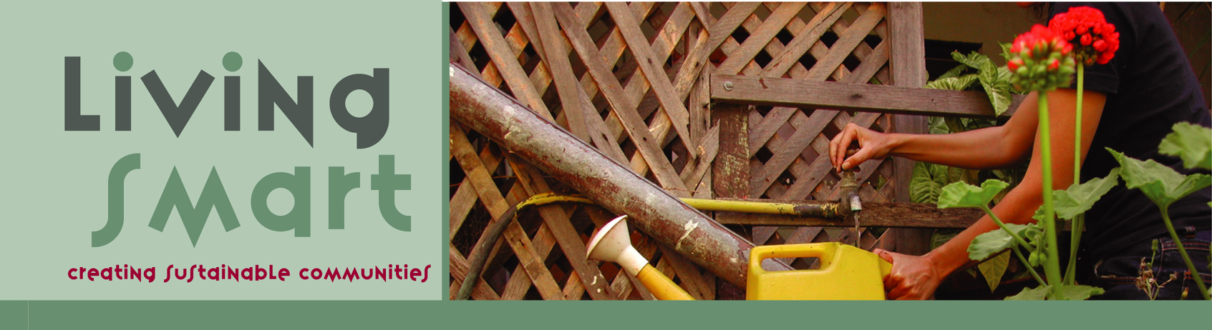

MY NAME IS _________________________________

My Living Smart Journey

Where is my household now?

Electricity __________ units per day
Lower / higher than a year ago
Perth average electricity consumption is 15-16 units per household a day

Gas __________ units per day
Lower / higher than a year ago
Perth average gas consumption is 14 units per household a day

Water __________ kL per day
Lower / higher than a year ago
Perth average scheme water use is 298kL per household per year,
which is 0.82kL per household per day

Car Travel __________ km per year
Australian average 14,800km per year

Air Travel __________ hours per year
See over for more on food etc

My Ecological Footprint: ________ha of productive land
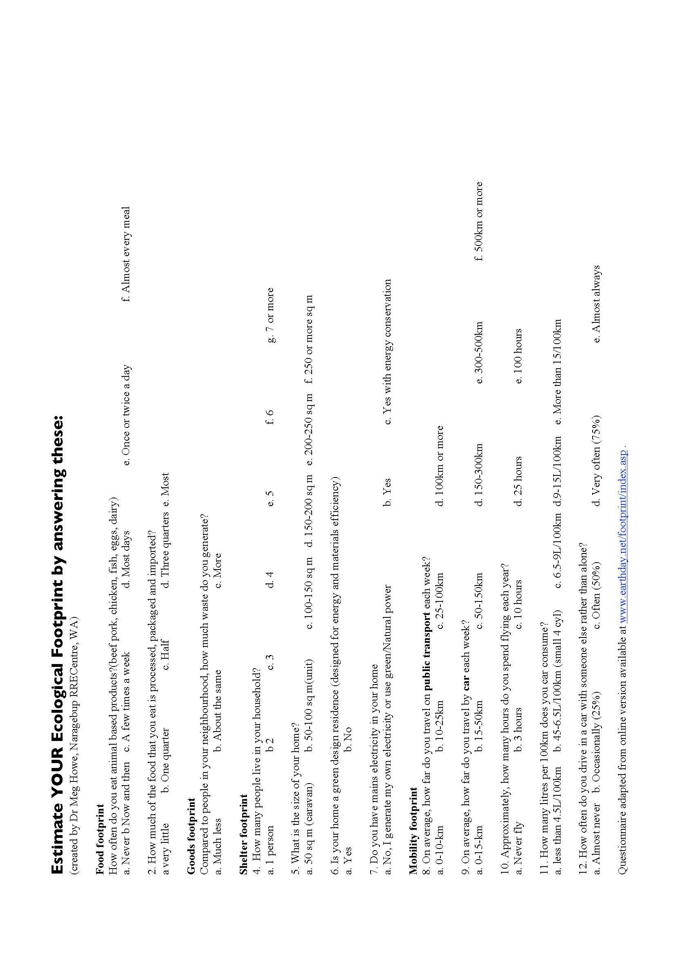
The earth only has 1.8 hectares of biologically productive land per person

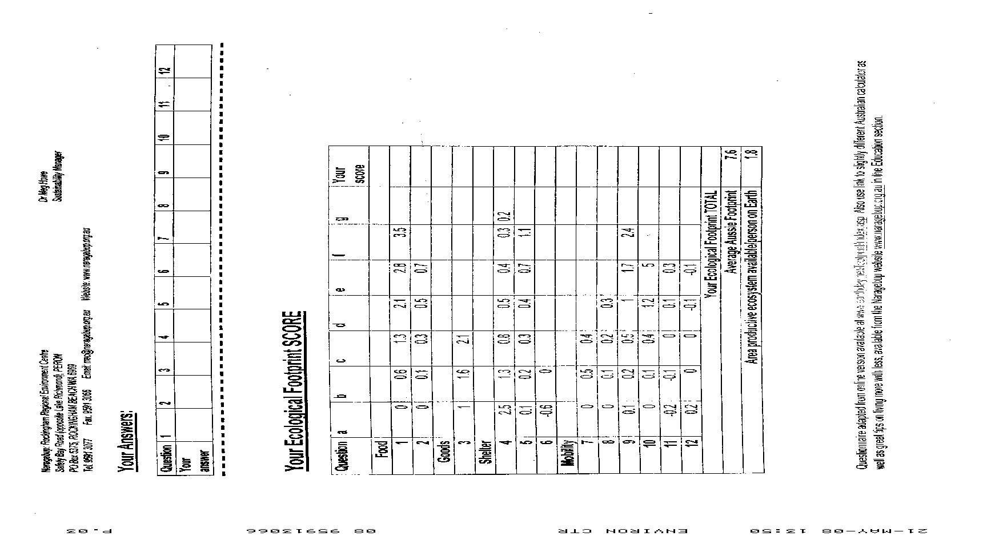
Estimate YOUR Ecological Footprint by answering these questions:
(created by Dr Meg Howe, Naragebup RRECentre, WA)

Food Footprint
1 How often do you eat animal‐based products? (beef, pork, chicken, fish, eggs, eggs, dairy)?
a) Never b) Now and Then c) A few times a week d) Most days e) 1‐2times a day f) Almost every meal
2 How much of the food that you eat is process, packaged or imported?
a) Very little b) One quarter c) Half d) Three quarters e) Most

Goods Footprint
3 Compared to people in your neighbourhood, how much wast do you generate?
a) Much less b) About the same c) More

Shelter Footprint
4 How many people live in your household?
a) 1 person b) 2 c) 3 d) 4 e) 5 f) 6 g) 7 or more
5 What is the size of your home?
a) 50sqm (caravan) b) 50‐100sqm (unit) c) 100‐150sqm d) 150‐200sqm e) 200‐250sqm f) more
6 Is your home a green design residence (designed for energy and materials efficiency)?
a) Yes b) No
7 Do you have mains electricity in your home?
a) No, I generate my own electricity or use natural power b) Yes c) Yes with energy conservation

Mobility Footprint
8 On average, how far do you travel on public transport each week?
a) 0‐10km b) 10‐25km c) 25‐100km d) 100km or more
9 On average, how far do you travel by car each week?
a) 0‐15km b) 15‐50km c) 50‐150km d) 150‐300km e) 300‐500km f) 500km or more
10 Approximately how many hours do you spend flying each year?
a) Never fly b) 3 hours c) 10 hours d) 25 hours e) 100 hours
11 How many litres per 100km does your car consume?
a) Less then 4.5l/100km b) 4.5‐6.5l/100km c) 6.5‐9l/100km d) 9‐15l/100km e) More
12 How often d you drive in a car with someone else rather than alone?
- Almost never b) 25% c) 50% d) 75% e) Almost Always
Question |  | Your Answer |  | a) |  | b) |  | c) |  | d) |  | e) |  | f) |  | g) |  |  | Your Score
1 |  |  | 0 |  | 0.6 |  | 1.3 |  | 2.1 |  | 2.8 |  | 3.5
2 |  |  | 0 |  | 0.1 |  | 0.3 |  | 0.5 |  | 0.7
3 |  |  | 1 |  | 1.6 |  | 2.1
4 |  |  | 2.5 |  | 1.3 |  | 0..8 |  | 0.5 |  | 0.4 |  | 0.3 |  | 0.2
5 |  |  | 0.1 |  | 0.2 |  | 0.3 |  | 0.4 |  | 0.7 |  | 1.1
6 |  |  | ‐0.6 |  | 0
7 |  |  | 0 |  | 0.5 |  | 0.4
8 |  |  | 0 |  | 0.1 |  | 0.2 |  | 0.3
9 |  |  | 0.1 |  | 0.2 |  | 0.5 |  | 1 |  | 1.7 |  | 2.4
10 |  |  | 0 |  | 0.1 |  | 0.4 |  | 1.2 |  | 5
11 |  |  | ‐0.2 |  | ‐0.1 |  | 0 |  | 0.1 |  | 0.3
12 |  |  | 0.2 |  | 0 |  | 0 |  | ‐0.1 |  | ‐0.1
Your Ecological Footprint TOTAL:
Average Aussie Footprint: |  |  |  |  |  |  |  |  |  |  |  |  |  |  |  |  | 7.6
Area Productive Ecosystem Available on Earth: |  |  |  |  |  |  |  |  |  |  |  |  |  |  |  |  | 1.8

Where do I want to be?

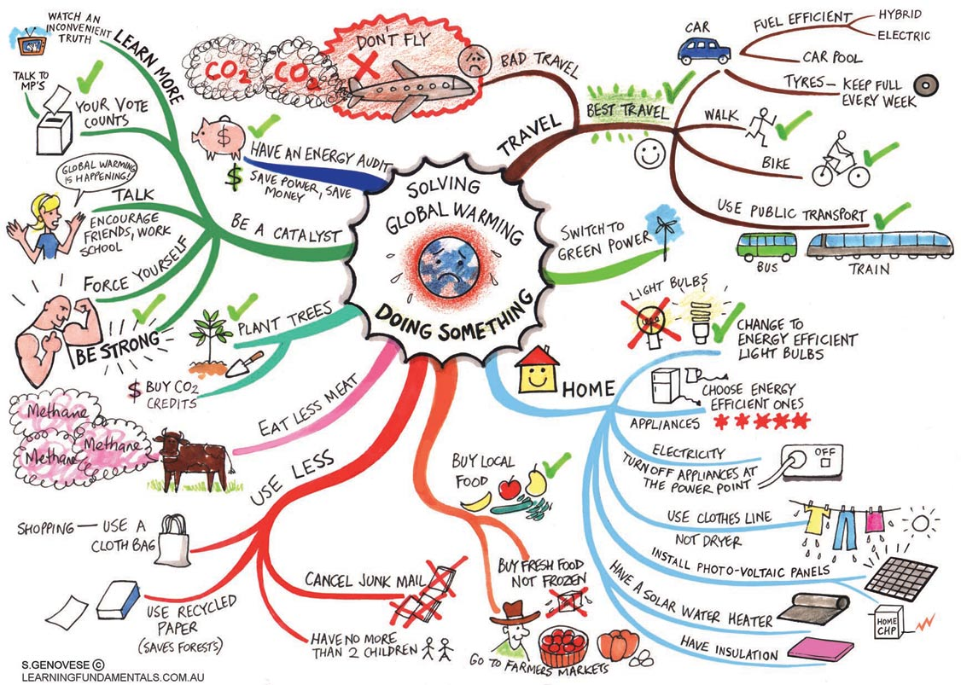

Shani’s Vision - A newspaper article from 2029
Chesterfield Celebrates 20 Years of Monthly Feasts

This month marks the 20th year of monthly feasts in what locals call the “unintentional” community of Chesterfield, located in South Fremantle. Chesterfield residents invite all members to join them for the feast, being held at the close of the 21st Sustainability Fiesta on September 7th and 8th 2029

“Every street used to have pretty good parties, but it was only when we decided to start working together that our little community grew. The Living Smart courses of 2008 and 2009 really got everyone speaking the same language” said facilitator Shani Graham.

Each month locals get together to share a meal comprising of garden produce and talk about issues in their local area. Celebrating is also a big part of the night. “It’s good to look at what needs to be done, but we also like to focus on what we have achieved.”

In preparing for the anniversary event, locals brainstormed what had been achieved in the last 20 years. Achievements included: 75% of homes being connected to solar power; a street wind generator being installed in 2012 with support from the local council; 80% of all fruit and vegetables being grown in resident’s gardens, old car parking spaces, and community allotments on the expanded road verges; a shared vehicle scheme where two cars, two vans, one car ute, and three bike utes are housed in each street for the needs of all residents; five big shared recycling bins at the end of each street, with all organic waste going to street large compost bays; one empty house in each street being the delegated “TV watching area and street office” (street computers, paper shredders, printers and scanners are located here); one large grey water treatment system per street, with water being used on the community orchard; and the number of people in the street doubling in 20 years, despite no new homes being built.

“The great depression of 2015 forced people to share houses more, but when things improved we didn’t want to change back! I can’t believe how we used to live”, said Ana from Hulbert Street. “I used to live in a big old house all by myself with no one to take care of me – I had five spare bedrooms! Now all the kids are around and I can potter in the garden with my gardener Ginny – 20 years ago it was a wasted sand pit!”

“What amazes me”, said local bike repair man and street gardener Tim Darby, “is we managed to achieve all this without committees, or constitutions, or even much money. Our yearly skills survey outlines what resources we have and can share and things grow from that. I have not had the need for money for years, since I grow or barter for most things I need. Any money we have needed has come from selling things we don’t need any more, or from people who attend our weekly Living Smart Tours.”

“And since the council delegated our streets “a special sustainable development zone” in 2012 and allowed us to trial new initiatives without legal impediment, we have even been able to raise money for the City of Fremantle by sharing what we have done with other councils. This money allowed the City to fund the City’s Community Solar Thermal and Wind Power Station which opened last year on the old tip site”, said street renewable power expert and lawyer Cassie Dunham.

Locals from Fremantle and elsewhere are invited to attend the feast on Sunday September 8th and enjoy some of the world renowned Chesterfield hospitality. Bring your own food, drink, games and musical instrument. Please no mobile communication or entertainment devices allowed.

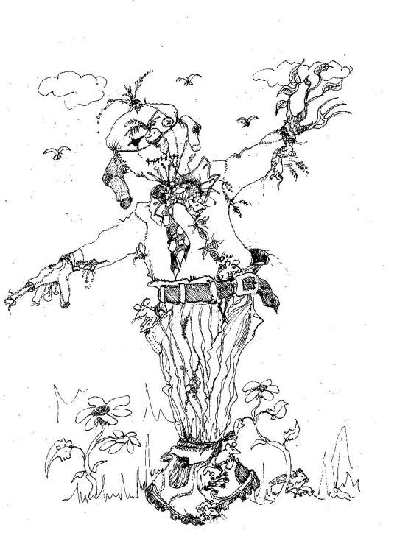
My Own Vision

So how do I get there? Good Goal Setting!

ASK
What?
Why?
When?
Where?
Who with?
How?

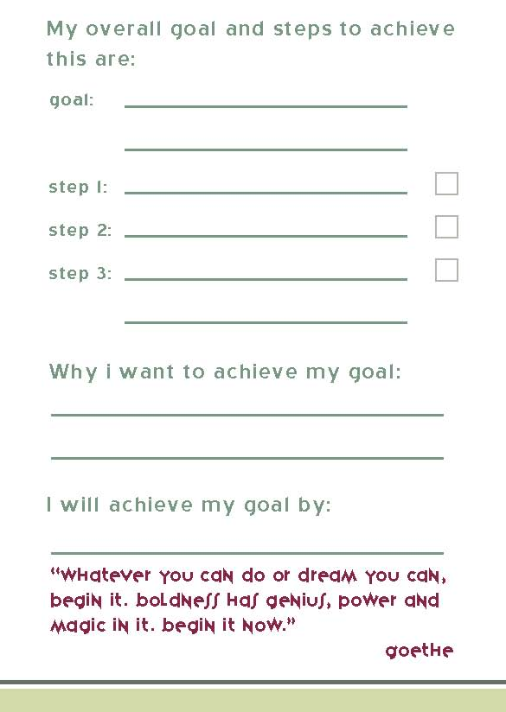
A GOAL FOR WEEK ONE

(My coach was ____________________)
Living Simply

Waste

Power

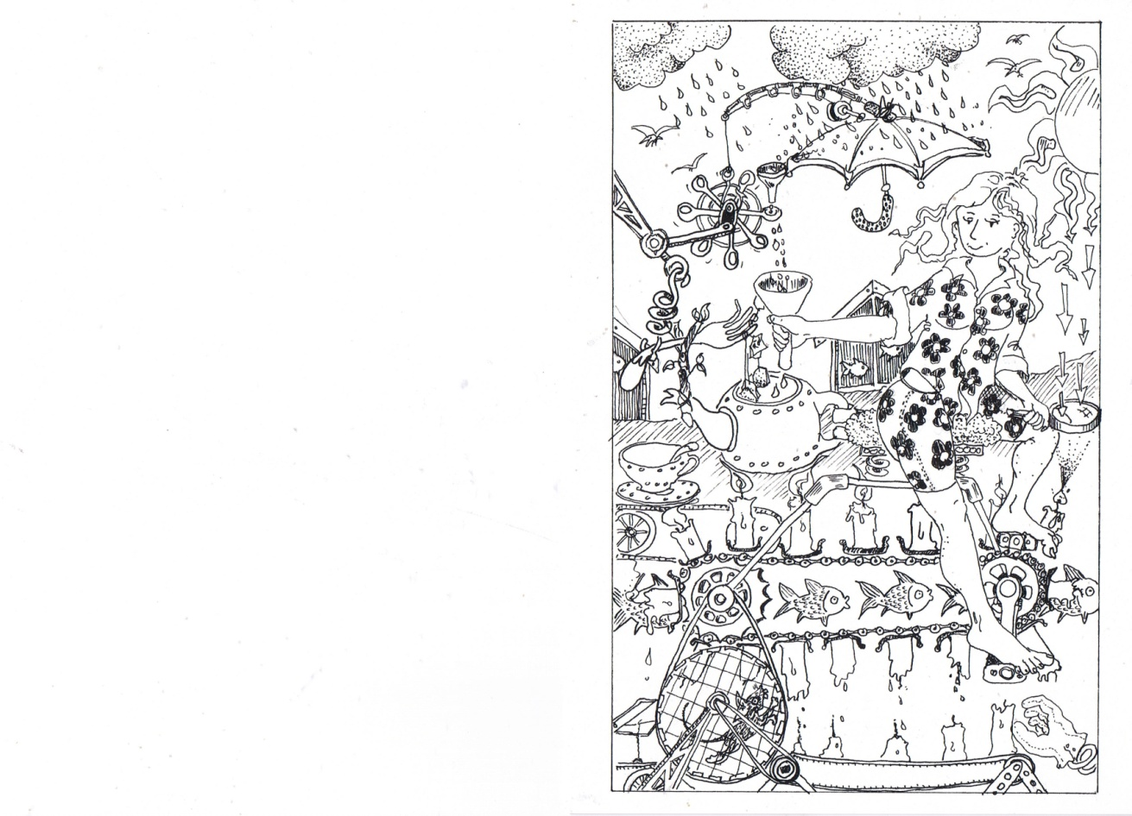

Water
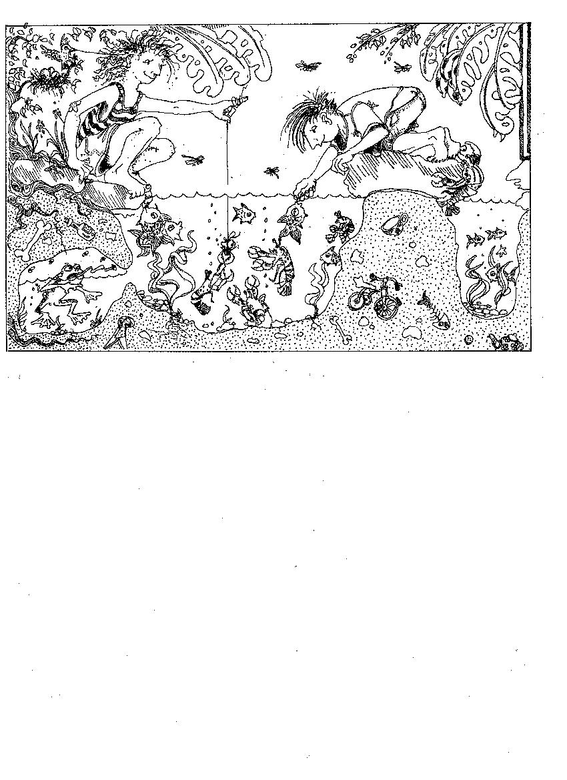

Transport

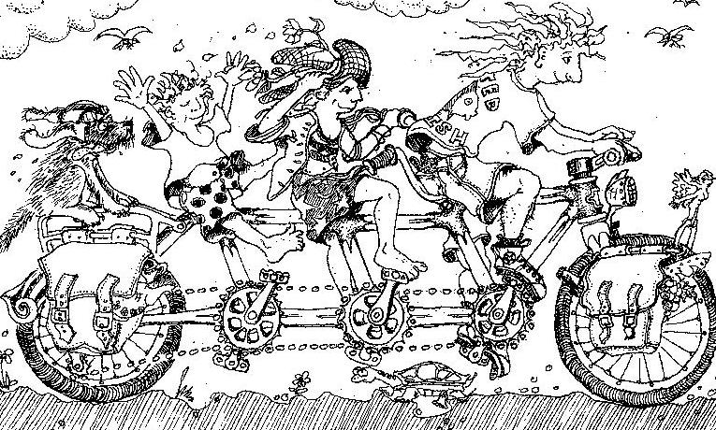

Peak Oil

Gardening

Healthy You

Healthy Home
Community

A NEW VISION

