Wicking Olive Barrel Pots
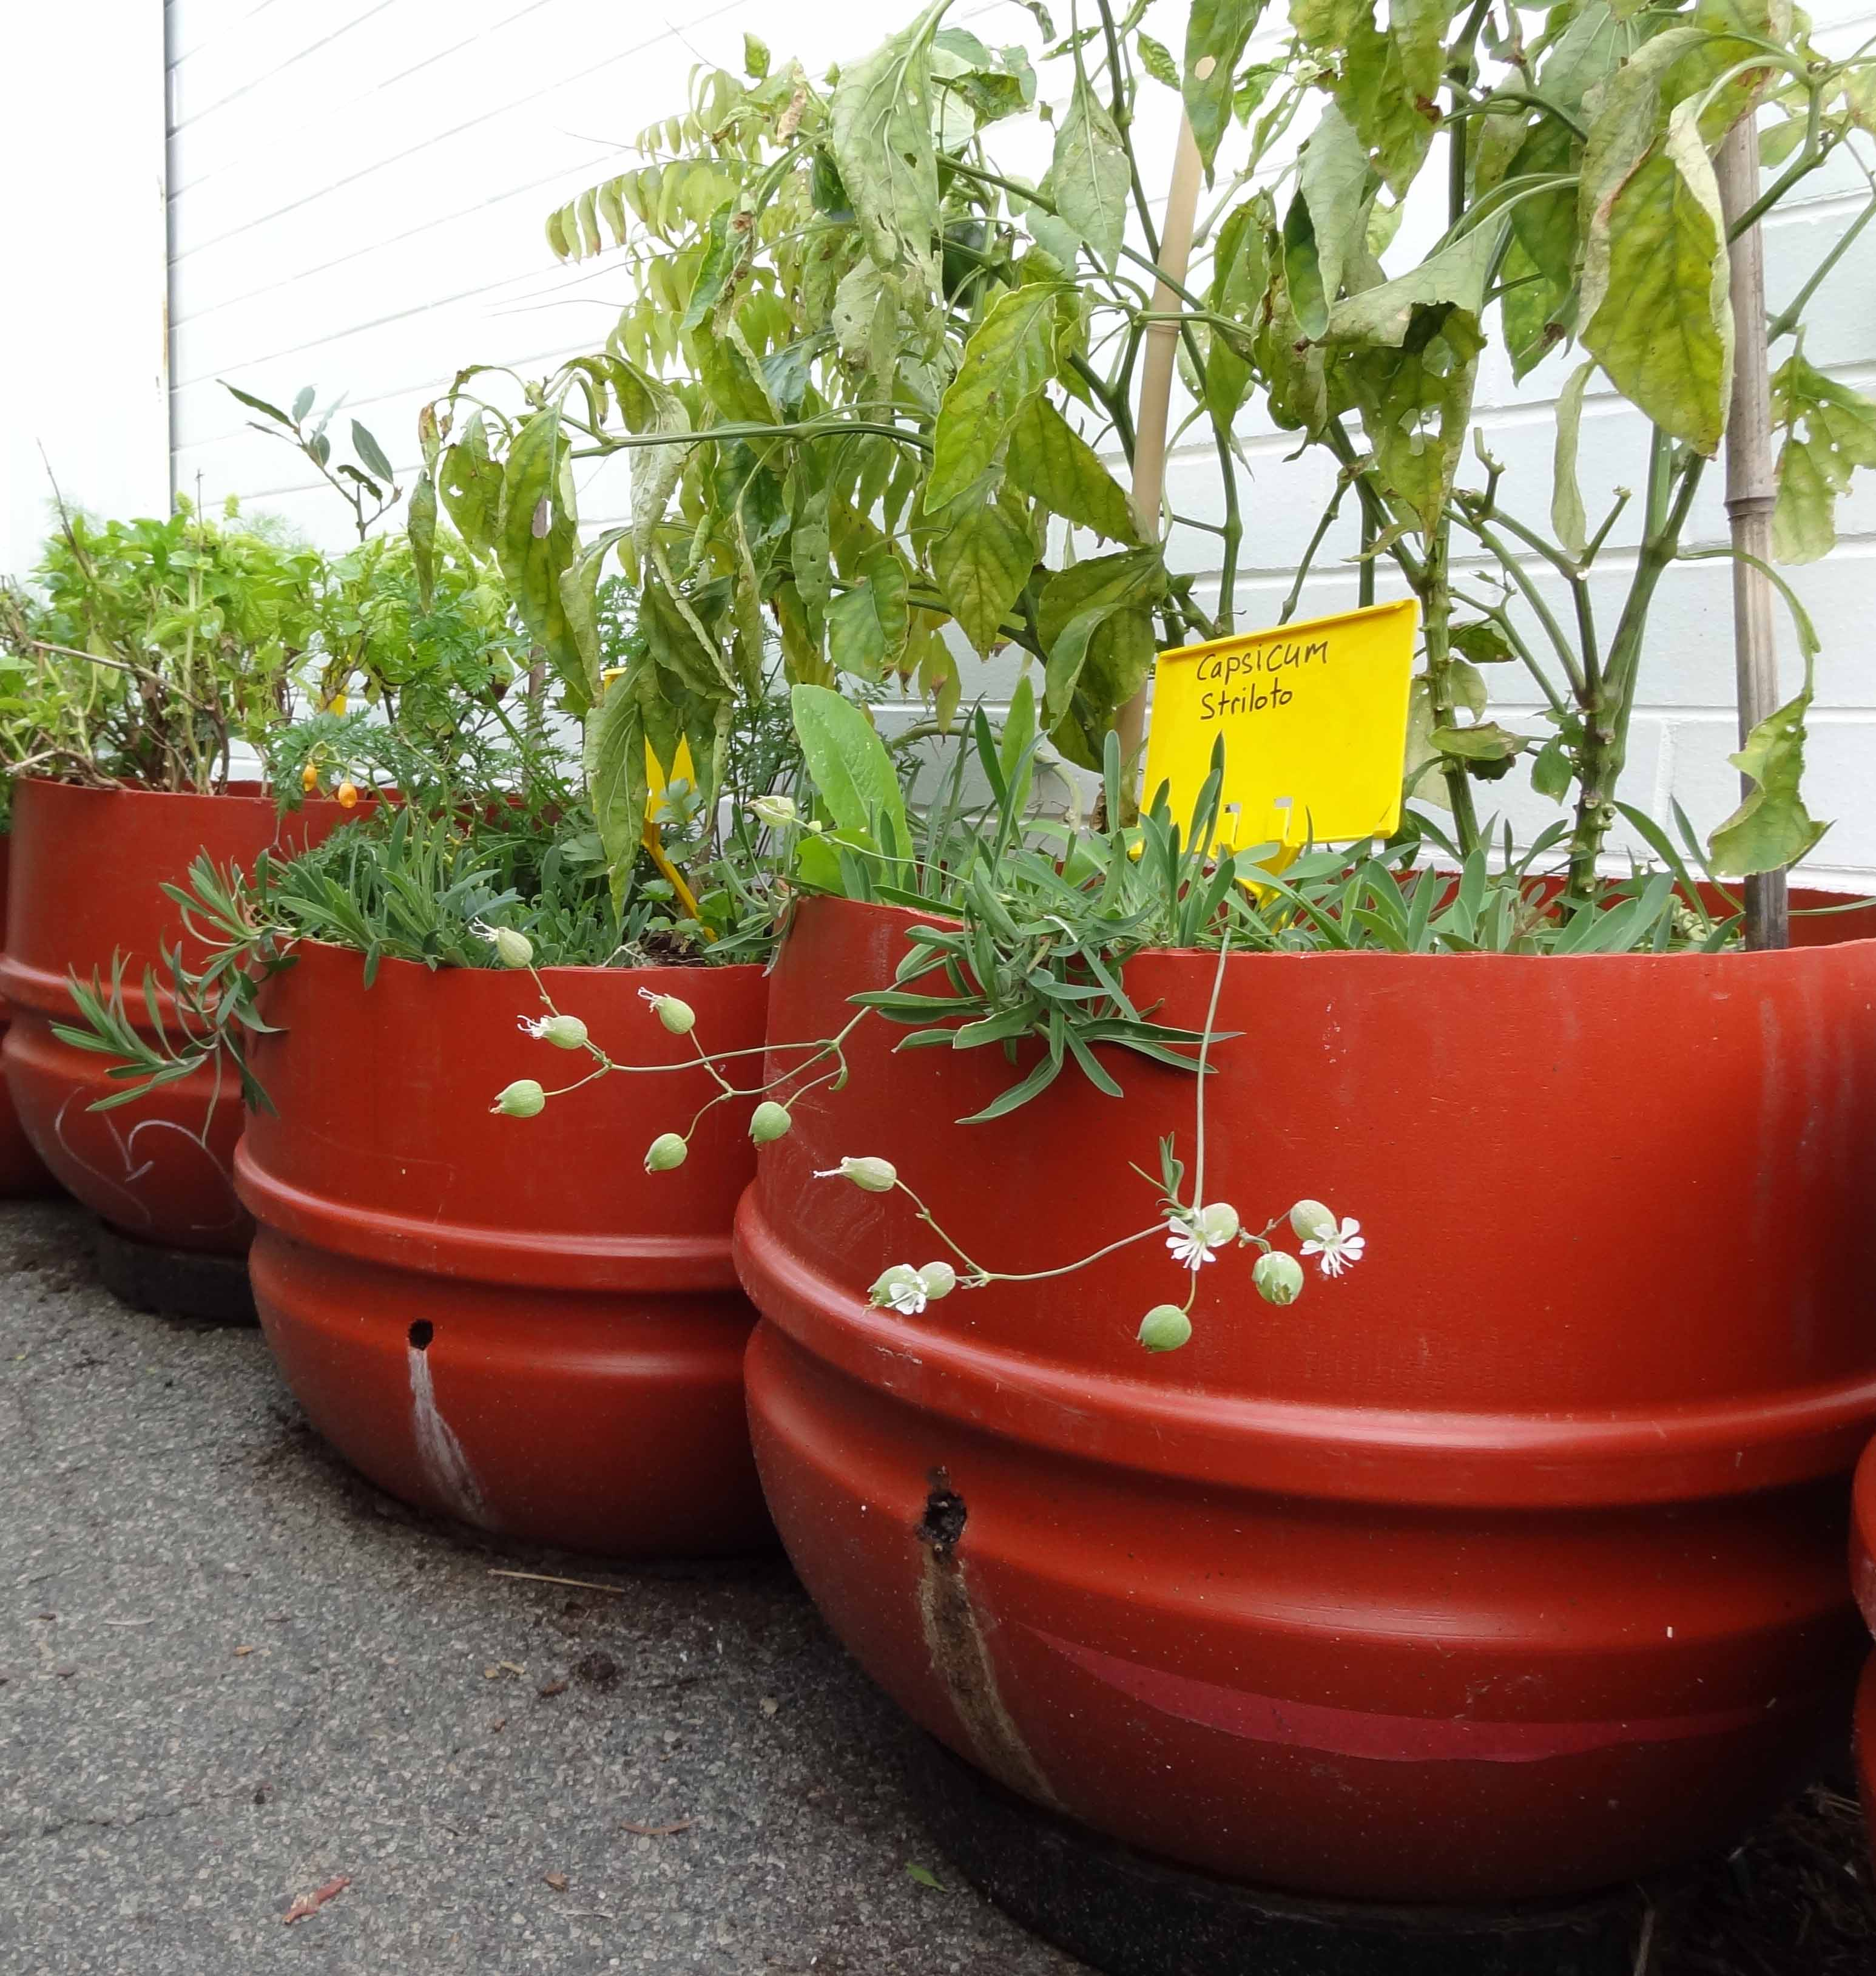
Wicking pots are based on the same principle as wicking beds, nutrient laden water normally lost below the shallow rooted vegetables and fruit trees is stopped and held under the soil to be brought back up as the above soil dries out.
These pots are for high yield veggies (annual or perennial), avoid planting fruit trees and other larger perennial herbs that don't like wet feet in there.
This is not a new idea 'self watering pots' have been around for years. However we are re-purposing a by-product of olive importation (and old pot plants destined for landfill), the barrels are food grade and UV stable, so this is a great safe sustainable product.
Compared to wine barrels they are much cheaper, and white ant and rot proof, and can be mobile (on casters or via occasional dragging). Compared to similar veggie pots which are especially made and imported from China.
A full 180 litre plastic barrel is used to make two pots, mark halfway between the ribs and cut with a saw. I use a circular cordless saw with a shallow depth to avoid it melting and blocking. A hand saw does a fine job but takes a little time to create the first cut to get the saw blade into.
Once you have two halves ensure the lid end has its rubber seal on and is tight so that it holds the water. The drill holes shown in the above photos are the only holes/outlets in the barrel. This means the height you drill it defines the maximum height of the water reservoir. I aim for about the height of the pots as it is better if not too much soil is waterlogged and anaerobic.
To avoid anaerobic activity and smells it is advised to allow the pots to roughly dry out the reservoir each cycle. As the water moves up via capillary and evaporation and condensation into the soil air comes in via the hole (replacing the void left by the water) to keep things aerobic.
The water sits in the bottom of the pot and is wicked (think candle wax or capillary action in trees) upwards into the soil as the soil/plants need it. Even without the water body touching the soil above, evaporation and condensation still allow the water to migrate up. The soil based capillary action works for about 30cm deep only so while you can make deeper soil you will need to top down water your seeds/seedling each day until they reach the wet zone.
Water percolates down via surface watering or drip retic you don't need a tube down into the water to fill it.
There are many advantages of these pots, the main ones being your water and nutrients (fertiliser) that normally runs out the bottom of pots every time you water wont anymore. Saving you money and helping the environment.

Your reservoir can be created by the inverted seedling pots and mulch and should hold around 10 litres of water with another 10 staying in the wet soil. Empty pots are light, but strong enough to hold up soil, and crate a decent sized void for water to fill This 20 L of water in the pot should allow you to water most plantings/veggies once a week in summer with mulching. You won't tend to water them in winter if it's raining.
Keep you your Wicking Veggie pot is in kit form until you have it in position as once it is filled with soil, watered and planted, it will weight 60 kg. If you put it on casters which is a great option on decks/pavers etc, make sure the casters can take 50-60kg.
So get your 1/2 a barrel with mesh covered overflow hole. 5-6 empty pots, the top of the pots should be just below the drilled hole outlet to help 'seal' the hole/reservoir from mozzi breeding. And some Mulch to fill the gaps between the pots to avoid lots of soil filling the wet zone.
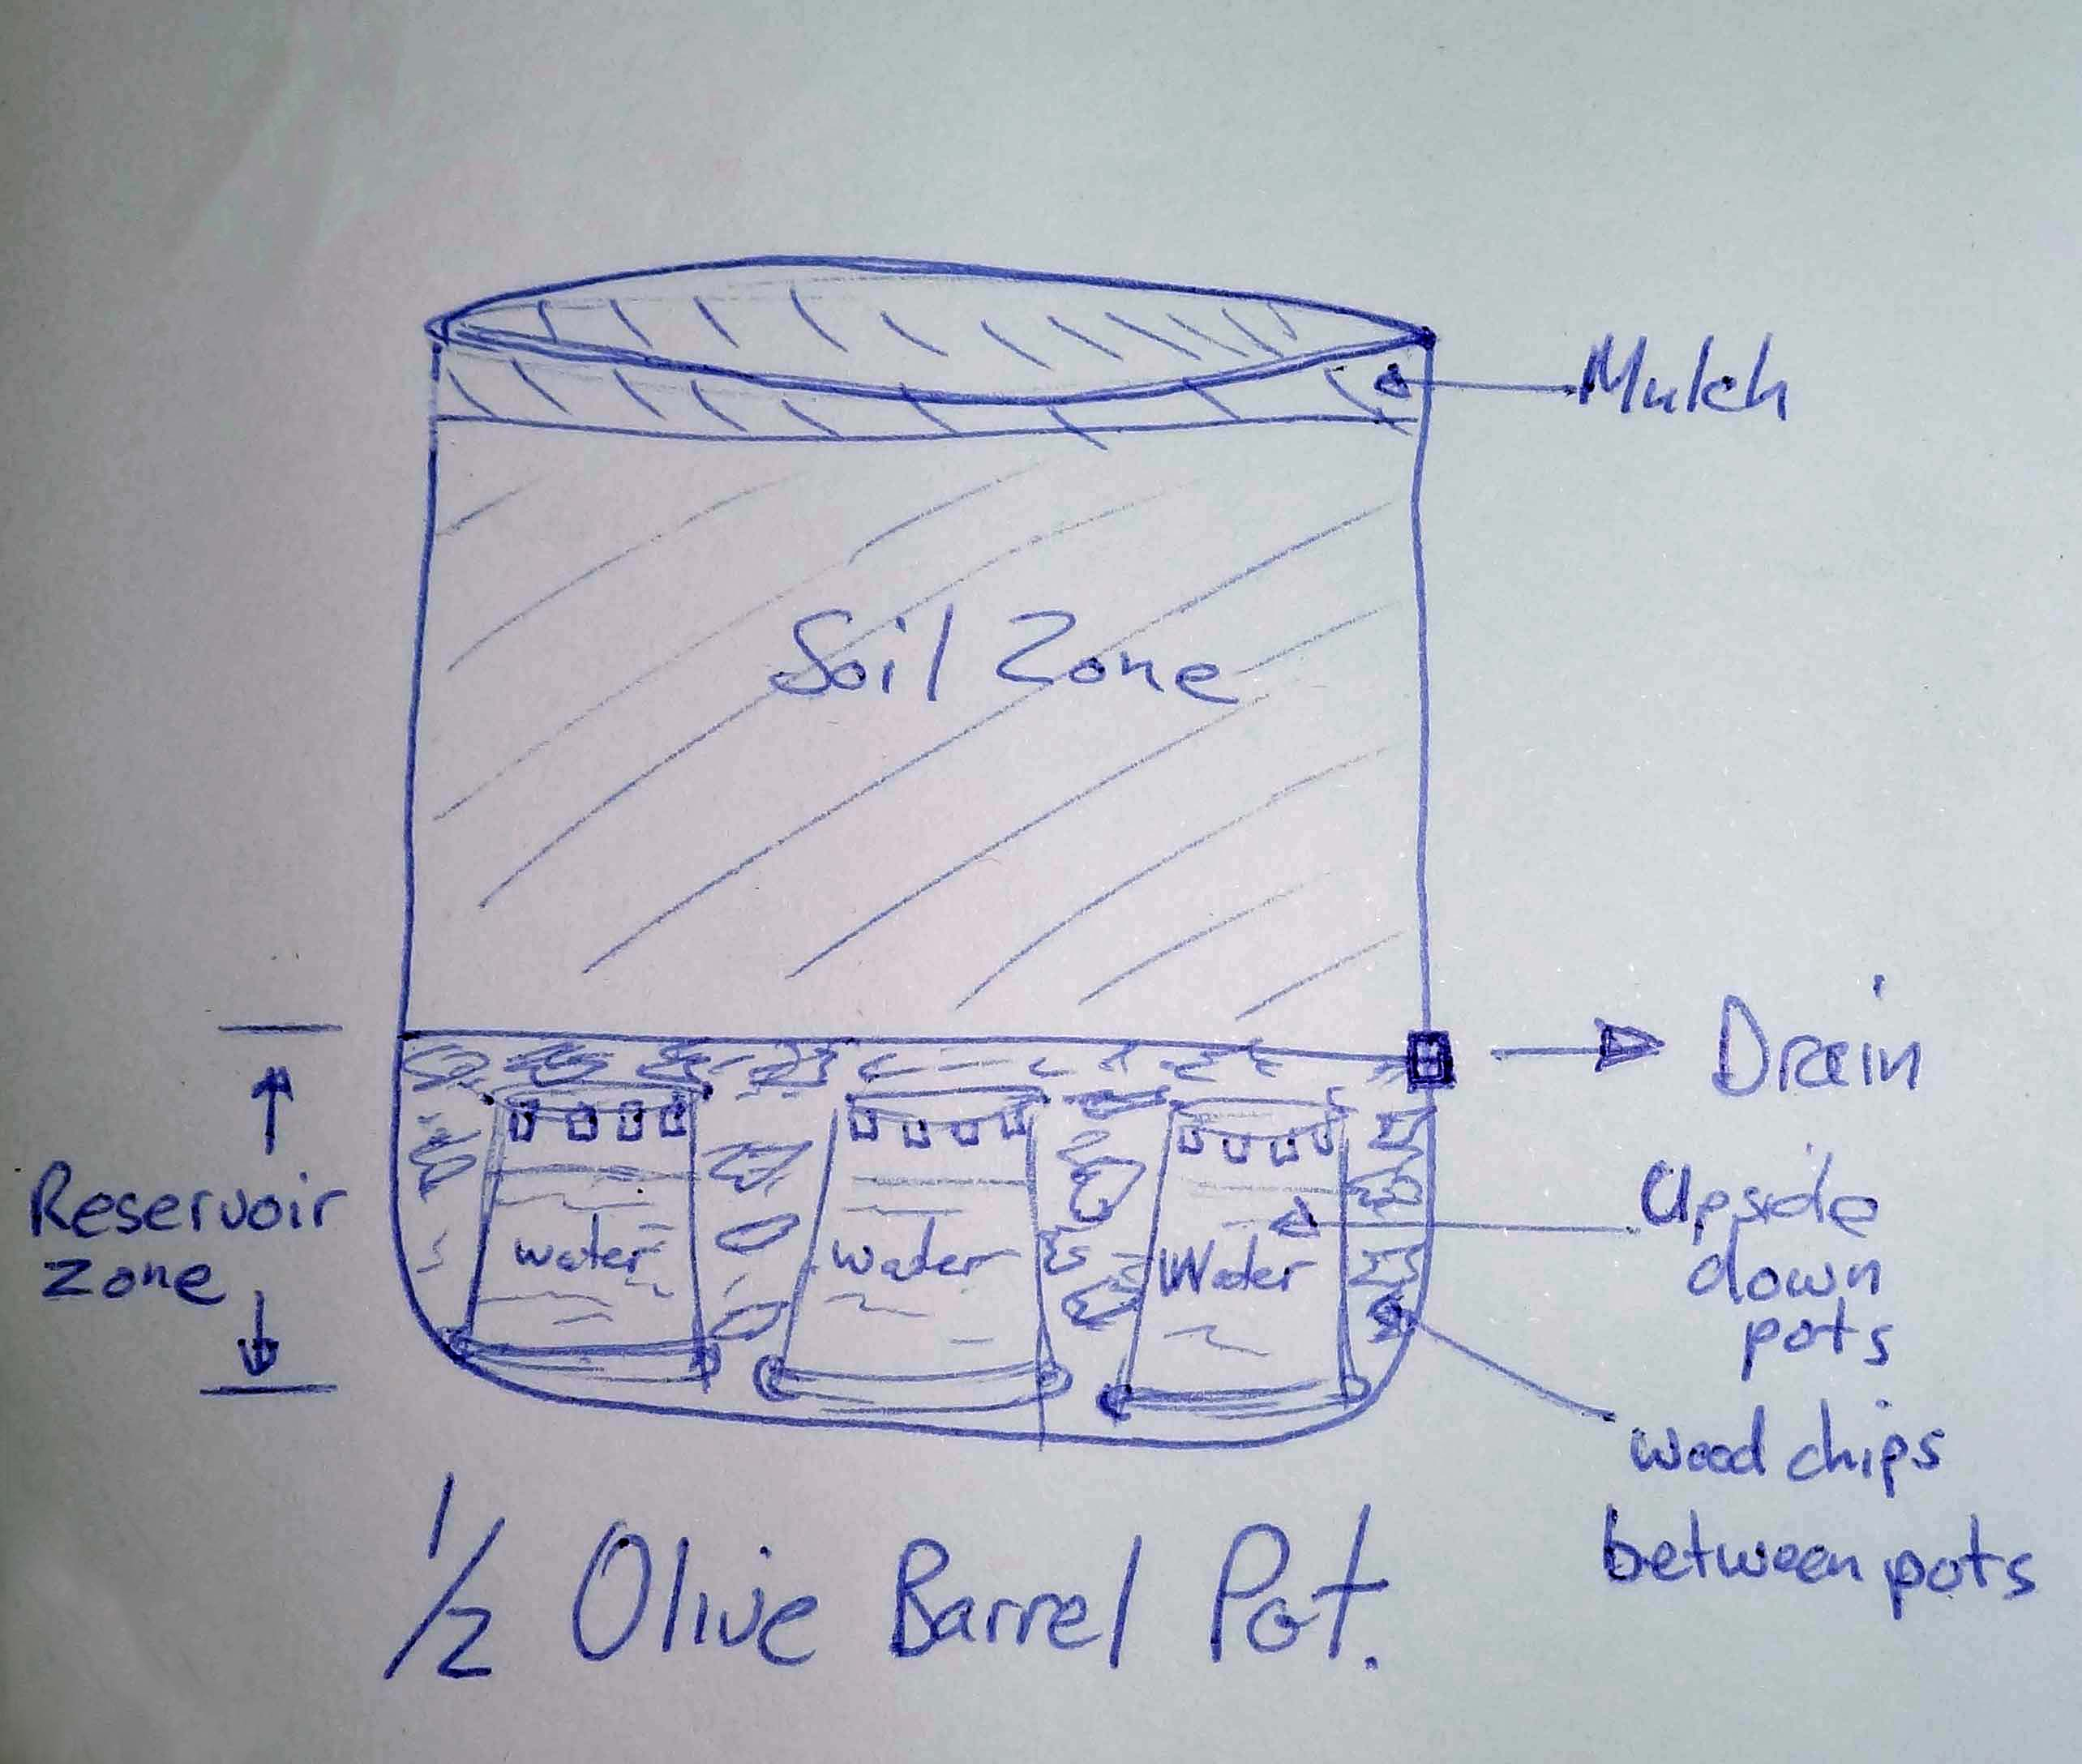
- Place the pot where you wish it to stay or place on movable platform (capable of taking 60kg).
- Put the plant pots upside down around the base. You will likely need, 6-10 depending on the size. If using small pots place one in the middle and others around that, if larger pots just make a ring. I use 1L to 1.5 L pots as these will be about the height of the overflow hole.
- Use the woodchips/mulch to fill the gaps between the pots up to the level of the over flow. Note the pot base should be level otherwise it won't work. This is the reservoir zone.
- You can place weedmat or shadecloth between the soil and reservoir to slow down the silting up but I don't bother as they are easy to empty each year if needed to refill woodchips and reorganise.
- Fill with soil mix, I use vegemix from greenlife or a compost and cocopeat (husk) 50/50 mix. Gently press the soil down and water well. If planting seeds top watering might be require on hot days to keep it moist. Use seaweed liquid on plant leaves/roots if transplanting seedlings.
- Feed with compost, Lucerne/lupin mulch, coffee grinds, small amounts of manure to top up organic material. Feed with small amounts of complete organic fertiliser after yielding a crop or in 3 months time. Note that strong artificial fertilisers are likely to concentrate in the water zone and ruin your soil unless flushed out.
- Additional info
- Over watering and heavy rain not a problem thanks to drain, excess overflows hole and drains away. Nutrients aren't all leached below plant roots reach, but end up in reservoir.
- incorporate a worm farm
- manifold several together via the drain point.

