
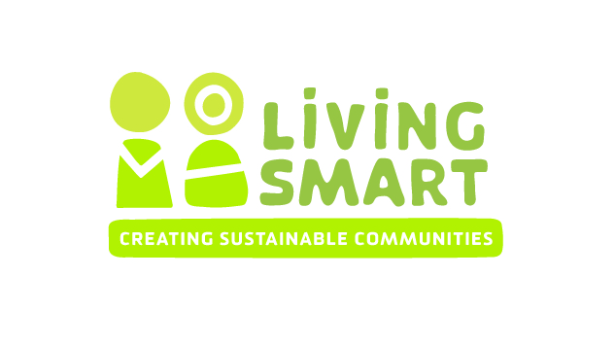

SAMPLE DRAFT FOR TRAINING PURPOSES ONLY - ADJUST TO YOUR REQUIREMENTS

Host and Facilitator “Conversation”

For Name of Facilitator to deliver the Living Smart course to Host Group
Basic Course information
An “Application to Deliver a Living Smart Facilitator Training Course” agreement has been completed.
The course will be held on DAY OF WEEK AND TIME
The course will start on DATE and running each DAY OF WEEK for ?? weeks (final week on DATE) Dates for the outing(s) and gardening day will be arranged and negotiated with course participants
Maximum course enrolment will be ?? people.
Venue - ?
Inclusion of the following acknowledgement clause will be made in media releases, course reports and posters: “The Living Smart program was developed by the City of Fremantle, Murdoch University and Southern Metropolitan Regional Council and is now coordinated by Be Living Smart Inc.”
The host name and logo can be listed as course sponsor.

Course cost. Must include $40 per person that is payable to BLS. Consider the cost of hard copies of the participant guide if applicable – usually about $10 per person to print (B&W)
Payment arrangements
Invoice 25% at the beginning of the course, and 75% at the end of the course. OR??

$440 (includes GST) for each course will be payable to BLS. An invoice will be provided to the Living Smart facilitator (not the host) and payment is to be made within four weeks of the end of the course.

A $40 (includes GST) course and Living Smart membership fee per participant will be charged and be payable to BLS. This fee will be collected by ????? The collection and banking of this fee will occur within 3 weeks of the course starting by the LS facilitator.
Contracts & Payment
?? is the main point of contact for queries with Facilitator regarding contract and will approve the final contract.
?? will receive Facilitators’ invoices and process payments

Facilitator Role & Responsibilities
Prepare draft media release, poster and course description and send to name of person from host for approval and distribution
Keep attendance records
Provide small participant prizes to reward action (such as native seedlings and organic food gifts)
Purchase refreshments and/ or organise roster for refreshments amongst participants
Facilitate at least 8 sessions (including 7 weekly sessions, and a field trip), including presenting on many topics, using up to 1 guest speaker per night to provide variety and specialist knowledge when required.

Ensure course quality and incorporate the following components, as outline in the LS Facilitator Policy and Licencing Agreement –

Course size to be minimum 15 and a maximum 40 enrolled participants.
All ten Living Smart topics are covered.
There is in-class time for goal setting during each session.
There is sharing of goal setting and/or actions taken each session.
There is some process for the setting of end of course goals setting and/or visioning process.
There is at least one field trip in each course.
Following best practise principles of adult learning, there are group discussion and activities in each session.
The minimum evaluation components will be completed. These are the current pre-course form, some sort of brainstorming activity where participants list achievements and plans in each Living Smart area and the post-course form.
A basic course report including results of all evaluations will be completed and a copy given to BLS, based on the pro-forma provided within a month of the course finishing.
A full list of participants and their contact details will be given to BLS within a month of the course finishing.
In addition:

Facilitate and/ or attendance at post course “celebration” about one month after the course finishes. Participants will be encouraged to self organise this event.
Prepare at least 7 brief ‘mid-week’ emails for participants following week 1 encouraging action and provided useful websites and resources.
Create pre and post questionaires based on Be Living Smart Inc, facilitator and host requirements.
Analyse data from pre- and post- course questionnaires and write up a brief report. Send to host as required

Equipment and resources provided by Facilitators
Basic paper, pens etc and other materials required for activities

Host Role & Requirements
Inform facilitator of addition pre or post assessment requirements.
Organise a suitable venue. Coordinate room hire agreement, venue insurance, payment for venue and access to key for facilitators. Organise keys
Approve press release and photos by name of person, distribution to local press contacts.
Print and circulate posters and information about the course amongst interested local groups, at local council and other local noticeboards etc.
Responsible for basic course publicity, and ongoing communication with facilitators prior to course about success of publicity.
Provide public liability insurance for course meetings and outings not otherwise covered (eg if at a participant’s home)
On request by facilitator, assist with local information relating to local activities, council policies and local contacts
Name is main point of contact for queries re course development

Equipment and resources provided by Hosts
Suitable venue, tables and chairs, kitchen area for preparing refreshments
Cups and plates for refreshments

Items to be negotiated
Finalise application to run course form and send to Be Living Smart Inc
Take all queries and data entry on course enrolments, receive money for course,
A laptop and data projector ??? OR HOST DISCUSS
Copies of participant handbook (DISCUSS COST AND HOW TO MANAGE THIS, evaluation forms and any other materials required for the course.
Personal Living Smart library – books and DVD’s available for participants to borrow IF YOU ARE WILLING TOO.
Host to attend at least Week 1 to assist facilitator with welcoming and greeting participants, collecting enrolment information and collecting money

Living Smart Facilitators Fee Schedule / Quote
( DRAFT FOR TRAINING PURPOSES)
Item | Hours | Costs provided by Host | Cost at Hourly Rate  Remember GST?
Pre-course |  |  | $30 – 50 per hr suggested
Start-up meeting/ communication | 2-3
Preparation of Participant Handbook, goal sheets,  Evaluation forms, draft poster | 2
Printing and photocopying costs – weekly course materials | 8 OR | Set amount
Venue Hire | na | provided
Publicity – preparation of media releases, posters | 2-3
Course Enrolments entered, updated, and email list prepared | 1-4
Evaluate participant requirements, prepare preliminary course program and speakers | 2-5
Course Preparation on Topics
Preparation for topics when no guest speaker | 2- 4hrs per major topic
Preparation of topic presentations given guest speakers) | 1-2 hrs per topic
Weekly setup, facilitation and pack up | 3 hrs ifsupport  4-5 if no support
Travel time | As required
Course facilitation
Field Trip – preparation & planning, attendance | 4-6
Mid-week email prep time | 5-8
Refreshments budget | ??
Rewards to active participants | ??
Guest speakers gifts | ??
Post Course catch up – attendance and assistance with coordinating if needed | 3-4
Course Evaluation
Evaluation Form data entry | 3-6
Analyse pre and post-course Living Smart evaluation forms | 3-6
Complete brief report | 5-8
Course fee $440 inc GST payable by facilitator to Be Living Smart Inc | $440
Participant Fees $40 each inc GST payable by facilitator to Be Living Smart Inc | Take out if you are collecting directly
TOTALS (GST inclusive or not??)

