
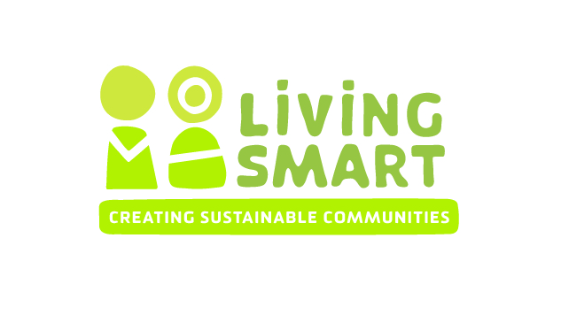

SAMPLE DRAFT FOR TRAINING PURPOSES ONLY

Facilitator Contract Services Outline for Host Group

For Name of Facilitator to deliver the Living Smart course to Host Group
Basic Course information
The course will be held on DAY OF WEEK AND TIME
The course will start on DATE and running each DAY OF WEEK for ?? weeks (final week on DATE) Dates for the outing(s) and gardening day will be arranged and negotiated with course participants
Maximum course enrolment will be 40 people, minimum 15.
Venue - ?

Inclusion of the following acknowledgement clause will be made in media releases, course reports and posters: “The Living Smart program was developed by the City of Fremantle, Murdoch University and Southern Metropolitan Regional Council and is now coordinated by Be Living Smart Inc.”
The host name and logo can be listed as course sponsor.
Payment arrangements
Principal contract with host for facilitation costs, guest speaker gift payment and rewards costs
Invoice 25% at the beginning of the course, and 75% at the end of the course. OR??
A payment of $440 (inclusive of GST) will be paid to Be Living Smart by ??
Participant fees of $40?? will be collected by ?? and forwarded to Be Living Smart.

Contracts & Payment
Name is the main point of contact for queries with Facilitator regarding contract and approves final contract.
Name will receive Facilitators’ invoices and process payments

Facilitator Role & Responsibilities
Prepare draft media release, poster and course description and send to name of person from host for approval and distribution
Take all queries and data entry on course enrolments, receive money for course keep attendance records (can be host!!)
Provide small participant prizes to reward action (such as native seedlings and organic food gifts)
Purchase refreshments and/ or organise roster for refreshments amongst participants
Facilitate at least 9 sessions (including 7 weekly sessions, a field trip and hands on gardening day), including presenting on many topics, using up to 1 guest speaker per night to provide variety and specialist knowledge when needed.
Ensure course quality and incorporates the following components, as outline in the LS Facilitator Policy and Licencing Agreement
- All Living Smart topics are covered
- There is in-class time for goal setting during each session
- There is sharing of goal setting and/or actions taken each session
- There is some process for the setting of end of course goals setting and/or visioning process
- There is at least one field trip in each course
- Following best practise principles of adult learning, there are group discussion and activities in each session
- The minimum evaluation components will be completed. These are the current pre-course form, some sort of brainstorming activity where participants list achievements and plans in each Living Smart area and the post-course form
- A list of potential participants will be forwarded to BLS one week before the course starts.
- A full list of participants and their contact details will be given to BLS within a month of the course finishing
- BLS membership forms will be given to participants and completed forms sent to the BLS Coordinator within a month of the end of the course
Facilitate and/ or attendance at post course “celebration” about one month after the course finishes. Participants will be encouraged to self organise this event.
Prepare at least 7 brief ‘mid-week’ emails for participants following week 1 encouraging action and provided useful websites and resources.
Create pre and post questionaires based on Be Living Smart Inc, facilitator and host requirements.
Analyse data from pre- and post- course questionnaires and write up a brief report. Send to host and Be Living Smart Inc as required.
Equipment and resources provided by Facilitators
A laptop, data projector and any additional materials for activities eg butchers paper
Copies of participant notes and goal setting booklet, evaluation forms and any other materials required for the course.
Personal Living Smart library – books and DVD’s available for participants to borrow

Host Role & Requirements
Finalise application to run course form and send to Be Living Smart Inc
Organise a suitable venue. Coordinate room hire agreement, venue insurance, payment for venue and access to key for facilitators. Organise keys
Approval of press release and photos by name of person, distribution to local press contacts.
Printing and circulating poster and information about the course amongst interested local groups, at local council and other local noticeboards etc.
Responsible for all course publicity, and ongoing communication with facilitators prior to course about success of publicity.
Attend at least Week 1 to assist facilitator with welcoming and greeting participants.
Provide public liability insurance for course meetings and outings not otherwise covered (eg if at a participant’s home)
On request by facilitator, assist with local information relating to local activities, council policies and local contacts Name is main point of contact for queries re course development
Equipment and resources provided by Hosts
Suitable venue, tables and chairs, kitchen area for preparing refreshments
Cups and plates for refreshments
Living Smart Facilitators Fee Schedule / Quote
( DRAFT FOR TRAINING PURPOSES)
Item | Hours | Costs provided by Host | Cost at Hourly Rate  GST?
Pre-course |  |  | $30 – 50 per hr suggested
Start-up meeting/ communication | 2-3
Preparation of Participant Guides, Goal sheets,  Evaluation forms, draft poster | 2
Printing and photocopying costs – weekly course materials | 8
Venue Hire | na | provided
Publicity – preparation of media releases, posters | 1-3
Course Enrolments entered, updated, and email list prepared | 1-4
Evaluate participant requirements, prepare preliminary course program and speakers | 2-5
Course Preparation on Topics
Preparation for topics when no guest speaker | 2- 4hrs per major topic
Preparation of topic presentations given guest speakers) | 1-2 hrs per topic
Weekly setup, facilitation and pack up | 3 hrs ifsupport  4-5 if no support
Travel time | As required
Course facilitation
Field Trip – preparation & planning, attendance | 4-6
Mid-week email prep time | 5-8
Refreshments budget | na
Rewards to active participants | na
Guest speakers gift | na
Post Course catch up – attendance and assistance with coordinating if needed | 3-4
Course Evaluation
Evaluation Form data entry | 3-6
Analyse pre and post-course Living Smart evaluation forms | 3-6
Complete brief report | 5-7
Course fee $440 inc GST payable to Be Living Smart Inc

Participant Fees $40 each inc GST payable to Be Living Smart Inc

TOTALS (GST inclusive)

