Dr Martin Anda

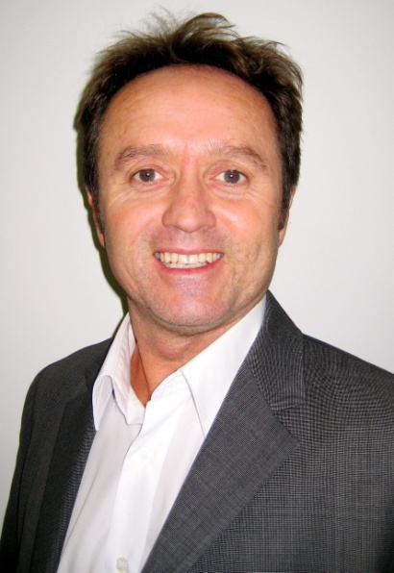

Martin is Academic Chair and Senior Lecturer in Environmental Engineering at Murdoch University. Martin coordinates a team of postgraduate researchers in a group called Environmental Engineering & Life Systems (EELS) that are conducting a range of PhD research projects across water efficiency, water recycling, sustainable livelihoods, carbon neutral settlements and green buildings. In the commercial world Martin is Principal Engineer Sustainability at ENV Australia Pty Ltd where he leads a team of sustainability, energy and water scientists on a wide range of government, utility and industry projects. In this role Martin has led a team of contractors to deliver the H2ome Smart water saving behaviour change program using Community Based Social Marketing Techniques to thousands of homes across Western Australia for the State utility Water Corporation. Martin is a founding member of the UDIA (WA) *Envirodevelopment* board of management to assess applications from the urban land development sector for this award.