**SWECHA**

1. **Team Name** – SWECHA  
   **Team Leader’ name** – Mr. T. Srikanth  
   **Team Leader’ email id** – [tadaboinasrikanth@gmail.com](mailto:tadaboinasrikanth@gmail.com)
2. **Solution Brief Overview** –

Our idea is about, In the COVID 19 pandemic situation, the Doctors and police people were working for the public and our nation for 24 hours without resting so they don’t have time to take care of their family needs. Doctors, Police, Medical staff are the frontline warriors during the time of crises. To help them, a mobile CHATBOT application is proposed, so the family members of Doctors, Police and can intimate information of their essential needs like groceries, medical-related, etc. or in any emergency situations through an app, we can connect to nearby volunteers or any social service people to help them.

To develop the proposed CHATBOT application, IBM services like **Watson Assistant, Cloudant Database, Node.js,** and **HERE location services** are used. IBM Watson Assistant is used to build, train, and deploy conversational interactions. The proposed CHATBOT plays a vital role in helping the families of front line warrior during the time of crises.

1. **Working Model** - <https://youtu.be/F5T6NVXW-F8>
2. **Solution description**-

In the implementation of the idea, IBM services like Watson Assistant, Cloudant Database, Node.js, and in addition external source HERE location services are used to develop an application for front line warriors. Here we have created a Chat-bot that is used to communicate with the User and the Volunteers. The conversion process is like if the user type HELLO then it responds like Hi, the SAHAYYA chat-bot replies how can I help you, if the user needs vegetables then e.g I need vegetables then it responds The vegetables will be delivered to you. so in this chat-bot where the response is given according to the intents, entities and dialogues which are imported in the chat-bot. so this is how the communication process goes on in the chat-bot. Firstly we have to Log in to an IBM cloud then by creating a Watson Assistant, imported intents i.e input given by the user, entities nothing but output given by the chatbot and then go to the dialog by adding nodes in that and the chat-bot is ready for the communication between user and volunteers. After that Preview the link to copy and run the application. Through this proposed application the user's essential needs are provided within a time by volunteers and take less time to help them by servicing their needs by social servicing volunteers. As per our knowledge, there is no application like this so we have developed this application. and this application is our contribution to the benefit of society and it falls under the category of community cooperation.

1. **Solution Architecture** –

* The user connected to a mobile app with Here location services which is interfaced with IBM cloud services -- Node.js linked with Watson assistant and Cloudant database.
* The first one is creating a Watson Assistant and then using Watson assistant a CHATBOT is created which is imported by the prepared intents, entities and dialogs which use natural language understanding and machine learning to extract intents and entities of the user question.
* In the IBM cloud, the Cloudant database should be created by adding new service credentials and copy the code of API server which is used in the Run the server.
* Generate an API key from the HERE developer portal for the location service to provide the essential things to the user location.
* Where the User i.e. frontline warriors visits the website of the SAHAYYA CHATBOT and ask their essentials things through the communication in the chatbot and the near by volunteers were help them out.

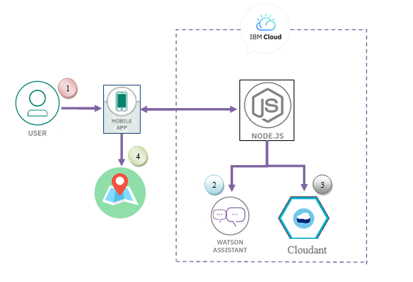

In the solution architecture, IBM services like Watson Assistant, Cloudant Database, Node.js, and HERE location services are used to develop CHATBOT to help families of front line warriors.

* + The user visits a website with the SHAYYA CHATBOT and asks a question.
  + Watson Assistant uses natural language understanding and machine learning to extract entities and intents of the user question.
  + Watson assistant and Cloudant database are interconnected to a Node.js and interfaced with the mobile app.
  + Here location services is connected to a mobile app to show the user location
  + The Node.js web server calls Watson Assistant hosted in IBM Cloud.
  + Watson Assistant replies to the user inquiry.
  + Run the mobile application which displays the chat answer to the user.

1. **IBM Cloud Services/Systems** – The List of IBM Services used in this solution
   * IBM Watson Assistant
   * CLOUDANT
   * NODE-Red Slack Integration
   * HERE Location Services