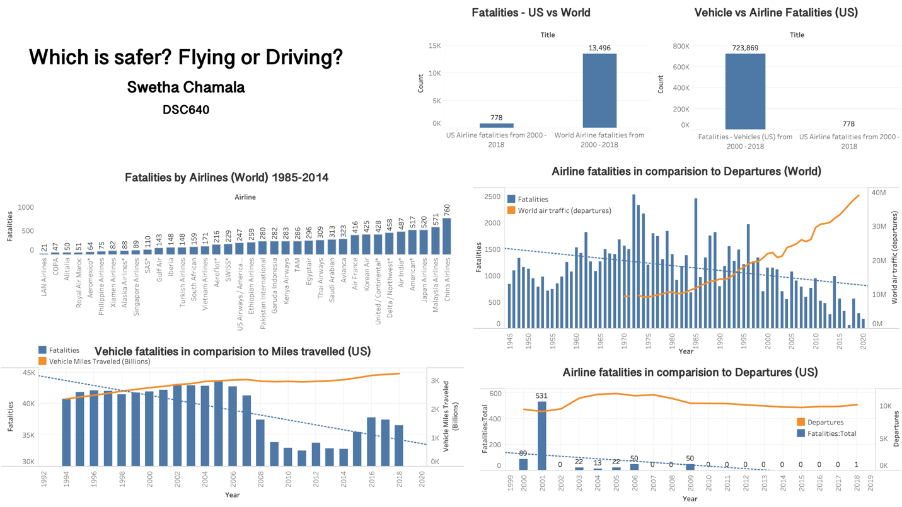

The Question?

Here we have the age-old question – which is safer? Flying or Driving? Just the thought of being suspended at an altitude of 35,000 feet and at a speed of 500mph makes us nervous. Air crashes are often deemed catastrophic due to the number of people involved and low survival rate. On the other hand, we feel much safer commuting, running errands or going to vacation by driving a car. The data shows otherwise.

Plan

To answer the question, I chose to compare the number of vehicle and airline fatalities occurred in the US and also to compare the number of airline fatalities within the US and World. The data was obtained from Aviation Safety Network, Airlines for America, and US National Highway Traffic Safety Administration.

Visualizations

For the visualizations, I have chosen dual combination bar and line graphs. Bars to represent fatalities (blue color), line to represent the number of miles or number of departures (orange color) and line (blue dotted line) to represent trends in fatalities over the years.

The first visualization on left (Fatalities by Airlines (World) 1985-2014) is to show a brief history of accidents that resulted in fatalities airlines around the world between the years 1985 and 2014. China, Malaysia and Japan airlines showing the highest number of fatalities around that time.

The graph of World airline fatalities in comparison to departures shows that there is a decrease in fatalities (blue dotted trend line) as the number of departures increased in recent years. This shows that airline travel around the world is much safer in recent years amounting to the newer technology and better safety standards of airplanes.

Airline fatalities in US are fairly low from 2000- 2018 in parallel to number of departures remaining constant. The spike in fatalities in 2001 is representative of the deadly hijack of airplanes.

The second visualization on left is to show the number of fatalities caused on ground by driving vehicles (blue bars) from the year 1994 – 2018 in comparison to the number of miles travelled (yellow line). We can see that from year 2006 there is a decrease in number of fatalities. The trend line (blue dotted line) confirms that the number of fatalities is following a downward trend as the years pass by.

Conclusion

The total US airline fatalities from 2000-2018 are 778 and World airlines fatalities during the same years are 13,496. That is a 7-fold difference. However, total fatalities caused by driving vehicles in US from 2000-2018 are 723,869. That is roughly 900 times more fatalities compared to airline fatalities in US. There is a clear distinction that vehicle fatalities are higher. This answers the question – Which is safer? The answer is “flying is much safer than driving”.