Analytical PET Simulator
v-1.1

Users’ guide

DEOEC PET Center
2004
Hungary
Supported by PVEOUT EU5-QLG3-CT2000-00594 project

Simulation concepts

A realistic simulation tool can remarkably contribute to modelling or tracking the data acquisition process of a PET system. The less versatile but much faster AS method is especially instrumental in repeated simulations. A simulator of this kind may provide highly reliable data for the PET images of the brain due to the nearly homogeneous tissue structure of this organ, as far as analytically describable processes are concerned (e.g. attenuation, Compton scatter, random coincidences).
We have chosen the analytical simulator to allow for the analytical calculation of distortions of primary (theoretical) activity distribution data caused by the physical characteristics of the scanner and the special features of image processing. The developed simulator generates the true count distributions along the brain slices as input data for the reconstruction using the tracer kinetic model of the applied radiopharmaceutical to any given brain region to be simulated. A presumed blood curve for the tracer can be selected as additional input information from a collection of 10 different types of curves.
Most of the generated physical effects are simulated as a Poisson process. Each effect, such as spatial blurring (using the Point Spread Function of the camera), attenuation, Compton scattering and random coincidences can be switched off/on, to analyze its contribution to the result of the simulation process (e.g. Partial Volume Effect).

Installation

Extract the zip file, (e.g. to folder c:\petsim) and add the petsim folder and all subfolders into the Matlab path.
Please read the readme files in the readme_doc folder.

Start the Simulator
Type PetAnalSimulator or petsim_Wrapper command in the Matlab prompt.
The main window is displayed in Figure 1.

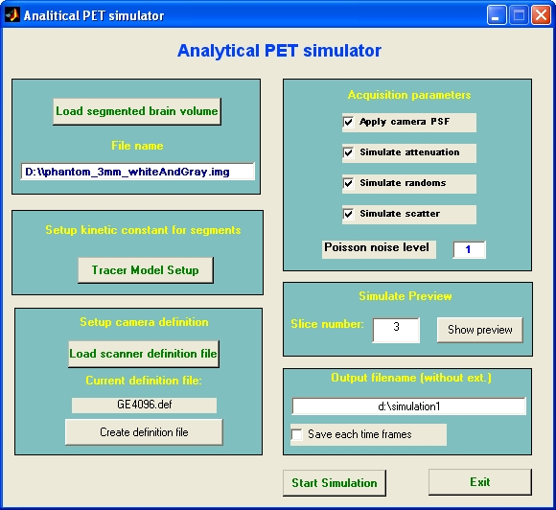
1
2
3
4
5
6
7
8
9
10
16
15
14
13
12
11

Figure 1.: The main window of the simulator

Parts of the main window:
- (pushbutton) Shows the file load dialog, loads the input segmented MR file and shows the axial, coronal and sagittal slices.
- (text field) Displays the name of the loaded MR file.
- (pushbutton) Shows the tracer model setup dialog box.
- (pushbutton) Loads own PET camera definition file.
- (text field) Displays the name of the current camera definition file.
- (pushbutton) Creates your own camera definition file by the default file.
- (checkbox) Turns on/off the simulation of the spatial resolution of the camera.
- (checkbox) Turns on/off attenuation effect simulation and correction.
- (checkbox) Turns on/off random coincidences simulation and corrections.
- (checkbox) Turns on/off Compton scatter effect simulation and correction.
- (line edit) Sets the Poisson noise level (between 0 and 1).
- (pushbutton) Simulates the predefined PET slice with the current parameters, and shows the summed image.
- (line edit) Displays the name of the output file (summed image).
- (checkbox) Stores all time frames.
- (pushbutton) Starts the simulation process for the whole segmented MR file.
- (pushbutton) Exit.

The necessary inputs for the simulations are: segmented MR file(s), Tracer kinetic model, blood curve, acquisition times and camera definition.

First Step: Loading the segmented MR file

The program can read only analyze format files.
Press the Load Segmented Brain Volume button (1). Choose one or up to 8 files in the file open dialog (Fig. 2.), and press the Add button, then the OK button.

The simulator can read MR files in three different ways:

- Reads one file, which should contain maximum 8 segments, labeled 1,2,…,8 whole numbers.

- Reads one, two or three files. If the form of the selected filename is XXX_seg1.img (containing the gray matter), the simulator reads automatically the XXX_seg2.img (the white matter) and XXX_seg3.img (the CSF) also, when they exist. In this case you must select only the XXX_seg1.img file in the File input dialog. If the voxels in these files are between 0 and 255, the simulator converts them into one binary segmented volume as follows: The simulator sets the voxels to 0 having a cumulative value below 128, (corresponding to <50%) and the voxels that are above or equal 128, are set to the segment number (1,2, or 3, this depends on the filename).

- Reads maximum 8 files, when you select 8 different files. The voxel conversion is same as in section b). The voxel values of the binary segmented volume are labeled 1,2,…,8, depending on the order of the files. In this case you must select up to 8 files in the File input dialog.

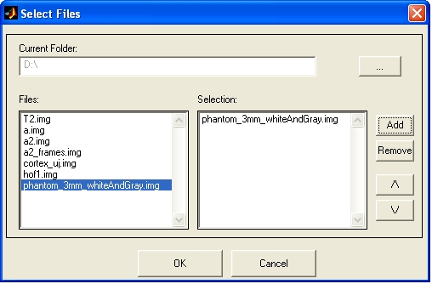
Figure 2.: File open dialog

After loading, the program shows the axial, coronal and sagittal slices of the segmented MRI file (Figure 3.)

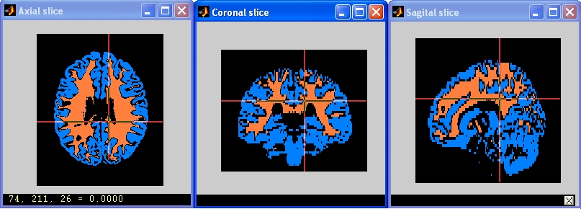
Figure 3.: The axial, coronal and sagittal views of the segmented MRI file

Second step: Tracer Model Setup

The simulator uses the 4-compartment tracer kinetic model to determine activity distribution in the human brain. The 3- and 2-compartment models are special versions of the 4-compartment model, when the k5, k6 and k3, k4 kinetic constants are 0. The 4-compartment model and interpretation of the kinetic constants are shown in Figure 4.

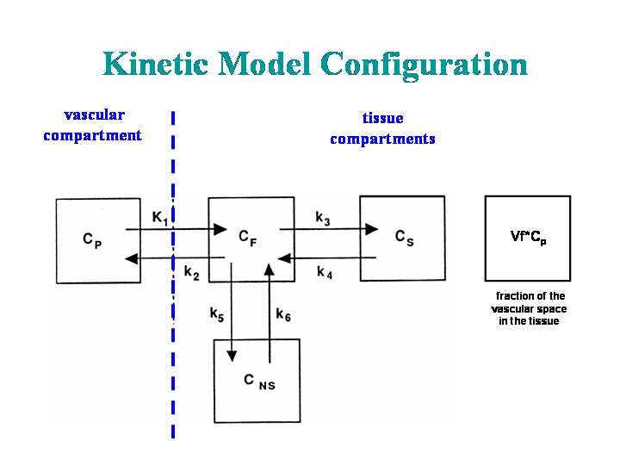
Figure 4.: The 4-compartment tracer kinetic model

Press the Tracer Model Setup button (3). The tracer model dialog is shown in Figure 5. The color codes of the different segments correspond to the colors of the loaded MRI file (Figure 3.).

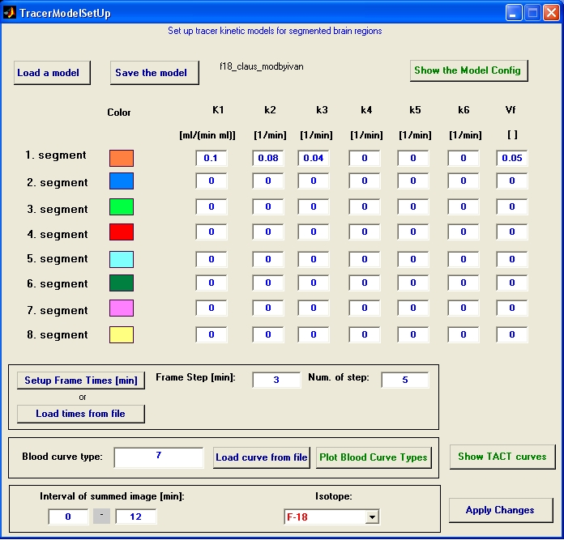
17
Load or save tracer model
20
Acquisition time setup
21
Blood curve definition
22
Time interval of summed image and isotope type
19
Tracer kinetic constants of the segments
18
Shows the kinetic model
23
Shows current TACT curves
24
Applies changes
Figure 5.: The tracer model setup dialog

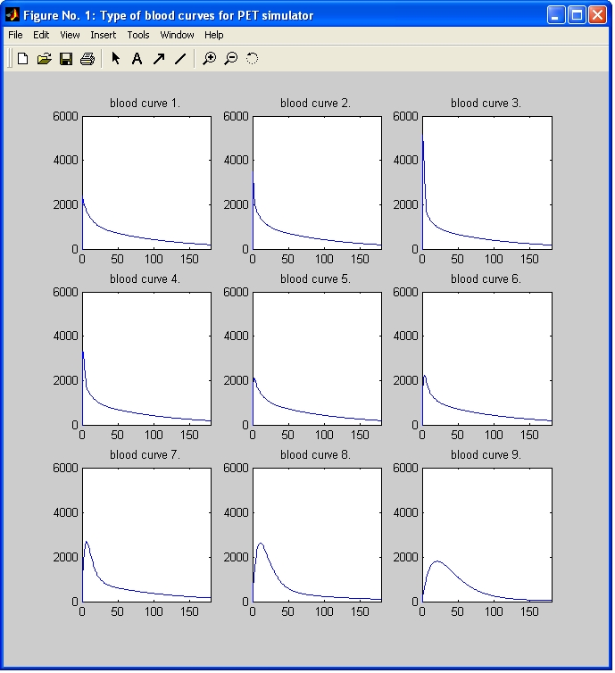
Figure 6.: Predefined blood curves

Steps of tracer model setup:

Load a predefined tracer kinetic model (press the Load a model button (17) ), or enter the tracer kinetic constants (19). (To store the current kinetic constants, press the Save the model button (17) ).

Setup frame times
- Setting up manually: Press the Setup Frame Times button (20), and enter the Frame Step in minutes and the Number of steps.
- Setting up from file: Press the Load times from file button (20) and select the file. The file is a simply text file, the column should contain the frame lengths (in minutes) of the study. ( See sample file: frametimes_c11.txt )

Define blood curve
- Using predefined curves: Type the number of the predefined blood curve into the Blood curve type field (21). The Plot Blood Curve Types button shows the predefined blood curves (Figure 6.).
- Loading own blood curve: press the Load curve from file button (21), and select your blood curve. In this case, the filename will be displayed in the Blood curve type field. The blood curve file is a simply text file. The first column should contain the time scale of the blood curve (in minutes), the second column should contain the corresponding activity concentration values in nCi/ml. (See sample file: mybloodcurve1.txt)

Specify the pharmacon: Choose the isotope (22). The default is the C-11, currently available isotopes in the simulator are C-11, F-18, O-15 and N-13.

Specify the time interval of the summed image: Enter the time from and time to in minutes (field 22). The simulator calculates the summed image by these values. Note: If you do not specify these values, the summed slices will contain only 0 voxels.

Visualize the current TACT curves: Press the Show TACT curves button (23), this displays the TACT curves, with the current settings.

Close dialog: Press the Apply Changes button (24) to apply current tracer model settings.

Third Step: Specify the PET camera parameters

The most commonly applied camera parameters are stored in a text file, with extension ‘def’. The default camera file is the GE4096.def (Appendix 1), describing the parameters of the GE4096plus PET scanner. This is the automatically loaded file. To load your own camera definition file, press the Load scanner definition file button (4) and choose a file. The file name will be displayed below the button.
To create your own definition file, press the Create definition file button (6), then type the new file name. This function saves the default definition file (GE4096.def) as “newname” and opens it in the Matlab Editor.

Fourth step: Select acquisition effects

The checkboxes in the Acquisition frame control the distortion effects and the corrections during the simulation process.

- Button 7 turns on/off the simulation of the spatial resolution of the camera.
- Button 8 turns on/off attenuation effect simulation and correction.
- Button 9 turns on/off random coincidences simulation and corrections.
- Button 10 turns on/off Compton scatter effect simulation and correction.

Each physical effect is simulated as a Poisson process. The default Poisson noise level is 1. You can specify other levels in the noise level field (11). The level value must be between 0 and 1. If the value is less than 0 or greater than 1, the simulator will convert it to 0 or 1.

To simulate and correct all distortion processes, please turn on all checkboxes.

Note: The specification order of the first, second, third and fourth steps is arbitrary.

Fifth Step: Simulation preview

You can preview the result of the simulation by pressing the Show Preview button (12). This procedure simulates the specified axial PET slice using the current parameters, such as tracer kinetic constants, time frames, blood curve, isotope type, summation interval, distortion effects and Poisson level. The result of the simulation is shown in a separate window. This takes approx. 3 minutes on one 2.8 GHz processor. The simulator does not store the preview data set.

Sixth Step: Specify the output file

Please type the output file name with full path to the Output filename field (13), before running the whole simulation process (The extension is not necessary). The output file format is analyze. If you check the Save each time frames box (14), the program saves all time frames into one dynamic analyze file called “outputname”_frames.img and “outputname”_frames.hdr, where the “outputname” is the value of the Output filename field (13).

Seventh step: Start the simulation

Press the Start button (15) to start the simulation for the whole segmented MRI slices. Simulation time strongly depends on the number of time frames and the voxel number of the segmented MRI volume to be simulated. More time frames and bigger volumes require longer calculation time. E.g.: The whole simulation takes about 2 hours on one 2.8 GHz processor, if the numbers of voxels are 60x217x181 and the number of time frames is 34. When the simulation process is finished, the summed image and the images of the time frames are stored automatically, with the specified file name. (See Sixth step)

Appendix 1

The structure of the GE4096.def file: The italicized texts are not part of the real file, they are only comments here.

The file is a simple text file, with extension def.

The simulator reads only those single lines, which include the = symbol. All other lines are comments.

General camera parameters: (Sample data of the GE4096 PET scanner)

FOV=550 : The field of view of the scanner, in millimeters

members=96 : The number of projections in the x direction (see radon transform, e.g. Matlab Help, or PhD thesis of Peter Toft)

theta=[270:-180/511:90] : The projection angles in degrees and Matlab format

projectionOffset=0 : The start of the first projection line, in degrees

calibrationFactor=2.8e5 : The camera acquisition efficiency with GE68 line source

voxelSize=0.048 : The volume of one voxel in ml.

pixelSize=2 : The size of one pixel on the axial slice (in millimeters)

radialResolutionValues=6 6.5 7 : The FWHM of a line source on the axial slice by different radius (in millimeters),
radialResolutionRadius=0 100 200 : and the corresponded radius values (in millimeters)

axialPixelSize=6.5 : The width of the axial slices (in millimeters)

axialResolutionValues=6 6.5 7 : The FWHM of a line source along the Z axis of the camera by different Z values (in millimeters),
axialResolutionRadius=0 100 200 : and the corresponding Z values (in millimeters)

Random effect parameters:
The random effect is described by the out = in / randomEffectConstant term and the random correction is described by the
out = randomCorrectionConstants(1)*in^2+randomCorrectionConstants(2)*in equation.

randomEffectConstant=1.0014

randomCorrectionConstants=0.0375 0.161

Scatter parameters: ( To measure these parameters on your camera, see H.Hoverath: Scatter correction in the axial slices of a whole-body positron emission tomography. Phys. Med. Biol. 38(1993) 717-728.

scale=2.5517
A1=1.6702e-3
A2=1.464
A3=2.145e-3
A4=1.352
A5=5.664e-2
A6=1.584e-2
A7=1.203
A8=0.2037
A10=1.195
A11=0.279
A12=0
A13=1.0907e-2
A14=0.6526e-2
A15=1.104
A16=9.334e-2
A18=1.77e-2
A21=0.118e-2

