# User Manual

BlackChat is very simple to use. Users interface with the device through a serial interface. This means that BlackChat can be used cross-platform as long as you have a serial interface client installed on your operating system, you can communicate to your BlackChat device. Since the device operates through a generic serial terminal, it is also simple to interact with the device through your own software, making the device flexible.

## Obtaining a serial interface client

To use BlackChat, a serial interface client is required. There are various programs available for this on all platforms. Some examples are PuTTY, Minicom, and Screen. These programs are free and readily available from the internet.

## Connecting to the device

Open your serial interface client of choice and connect to the serial port that the device is connected to. The serial port may be determined as follows:

### Windows

On Windows, this can be done through the Device Manager. Run devmgmt.msc and look under the serial devices tab to see what COM port the device has enumerated as. If there is more than one COM port listed, re-plug the device to see which port reappears.

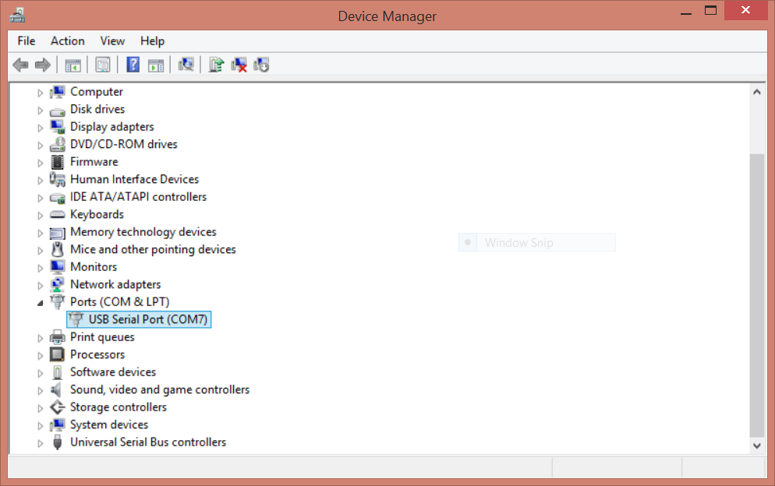

### Linux / Mac

Browse to **/dev/** and determine which tty* is created when the device is plugged in.

Once the serial terminal has been opened, type the TAB character. This will begin the BlackChat session, and a welcome message will be printed.

## Sending a message

Wait for the Message prompt, and begin typing your message. The maximum message length is 27 characters, and the device will send a BEL when this maximum has been reached. The Backspace character functions appropriately, but DEL may have undefined results. Sending control characters, including TAB, is not supported and will have undefined results. When you are finished typing your message, press the Enter key. BlackChat will now begin transmitting this message. You may send another message once the message has been successfully received by the other device and the Message prompt returns.

## Receiving a message

When BlackChat receives a message, it will be displayed in the terminal window.

## Ending your session

To end the BlackChat session, simply close your serial interface program and disconnect the device.