Equality Check:

Write a program to check if two integers provided by the user are equal or not.

Greater Number Identification:

Write a program to determine which of two numbers is greater using relational operators.

Check if a Number is Positive:

Use relational operators to check if a given number is positive (greater than 0).

Rectangle Validity Check:

Write a program to verify if the given length and breadth of a rectangle satisfy the condition of a valid rectangle (length > 0 and breadth > 0).

Grade Eligibility Check:

Given a student's marks in a subject, determine if the student has passed (marks >= 40).

Check if Number is Within Range:

Use relational operators to check if a given number lies between 10 and 50 (inclusive).

Verify Alphabetic Range:

Write a program to check if a given character is a lowercase English letter (between 'a' and 'z').

Age Comparison:

Compare the ages of two people and determine who is older or if both are of the same age.

Weight Limit Check:

Write a program to determine if the weight of an object exceeds the specified maximum limit (e.g., 50 kg).

Rectangle Larger Area Check:

Compare the areas of two rectangles given their lengths and breadths and determine which rectangle has a larger area.

has context menu

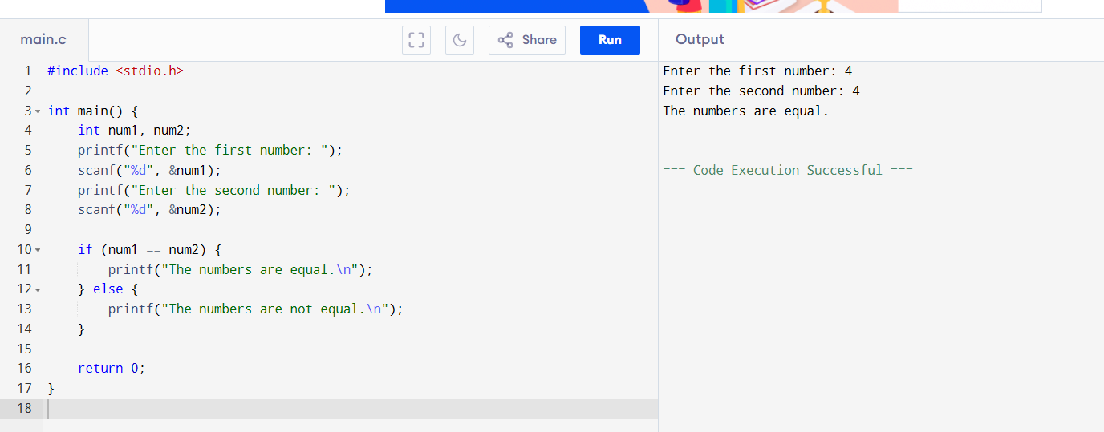

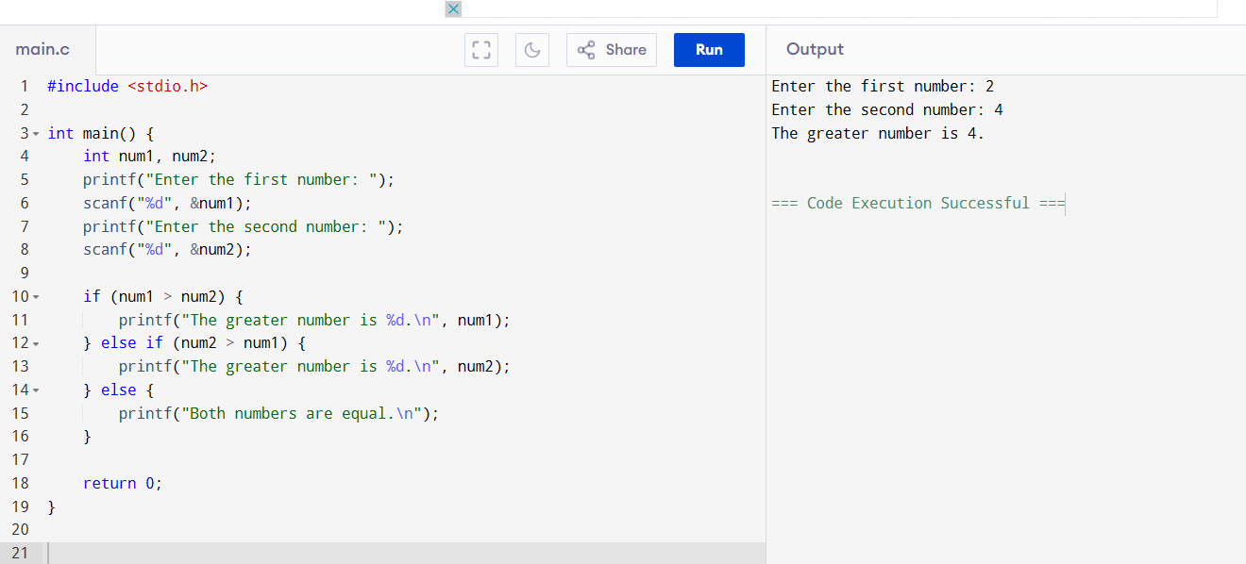

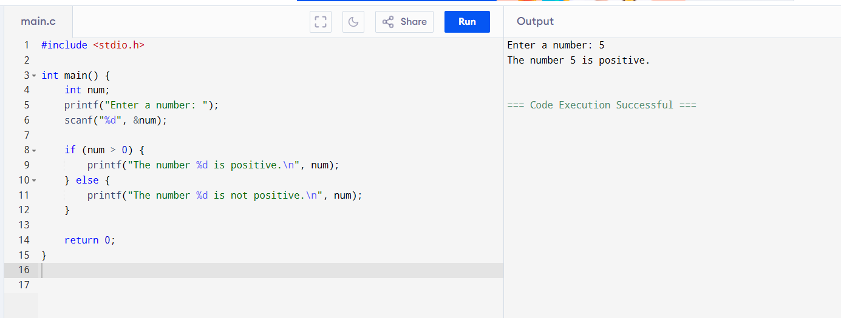

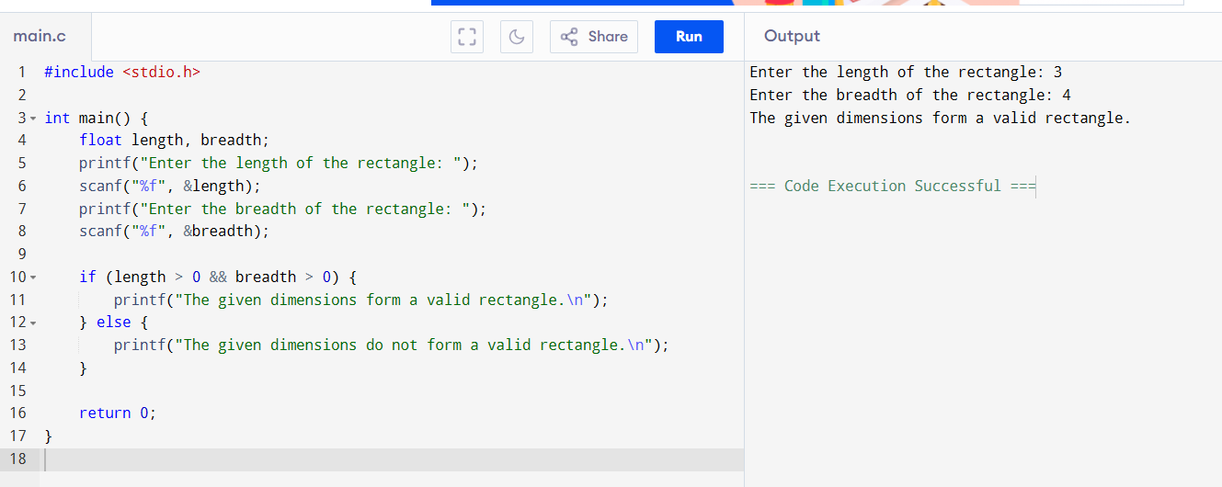

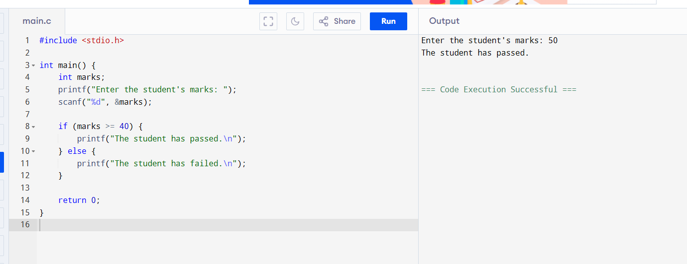

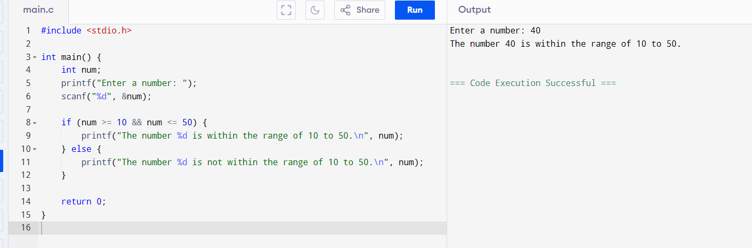

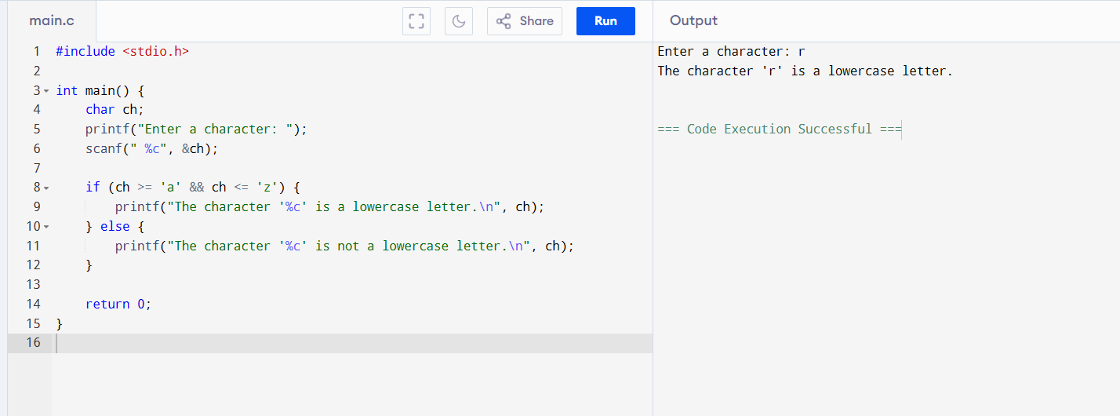

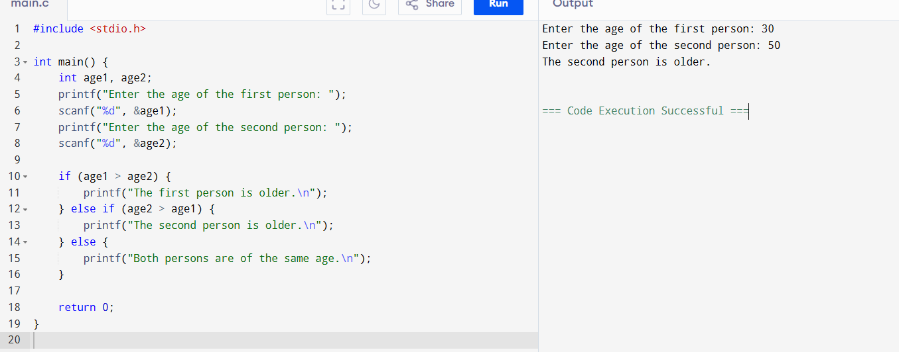

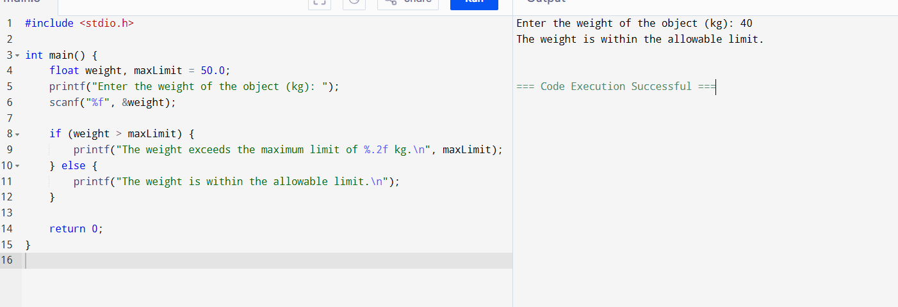

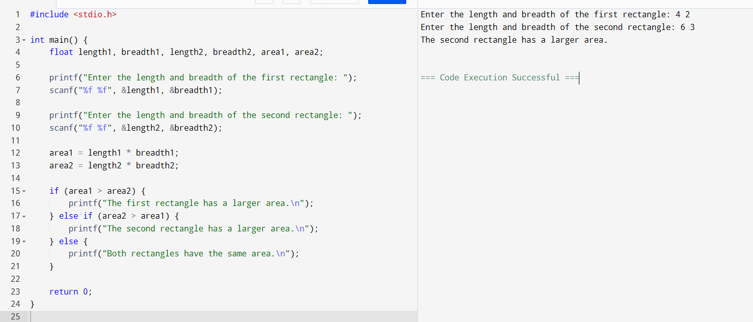

Write a program to compute the result of the bitwise AND operation between two integers provided by the user.

Write a program to compute the result of the bitwise OR operation between two integers provided by the user.

Write a program to compute the result of the bitwise XOR operation between two integers provided by the user.

Write a program to find the bitwise complement of a given integer and print the result.

Given an integer n and a position p, write a program to toggle the bit at position p using the XOR operator.

Write a program to set the bit at a given position p in an integer n to 1 using the OR operator.

Write a program to clear (set to 0) the bit at a given position p in an integer n using the AND and NOT operators.

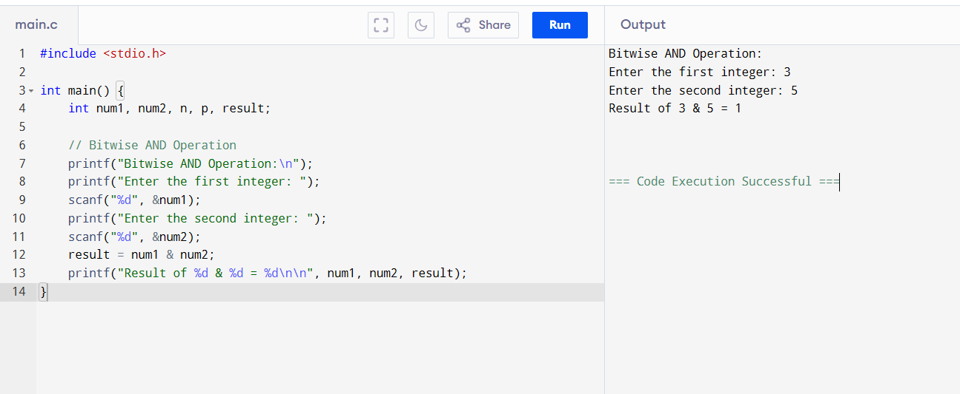

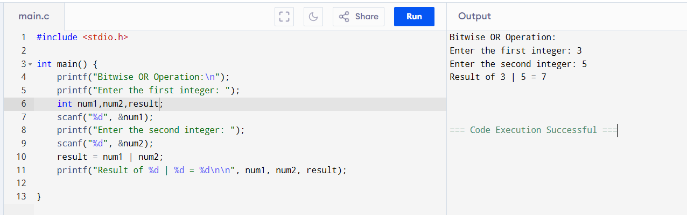

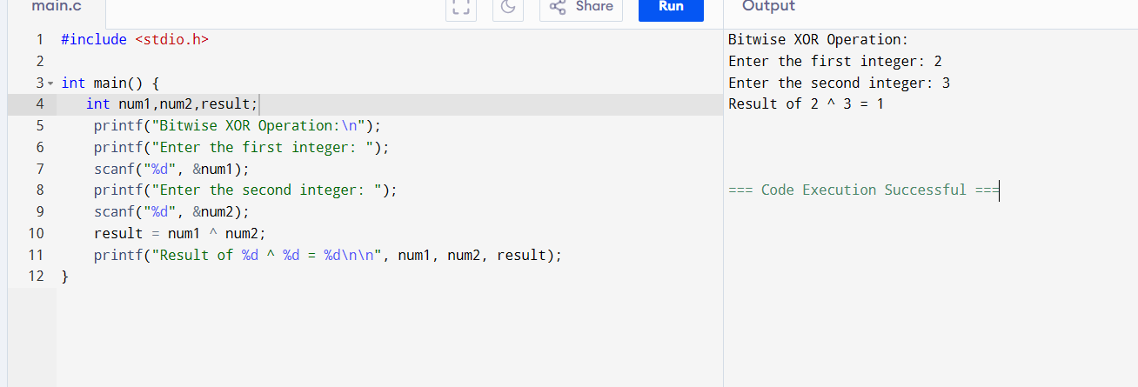

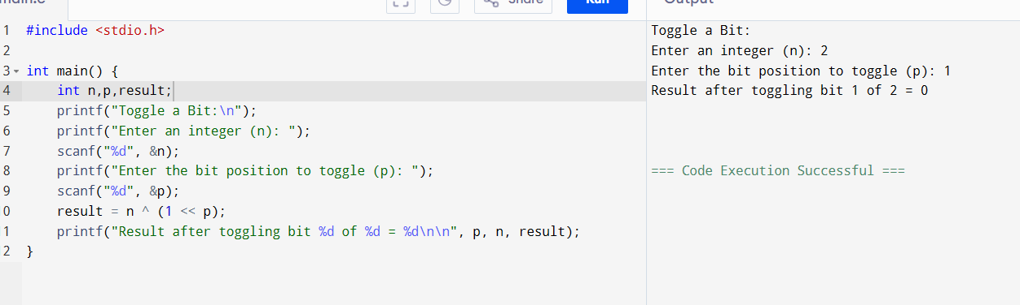

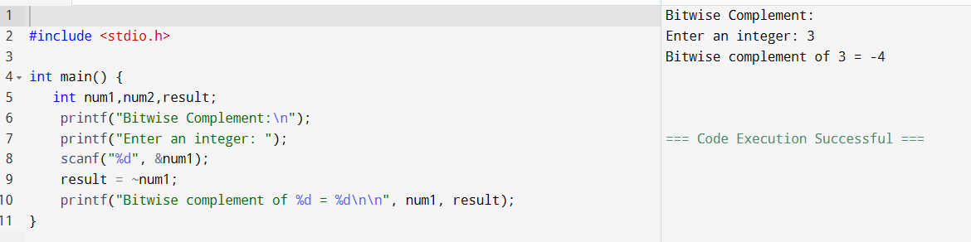

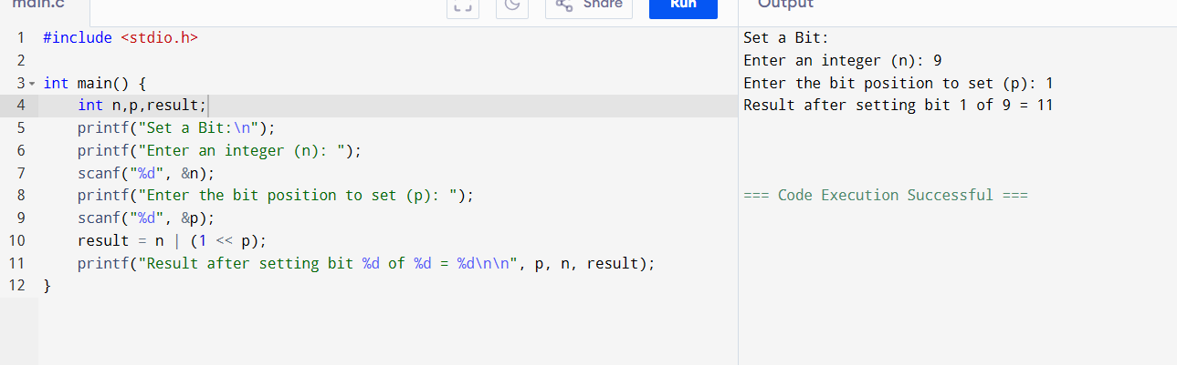

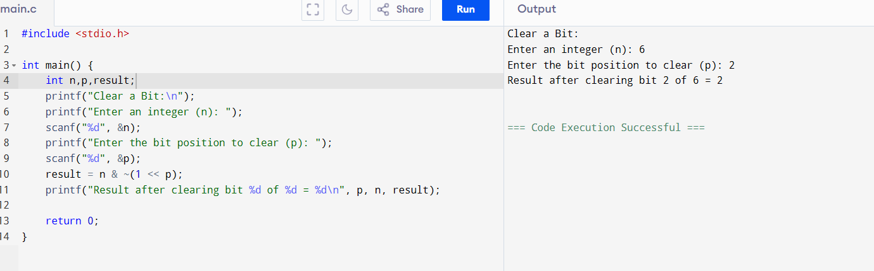

Big problems:

Number Properties Validation: Write a program to check if a given integer is both a multiple of 5 (arithmetic operator) and greater than 50 (relational operator). Additionally, verify if its binary representation has its least significant bit set (bitwise AND operation).

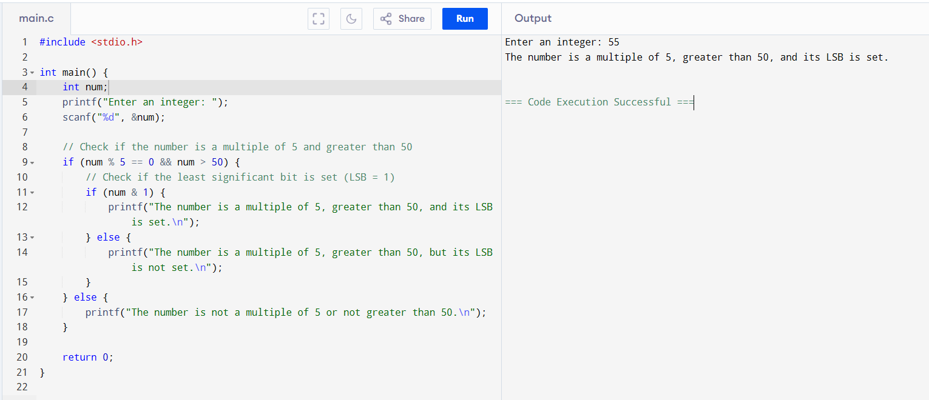

Given an integer n and a bit position p:

* Use bit masking and bitwise XOR to toggle the bit at position p.
* After toggling, check if the updated number is positive (arithmetic and relational operators) and divisible by 2 (logical operators).

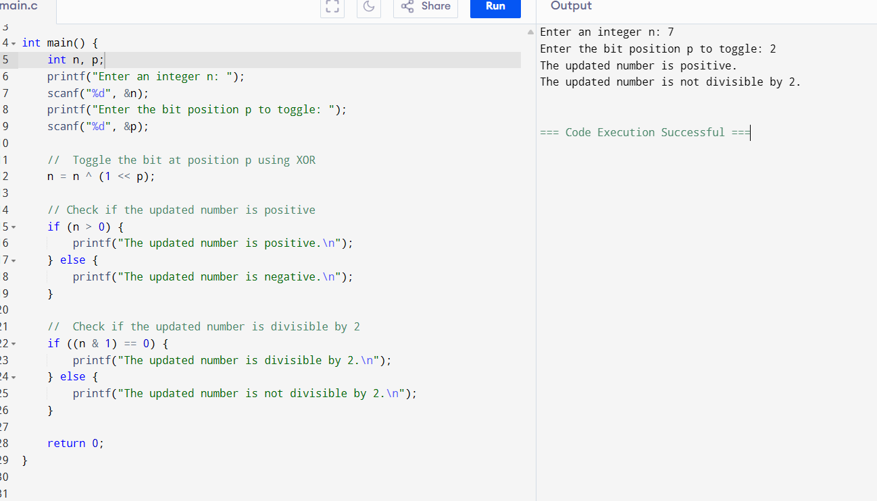

**Determine Voting Eligibility with Criteria:**  
A person can vote if:

* Their age is greater than or equal to 18 (relational operator).
* They are a registered citizen, represented by a specific bit set in their ID number (bit masking and bitwise AND).  
  Write a program to verify these conditions using logical operators

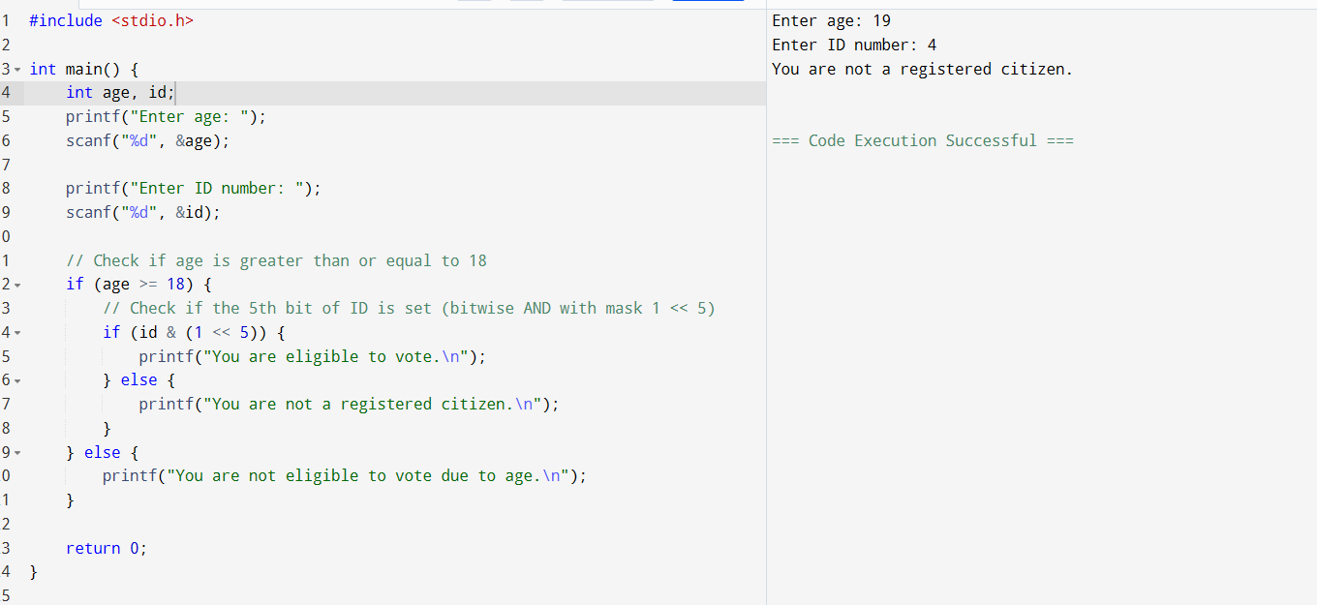

Set, Clear, and Check Specific Bit: Write a program to: Use bit masking and bitwise OR to set a specific bit in a number. Use bitwise AND and NOT to clear another specific bit. Check if the resulting number is odd (arithmetic and relational operators) and lies within a range (logical operators).

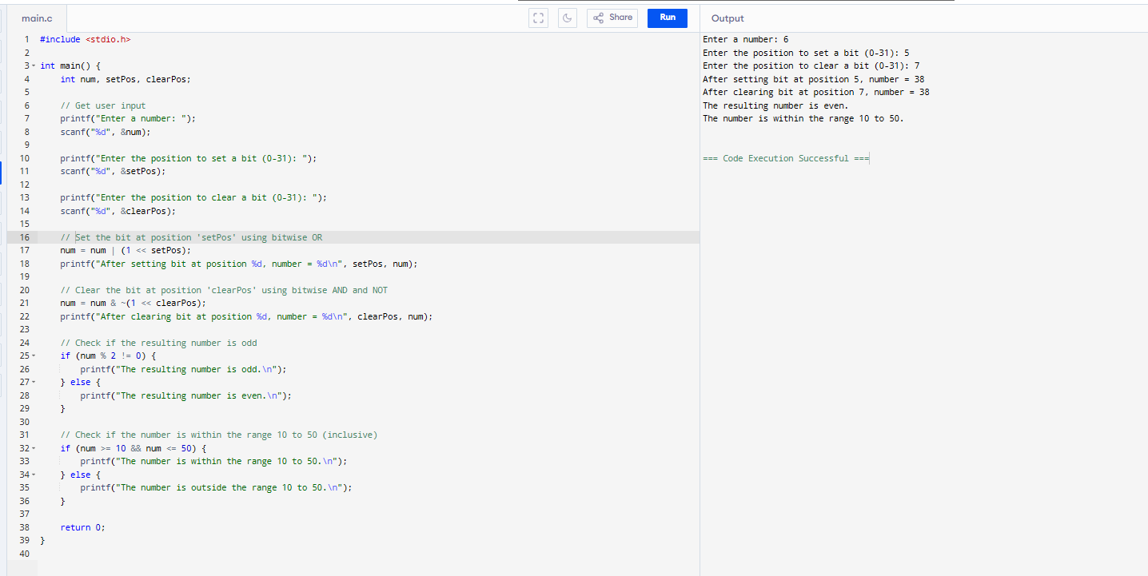

Custom Mathematical Condition with Bits: Given two integers a and b, perform the following: Compute their sum and product (arithmetic operators). Verify if the sum is greater than 100 and the product is divisible by 4 (relational and logical operators). Check if the binary representation of a has its second bit set (bitwise AND with a mask).

