Design:

**Main page** – this page will be the ‘home’ page that all the users would see first when opening our site.

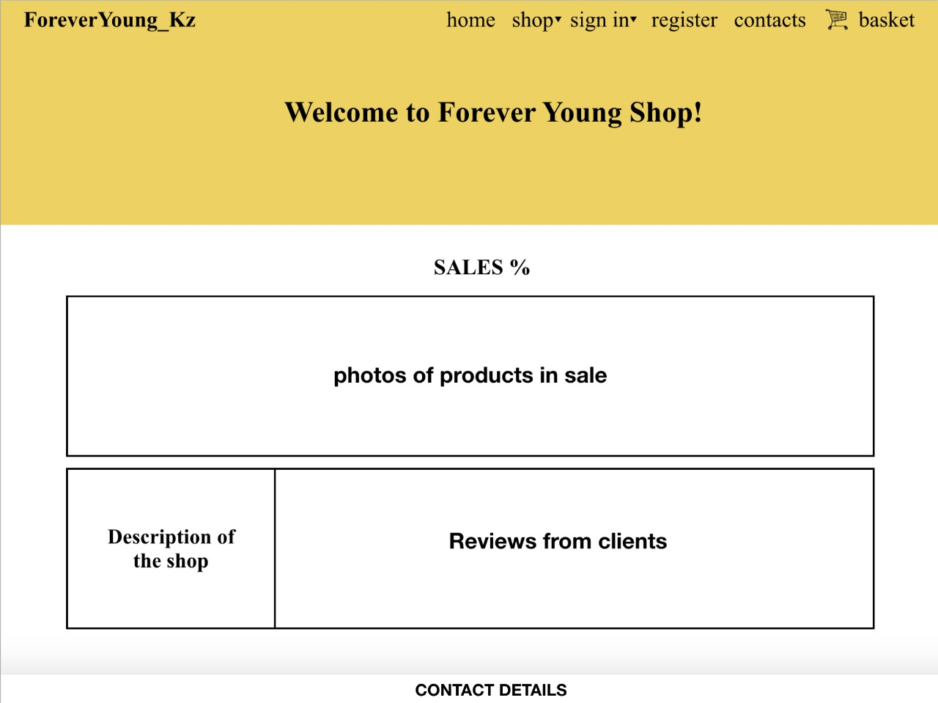

**Products** – this page will have different categories of the products the number of which depends on the number of the available categories of products.

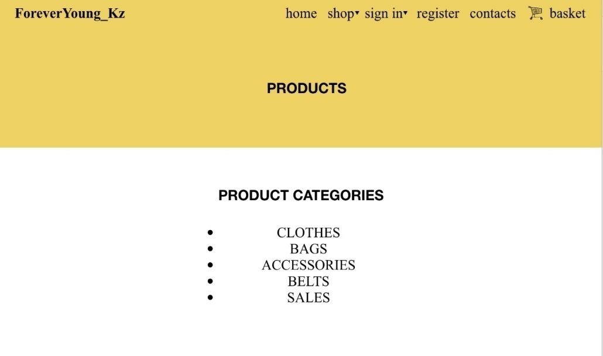

**About us** – this page will provide users with introductory information about the shop.

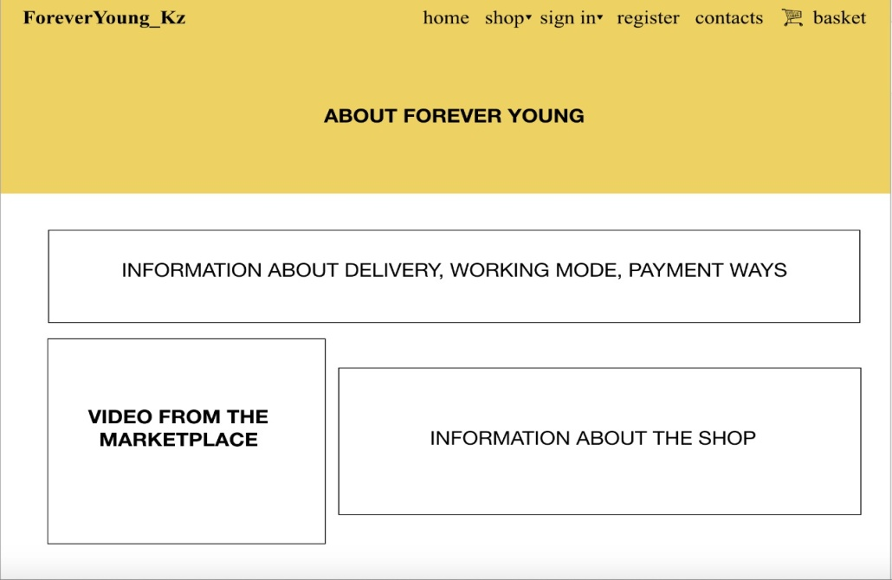

**Login pages** **(for users/for administrator)** – these pages will provide customers/administrator with access to their own personal account panel with its databases.

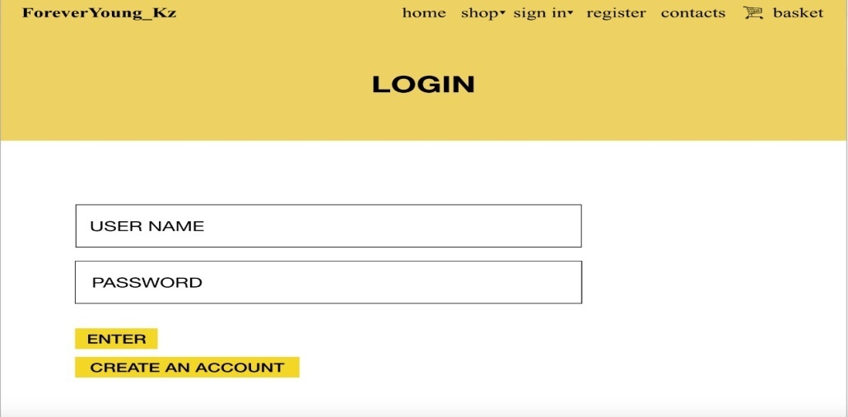

**Register** – users will have an opportunity to create their own accounts by filling a form and pressing the ‘register’ button on this page.

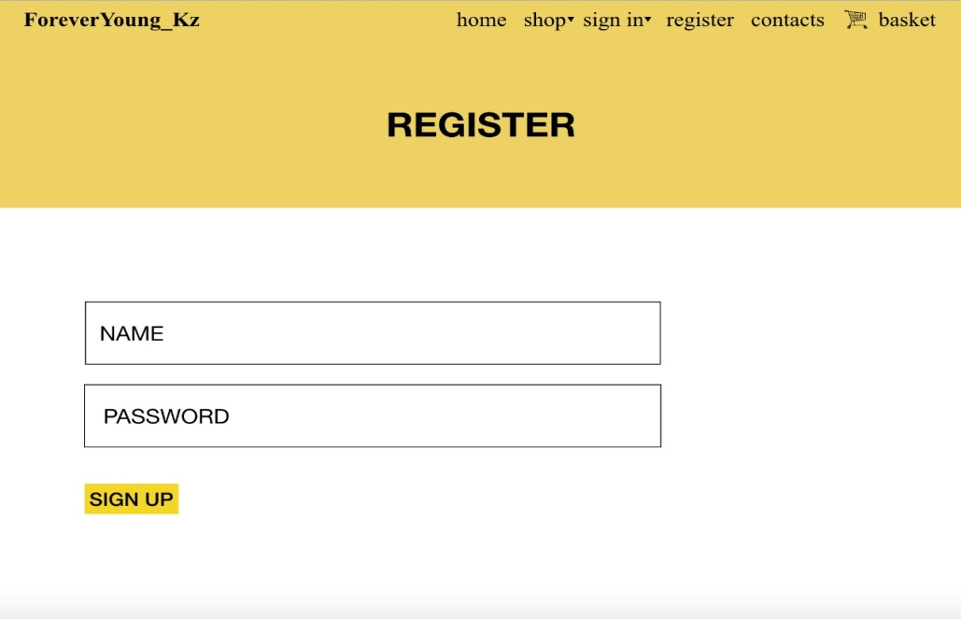

**Contacts** – this page will give contact details for users to communicate with the administrator or the other representative of the shop (manager).

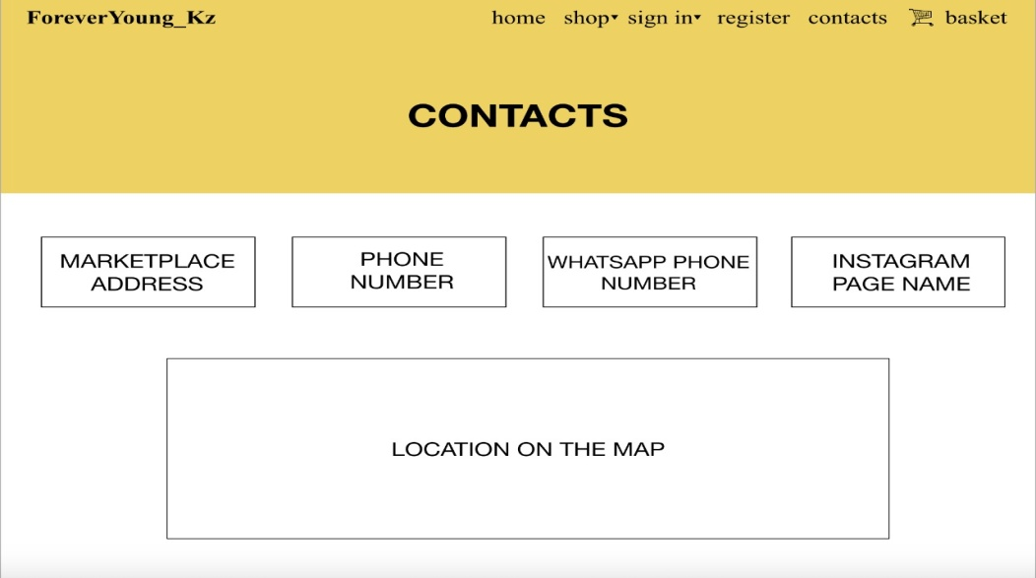

**Basket** – this page stores the products that customer want to buy or preferred to buy products.

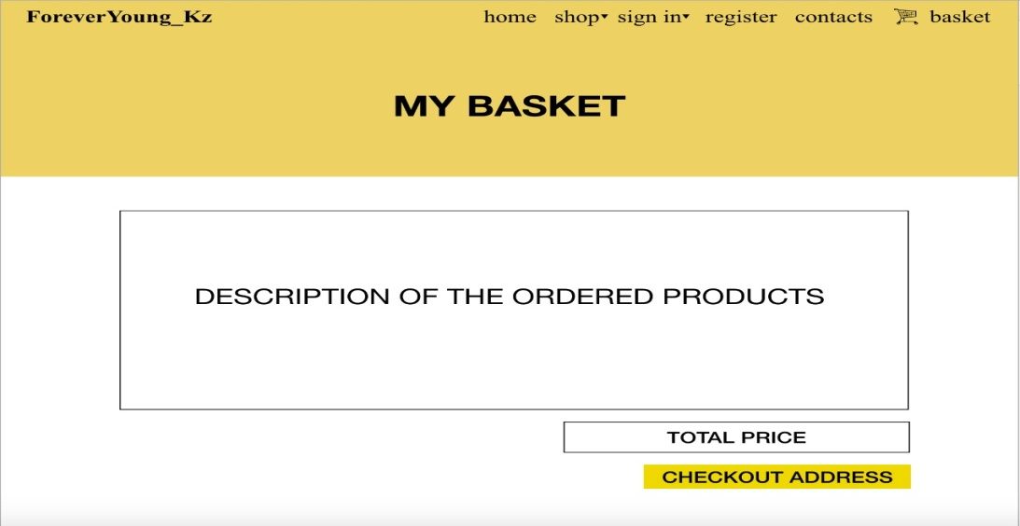

**Checkout address** – this page will have a form about address information of every potential customer for future delivery purposes.

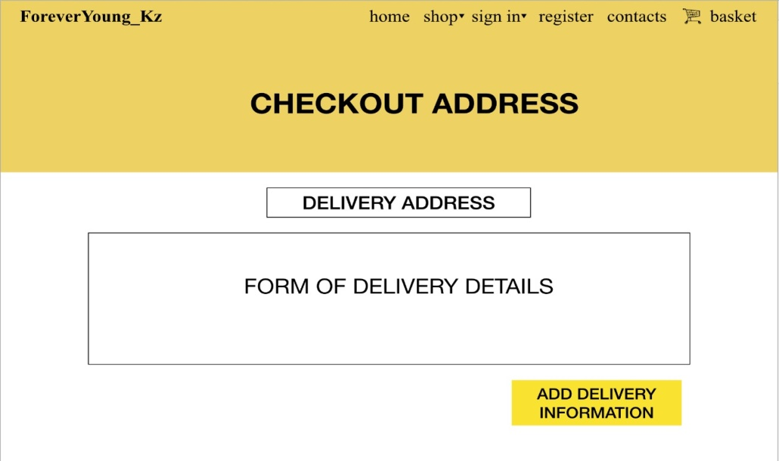

**Checkout pay** – this page will have a form about payment details. It will require users to choose the way of payment for the order.

