Software Prototype/Proposal Document (SPD)

22 September 2010
Version 1.0

Team Snow Crash
Dale Earnest
Mike McWilliams
Jeff Dunn
Dong Luo

Table of Contents
Revision History 3
1.Project Proposal 4
1.1Summary and Purpose 4
1.2Description 4
1.3Basic Design 4
1.4Look and Feel 5
1.5Basic Architecture 9
1.6Risks 10
2.Hours 11
2.1Total Hours 11
2.2Hours Broken Down 11

Revision History
Name | Date | Reason For Changes | Version(s)
Dale | 20 Sept | Initial version | 0.1
Dale | 21 Sept | Added mockups, hours, edited for grammar and content | 0.2
Dale | 22 Sept | Final version | 1.0

Project Proposal

Summary and Purpose
This project will create an evolution simulation program. This Java-based desktop application will teach basic evolutionary principles in a fun and engaging manner.

Description
The user of the evolutionary simulation creates (or uses default) “critters” that inhabit a simple game world. Critters inhabit a game world and strive against each other in competition for resources and space. Successful critters reproduce, pass their genes, and thrive while unsuccessful critters die out. They have traits that make it easier, or more difficult, to survive in this world and pass on their genes to future generations. After a set number of turns, the results of the critters' interactions in the world are evaluated and the user is presented with statistics on how the world has changed.

Basic Design
The user may generate critters or use default critters to populate a simple game world (a flat 2D bounded grid). Simulations run for a set amount of time.

Critters are Plants (that thrive over time), Prey (that eat Plants), and Predators (that eat Prey). Each type of critter has a series of pairs traits that it can pass on through reproduction. Traits could include:
- Vision distance
- Camouflage
- Claws
- Movement speed
- Endurance
- Size
- Age

Each critter is built using a number of points. These points determine how many traits can be applied to the critter. For a balanced simulation, all critters should be built with the same number of points. For an unbalanced simulations, critters can be built with different numbers of points.

Critters are randomly placed on the map at simulation start. Only one critter may occupy a space on the grid at one time. Plants do not move. Prey and Predators move according to their type.

Each creature has a “health” meter; when the creature eats, the health increases (up to some maximum). When a creature doesn't eat, the creature's heath meter decreases every round until the meter reaches zero (death). All critters disappear after death. If a critter eats another critter, then the “eater” replaces the “eaten” on the grid.

Look and Feel

Proposed UI Screen Flow
Customization
Simulation
Results
Play
Stop
Simulation
Ends
Open
Results
New
Simulation
Import Critters,
Export Critters,
Modification
Paused
Pause
Play
Save
Results

Proposed Customization Screen (Wireframe)
Simulation Bar – Play, Pause, Stop buttons
Simulation Duration (either a bar or timer)
Critters list
Editable critter settings
World Settings

Proposed Simulation Screen (Wireframe)
Simulation Bar – Play, Pause, Stop buttons
Simulation Duration (either a bar or timer)
World Grid
Console
(Maybe?)

Proposed Results Screen (Wireframe)
Simulation Bar – Play, Pause, Stop buttons
Simulation Duration (either a bar or timer)
World grid
World
Statistics
Critters
Statistics

UI Mockup(Simulation Screen)
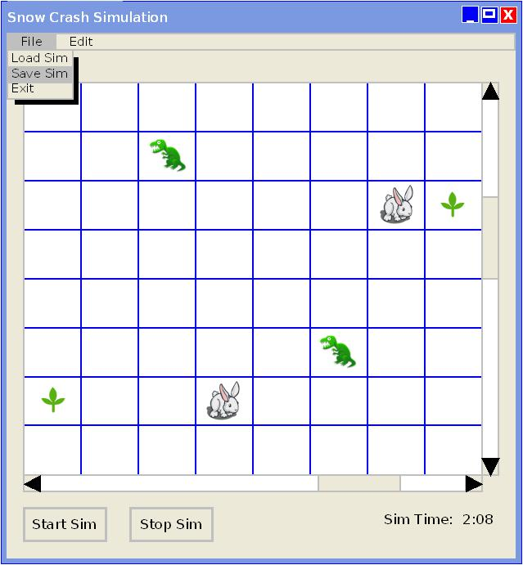

Basic Architecture
The application is a Java-based desktop application. The UI relies on a Swing interface and there are three primary screens: the “setup” screen (where critters are created and saved simulations are loaded into the UI), the “simulation” screen (where simulations are run), and the “results” screen (where the results of the simulation are published).

Data describing the simulation are kept in a configuration file loaded on startup. This configuration data is cached so that the simulation does not have to make IO requests every time it needs data. Simulations and critters are saved to disk as files as well.

The mechanics of Predators and Prey finding food are as follows.
To spot:
- Check vision – camouflage + random number;
- If check is > 0, spotted.

To catch (only for Predator and Prey):
- Check (PredatorVision – Prey Vision)/Predator Speed + (Predator Speed * distance)/(Predator Speed – Prey Speed)
- If check < Predator Endurance, caught.

Risks
There are a few risks involved in this project. They are the file IO, caching, the UI, and the world mechanics.

File IO
The File IO is problematic as the file format has not yet been finalized. We need to model a more descriptive view of a trait, a critter, and a saved simulation to ensure we can write these models to disk and load. We have studied using CSV as our format but are concerned it is not robust enough. We'll also be looking into using XML, random access, and JSON.

Caching
Related to the above, we need to model a cache to ensure that the cache is well organized as the system will be highly dependent on the cache to provide data.

GUI
The GUI has been identified as a particularly risky piece of the application as there is not a lot of Swing UI experience in the group. To mitigate this risk we will be identifying the pieces of functionality we need and devoting one team member to prototyping and developing the UI components.

Mechanics
Another risk identified is with the mechanics and how they adjudicate critter behavior. If the model and mechanics are wrong, then the critter behavior and world interactions will be unbelievable.

Also affecting the world mechanics are how we model the Critters to interact with each other on the world map.

Hours

Total Hours

Hours Broken Down

