CS 673
Assignment #6
Software Definition Document (SDD)

Team Snow Crash
Dale Earnest
Jeff Dunn
Dong Luo
Mike McWilliams

Table of Contents
Revision History 3
1.Introduction 4
1.1 Design Overview 4
1.2 Definitions, Acronyms and Abbreviations 4
1.3 References 5
2. System Architectural Design 6
2.1 Chosen System Architecture 6
2.2 Assumptions and Constraints 6
2.3 Software Dependencies 6
2.4 Alternative Designs 7
2.5 System Interface Descriptions 7
3. Detailed Description of Components 8
3.1 Graphical User Interface 8
3.2 Controller Layer 10
3.3 File I/O Manager 17
3.4 World, Critter, and State Model 20
3.5 Utility Classes 26
3.6 Main Classes 26
4. User Interface Design 27
4.1 Description of the User Interface 27
5. Screen Images 27
5.2 Sequence Diagrams 29
6. Post Mortem 30
6.1 Deliverable Effort 30
6.2 Individual Contribution 30
6.3 Team Effectiveness 30
6.4Gantt Chart 31

Revision History
Name | Date | Reason For Changes | Version(s)
Dale | 07 Nov | Initial Draft | 0.1
Dale | 15 Nov | Sections 1 and 2 completed | 0.2
Dale | 16 Nov | Added diagrams from team members, revisions | 0.3
Dale | 17 Nov | Added additional diagrams from team members | 0.4

Introduction
The project is an application that allows the user to create or use default critters and see how they might interact in a simulated world.
This document contains all the design and architecture information necessary to develop the Evolution Simulation desktop application in Java.
This document's audience are the software developers who would develop the system and the business stakeholders that should know the scope of the requirements.

Design Overview
The “Evolution Simulation” application consists of a user interface, simulation engine, and file import/export subsystem. The user creates and configures custom critters, starting from default templates, and determines the size of the simulated world. Critters are placed in the world according to the user's specifications when the simulation is started. Following the simulation, the user is presented with the results of the simulation.
During critter-configuration time, the user can allot scores from a points pool to each of various Traits. These Traits determine how the critter interacts with the world and other critters. At any time during this phase, the user may choose to export or import critters to or from files.
When the user is satisfied with his critters, he can run the simulation. The simulation may be paused and resumed, or stopped completely, resetting the turns to zero. The simulation has elements of randomness, so the same inputs may not necessarily generate the same outputs. The user may save the state of the world and its critters during a simulation and open that simulation at a later date.
When the simulation is over, the user is presented with a summary of results. The user may save simulation results and open them at a later date. Analysis of results is left to the user.

Definitions, Acronyms and Abbreviations
Critters – Instances of a Critter Template that populate the World.
Critter Prototypes – The different base types of critters; there are Plants, Prey, and Predators. The prototype determines how the Critter will interact with the world.
Critter Templates – The model of a Critter that the user may design that contains ranges of Trait values that determine the specific Critters that will populate the world. Each template is defined by a Critter Prototype.
GUI- Graphical User Interface, this describes the user interface based on graphics (icons and pictures and menus) instead of text and uses a mouse as well as a keyboard as an input device.
States – These describe the various states that a critter may be in. A state describes an activity that the critter is doing on the world map and may lead to another state.
Traits – A pair of integer values, assigned by the user, that determine how good a critter is at a given task. This is a measure of how successful the critter will be in the world.
Turn – The resolved critter activities in one pass through of the grid. This should take exactly one second to conclude.
World – A bounded grid upon which critters live, interact, and die.

References
For further information regarding this project, please refer to the following documents:

System Architectural Design

Chosen System Architecture
The “Evolution Simulation” application is a multi-platform desktop application written in Java. It will run on the desktop of any desktop operating system (Windows XP SP3 or later, Windows Vista, Windows 7, MacOS X, or Linux 2.6) that contains a Java 6 runtime engine.
The application uses a Model-View-Controller style pattern:
- The Model, exemplified by the Critter and State packages, manages the behavior and data of the application.
- The View, exemplified by the GUI package, manages user interactions and inputs and provides a view of the Model objects as they change through the lifespan of the application. The View is written in Swing.
- The Controller, exemplified by the Command package, receives inputs from the View and calls on the Model objects for a response. It also contains the data access layer.

Assumptions and Constraints
The “Evolution Simulation” application is designed to run on personal computer hardware and software than supports Java 6. Any operating system that can support Java 6 should be able to support this application. This application will run on the Windows XP v5.1 SP3 or later (32-bit), Windows Vista v6.0 SP2 (64-bit), Windows 7 v6.1 (32- and 64-bit), MacOS 10.6 (32- and 64-bit), and Ubuntu Linux v10.04 kernel 2.6.32 (64-bit) operating systems.
We expect the GUI to perform responsibly and to have no appreciable delay between user activities and their results (no longer than .25 to .5 seconds delay). For any given turn, we expect the UI to resolve it in 1 second's time to provide a constant screen update between turns while a simulation is running.

Software Dependencies
The “Evolution Simulation” application depends on the user previously having installed the Java 6 runtime engine according to their operating systems instructions.
The software utilizes one third party library not included in the Java 6 runtime engine: gson-1.5.jar. This library provides the application with the ability to read and write files in the JSON format.

Detailed Description of Components
The following is a detailed description of the components of the application.

Graphical User Interface

Package Summaries
- org.snowcrash.gui

- org.snowcrash.gui.widgets

GUI Package Diagram
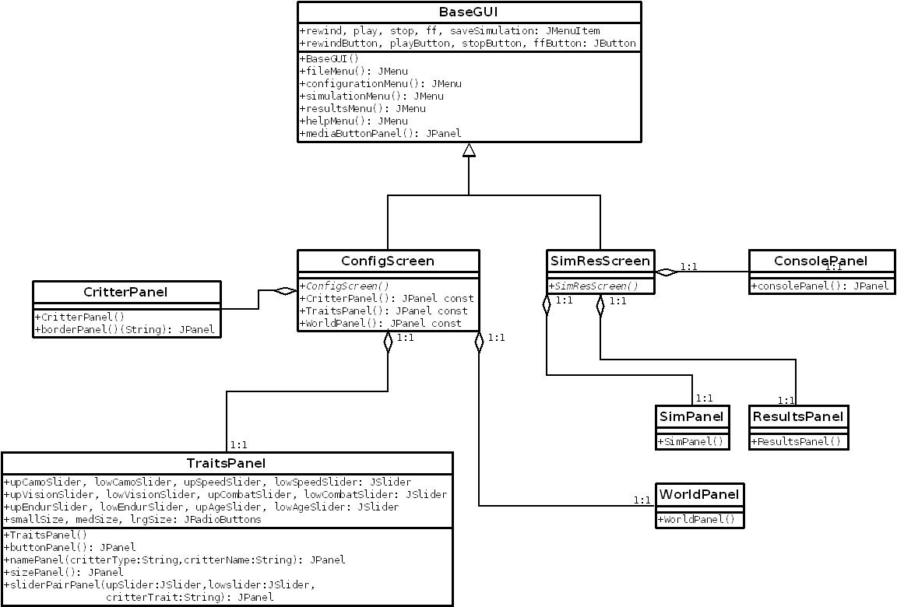

Controller Layer

Package Summaries

- org.snowcrash.commands

- org.snowcrash.configurationservice

- org.snowcrash.dataaccess

- org.snowcrash.timeengine

Command Package Diagram

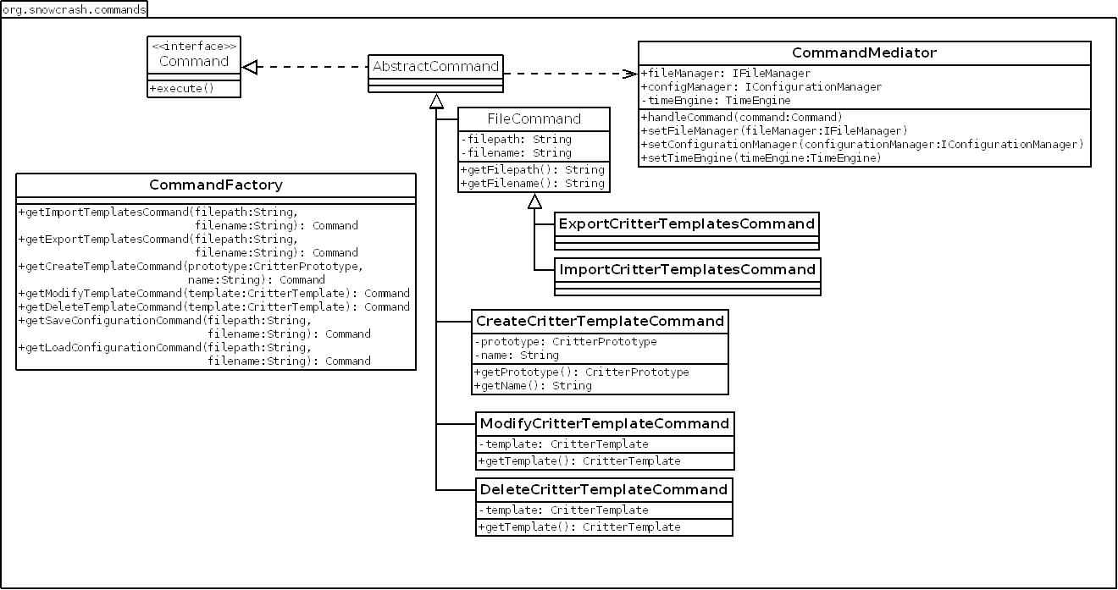

Command Sequence Diagrams
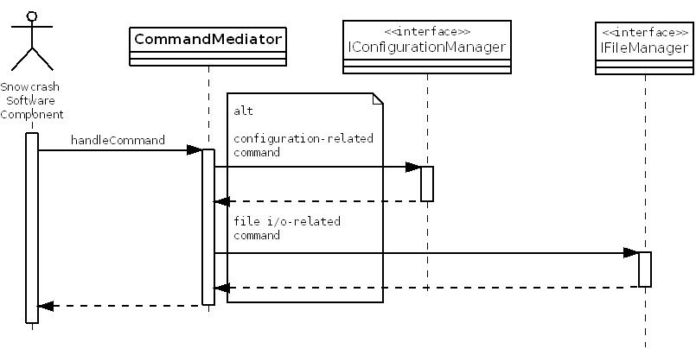

Configuration Package Diagram

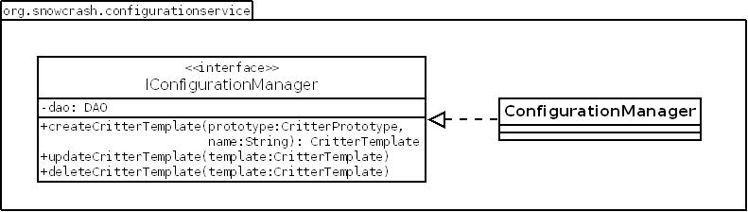

Configuration Sequence Diagrams
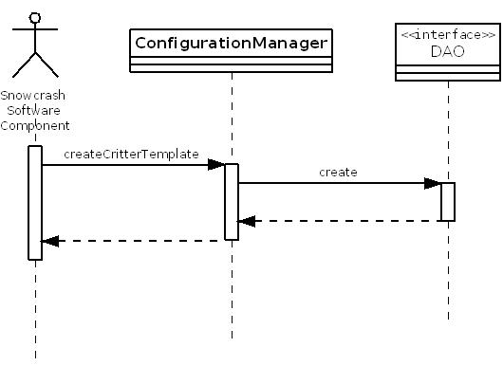
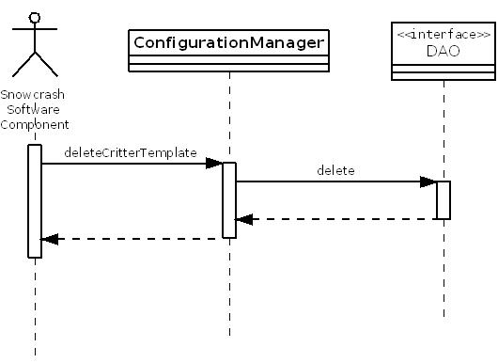
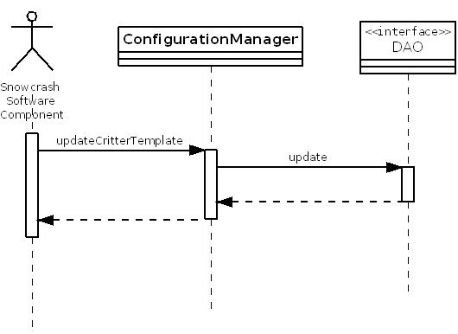

Data Access Package Diagram

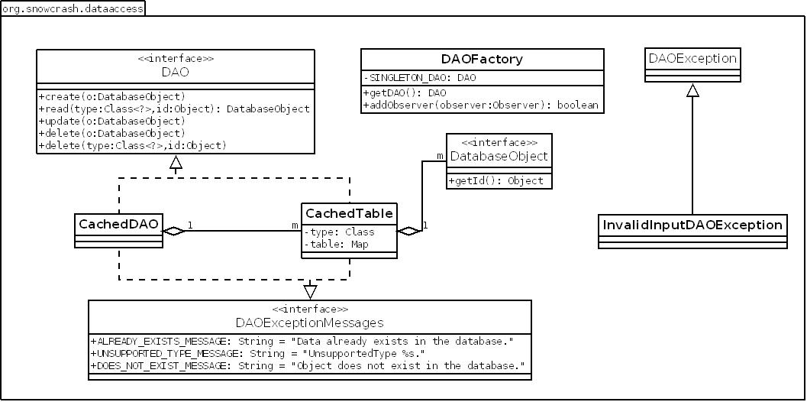

Data Access Relationship Diagram

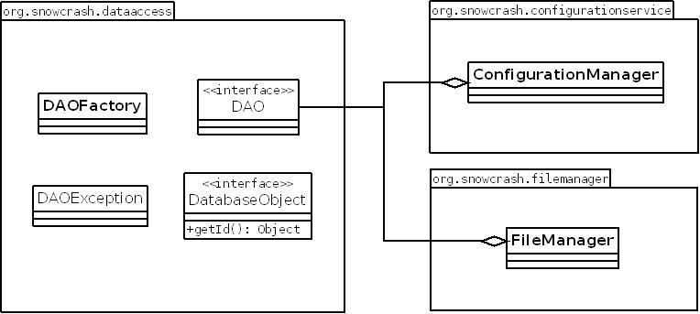

Time Engine Package Diagram

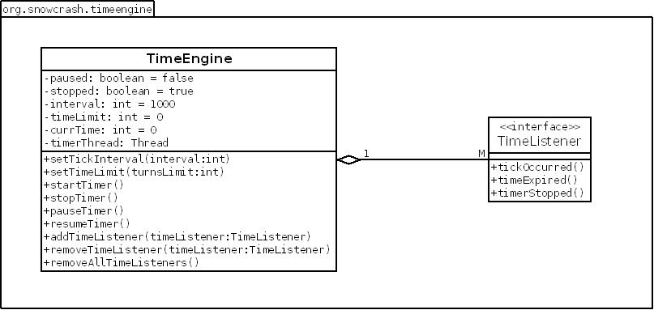

File I/O Manager

Package Summaries

- org.snowcrash.filemanagement

File Manager Class Diagram
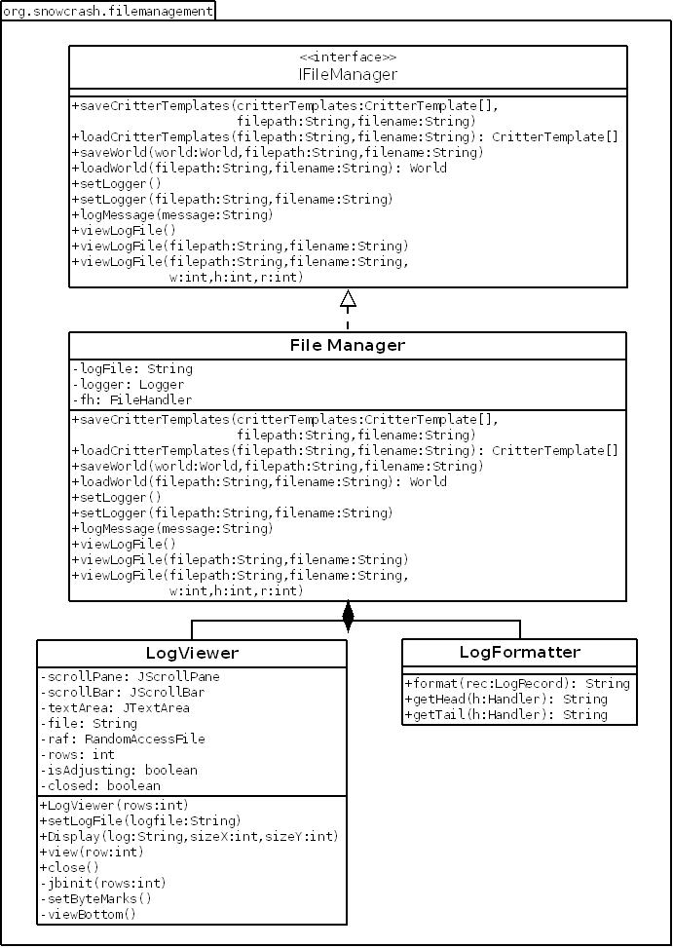

File Manage Load/Save Sequence
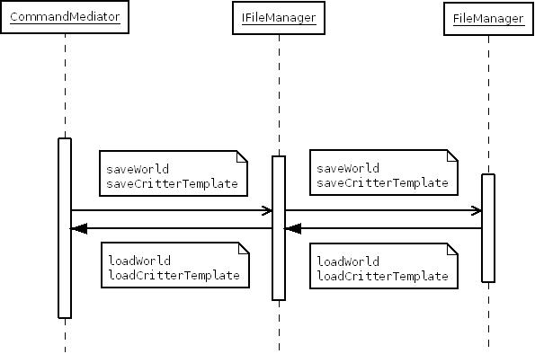

File Logger Sequence
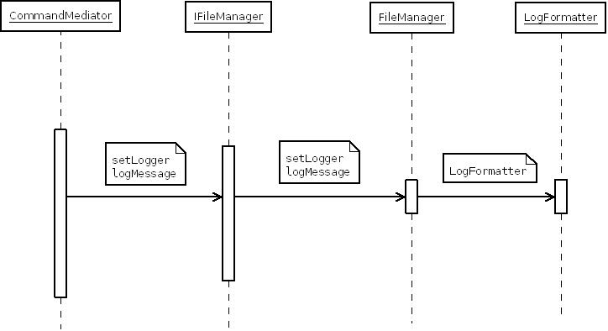

File Log Viewer
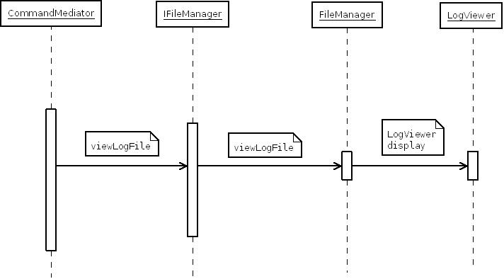

World, Critter, and State Model

Package Summaries
- org.snowcrash.critter

- org.snowcrash.critter.data

- org.snowcrash.world

- org.snowcrash.state

Relational Model
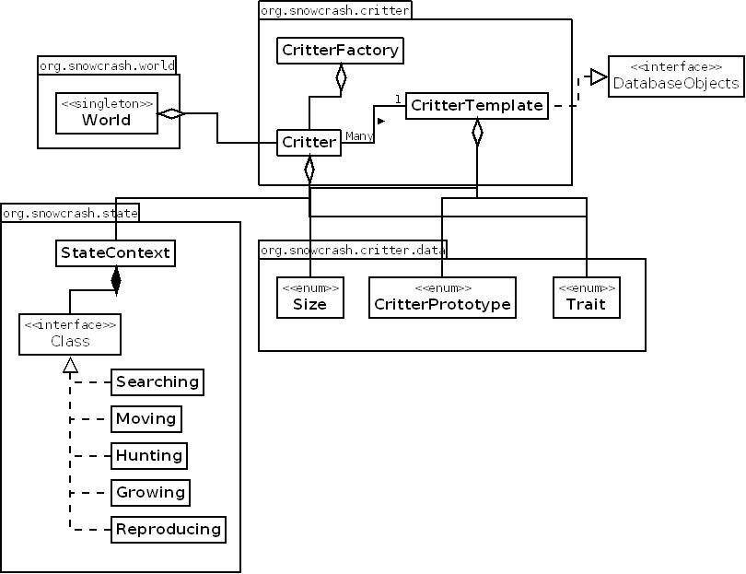

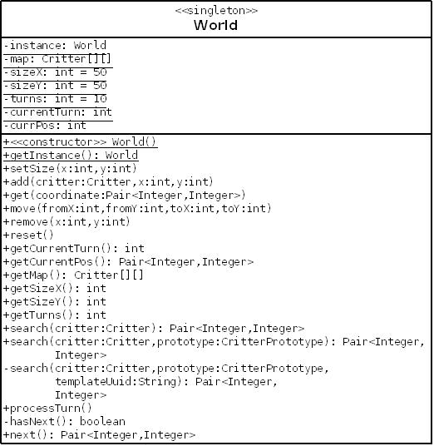
World Package Diagram

Critter Package Diagram
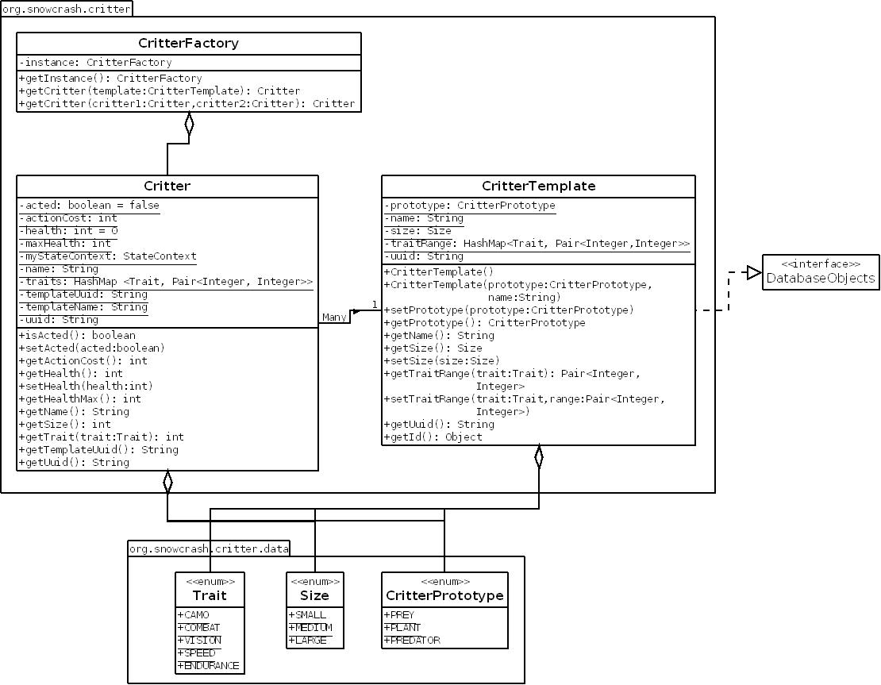

Critter State Model
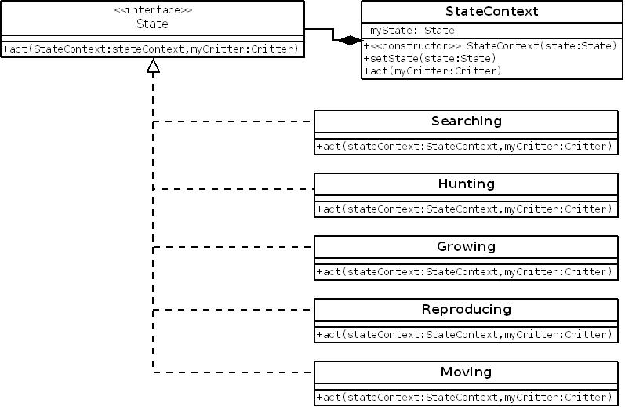

Searching State Pseudocode

- if PLANT
  - if HEALTH > 75%
    - Change State to Reproducing
  - else
    - Change State to Growing
- if PREY or PREDATOR
  - if HEALTH > 75%
    - Change State to Reproducing
  - else
    - Change State to Hunting

Hunting State Pseudocode

- if candidate victims in the world found [hunter VISION – victim CAMO + hunter SIZE – victim SIZE + random#]
  - if attack successful [(hunter VISION – victim VISION) / hunter SPEED + hunter SPEED * distance / (hunter SPEED – victim SPEED) + hunter COMBAT – victim COMBAT < hunter ENDURANCE]
    - victim dies
    - hunter fills up health
    - hunter replaces victim on grid
  - else
    - Change State to Moving

Growing State Pseudocode

- Regenerate health by HEALTH_REGEN value.

Reproducing State Pseudocode

- if PLANT
  - if candidate mate in the world found
    - sexual reproduction
  - else
    - asexual reproduction (clone)
- else
  - if candidate mate in the world found
    - sexual reproduction
  - else
    - Change State to Moving

Moving Pseudocode

- if candidate empty spots found in range
  - move to random candidate spot
- else
  - do not move

World Sequence Diagram

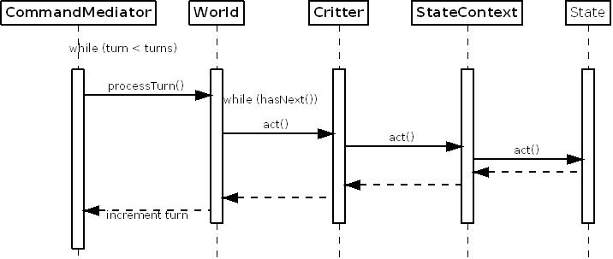
Note: Critters are processed through the World grid in serial starting from (0,0) and proceeding row by row until the entire grid has been traversed.

Utility Classes
The org.snowcrash.utility package encompasses classes that are not directly related to any other classes but are used by multiple classes for their utility and functionality.

Package Summary
- org.snowcrash.utility

Main Classes
The Main package encompasses classes that launch, run, and test the application.

Package Summary
- No package

User Interface Design
This section describes the User Interface, describing and showing concrete versions of the screens and how they interact with each other.

Description of the User Interface
There are three screens in the UI: the configuration screen which is the first screen that appears when the user starts the application; the simulation screen which runs the simulation; and the results screen which displays the results of a simulation. Each screen consists of the window frame, menu bar, and central panel.
From the configuration screen, the user can either start or load a saved simulation, and go to the simulation screen, or the user can load saved results and go to the results screen.
From the simulation screen, the user can return to the configuration screen to define a new simulation or stop the simulation and view the results.
From the results screen, the user can return to the configuration screen.
Note: Please refer to the SRS for complete details of the UI functionality. The results screen is not shown among the screen shots as it has not been prototyped yet.

Screen Transition State Diagram
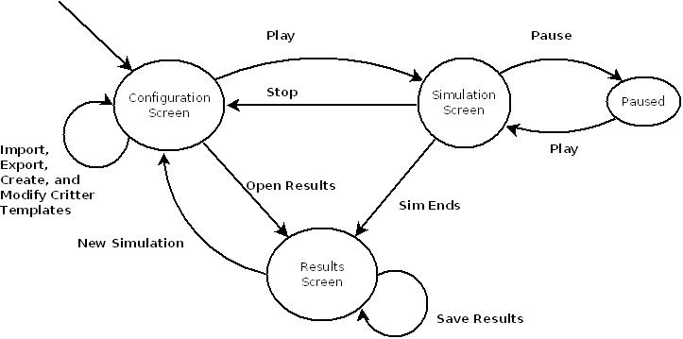

Screen Images

Configuration Screen
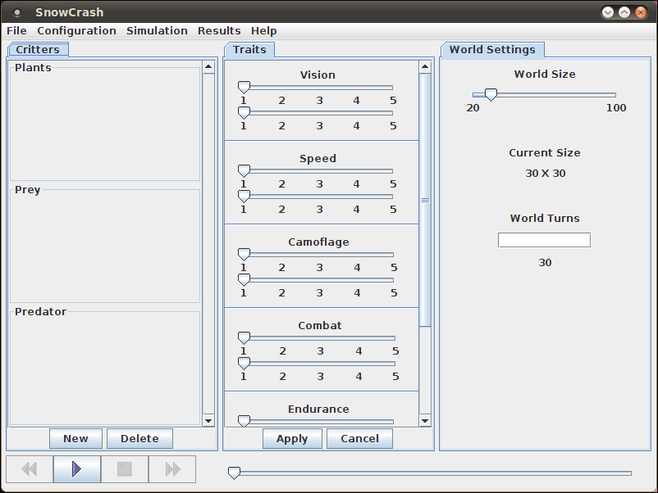

Configuration Screen with File Menu Items
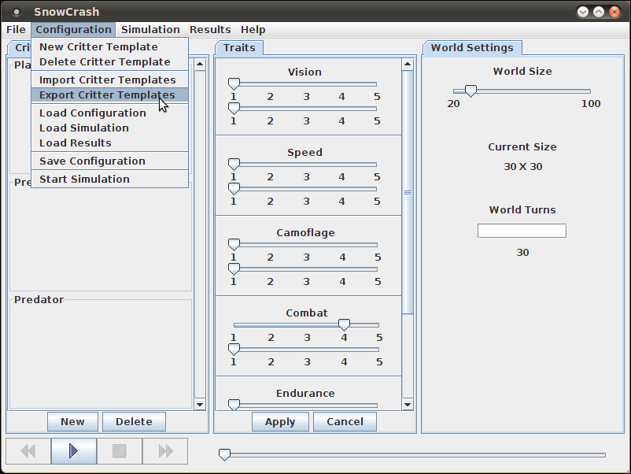

Simulation Screen
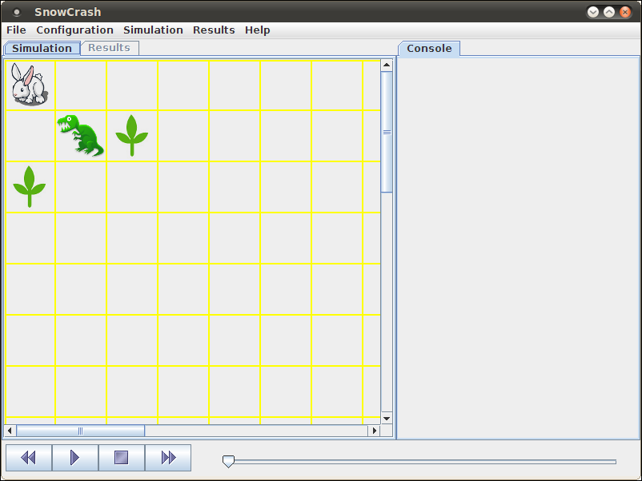

Critter Template Export To File Dialog Box
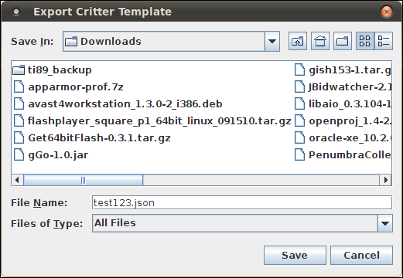

About Snow Crash Dialog Box

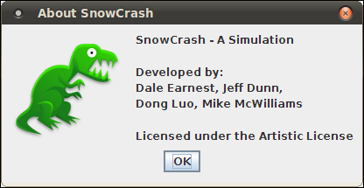

UI Activity Diagram
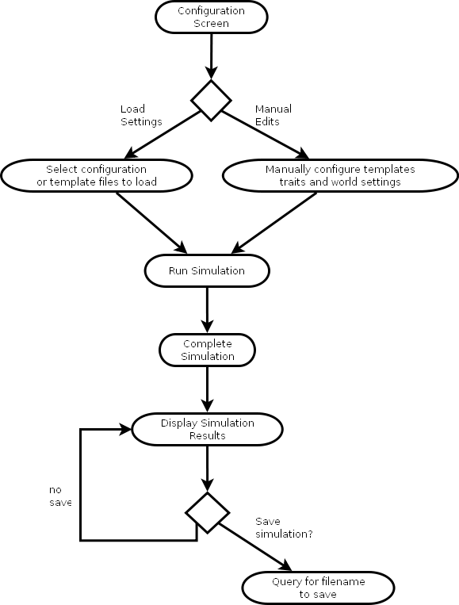

Post Mortem

Deliverable Effort

Individual Contribution

Team Effectiveness

Team Meeting
Score: 10
Details: Meetings are effective, on topic, with little distraction. Team members are focused, contributing, and eager to complete tasks on the agenda.

Document Preparation
Score: 5
Details: Communication is good but timeliness needs improvement. Real life time factors, other classes, and a drive to hit code milestones have affected the quality of the documentation.

Development
Score: 7
Details: Still behind schedule but we're catching up. Code quality is good and communication between team members is still high, but real life time factors.

Summary
Score: 22 out of 30
Details: This score indicates that the project is in a warning zone, that though we have some strong team members our documentation is suffering as we've made a development push.

Gantt Chart
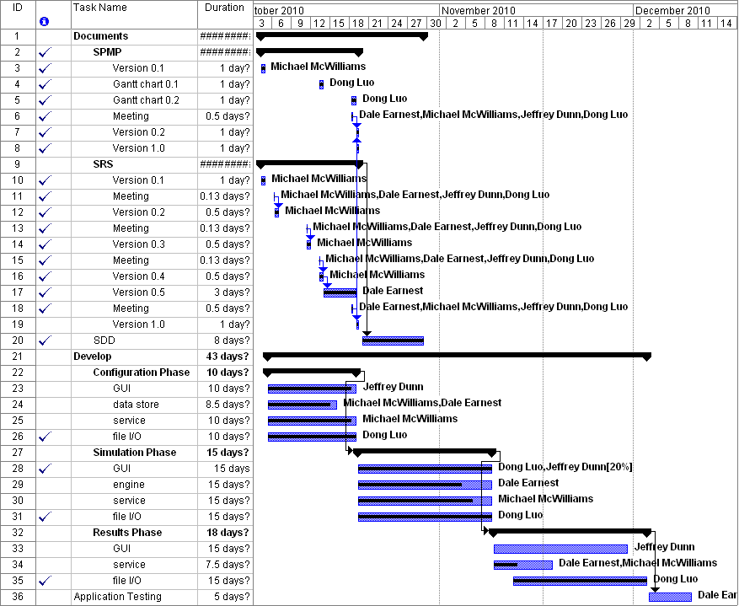
Milestones Accomplished
- SDD is complete.
- Team Meetings have met on time.
- PR 0.1 is 90% complete.
- Simulation Screen UI duty was reassigned to Dong and is complete.
- Critter States is 80% complete and almost ready for integration testing.

