CS 673
Assignment #7
Code Review

Team Snow Crash
Dale Earnest
Jeff Dunn
Dong Luo
Mike McWilliams

Table of Contents
Revision History 3
1.Introduction 4
1.1Code Review Template 4
2.Code Review of Team PACK 5
3.Code Review of Team Snow Crash 6
4.Post Mortem 7
4.1 Deliverable Effort 7
4.2 Individual Contribution 7
4.3 Team Effectiveness 7
4.4 Gantt Chart 9

Revision History
Name | Date | Reason For Changes | Version(s)
Dale | 26 Nov | Initial Draft | 0.1

Introduction
This document contains the code reviews for both Team PACK and Team Snow Crash.

Code Review Template
Each issue brought up shall be formatted as below. An explanation of each field follows.
Issue #: | Unique number to identify the code problem
Who Raised? | This is the person who raised the issue.
Owner: | This is the person whose responsible for addressing the issue.
Severity: | One a scale from 1-10, how severe is this error?
Category: | Valid categories of review are: Readability, Relevance of Comments, Naming Conventions, Maintainability, Large Methods, Error Handling, Logical, Algorithms
File and Line #: | This is the file and line number of the issue.
Detailed Description: | This is a detailed description of the issue raised.
Remedy: | This is the suggested remedy of the issue.
Due Date: | This is the date that the issue will be addressed.

Code Review of Team PACK

Issue #:
Who Raised?
Owner:
Severity:
Category:
File and Line #:
Detailed Description:
Remedy:
Due Date:

Issue #:
Who Raised? | Dale
Owner:
Severity: | 3
Category: | Logical
File and Line #: | MediaManager, #20
Detailed Description: | SVC_Account get does not look thread safe.
Remedy: | Make the method synchronized?
Due Date:

Issue #:
Who Raised? | Dale
Owner:
Severity: | 8
Category: | Logical, ExceptionHandling
File and Line #: | MediaManager, #182
Detailed Description: | It doesn't look like the method PurchaseMedia, or the call to svcAcct.ActInfo.Credits, is synchronized. It looks like it is possible for two users logged in with the same account to make purchases and, once it enters the method and both get passed the initial “if” that they could both succeed even if the account doesn't have enough Media Credits to cover both purchases.
Remedy: | Synchronize the if statement in PurchaseMedia.
Due Date:

Code Review of Team Snow Crash

Issue #:
Who Raised? | Dale
Owner:
Severity: | 3
Category: | Logical
File and Line #: | World, #47
Detailed Description: | getInstance() is not thread safe.
Remedy: | Make the method synchronized.
Due Date:

Issue #:
Who Raised? | Dale
Owner: | Dale
Severity: | 7
Category: | Logical, Maintainability
File and Line #: | Critter, #151
Detailed Description: | setSizeData() contains a large number of constants and logic that would be unnecessary if it were simply included within the Size enum.
Remedy: | Move the constants out of Critter and into Size. Set the data that Critter needs by getting the data from Size.
Due Date:

Post Mortem

Deliverable Effort

Individual Contribution

Team Effectiveness

Team Meeting
Score: 10
Details: Meetings are effective, on topic, with little distraction. Team members are focused, contributing, and eager to complete tasks on the agenda.

Document Preparation
Score: 5
Details: Communication is good but timeliness needs improvement. Real life time factors, other classes, and a drive to hit code milestones have affected the quality of the documentation.

Development
Score: 7
Details: Still behind schedule but we're catching up. Code quality is good and communication between team members is still high, but real life time factors.

Summary
Score: 22 out of 30
Details: This score indicates that the project is in a warning zone, that though we have some strong team members our documentation is suffering as we've made a development push.

Gantt Chart
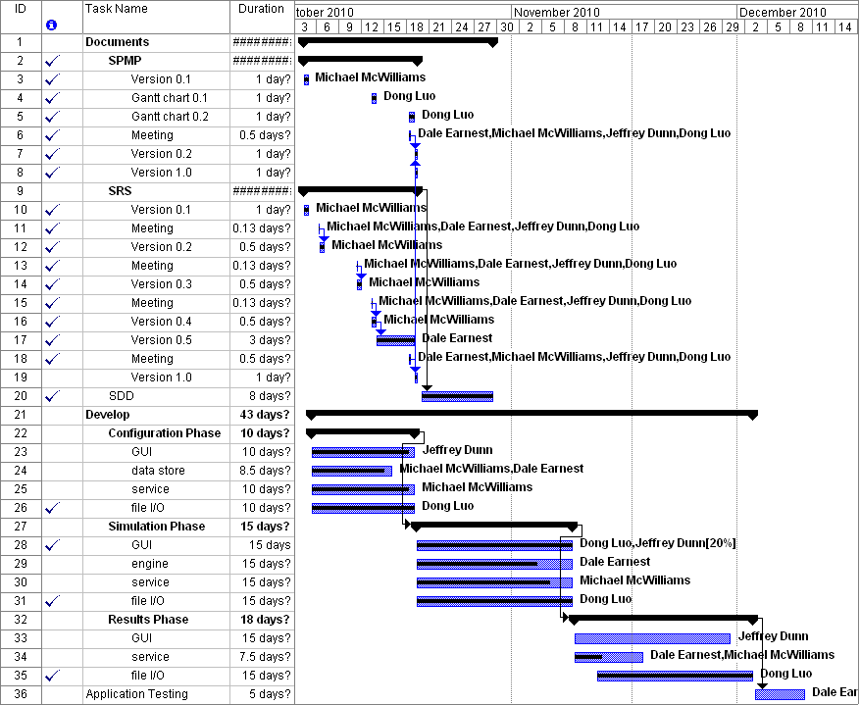
Milestones Accomplished
- SDD is complete.
- Team Meetings have met on time.
- PR 0.1 is 90% complete.
- Simulation Screen UI duty was reassigned to Dong and is complete.
- Critter States is 80% complete and almost ready for integration testing.

