**Task1**

Creating the S3 Bucket

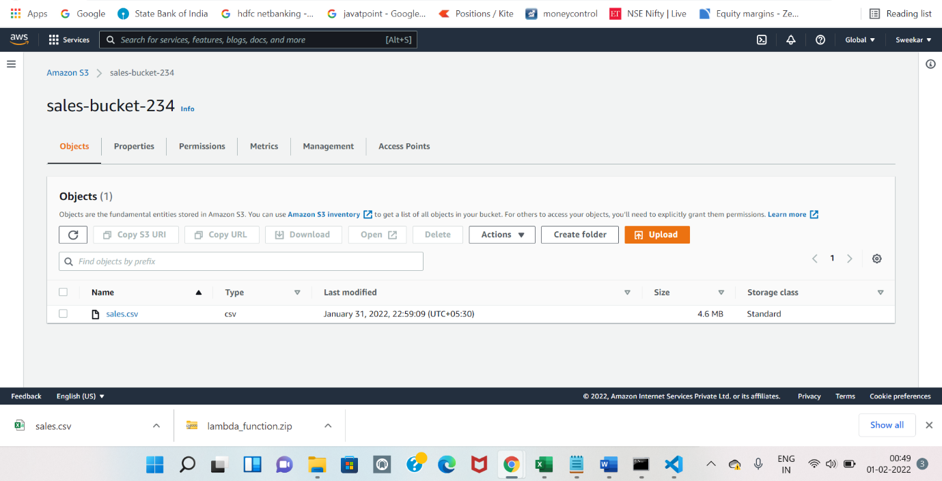

Creating the Lambda Function

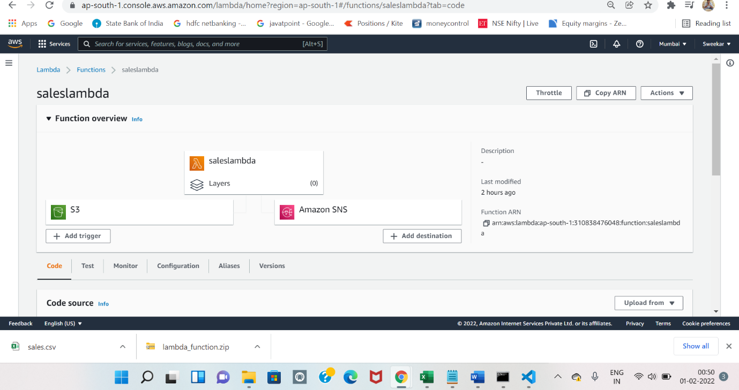

Reading the Csv File From S3 Bucket

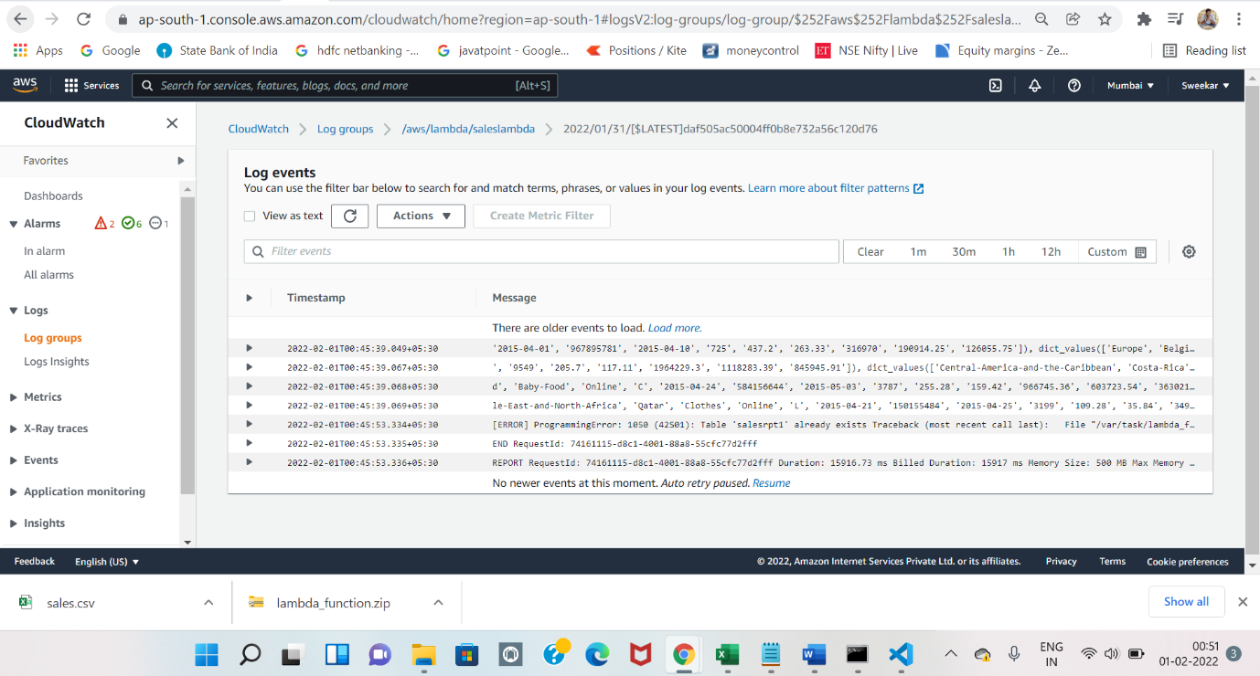

Csv Result in CloudWatch Logs

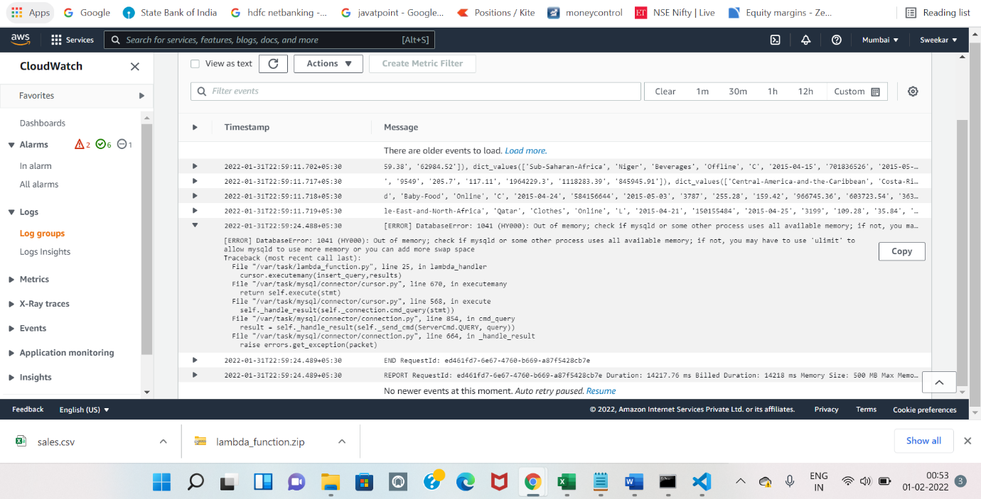

IAM Access and Policies attaching to Roles

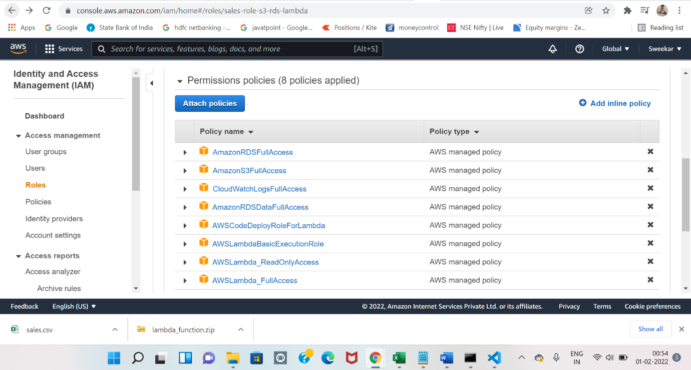

Source Code to Lambda_function.py

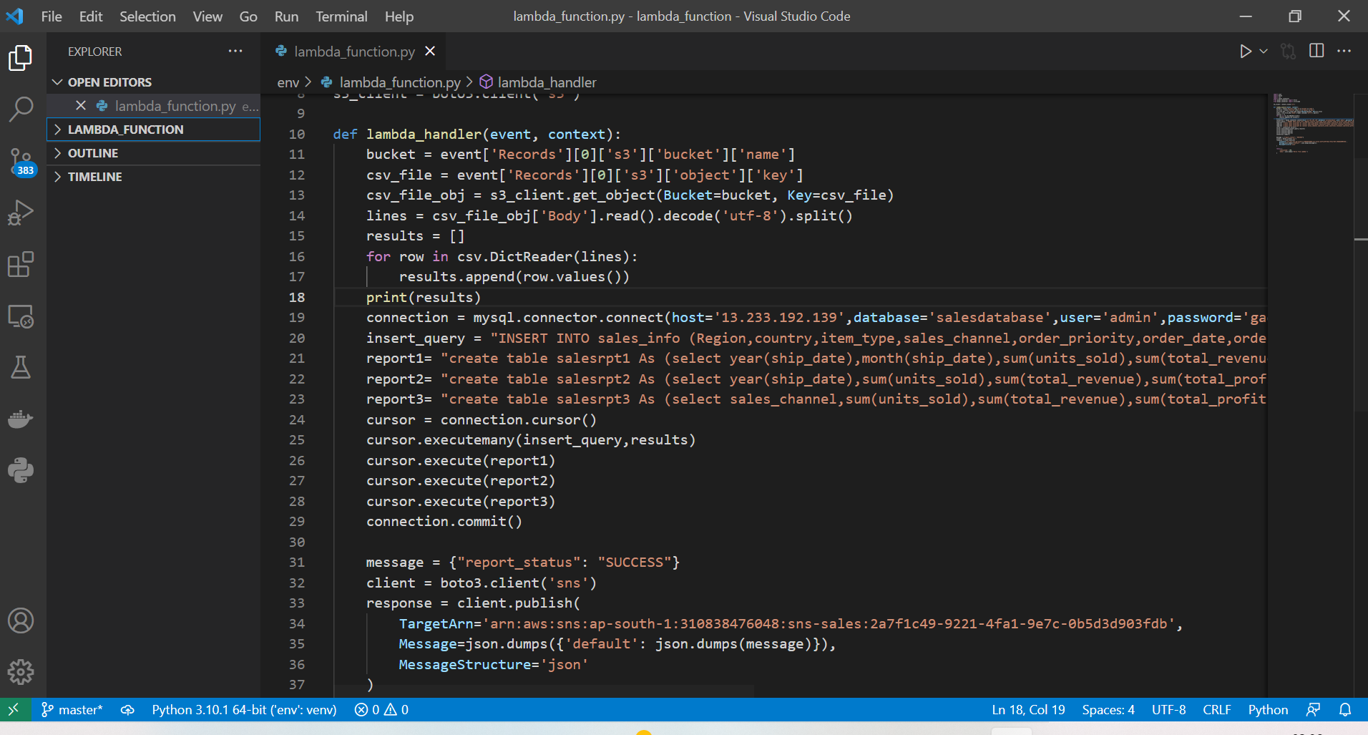

Creating the Tables and and Getting the Data

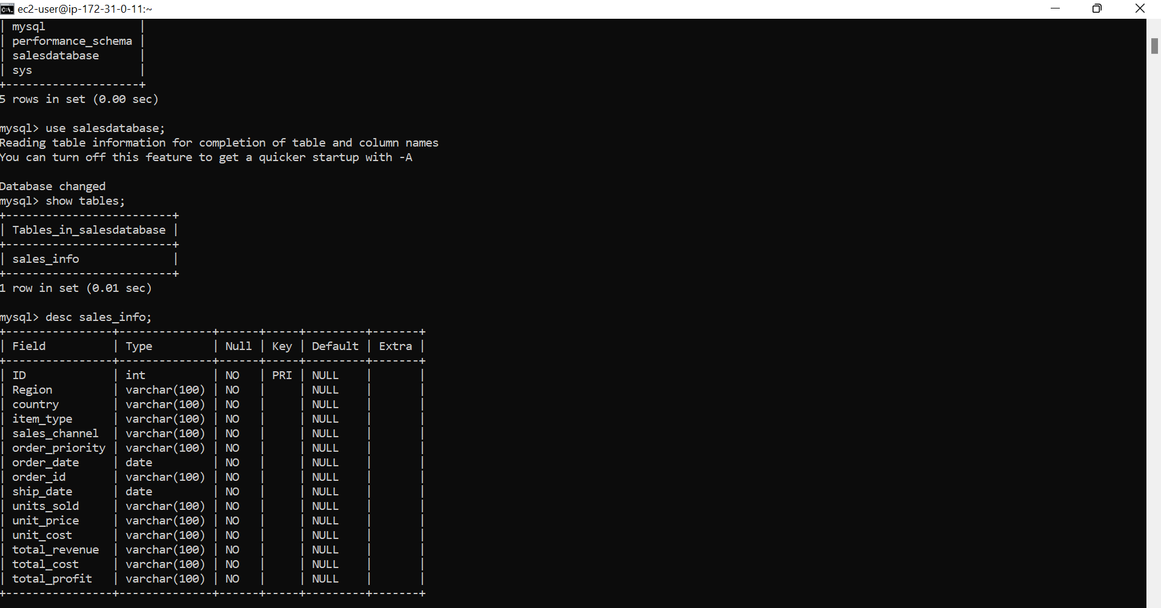

Data Receiving in the tables Report 1

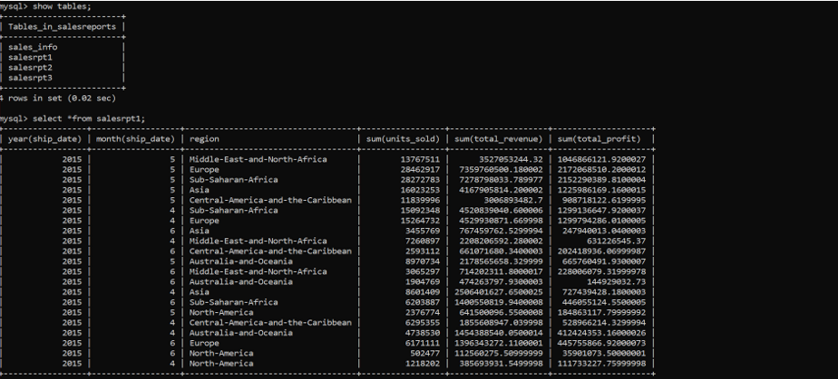

Report 2

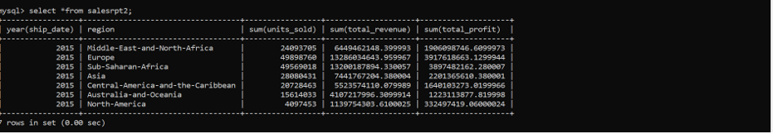

Report 3

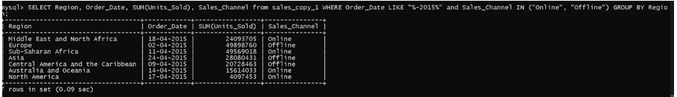

SNS Triggered Status

