Sweekriti Gautam

Summary
In this project, I implemented end-to-end Infrastructure as Code using Terraform across two environments: a multi-container Docker stack and a lightweight Kubernetes cluster created with k3d. In the Docker portion, I built a complete three-tier local environment by provisioning four modules: Nginx, a Flask backend, Postgres, and Redis, each defined as separate Terraform modules. I configured a custom Docker network, mounted configuration files, used variables and a .tfvars file for sensitive values, and deployed a persistent Postgres volume. I also replaced the default Nginx welcome page by mounting a custom nginx.conf file, which routed all browser traffic through Nginx to the backend API, fully validating the reverse-proxy behavior. The entire Docker stack was tested through internal curl calls, container networking checks, and web browser verification.
In the Kubernetes portion, I set up a k3d cluster and connected Terraform to it using the Kubernetes provider. I deployed a dedicated namespace, Nginx Deployment, a NodePort Service exposed on port 30080, and a Horizontal Pod Autoscaler that scales the deployment based on CPU utilization. I also created a custom index.html page and integrated it into the Nginx Deployment to replace the default welcome page. Step-by-step verification using kubectl allowed me to confirm that all resources: pods, deployments, services, and the HPA, were created and functioning correctly.
Overall, this project demonstrated how Terraform can consistently automate infrastructure provisioning across different platforms. It strengthened my understanding of modular configuration design, state management, dependency handling, and applying IaC principles to real Docker and Kubernetes environments.

Screenshots
- Shows modules, main.tf, variables.tf, and tfvars.
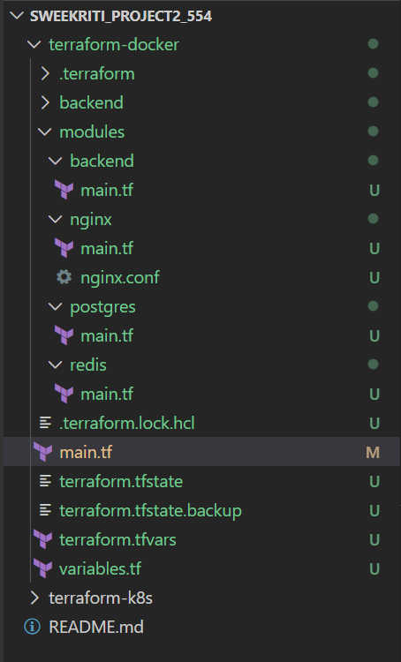
Figure 2: Terraform Docker project organized with modules and variable files.

- Shows modules, main.tf, variables.tf, and tfvars.

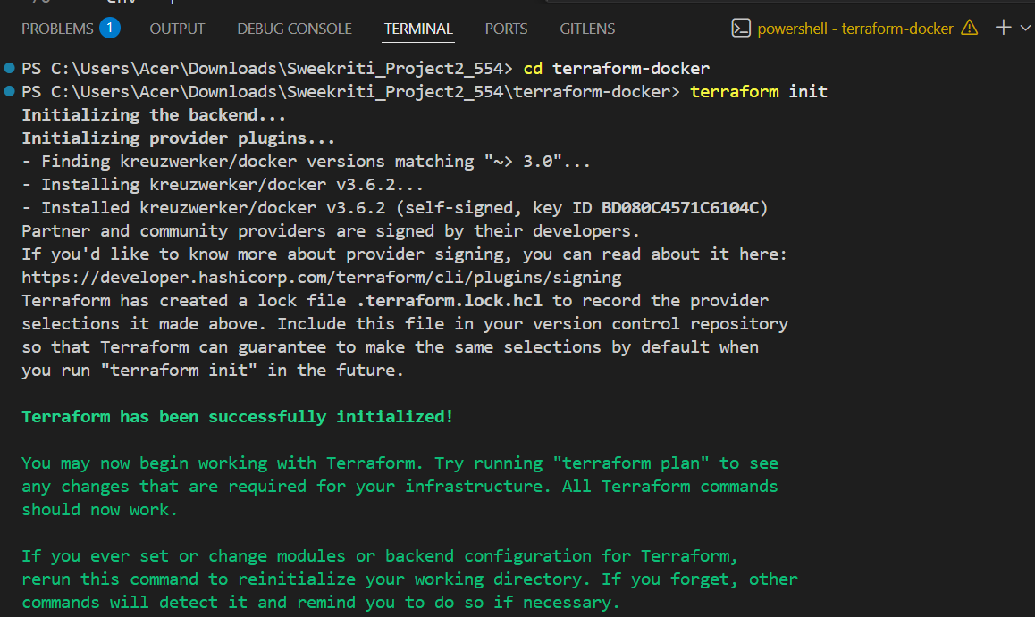
Figure 1: Install and init terraform
- Secrets managed through variables and .tfvars.
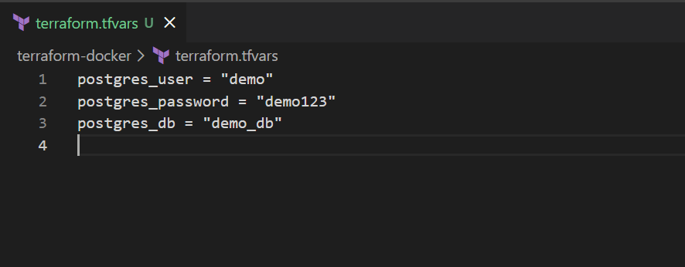
Figure 3: Terraform.tfvars file

- Creates demo-net network and demo-nginx container.
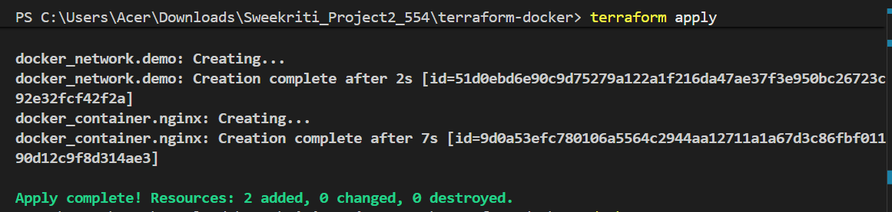
Figure 4: Terraform successfully deployed the initial Docker setup.
- Verifies the frontend Nginx container is up.
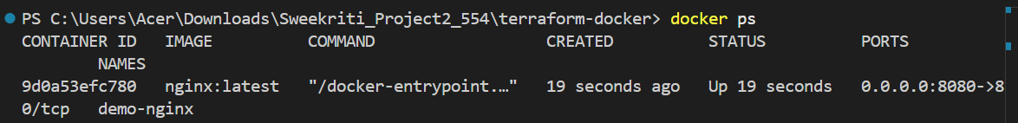
Figure 5: Initial Docker infrastructure showing only the Nginx container deployed
- Custom network demo-net created.
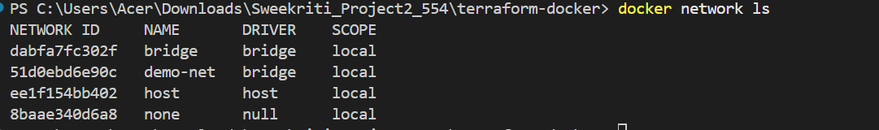
Figure 6: Custom Docker network demo-net created and managed by Terraform.
- Creates the postgres container
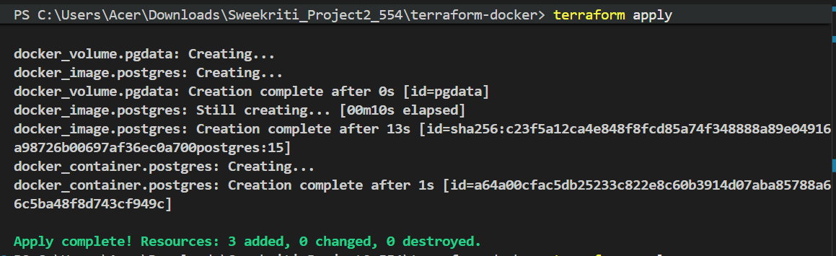
Figure 7: Terraform applied updated configuration including the Postgres container.
- Deploys Postgres 15 with persistent volume.
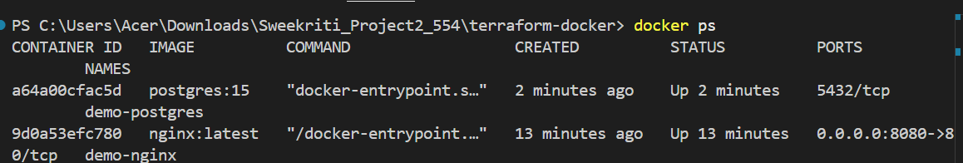
Figure 8: Docker environment with Nginx and Postgres running
- Volume pgdata created for Postgres.
Figure 9: Docker volume pgdata created to persist Postgres database data.
- Creates the backend
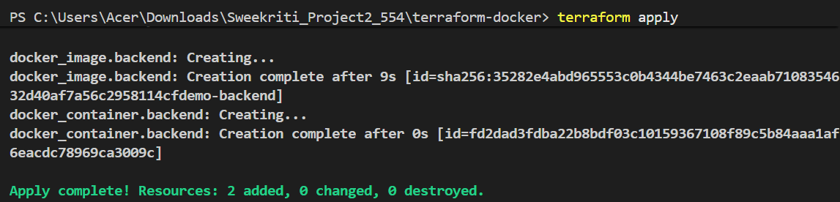
Figure 10: Terraform deployed the backend Flask API container connected to the same Docker network as Postgres and Nginx.
- Backend image built using Dockerfile.
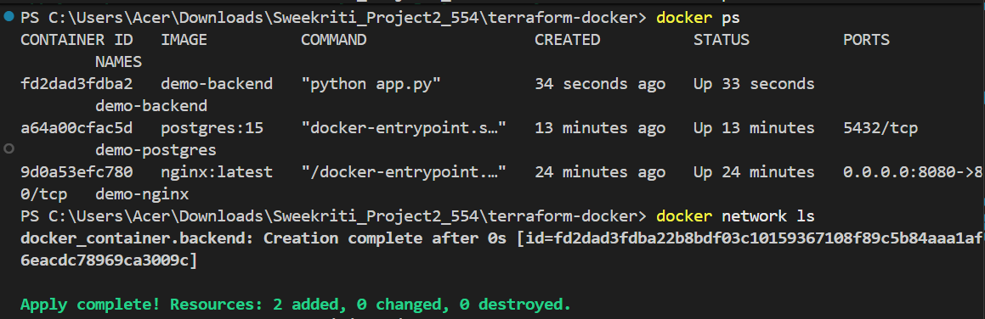
Figure 11: Docker environment with nginx, postgres, and backend running
- Backend API responding as expected.
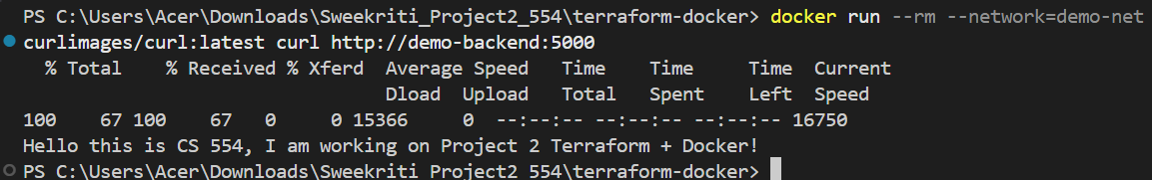
Figure 12: Backend API responding successfully inside the Docker network using its container hostname demo-backend.
- Custom nginx.conf applied; backend served via Nginx.
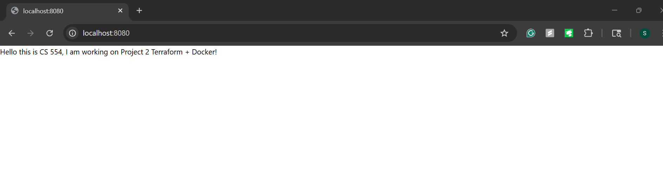
Figure 13: Nginx proxies http://localhost:8080
- Enhancement container successfully deployed.
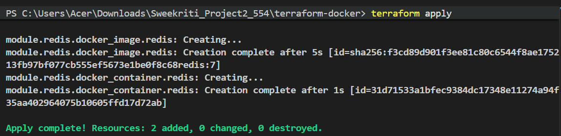
Figure 14: Terraform successfully deployed the Redis enhancement module, creating the Redis image and container on the shared Docker network.
- Final Docker stack verified.
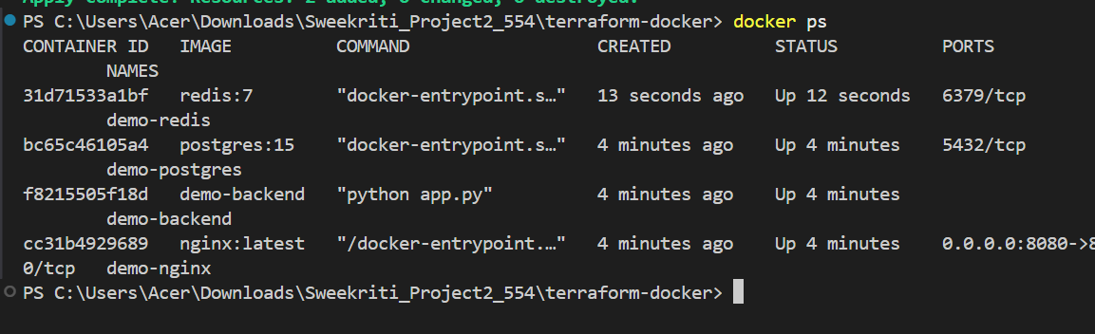
Figure 15: Final Docker stack showing Nginx frontend, backend API, Postgres database, and Redis enhancement

Part 2:
- Cluster is running and kubectl is correctly configured.
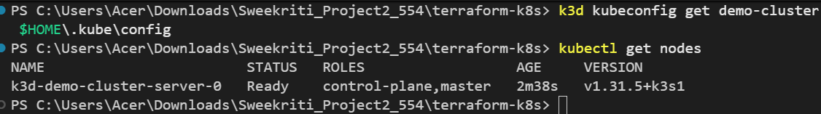
Figure 16: k3d Kubernetes cluster demo-cluster created successfully, with node in Ready state.
- All Kubernetes resources created via Terraform.
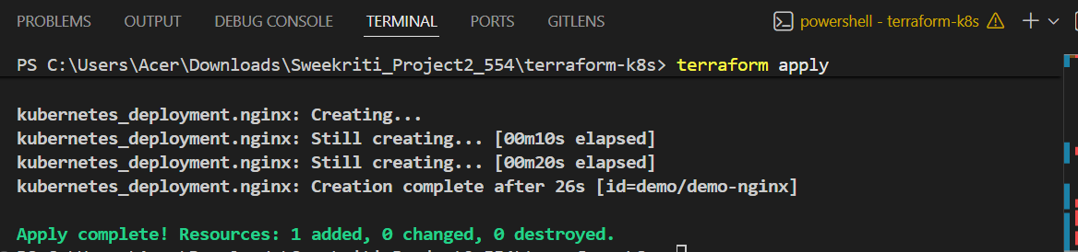
Figure 17: Terraform created the Nginx Deployment in the demo namespace.
- Verifies Nginx pod is running.
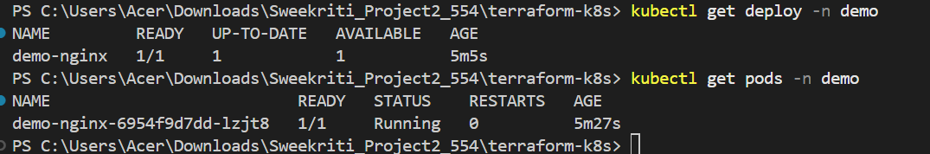
Figure 18: Nginx Pod running inside the demo namespace.
- Deployment successfully created.
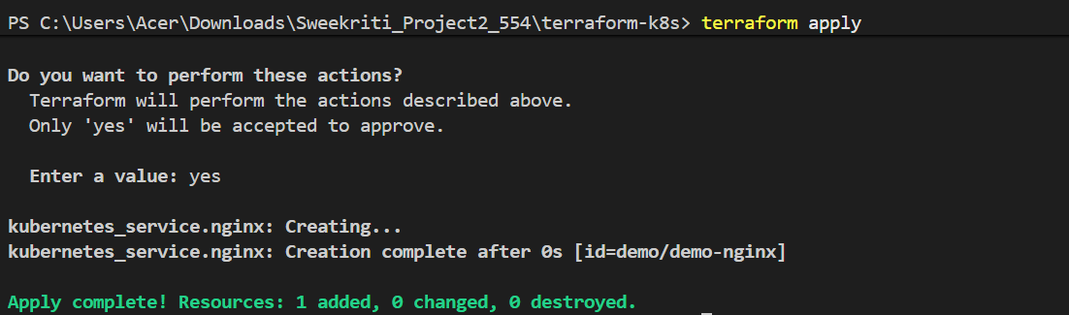
Figure 19: Terraform created the NodePort service exposing Nginx on port 30080.
- NodePort service exposing port 30080.
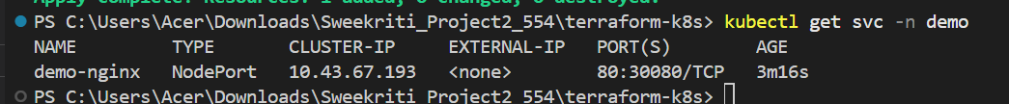
Figure 20: NodePort Service exposing Nginx externally on port 30080.
- Horizontal Pod Autoscaler deployed.
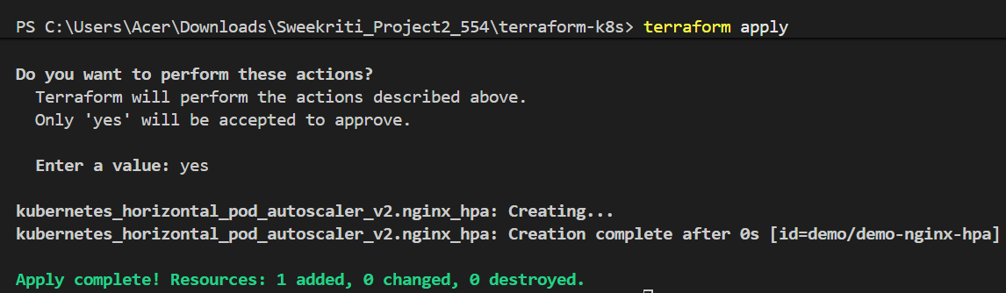
Figure 21: Terraform deployed the HPA scaling demo-nginx between 1–3 replicas.
- HPA confirmed and active.
Figure 22: HPA detected for the Nginx Deployment.
- Custom index.html successfully displayed on http://localhost:30080.
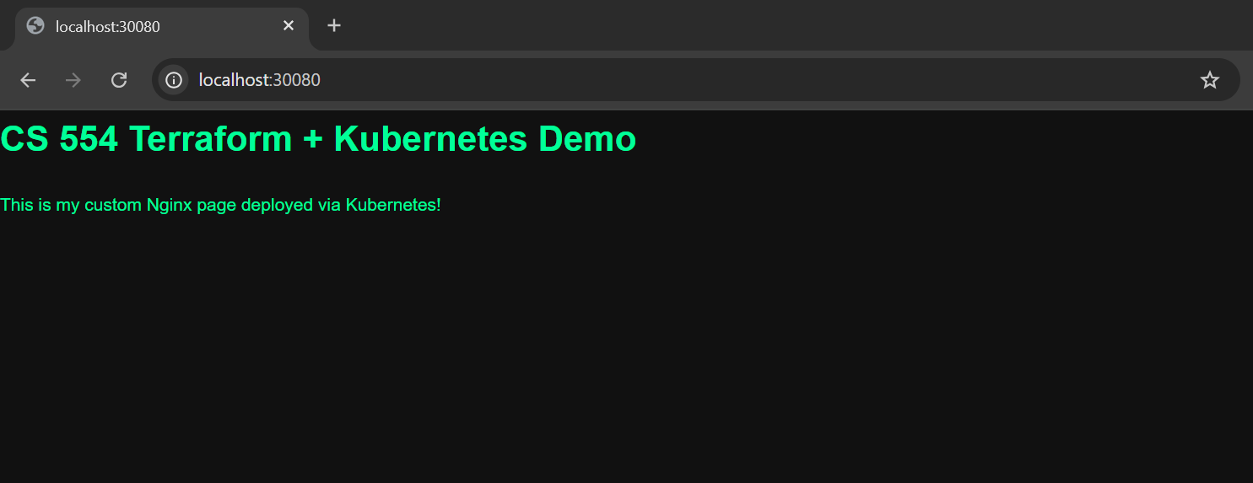
Figure 23: Nginx serving custom HTML from a ConfigMap managed by Terraform.

Reflection
This project helped me gain practical experience with Terraform by deploying infrastructure in a structured and repeatable way. In the Docker part, I learned how to build a fully modular setup that manages Nginx, a backend API, Postgres, and Redis, all connected through a custom Docker network. Using variables and a .tfvars file made the configuration more organized, secure, and easier to maintain. In the Kubernetes part, I learned how to create and manage a k3d cluster, configure kubectl, and use Terraform to deploy a namespace, deployment, service, and an HPA. I also created a custom index.html page and served it through the Nginx deployment, which helped me better understand how file mounting and container customization work in Kubernetes. Verifying each component step-by-step strengthened my understanding of how Terraform interacts with container orchestration systems.

