

BORDERSHIELD AI
An AI-Based Route Risk Prediction and Intelligent Decision Support System for Mission Route Planning
Official Initial Project Document
Version 1.0 — Requirements / Pre-Implementation Baseline

Academic B.Tech Project
Real-geography-inspired environment with fictional operational infrastructure

1. Project Title
BorderShield AI: An AI-Based Route Risk Prediction and Intelligent Decision Support System for Mission Route Planning

2. Problem Statement
Planning routes in geographically challenging and environmentally variable regions is difficult because the shortest route may not always be the safest or most suitable route. Weather, terrain, road conditions, altitude and mission requirements can change the risk and travel time associated with different routes. BorderShield AI addresses this problem by evaluating these factors to predict route risk, estimate ETA and recommend a suitable route over a connected operational road network.
Research basis: Sohrabi & Lord (2022) demonstrated that faster route choices can conflict with safety and that route safety can vary with weather conditions.

3. Background Study
Route planning is traditionally treated as a shortest-path problem in which a road segment is assigned a fixed numerical cost such as distance or travel time. In a dynamic mountainous environment, however, the suitability of a road segment can change because of weather, snowfall, visibility, terrain difficulty, elevation, road status and mission requirements.
Recent research has consequently moved toward safety-aware, terrain-aware, weather-aware and risk-aware path planning. These studies provide the research foundation for treating route selection as a multi-criteria decision problem rather than a distance-only problem.
- Safety-aware routing: route choice can involve a trade-off between travel time and safety.
- Terrain-aware planning: terrain roughness, slope and traversability can influence route cost.
- Weather-aware routing: changing environmental conditions can change the preferred route.
- Risk-aware planning: uncertainty and operational risk can be incorporated into path selection.
- Dynamic routing: changing input conditions can produce different route recommendations without changing the underlying graph structure.

4. Need of the Project
A mission-oriented route should not be selected using distance alone. A longer route may be more suitable when a shorter route has substantially higher operational risk. BorderShield AI is therefore intended to combine route distance, environmental conditions, road characteristics and mission requirements to support a more informed route decision.
- Weather can change the condition and accessibility of road segments.
- Snowfall, poor visibility and other environmental conditions can increase route risk.
- Terrain difficulty and elevation can affect route suitability and travel time.
- Road status or temporary restrictions can make an otherwise connected route unsuitable.
- Different mission requirements can produce different route preferences.
- The system should provide risk and ETA along with the recommended route rather than only a path on a map.

5. Objective
- To design a structured PostgreSQL database for managing geographical, terrain, weather, road, checkpoint, helipad, and operational datasets.
- To develop a graph-based road network representing the operational region.
- To implement an AI-based risk assessment model using factors such as weather, terrain, road condition, altitude, and mission parameters.
- To generate intelligent route recommendations based on risk-aware path planning rather than shortest distance alone.
- To estimate travel distance and Expected Time of Arrival (ETA) for recommended routes
- To provide alternative route recommendations when the primary route presents high operational risk.
- To develop an interactive dashboard for visualizing routes, operational information, and risk analysis.
- To build a modular and scalable architecture that supports future integration of additional datasets and advanced AI models.

6. Scope of the Project

6.1 Geographic and GIS Scope
The project uses a geographical environment inspired by the Leh–Ladakh–Siachen region. Publicly available geographic information is used as the reference foundation, while the operational infrastructure placed on the map is fictional and created for academic simulation.
- Latitude and longitude coordinates
- Elevation/altitude
- Terrain and geographic context
- Mountain, valley, river, pass and glacier context
- Spatial relationships between nodes
- Road connectivity and route distances

6.2 Operational Network Scope
The operational network contains the project's defined fictional operational locations L01–L20 together with supporting checkpoints, helipads, rest points, bridges, observation towers and road junctions.

6.3 Road Routing Scope
- The connected road network is the core routing network.
- Road segments are represented as graph edges.
- Operational nodes are represented as graph nodes.
- Each edge receives a dynamically calculated operational cost.
- The final route is selected using the dynamically weighted graph.

6.4 Air / Helicopter Scope
Air/heli routing is conditional on the mission input and is not the primary routing network. Normal land missions use the connected road graph; missions explicitly requiring air transport may use the defined helipad/air-route information.

6.5 Risk, ETA and Recommendation Scope
- Risk evaluation using multiple operational factors.
- Route distance calculation.
- ETA estimation.
- Recommended route generation.
- Alternative route generation when the preferred route becomes unsuitable.
- Display of major factors affecting the route decision.

7. Project Environment and Data Philosophy
The project intentionally separates real-world reference information from fictional operational infrastructure.
Layer | Status | Purpose
Geography / GIS | Real-world public reference | Geographic foundation of the simulation
Coordinates / elevation | Real-world geographic reference data used for coordinates, elevation, terrain context and spatial verification. | Spatial and terrain inputs
Weather | Public meteorological reference | Environmental risk inputs
Operational locations | Fictional | Academic mission environment
Road network | Project-defined over the geographic environment | Routing graph
Mission information | Project-defined | Route decision constraints/preferences

8. Dataset Collection

8.1 Geographic and GIS Data
- Coordinates of selected geographic and operational reference points.
- Elevation/altitude values.
- Terrain and regional context.
- Relative spatial relationships between roads and nodes.
- Public geographic/GIS references including Google Earth for coordinate verification, geographic verification, spatial relationships, terrain context, and visualization of the study region.
- Google Earth is used as a geographic reference and visualization source for checking coordinates, spatial relationships, terrain context, and the placement of project-defined features.

Important: Google Earth and other public geographic sources are used only as references for the real geographical environment. The operational locations, checkpoints, road network configuration, mission infrastructure and other operational elements shown in BorderShield AI are project-defined fictional components created for academic simulation and must not be interpreted as actual military infrastructure.

8.2 Meteorological Data
- India Meteorological Department (IMD) public weather information.
- Meteorological Centre Leh information where applicable.
- IMD Climate Research & Services, Pune, where applicable.
- Historical/reference weather variables required by the project.
- Live weather values may be obtained later through an appropriate API for temporary prediction-time use.

8.3 Project-Created Operational Data
- Operational locations L01–L20.
- Road Master and connected road network.
- Checkpoints and junctions.
- Helipads.
- Rest points.
- Observation towers.
- Bridges and supporting infrastructure references.
- Operational zones.
- Mission information and mission types.

8.4 Dataset Design Principle
The validated PostgreSQL database is treated as the stable historical/reference database. During a route prediction, live weather values, if available, are combined with the reference data in temporary working data. Live values do not overwrite the historical database.

9. Data Validation and Quality Control
Validation is performed according to the type of data. Externally referenced geographic and weather values are cross-checked against their corresponding public sources, while fictional project-created operational data is checked for internal consistency, connectivity and logical correctness.
- Coordinate validation against geographic references.
- Elevation validation against available geographic/elevation references.
- GIS consistency checks for spatial relationships.
- Road connectivity validation to ensure the graph is connected as designed.
- Road distance verification using the selected geographic reference and project tolerance.
- Weather cross-checking against IMD/reference information.
- Unit and range validation.
- Duplicate and missing-value checks.
- Logical consistency checks between roads, nodes, checkpoints, rest points and other infrastructure.
- Validation of reserved/deployed status so that non-deployed reserved facilities are not incorrectly treated as active routing nodes.
The project should not claim that every dataset is '100% accurate' unless a formal, reproducible comparison demonstrates that result for the specific attributes and records tested. The final report will instead state the measured validation result for each dataset/category.

10. Limitations
- The operational infrastructure is fictional and created for academic simulation.
- The system does not use classified military information, military communication networks or restricted operational infrastructure.
- The system is a decision-support prototype and does not autonomously issue or execute real-world military commands.
- Weather and environmental predictions depend on the availability, quality and temporal accuracy of the input data.
- Real-world weather can change faster than the update interval of an available data source or API.
- The road network represents the project's defined operational network and is not claimed to represent the complete real-world military road network.
- ETA depends on assumptions about road type, road condition and movement speed.
- Risk values depend on the selected risk model and the quality of the input data.
- The initial prototype is designed for a limited operational network and may require optimization for much larger networks.
- Air/heli routing is conditional and is not the primary routing focus.

11. Literature Survey
The literature survey is divided into two complementary forms. Part A provides a narrative synthesis of relevant research and contextual evidence. Part B provides a structured comparative table. Peer-reviewed research is kept distinct from government/official reports and news/contextual material.

11.1 Part A — Narrative Research Survey

1. Safety-Aware Route Finding
Sohrabi and Lord (2022) examined safety in route finding and reported that faster route choices can conflict with safety. Their study also showed that the safest route can vary with weather conditions. This directly supports the BorderShield problem of moving beyond shortest/fastest routing.
Source: https://www.sciencedirect.com/science/article/pii/S0968090X21005246

2. Risk-Aware Off-Road Planning
Tian et al. (2023) studied risk-averse motion planning in off-road environments and incorporated terrain-related risk into planning. The work supports the use of terrain as a route-cost/risk factor.
Source: https://www.sciencedirect.com/science/article/pii/S0957417422024459

3. Risk-Aware Dynamic Path Planning
Karlsson et al. (2023) proposed D+*, a risk-aware path planner supporting dynamic map/risk information and evaluation on ground and aerial platforms. It supports the architectural separation between risk evaluation and path computation.
Source: https://www.sciencedirect.com/science/article/pii/S0957417422024277

4. Terrain-Based Cost Modeling
Sánchez-Ibáñez et al. (2023) investigated optimal path planning on irregular terrain using an anisotropic cost model. The study supports representing terrain difficulty as a variable navigation cost.
Source: https://link.springer.com/article/10.1007/s11370-022-00450-6

5. Terrain-Aware Path Planning
Yoon et al. (2024) compared terrain-aware path-planning approaches for off-road navigation, considering terrain roughness, slope and step height. The study supports terrain-aware route evaluation.
Source: https://pure.kaist.ac.kr/en/publications/analysis-of-terrain-aware-optimal-path-planning-methods-for-stabl/

6. Rough-Terrain A*
Liu et al. (2024) proposed an improved A* approach using trafficability and ruggedness models for rough terrain. This demonstrates how terrain-derived costs can be integrated with a graph-search algorithm.
Source: https://www.mdpi.com/1424-8220/24/15/4884

7. Weather-Aware Route Planning
Wang et al. (2024) developed a multi-objective route-planning model incorporating meteorological risk and navigation constraints with a bidirectional A* approach. Although maritime, the principle of environmental-risk-aware routing is directly relevant.
Source: https://www.mdpi.com/2076-3417/14/17/8029

8. Risk-Aware Routing Under Weather Uncertainty
Nuñez et al. (2024) investigated risk-aware stochastic routing under uncertain weather conditions. The study demonstrates that environmental uncertainty and risk tolerance can be incorporated into route selection.
Source: https://www.sciencedirect.com/science/article/pii/S0029801824029196

9. Risk-Aware Traversability
Dixit et al. (2024) presented STEP, a stochastic traversability and planning framework for hazardous environments. It combines traversability, uncertainty and risk-aware planning, supporting the broader design principle used in BorderShield AI.
Source: https://doi.org/10.1109/TFR.2024.3512433

11.2 Part B — Comparative Literature Survey
No. | Authors | Year | Title | Dataset / Data Source | Methodology | Algorithm | Evaluation Parameters / Metrics | Key Finding | Limitation / Future Scope
1 | Sohrabi & Lord | 2022 | Navigating to Safety | Road-safety / route-finding data and weather context | Safety-aware route evaluation | Route finding / safety analysis | Travel time, safety/crash risk, weather variation | Shows faster routes can have higher risk and safest route can vary with weather. | Civilian road-safety focus; not mountainous mission routing.
2 | Tian et al. | 2023 | Driving risk-aversive motion planning in off-road environment | Simulated off-road environments | Risk field + motion planning | PF-RRT* | Safety, trajectory quality, convergence | Balances safety and travel efficiency in off-road planning. | Motion/vehicle planning rather than a fixed road-network DSS.
3 | Karlsson et al. | 2023 | D+*: A risk aware platform agnostic heterogeneous path planner | Dynamic 2D/3D maps and field experiments | Risk-aware global planning | D+* | Planning success, risk handling, field performance | Supports dynamic risk/map updates across ground and aerial platforms. | Robotic environment differs from BorderShield's operational road graph.
4 | Sánchez-Ibáñez et al. | 2023 | Optimal path planning using a continuous anisotropic model for navigation on irregular terrains | Virtual irregular-terrain simulation | Anisotropic terrain-cost modeling | OUM / bi-OUM | Accumulated cost, path optimality | Reported up to 20% accumulated-cost reduction in evaluated scenarios. | Simulation-focused and not mission-route specific.
5 | Yoon et al. | 2024 | Analysis of Terrain-Aware Optimal Path Planning Methods for Stable Off-Road Navigation | Simulated realistic off-road terrain | Terrain traversability cost | RRT-Connect, RRT*, PRM* | Cost and planning performance | Demonstrates the importance of terrain-aware planning. | Robot/off-road navigation context.
6 | Liu et al. | 2024 | Improved A* Algorithm for Mobile Robots under Rough Terrain | Rough-terrain mobile-robot scenarios | Trafficability + ruggedness modeling | Improved A* | Path quality, terrain stability, planning performance | Integrates terrain characteristics into A* routing. | Mobile-robot context and different network assumptions.
7 | Wang et al. | 2024 | Multi-Objective Route Planning Model ... Considering Meteorological Risk and IMO Guidelines | Meteorological/weather data + vessel model | Multi-objective weather-aware planning | Bidirectional A* | Route length, risk, meteorological constraints | Demonstrates environmental-risk-aware route optimization. | Maritime rather than mountainous road routing.
8 | Nuñez et al. | 2024 | Risk-aware stochastic ship routing using constrained continuous belief tree search | Real ship and weather data | Stochastic risk-aware routing | CBTS + CVaR | Fuel, computation time, risk, schedule | Reported 2.5–13% lower fuel use and 5–30% lower computation time in comparisons. | Maritime and stochastic optimization context.
9 | Dixit et al. | 2024 | STEP: Stochastic Traversability Evaluation and Planning for Risk-Aware Navigation | Field environments / DARPA Subterranean Challenge | Traversability + uncertainty + risk | Risk-aware planning with CVaR components | Traversability, risk, recovery, field performance | Demonstrates risk-aware navigation in hazardous environments. | Autonomous robotics rather than a predefined road graph.

Note: 'Accuracy %' is intentionally not used as a mandatory metric because these studies are predominantly route-planning/optimization studies rather than classification problems. Appropriate metrics include route cost, distance, travel time, risk, fuel, computation time, planning success and traversability.

12. Official / Government / Real-World Contextual Evidence
- IMD's Ladakh hazard information identifies hazards including heavy rain/snow, flash floods, mudslides and earthquakes, supporting the relevance of environmental risk in the region.
- IMD advisories provide real-world examples of snowfall, sub-freezing temperatures, icy roads and possible disruption to surface/air transportation.
- Government/BRO information describes the operational difficulty of maintaining connectivity in high-altitude Ladakh under snowfall, avalanche and difficult-terrain conditions.
- These sources provide real-world context for the problem domain; they are not treated as sources of the project's fictional operational infrastructure.
IMD Ladakh hazard profile: https://mausam.imd.gov.in/leh/pdf/hazard_profile.pdf
IMD Meteorological Centre Leh: https://mausam.imd.gov.in/leh/
PIB/BRO context: https://www.pib.gov.in/PressReleaseIframePage.aspx?PRID=2016417&lang=2&reg=48
BRO Project Himank: https://www.bro.gov.in/himank

13. Research Gap
The reviewed literature establishes strong foundations for safety-aware routing, terrain-aware planning, weather-aware routing, risk-aware path planning, multi-objective optimization and traversability assessment. However, the reviewed studies generally focus on specific domains such as civilian road safety, autonomous robots, off-road vehicles, maritime navigation or subterranean robotics.
BorderShield AI proposes an academic opportunity to integrate geographical information, a predefined connected road network, terrain and elevation, weather conditions, road operational status, mission parameters, route risk, ETA and route recommendation within a single modular decision-support framework for a fictional high-altitude operational environment.
The project therefore does not claim that risk-aware routing itself is new. The proposed contribution is the integration and adaptation of established ideas into the BorderShield AI decision-support framework.

14. Proposed System
BorderShield AI is proposed as a modular decision-support system. The system receives a mission request, reads validated reference data from PostgreSQL, optionally obtains current weather information, constructs temporary working data for the current prediction, evaluates operational risk/cost for road segments, and performs route computation on the resulting weighted graph.

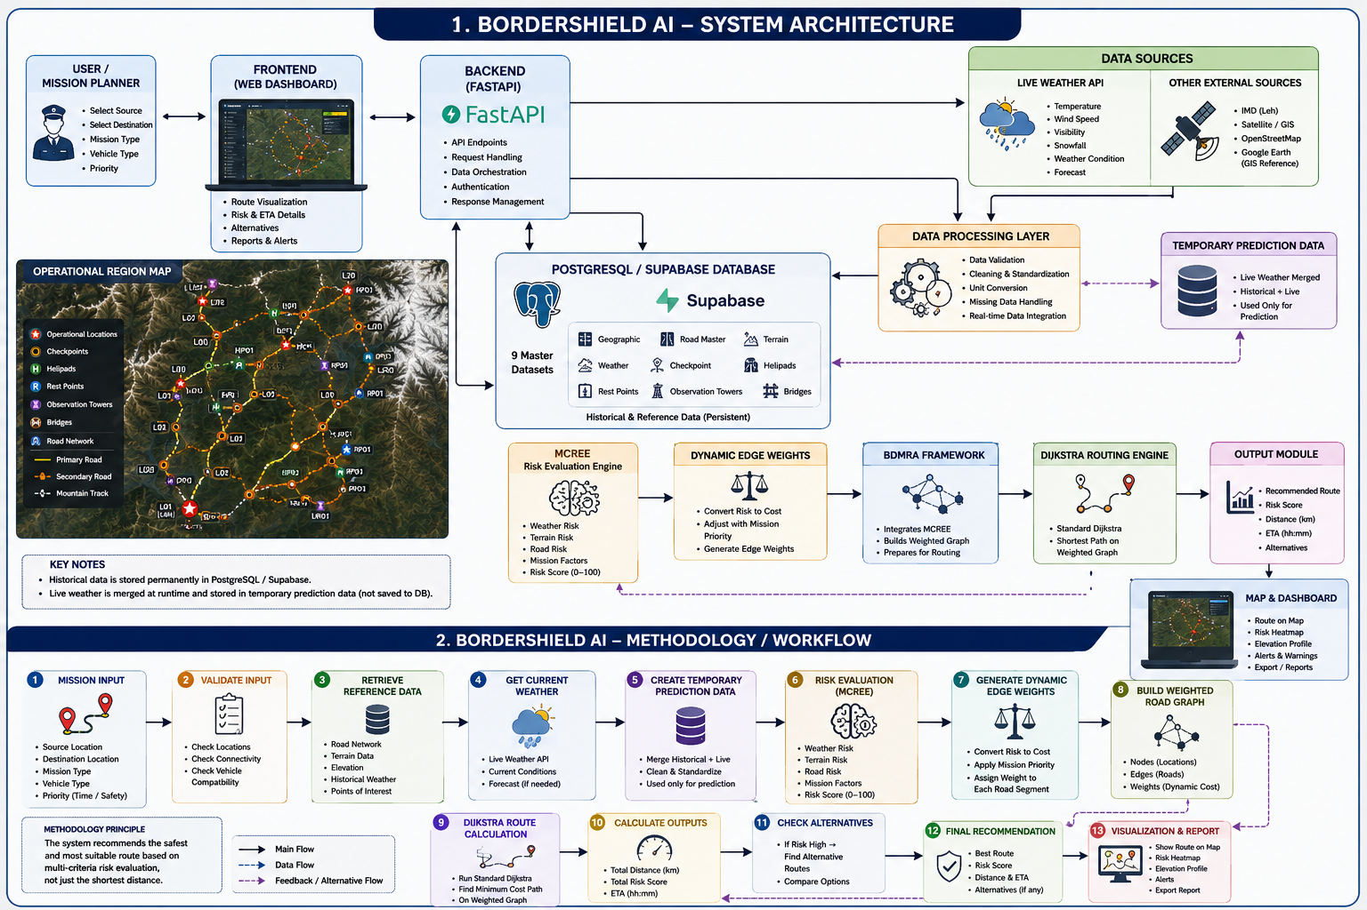
Figure 1. Overall BorderShield AI System Architecture and Methodology

14.1 Proposed Core Routing Framework — BDMRA
The BorderShield Dynamic Multi-Criteria Routing Algorithm (BDMRA) is a project-specific hybrid routing framework. It is not presented as a newly invented shortest-path algorithm. It combines the Multi-Criteria Risk Evaluation Engine (MCREE), dynamic edge-weight generation, weighted graph construction and the Standard Dijkstra shortest-path algorithm.
Project technical basis: the uploaded BDMRA design explicitly defines MCREE as the operational evaluation component and Standard Dijkstra as the core route-computation algorithm. fileciteturn3file0L1-L24

14.2 MCREE
- Reads the relevant operational datasets.
- Evaluates multiple risk/operational factors for each road segment.
- Produces a dynamic operational cost.
- The dynamic cost becomes the edge weight for routing.
- Risk evaluation and path computation remain separate modules.

14.3 Dynamic Data Principle
Historical/reference values remain in PostgreSQL. When live weather is available, the current values are merged into temporary in-memory working data for the prediction. The historical database is not overwritten by live values.

14.4 Detailed System, Data and Routing Architecture

The following diagram provides a detailed representation of the BorderShield AI system, including its geographic and GIS reference layer, nine master datasets, MCREE risk evaluation, BDMRA routing framework, dynamic weather handling, and end-to-end processing workflow.

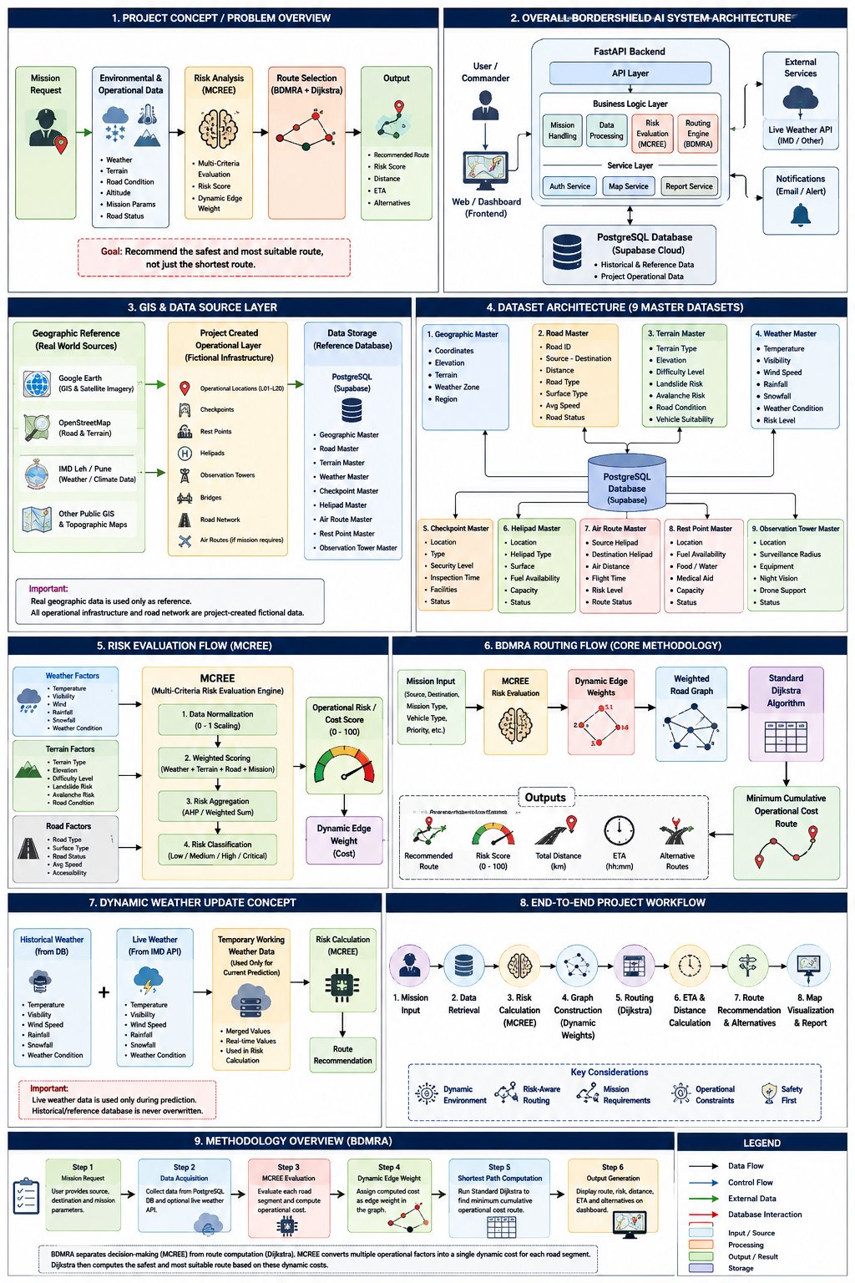
Figure 2. Detailed BorderShield AI Technical Architecture, Data and Routing Workflow

Figure 2 shows how the project's geographic references, project-created operational data and validated datasets are integrated into the PostgreSQL/Supabase database. During prediction, available live weather information is combined with reference data in temporary working data. MCREE evaluates the relevant operational factors and generates dynamic edge costs, which are used to construct the weighted road graph. Standard Dijkstra then computes the minimum cumulative operational-cost route, after which route risk, distance, ETA and alternatives are presented through the dashboard.

15. Algorithm Selection Summary
Algorithm / Approach | Decision | Reason
BFS | Rejected | Designed for unweighted graphs; cannot represent varying operational edge costs.
DFS | Rejected | Does not guarantee an optimal weighted route.
Bellman-Ford | Rejected | Negative edge weights are unnecessary; higher complexity for this positive-cost graph.
Floyd-Warshall | Rejected | All-pairs computation is unnecessary for individual source-to-destination mission requests.
A* | Not Selected | Heuristic complexity is not justified for the current approximately 20-node operational network.
Multi-Criteria Path Planning | Adopted as decision strategy | Used to evaluate multiple operational criteria before route computation.
Standard Dijkstra | Selected | Reliable weighted shortest-path algorithm suitable for the current positive-cost graph.
BDMRA | Proposed framework | Combines MCREE + dynamic edge weights + weighted graph + Standard Dijkstra.

16. Expected Outcomes
- A validated PostgreSQL reference database containing the project's finalized datasets.
- A connected graph representation of the defined operational road network.
- Dynamic risk/operational-cost evaluation for route segments.
- Risk-aware route recommendation rather than distance-only routing.
- Route distance and ETA outputs.
- Alternative route recommendations when the preferred route becomes unsuitable.
- GIS-based visualization of the selected route and relevant operational information.
- A modular software architecture suitable for team development, testing and deployment.

17. Technology and Development Baseline
Component | Selected Technology / Approach
Database | PostgreSQL
Cloud database | Supabase-hosted PostgreSQL
Backend | Python + FastAPI
Version control | Git + GitHub
Routing | Standard Dijkstra
Decision engine | MCREE
Routing framework | BDMRA
GIS / map layer | Project GIS/map interface
Reference data | Validated project datasets + public geographic/weather sources
Real-time data | Optional live weather API; temporary prediction-time use

18. Document Freeze Status
This document is intended to serve as the official initial baseline for the BorderShield AI project. The project title, four-line problem statement, primary objective, eight objectives, scope, limitations, dataset philosophy, literature-survey structure and proposed high-level routing architecture should be treated as the baseline for subsequent requirement, database, backend, AI and frontend development.
- The mathematical risk formula is not frozen in this initial document.
- Final risk weights and thresholds will be defined in the AI/Methodology phase after research and testing.
- Implementation-specific details may be refined without changing the project problem, objectives or scope.
- Any later change that affects the problem statement, objectives or project scope should be reviewed as a requirements change.

19. References — Initial Research and Context Sources
- Sohrabi, S. & Lord, D. (2022). Navigating to safety: Necessity, requirements, and barriers to considering safety in route finding. Transportation Research Part C. https://www.sciencedirect.com/science/article/pii/S0968090X21005246
- Tian, et al. (2023). Driving risk-aversive motion planning in off-road environment. Expert Systems with Applications.
https://www.sciencedirect.com/science/article/pii/S0957417422024459
- Karlsson, et al. (2023). D+*: A risk aware platform agnostic heterogeneous path planner. Expert Systems with Applications.
https://www.sciencedirect.com/science/article/pii/S0957417422024277
- Sánchez-Ibáñez, et al. (2023). Optimal path planning using a continuous anisotropic model for navigation on irregular terrains. Intelligent Service Robotics.
https://link.springer.com/article/10.1007/s11370-022-00450-6
- Yoon, et al. (2024). Analysis of Terrain-Aware Optimal Path Planning Methods for Stable Off-Road Navigation.
https://pure.kaist.ac.kr/en/publications/analysis-of-terrain-aware-optimal-path-planning-methods-for-stabl/
- Liu, et al. (2024). Improved A* Algorithm for Mobile Robots under Rough Terrain Based on Ground Trafficability Model and Ground Ruggedness Model. Sensors.
https://www.mdpi.com/1424-8220/24/15/4884
- Wang, et al. (2024). Multi-Objective Route Planning Model for Ocean-Going Ships Based on Bidirectional A-Star Algorithm Considering Meteorological Risk and IMO Guidelines. Applied Sciences. https://www.mdpi.com/2076-3417/14/17/8029
- Nuñez, et al. (2024). Risk-aware stochastic ship routing using constrained continuous belief tree search. Ocean Engineering.
https://www.sciencedirect.com/science/article/pii/S0029801824029196
- Dixit, et al. (2024). STEP: Stochastic Traversability Evaluation and Planning for Risk-Aware Navigation. IEEE Transactions on Field Robotics.
https://doi.org/10.1109/TFR.2024.3512433
- India Meteorological Department. Meteorological Centre Leh.
https://mausam.imd.gov.in/leh/
- India Meteorological Department. Ladakh Hazard Profile. https://mausam.imd.gov.in/leh/pdf/hazard_profile.pdf

- Border Roads Organisation. Project Himank.
https://www.bro.gov.in/himank
- Press Information Bureau / Government of India. BRO and Ladakh connectivity context. https://www.pib.gov.in/PressReleaseIframePage.aspx?PRID=2016417&lang=2&reg=48
- Google Earth. Google Earth — Geographic and Satellite Imagery Reference Platform. Google. Available at: https://earth.google.com/

