TRIP3D

To do this, I am going to write a new start.points.in in the directory /fusion/projects/results/trip3d/sweeneyrm/ specifying the starting points for field lines along the SPI trajectory. The format for the start.points.in was described by Todd Evans in an email Oct. 1, 2008.

You can create a file called ‘start.points.in’ with provides the starting coordinates for each field line to be traced. The format of this file is:

- the first line has 3 integers - the total number of field lines to be followed, number of surfaces and number of lines per surface

- the other lines have coordinates of starting points in r (m), theta (deg), phi (deg)

For making a Poincare plot at the interferometer at 105 degrees:

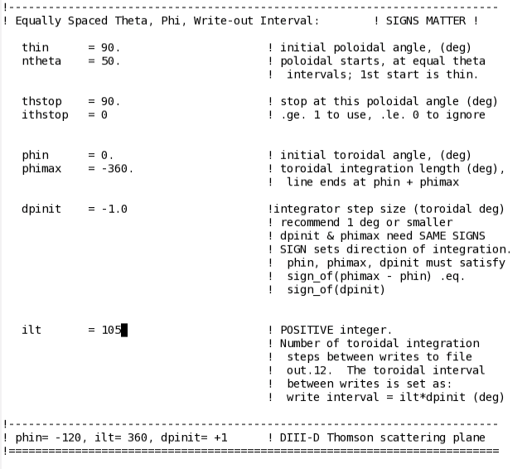

Running the file is described by the README.trip3d in /fusion/projects/codes/trip3d/. Note that this README is different from the one that comes in the generic template folder, like the one in my results directory.

sbatch --export=CODE=trip3d /fusion/projects/codes/trip3d/scripts/run.sh