Mississippi State University Software Engineering Management

Software Architecture Document

Version 1.2

Team Ano Yo

Alexander Howington
David Giametta
Lona Smith

Revision History
Date | Version | Description | Author
02/12/09 | 1.0 | Collaboration Diagrams 2.2.2.1 – 2.2.2.13 | Alex Howington  Brian Pace  David Giametta  Lona Smith
02/16/09 | 1.0 | Collaboration Diagrams 2.2.2.4 - 2.2.2.13 | David Giametta  Lona Smith
02/17/09 | 1.0 | Collaboration Diagrams 2.2.2.14 – 2.2.2.31 | Alex Howington  David Giametta  Lona Smith
02/17/09 | 1.0 | Sections 1.0, 2.1.3, 2.3 | David Giametta
02/17/09 | 1.0 | Sections 2.1.2, 2.5 | Alex Howington
02/17/09 | 1.0 | Sections 2.1.1, 2.2.1, 2.6 | Lona Smith
02/21/09 | 1.1 | Sections 2.2.2.1, 2.2.2.12-2.2.2.21 collaboration diagram descriptions, Class diagrams | Lona Smith
02/24/09 | 1.1 | Sections 2.2.2.2-2.2.2.11 | David Giametta
02/24/09 | 1.1 | Sections 2.2.2.22-2.2.2.31 | Alex Howington
03/12/09 | 1.2 | Changes to sections 2.2.2.1 – 2.2.2.31 | Lona Smith
3/12/09 | 1.2 | Sections 2.3 and 2.5 | Lona Smith
3/12/09 | 1.2 | Sections 2.2.1-2.2.3 Descriptions | David Giametta

Table of Contents

1.1 Purpose 4
1.2 Scope 4
1.3 Definitions, Acronyms, and Abbreviations 4
1.5 Overview 4
2. Architectural Representation 4
2.1 Static Structural Model 4
2.1.1 Architectural Model 5
2.1.2 Subsystem Models 5
2.1.3 Hardware Configuration 5
2.2 Dynamic Process Model 5
2.2.1 Overview 5
2.2.2 Significant Dynamic Models 5
2.3 Interface model 26
The relationship between MSU SEM and the database consists of the PC with MSU SEM constantly inheriting from the database stored on Pluto. 26
2.4 Relationship model 26
2.5 Distribution Model 26
2.6 Implementation View 27
3.4 Database Design 30
Database Functions: 30
Database Creation: 31

Software Architecture Documentation

1. Introduction

Purpose
This document is intended for future software engineering students of the Mississippi State University Computer Science and Engineering Department. This document will describe how to test MSU SEM software for errors and how it will benefit software engineering teams.

Scope
This document should be used as a guideline for creating required functionality in our software.

Definitions, Acronyms, and Abbreviations
Throughout this document the MSU Software Engineering Management software will be referred to by its abbreviation, MSU SEM.

1.4 References
1.4.1 SDD Template
https://mycourses.msstate.edu/webct/cobaltMainFrame.dowebct?appforward=/webct/startFrameSet.dowebct%3Fforward=manageCourse.dowebct%26lcid=155943956011

1.4.2 IEEE SDD example
This document was provided to us on MSU my courses.

1.4.3 Notes
These include notes taken during CSE 4214 (Intro to Software Engineering) or guidelines given during lab.

1.5 Overview
This document describes the relationships between our classes, the relationship between a users computer and the program and, the relationships of the users and the network.

Architectural Representation

Static Structural Model

Architectural Model
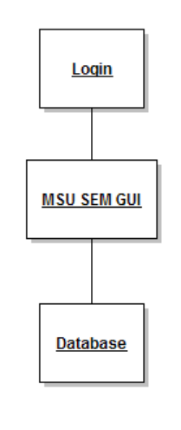
There are three basic steps in our architectural model: the login page, the MSU SEM GUI and the database. First, when starting the program the user is prompted to login at the login page, then the MSU SEM GUI appears which in turn constantly accesses the database.

Subsystem Models
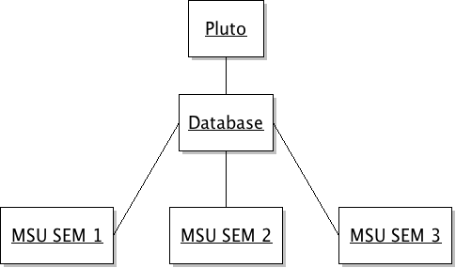
In our Subsystem Model Pluto serves as a host for the database which can be accessed by multiple MSUSEM GUI's.

Hardware Configuration

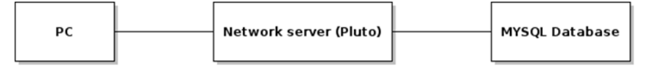
In our Hardware Configuration Model a PC connects to the network server, Pluto, in order access the database.

Dynamic Process Model

Overview
See Mississippi State University Software Engineering Management Software Requirements Specification For: Introduction to Software Engineering version 1.0 use cases 3.1.1 through 3.1.32.

Significant Dynamic Models

2.2.2.1 Login
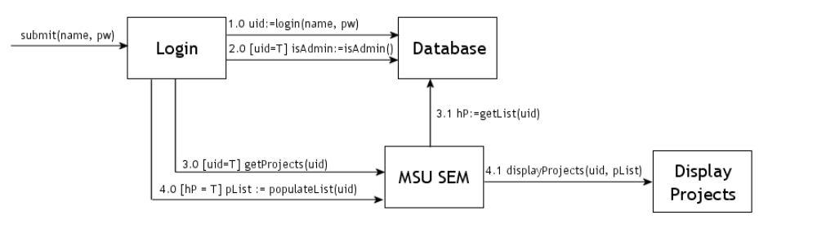
User requests Login to submit his account information (username and password) and to log him into the system.
Login sends a message to login to the database wtih the username and password and sets uid ←positive if information is retrieved, negative if not retrieved
If(user exists):Login sends message isAdmin to Database to see if the user is the administrator
Login sends message getProjects to MSUSEM to populate the list of projects for the user.
MSU SEM sends message getList to the Database to get a list of the user’s projects
If(user has projects)
Login requests to populateList to get populate the list of projects
MSU SEM then sends message to displayProjects to display the user’s projects
If(user has no projects)
MSU SEM displays no projects for the user
If(user does NOT exist): MSU SEM displays an error message to the user that he could not be logged in

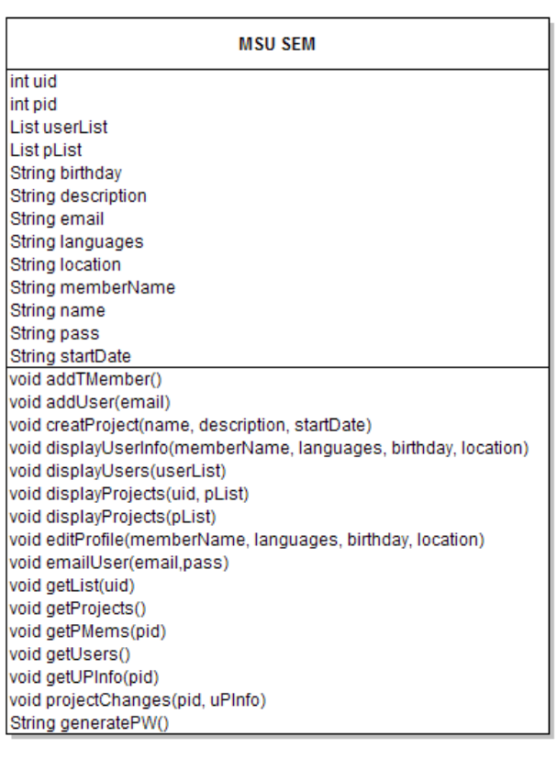
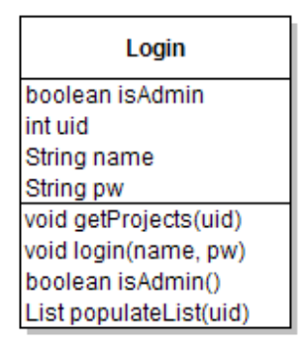

2.2.2.2 Create Account
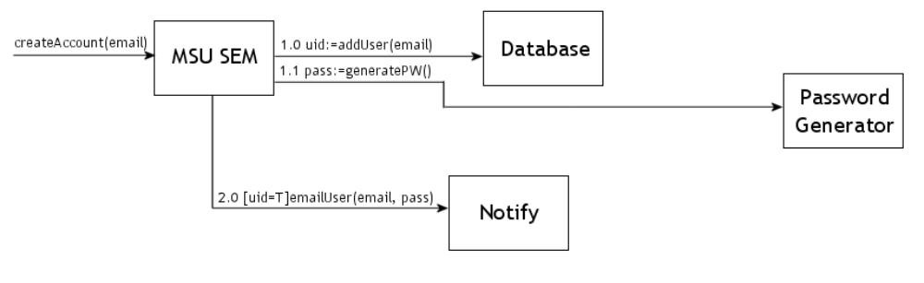
User requests MSUSEM to create an account using (email) and store them in the system.
MSUSEM sends message addUser and returns uid from the Database←positive if information is retrieved, negative if not retrieved. If uid is positive EmailUser will pass (email, pass) to Notify.
MSUSEM generates a password to e-mail to the user.
If(account was created):
MSUSEM sends message emailUser and passes (email, pass) to Notify.
If(user does NOT exist): MSU SEM displays an error message to the user Account was not created

2.2.2.3 Remove Account
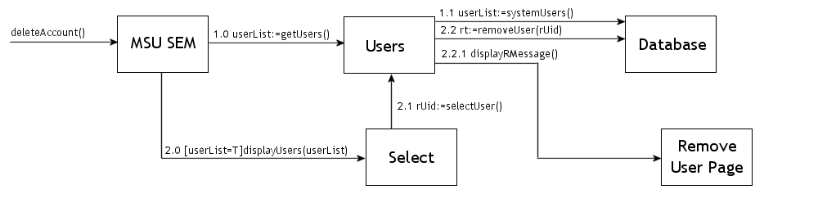
User requests MSUSEM to delete an account from the system.
MSUSEM sends a message getUsers to Users and sets userList ←to something if information is retrieved, null if not retrieved. If the user list is not null displayUsers will pass (userList) to Select. MSUSEM sends message selectUser to Select and sets rUid equal to rt. Users sends message removeUser with (rUid) and sets rt equal to true if the user is removed from the database and false if not.
MSUSEM sends message getUsers and sets userList equal to the result from the Users.
Users sends message systemUsers and sets userList equal to the result from the Database.
If(userList is not Null)
MSUSEM sends message displayUsers with (userList) to Select.
Select sends message selectUser to Users and sets rUid to the result.
Users sends message removeUser with (rUid) to the Database and sets rt to true if successful or false if not.
If(rt = true):
MSUSEM sends a message displayRMessage to Remove User Page .
If(rt = false): MSU SEM displays an error message to the user User was not removed.

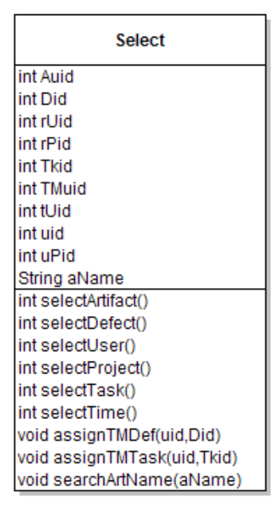
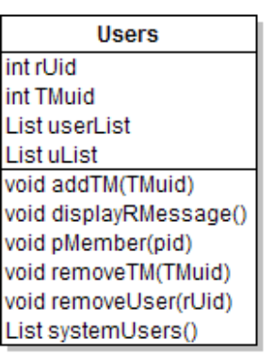

2.2.2.4 Update Account
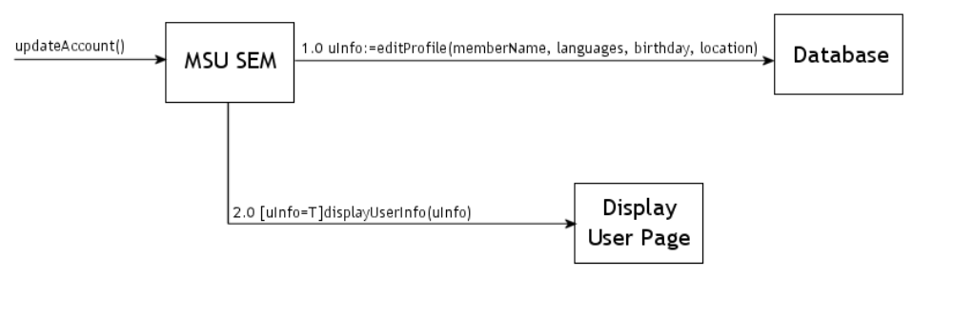
User requests MSUSEM to update an account in the system.
MSUSEM sends message editProfile to the Database with (memberName, languages, birthday, location) and sets uinfo to a positive value if information is retrieved.
If(uinfo is not Null)
MSUSEM sends message displayUserInfo with (uinfo) to Display User Page.
If(uinfo is null): MSU SEM displays an error message to the user User was not updated.

2.2.2.5 Create Project
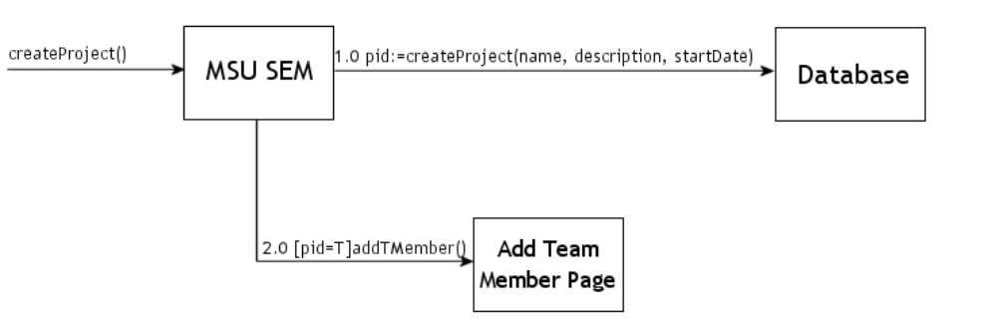
User requests MSUSEM to create a project in the system.
MSUSEM sends message createProject with (name, description, startDate) and sets pid equal to the value obtained from the Database.
If(pid is not null):
MSUSEM sends message addTMember to Add Team Member Page.
If(uinfo is null): MSU SEM displays an error message to the user Project was not created.

2.2.2.6 Remove Project

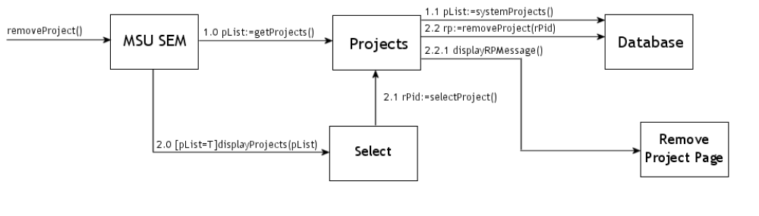
User requests MSUSEM to remove a project from the system.
MSUSEM sends message getProjects and sets pList equal to the result from the Projects.
Projects sends message systemProjects and sets pList equal to the result from the Database.
If(pList is not Null)
MSUSEM sends message displayProjects with (pList) to Select.
Select sends message selectProject to Users and sets rPid to the result.
Projects sends a message removeProject with (rPid) to Database.
Projects sends message displayRPMessage to the remove project page.
If(pList is null): MSU SEM displays an error message to the user Project was not removed.

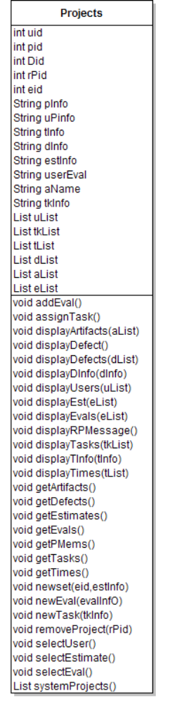
2.2.2.7 Update Project
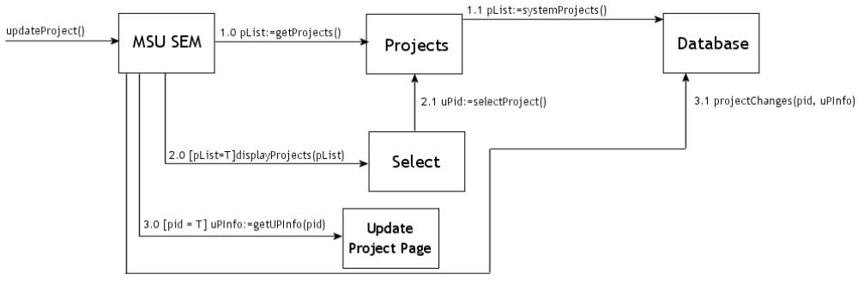
User requests MSUSEM to update a project in the system.
MSUSEM sends message getProjects and sets pList equal to the result from the Users.
Users sends message systemProjects and sets pList equal to the result from the Database.
If(pList is not Null)
MSUSEM sends message displayProjects with (pList) to Update Project Page.
MSUSEM sends message selectProject to Users and sets uPid equal to the result.
MSUSEM sends message getUPInfo with (pid) to Users and sets uPInfo equal to the result.
Users sends message projectChanges with (pid, uPInfo) to the Database.
If(uinfo is null): MSU SEM displays an error message to the user Project was not updated.

2.2.2.8 Add Team Member
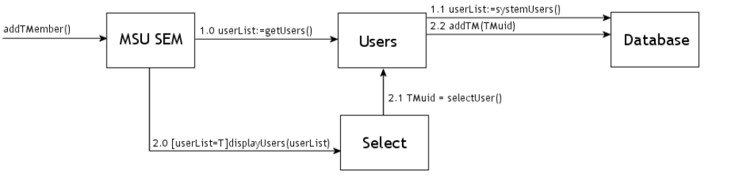
User requests MSUSEM to add a team member to a project.
MSUSEM sends a message getUsers to Users and sets userList ←to something if information is retrieved, null if not retrieved.
MSUSEM sends message getUsers and sets userList equal to the result from the Users.
Users sends message systemUsers and sets userList equal to the result from the Database.
If(userList is not Null)
MSUSEM sends message displayUsers with (userList) to Select.
Select sends message selectUser to Users and sets TMuid to the result.
Users sends message addTM with (TMuid) to the Database.
If(userList is Null): MSU SEM displays an error message to the user User was not added to the Project.

2.2.2.9 Remove Team Member
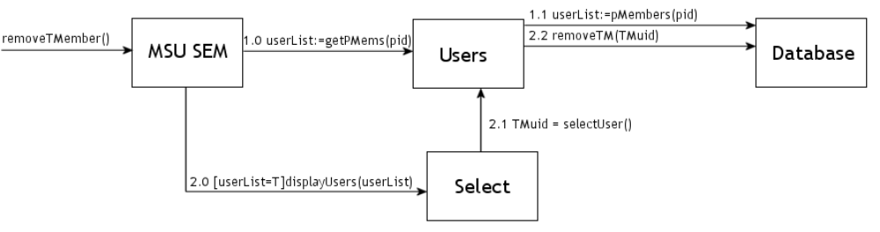
User requests MSUSEM to remove a team member from a project.
MSUSEM sends a message getPMems with (pid) to Users and sets userList ←to something if information is retrieved, null if not retrieved.
MSUSEM sends message getPMems with (pid) and sets userList equal to the result from the Users.
Users sends message pMembers with (pid) and sets userList equal to the result from the Database.
If(userList is not Null)
MSUSEM sends message displayUsers with (userList) to Select.
Select sends message selectUser to Users and sets TMuid to the result.
Users sends message removeUser with (TMuid) to the Database
If(userList is Null): MSU SEM displays an error message to the user Team Member was not removed.

2.2.2.10 View Time
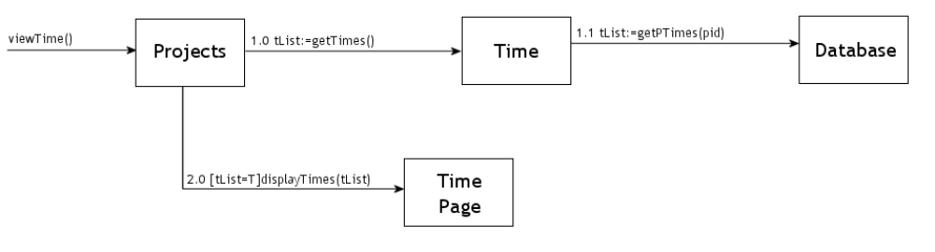
Team Member requests view time submited.
Projects sends a message to getTimes and sets tList equal to it. If tList is not null Projects sends message displayTimes with (tList) to Time Page.
Projects sends message getTimes to Time and sets tList equal to the result.
Time sends message getPTimes with (pid) to the Database and sets tList equal to the result.
If (tList is not Null)
Projects sends message displayTimes with (tList) to Time Page.
If (tList is Null): MSU SEM displays an error message to the user Time cannot be viewed or there is no time to be viewed.

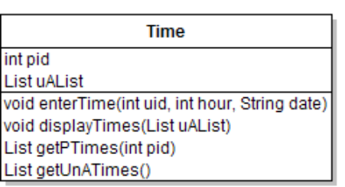

2.2.2.11 Submit Time
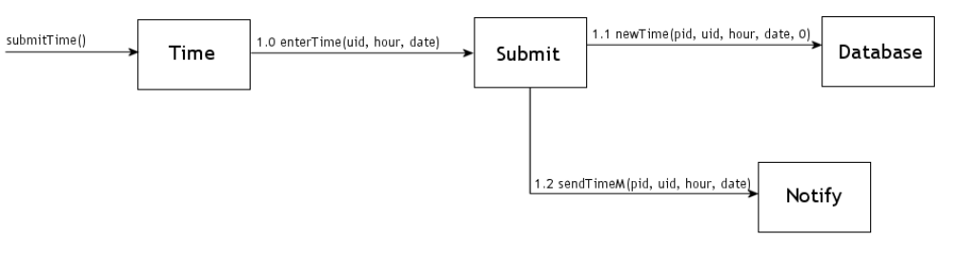
Team Member requests Time to submit his time records.
Time sends a message to enter the uid, hour, and date to Submit
Submit sends a message to set newTime to the Database with the pid, uid, hour, date, and 0 (flag for unapproved time)
Submit sends message sendTimeM to Notify to send a message to the project manager that a team member has entered a new time

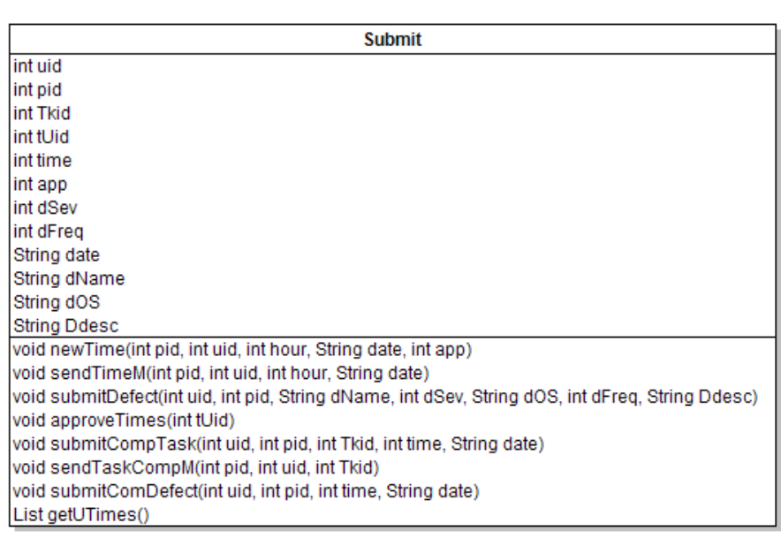

2.2.2.12 Approve Time
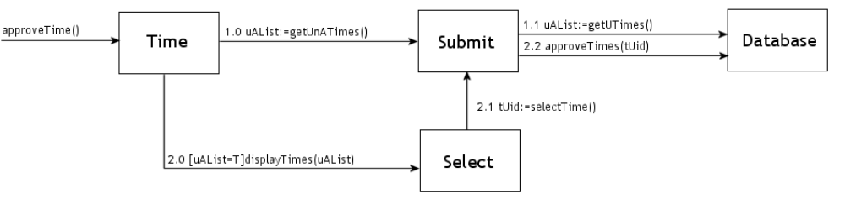

The Administrator or Project Manager requests Time to approve a team member’s time.
Time sends a message to getUnATimes to Submit and set uAList ←contains data if there are unapproved times, is null if there are no unapproved times
Submit sends a message to getUTimes to the Database and returns the list of unapproved times
If(there are unapproved times):Time sends message displayTimes to Select to display a list of unapproved times
Select sends message selectTime to Submit that returns a positive tUID if a time is selected
Submit sends message approveTimes to Database to approve the selected time with the given tUid
If(there are NO unapproved times): MSU SEM displays an error message that there are no unapproved times

2.2.2.13 View Task
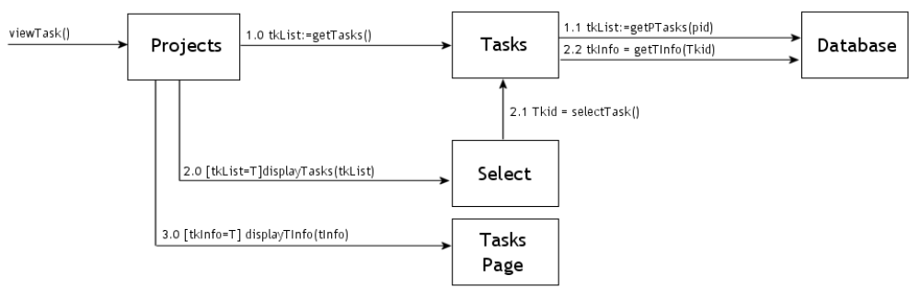
User requests Projects to view project tasks.
Projects sends a message to getTasks to Tasks and sets tkList ←contains data if there are tasks, is null if there are no project tasks
Tasks sends a message to getPTasks to the Database with the project’s id and returns a list of all of the project tasks
If(there are project tasks):Projects sends message displayTasks to Select to display the project’s tasks
Select sends message selectTask to Tasks that returns a positive Tkid if a task is selected
Projects sends message getTInfo to Database to get information about a task and set tkInfo←contains data if there is information on that task, is null if there is no information
Projects sends message displayTInfo if there is information on the task to Tasks Page to display the task information
If(there are NO project tasks): MSU SEM displays an error message to the user that there are no project tasks

2.2.2.14 Create Task
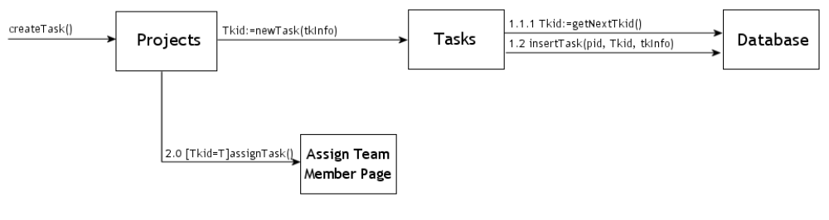
Administrator or Project Manager requests Projects to create a project task.
Projects sends a message newTask to Tasks and sets Tkid←positive if a new task can be created, negative if there was an error creating a project task
Tasks sends a message to getNextTkid to the Database to get the next task id and returns it
Tasks sends message insertTask to the Database to insert the new task in the database with pid, Tkid, and tkInfo.
If(the task id is positive): Projects sends message assignTask to Assign Team Member Page so that the administrator or project manager can then select a team member to assign a task to
If(there are NO project tasks): MSU SEM displays an error message that the new task could not be created

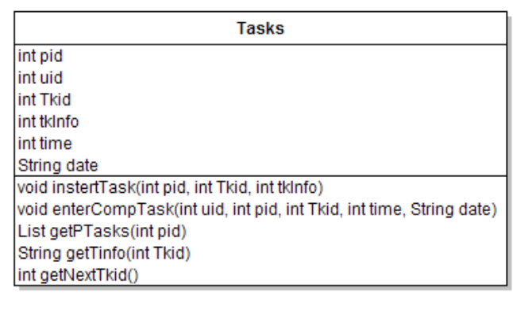

2.2.2.15 Report Completed Task
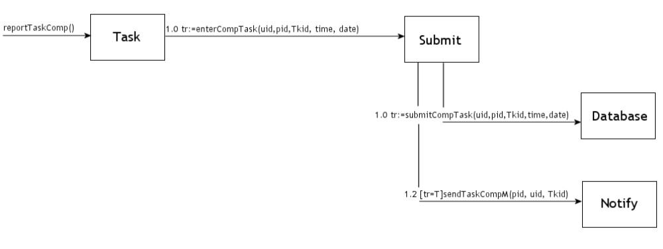
Team Member requests Tasks to report a task as completed.
Tasks sends a message enterCompTask to Submit and sets tr←positive if a task can be reported as completed, negative if it can’t
Submit sends a message to submitCompTask to the Database and returns tr
If(the task was reported as completed): Submit sends message sendTaskCompM to Notify to send a message about the task being marked as completed
If(the task was NOT reported as completed): MSU SEM displays an error message that the new task could marked as completed

2.2.2.16 Assign Task
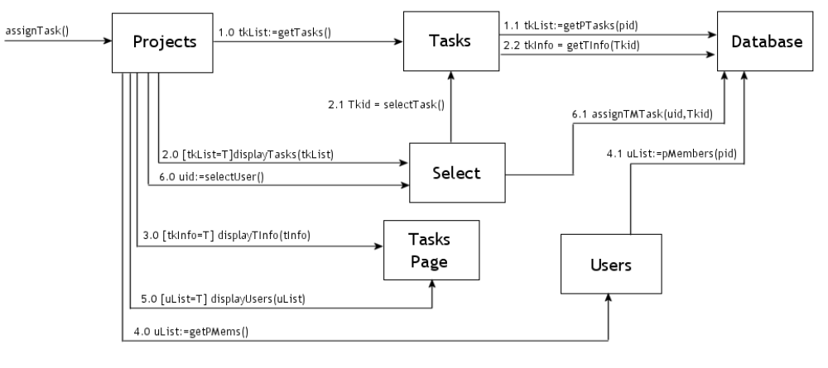
Administrator or Project Manager requests Projects to assign a task to a team member.
Projects sends message getTasks to Tasks to request for a list of tasks, tkList ← contains data if a list can be retrieved, null if data cannot
Tasks sends a message to getPTasks to the Database and returns a list of project tasks, tkList if the project with the given pid has tasks
If(tasks exist): Projects sends message displayTasks to Select to display a list of the project tasks
Select sends message selectTask to Tasks that returns a positive Tkid if a task is selected
Projects sends message getTInfo to Database to get information about a task and set tkInfo←contains data if there is information on that task, is null if there is no information
Projects sends message displayTInfo if there is information on the task to Tasks Page to display the task information
If(task contains information):Projects sends message displayTInfo to Tasks Page to display information about the selected task
Projects sends message getPMems to Users and returns uList← contains data if a list can be retrieved, null if data cannot
Users sends message pMembers to Database and returns a list of users of the project with the given pid
If(there are users of the project): Projects sends message displayUsers to Tasks Page to display a list of project users
Projects sends message selectUser to Select that returns a positive uid if a user is selected.
Select sends message assignTMTask to the Database to assign a task to a team member with the user’s uid and the task’s Tkid
If(there are NO users of the project): MSU SEM displays an error message that there are no users of the project.
If(task has NO information): MSU SEM displays an error message that the task has no information associated with it.
If(NO tasks exist): MSU SEM displays an error message that there are no tasks to assign a team member to

2.2.2.17 View Defect
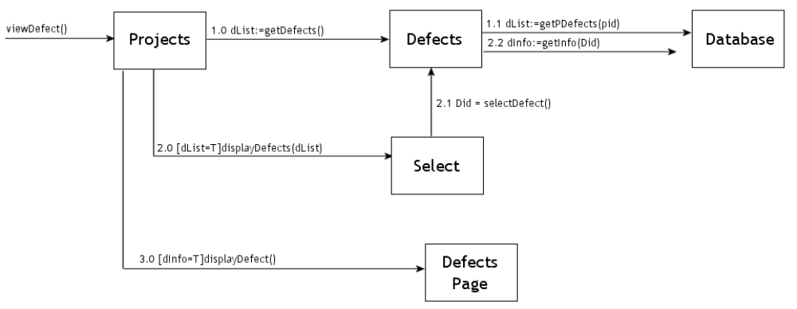
User requests Projects to view project defect.
Projects sends a message to getDefects to Defects and sets dList ←contains data if there are defects, is null if there are no project defects
Defects sends a message to getPDefects to the Database with the project’s id and returns a list of all of the project defects
If(there are project defects):Projects sends message displayDefects to Select to display the project’s defects
Select sends message selectDefect to Defects that returns a positive Did if a defect is selected
Projects sends message getDInfo to Database to get information about a defect and set dInfo←contains data if there is information on that defect, is null if there is no information
Projects sends message displayDefect if there is information on the defect to Defects Page to display the defect information
If(there are NO project defects): MSU SEM displays an error message to the user that there are no project defects
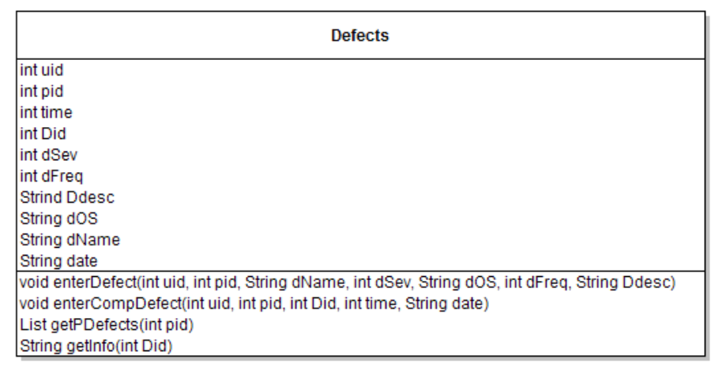

2.2.2.18 Assign Defect

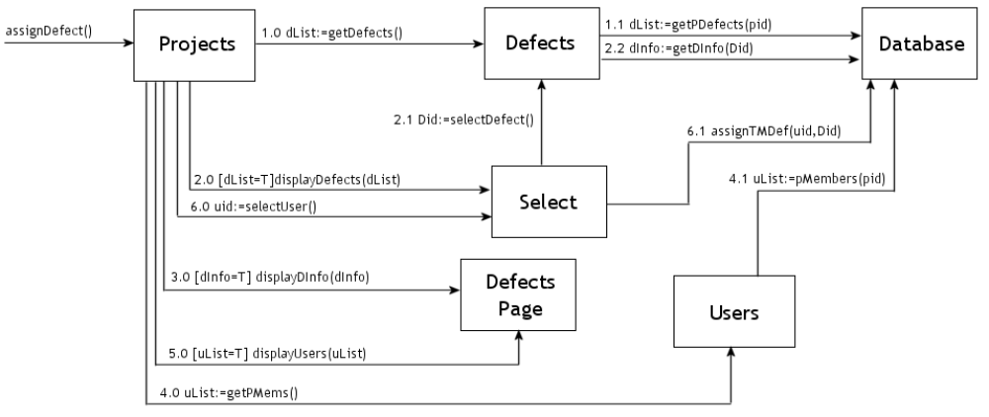
Administrator or Project Manager requests Projects to assign a defect to a team member.
Projects sends message getDefects to Defects to request for a list of defects, dList ← contains data if a list can be retrieved, null if data cannot
Defects sends a message to getPDefects to the Database and returns a list of project defects, dList if the project with the given pid has defects
If(defects exist): Projects sends message displayDefects to Select to display a list of the project defects
Select sends message selectDefect to Tasks that returns a positive Did if a defect is selected
Projects sends message getDInfo to Database to get information about a defect and set dInfo←contains data if there is information on that defect, is null if there is no information
Projects sends message displayTInfo if there is information on the defect to Defects Page to display the defect information
If(defect contains information):Projects sends message displayDInfo to Defects Page to display information about the selected defect
Projects sends message getPMems to Users and returns uList← contains data if a list can be retrieved, null if data cannot
Users sends message pMembers to Database and returns a list of users of the project with the given pid
If(there are users of the project): Projects sends message displayUsers to Defects Page to display a list of project users
Projects sends message selectUser to Select that returns a positive uid if a user is selected.
Select sends message assignTMDef to the Database to assign a defect to a team member with the user’s uid and the defect’s Did
If(there are NO users of the project): MSU SEM displays an error message that there are no users of the project.
If(defect has NO information): MSU SEM displays an error message that the defect has no information associated with it.
If(NO defects exist): MSU SEM displays an error message that there are no defects to assign a team member to

2.2.2.19 Report Defect
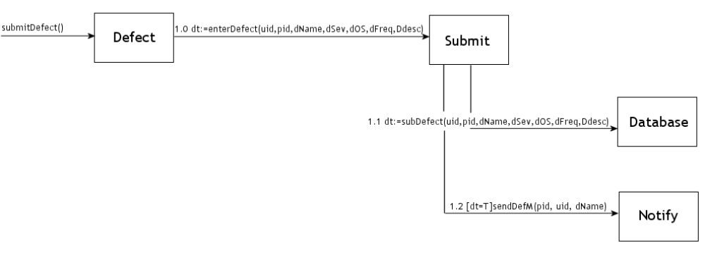
User requests Defects to submit a defect.
Defects sends message enterDefect to Submit and returns dt ← positive if a defect can be submitted with the given information, negative if it cannot
Submit sends a message to subDefect to the Database with the given information
If(defect was submitted): Submit sends message sendDefM to Notify to send a message to the project manager or administrator about a defect being submitted
If(defect was NOT submitted): MSU SEM displays an error message that the defect could not be submitted

2.2.2.20 Report Defect Fix
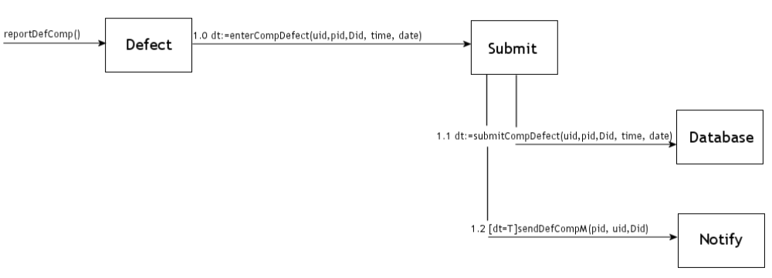
Team Member requests Defects to report a defect as completed.
Defects sends message enterCompDefect to Submit and returns dt ← positive if a defect can be reported as completed with the given information, negative if it cannot
Submit sends a message to subCompDefect to the Database with the given information
If(defect fix was submitted): Submit sends message sendDefComM to Notify to send a message to the project manager or administrator about a defect fix being submitted
If(defect fix was NOT submitted): MSU SEM displays an error message that the defect fix could not be submitted

2.2.2.21 View Artifact
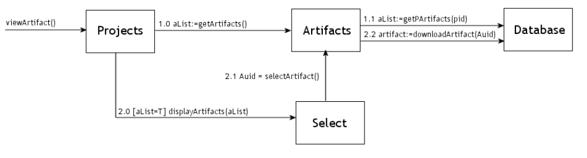
User requests Projects to view project artifact.
Projects sends a message getArtifacts to Artifacts and aList ←contains data if there are artifacts, is null if there are no project artifacts
Artifacts sends a message getPArtifacts to the Database with the project’s id and returns a list of all of the project artifacts
If(there are project artifacts):Projects sends message displayArtifacts to the Select to display the project’s artifacts
Select sends message selectArtifact to Artifacts that returns a positive Auid if an artifact is selected
Artifacts sends message downloadArtifact to Database to download an artifact and artifact←contains data if there is information on that artifact, is null if there is no information
If(there are NO project artifacts): MSU SEM displays an error message to the user that there are no project artifacts

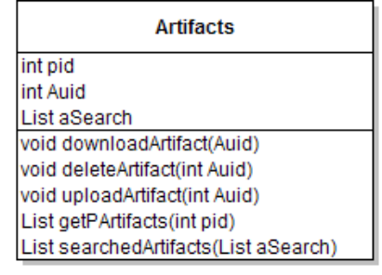

2.2.2.22 Search Artifacts
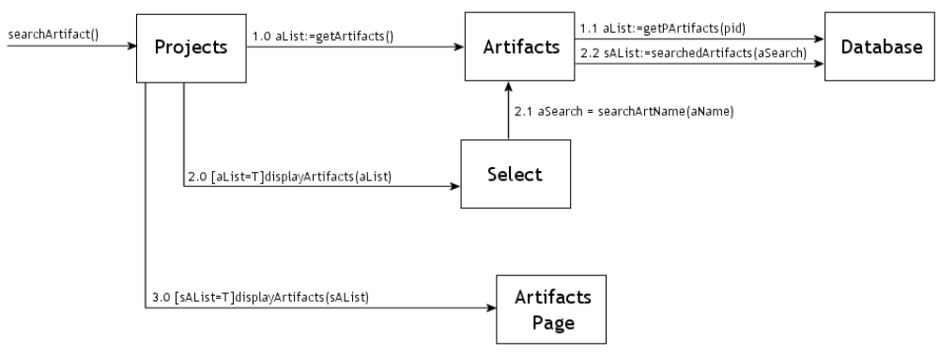

User requests Projects to search for a project artifact.
Projects sends a message getArtifacts to Artifacts and sets aList ←contains data if there are artifacts, is null if there are no project artifacts
Artifacts sends a message to getPArtifacts to the Database with the project’s id and returns a list of all of the project artifacts
If(there are project artifacts):Projects sends message displayArtifacts to the Select to display the project’s artifacts
Select sends message searchArtName to Artifacts that returns a positive aSearch if an artifact is found
Artifacts sends message searchedArtifacts to Database to download an artifact’s information and sAList←contains data if there is information on that artifact, is null if there is no information
if(there is a found artifact):Projects sends a message displayArtifacts to the Artifacts Page to display the found artifact
If(there are NO project artifacts): MSU SEM displays an error message to the user that there are no project artifacts

2.2.2.23 Delete Artifact
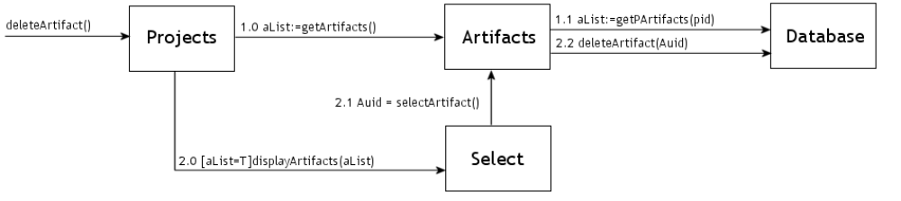
User requests Projects to delete an artifact.
Projects sends a message getArtifacts to Artifacts and sets aList ←contains data if there are artifacts, is null if there are no project artifacts
Artifacts sends a message to getPArtifacts to the Database with the project’s id and returns a list of all of the project artifacts
If(there are project artifacts):Projects sends message displayArtifacts to the Select to display the project’s artifacts
Select sends message selectArtifact to Artifacts that returns a positive Auid if an artifact is found
Artifacts sends message deleteArtifact to Database to delete the selected artifact
If(there are NO project artifacts): MSU SEM displays an error message to the user that there are no project artifacts

2.2.2.24 Submit Estimate
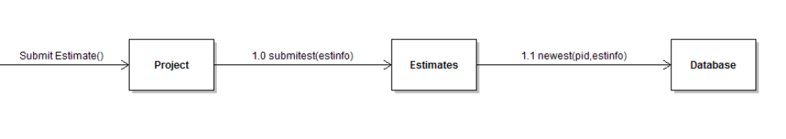
User requests Project to submit an estimate.
Project sends a message to submitest the estinfo to Estimates
Estimates sends a message newest to the Database with the pid and estinfo

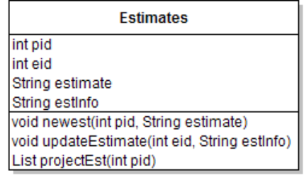

2.2.2.25 Update Estimate
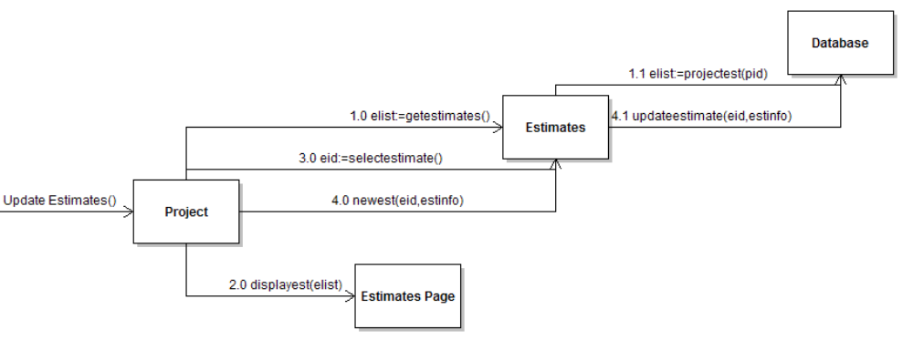
User requests Project to delete an artifact.
Project sends a message getestimates to Estimates and sets eList ←contains data if there are estimates, is null if there are no project estimates
Estimates sends a message projectest to the Database with the project’s id and returns elist of all of the project estimates
If(there are project estimates):Project sends message displayest to the Estimates Page to display the project’s estimates
Project sends message selectestimate to Estimates that returns the eid if an estimate is found
Project sends message newest to Estimates with eid and estinfo
Estimates sends message updateestimate to the Database with eid and estinfo
If(there are NO project estimates): MSU SEM displays an error message to the user that there are no project estimates

2.2.2.26 View Estimates
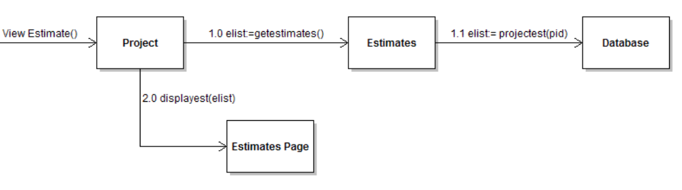
User requests Project to view project estimate.
Project sends a message getestimates to Estimates and elist ←contains data if there are estimates, is null if there are no project estimates
Estimates sends a message projectest to the Database with the project’s id and returns a list of all of the project estimates
If(there are project estimates):Project sends message displayest to the Estimates Page to display the project’s estimates in elist
If(there are NO project estimates): MSU SEM displays an error message to the user that there are no project estimates

2.2.2.27 Create Peer Evaluation
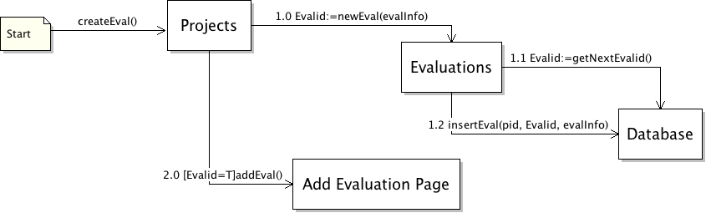

Administrator or Project Manager requests Projects to create new evaluation.
Project sends a message newEval to Evaluations and Evalid ←contains data if the evaluation is successfully entered into the database
Evaluations sends a message getNextEvalid to the Database, the result of which is stored in Evalid
Evaluations sends a message insertEval to the Database with pid, Evalid, and evalInfo
If(Evalid exists):Projects sends message addEval to the Add Evaluations Page to confirm that the evaluation was added to the database
If(Evalid does not exist): MSU SEM displays an error message to the user that the evaluation was not successfully saved

2.2.2.28 View Peer Evaluation
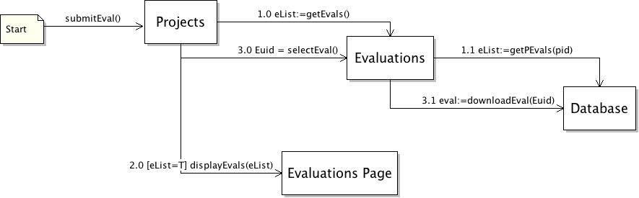
User requests Projects to view an evaluation.
Project sends a message getEvals to Evaluations and eList ←contains data if there are evaluations stored in the database, is null if there are no project evaluations
Evaluations sends a message getPEvals to the Database along with the project id and returns eList
if(there are project evaluations):Projects sends a message displayEvals with eList to the Evaluations Page
Projects sends a message selectEval to Evaluations which returns Euid
Evaluations sends message downloadEval to the Database which returns eval
If(there are NO project evaluations): MSU SEM displays an error message to the user that there are no project evaluations to view.

2.2.2.29 Submit Evaluation
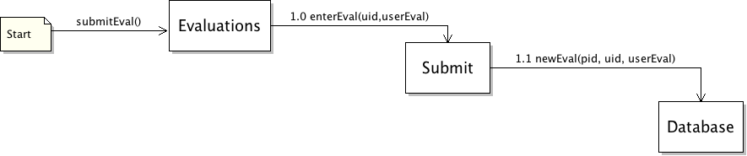
User requests Evaluations to submit an evaluation.
Evaluations sends a message enterEval to Submit with the uid and userEval
Submit sends a message newEval to the Database with the pid, uid, and userEval

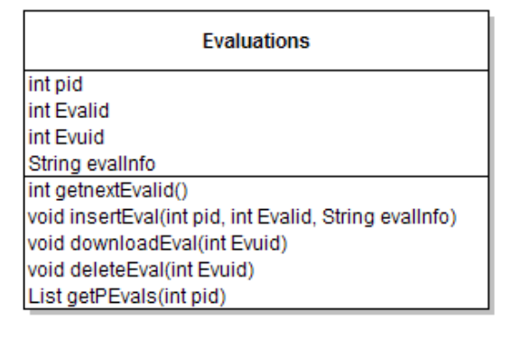
2.2.2.30 Delete Evaluation
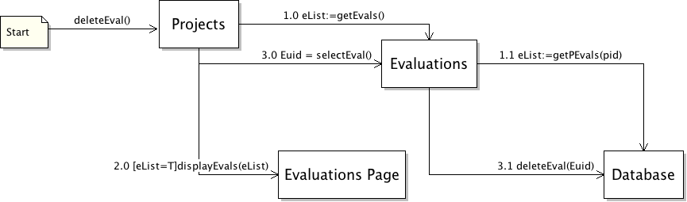
Administrator or Project Manager requests Projects to delete an evaluation.
Project sends a message getEvals to Evaluations and eList ←contains data if there are evaluations stored in the database, is null if there are no project evaluations
Evaluations sends a message getPEvals to the Database along with the project id and returns eList

if(there are project evaluations):Projects sends a message displayEvals with eList to the Evaluations Page
Projects sends a message selectEval to Evaluations which returns Euid
Evaluations sends message deleteEval to the Database with the Euid
If(there are NO project evaluations): MSU SEM displays an error message to the user that there are no project evaluations to view.

Interface model

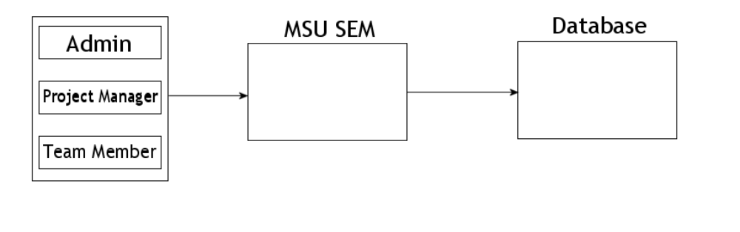
A user logs onto MSU SEM as an administrator, project manager, or team member. MSU SEM then connects to the database to collect information such as project information and user status information.

Relationship model

Distribution Model
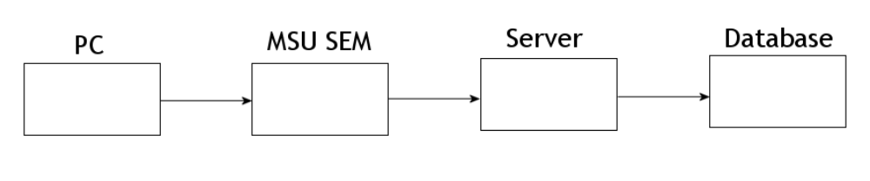

The relationship between MSU SEM and the database consists of the PC with MSU SEM constantly inheriting from the database stored on Pluto. The PC connects to MSU SEM; MSU SEM connects to the Pluto sever; the server connects to the database.

Implementation View

3.4 Database Design

Database Functions:
deleteArtifact(Auid)
deleteEval(Euid)
downloadEval(Euid)
getNextEvalid()
getPArtifacts(pid)
getPDefects(pid)
getPEvals(pid)
getDinfo(Did)
getPTasks(pid)
getTInfo(Tkid)
insertEval(pid,Evalid,evalInfo)
newest(pid,estInfo)
newEval(pid,uid,userEval)
projectEst(pid)
searchedArtifacts(aSearch)
subDefect(uid,pid,dName,dSev,dOS,dFreq,Ddesc)
submitCompDefect(uid,pid,Did,time,date)
submitCompTask(uid,pid,Tkid,time,date)
updateEstimate(eid,estinfo)
validate(name, pw)
isAdmin()
populateList(uid)
getNextID()
insertNewUser(uid, email, pass)
systemUsers()
removeUser(rUid)
getUserInfo(uid)
setInfo(uid, nInfo)
getNextPid()
insertProject(pid, pInfo)
systemProjects()
removeProject(rPid)
projectChanges(pid, uPInfo)
getInfo(pid)
status(pid, uid)
systemUsers()
addTM(TMuid)
pMembers(pid)
removeTM(TMuid)
getPTimes(pid)
newTime(pid, uid, hour, date, 0)
getUTimes()
approveTimes(tUid)
getPTasks(pid)
getTInfo(Tkid)
getNextTkid()
insertTask(pid, Tkid, tkInfo)

Database Creation:
CREATE TABLE `time` (
`tid` INT( 10 ) NOT NULL AUTO_INCREMENT ,
`date` VARCHAR( 10 ) NOT NULL ,
`time start` VARCHAR( 10 ) NOT NULL ,
`time end` VARCHAR( 10 ) NOT NULL ,
`uid` INT( 10 ) NOT NULL ,
`pid` INT( 10 ) NOT NULL ,
`aprroved` BOOL NOT NULL ,
PRIMARY KEY ( `tid` ) ,
INDEX ( `uid` , `pid` )
) TYPE = INNODB CHARACTER SET latin1 COLLATE latin1_swedish_ci

CREATE TABLE `estimates` (
`uid` INT( 10 ) NOT NULL ,
`pid` INT( 10 ) NOT NULL ,
`eid` INT( 10 ) NOT NULL AUTO_INCREMENT ,
`etname` VARCHAR( 10 ) NOT NULL ,
`estinfo` VARCHAR( 10 ) NOT NULL ,
`date` VARCHAR( 10 ) NOT NULL ,
`completed` BOOL NOT NULL ,
PRIMARY KEY ( `eid` ) ,
INDEX ( `uid` , `pid` )
) TYPE = INNODB CHARACTER SET latin1 COLLATE latin1_swedish_ci

CREATE TABLE `evaluations` (
`pid` INT( 10 ) NOT NULL ,
`uid` INT( 10 ) NOT NULL ,
`evalid` INT( 10 ) NOT NULL AUTO_INCREMENT ,
`ename` VARCHAR( 20 ) NOT NULL ,
`evalinfo` VARCHAR( 50 ) NOT NULL ,
`uaddress` VARCHAR( 50 ) NOT NULL ,
`daddress` VARCHAR( 50 ) NOT NULL ,
PRIMARY KEY ( `evalid` ) ,
INDEX ( `pid` , `uid` )
) TYPE = INNODB CHARACTER SET latin1 COLLATE latin1_swedish_ci

CREATE TABLE `tasks` (
`uid` INT( 10 ) NOT NULL ,
`pid` INT( 10 ) NOT NULL ,
`tkid` INT( 10 ) NOT NULL AUTO_INCREMENT ,
`tkinfo` VARCHAR( 50 ) NOT NULL ,
`time` VARCHAR( 10 ) NOT NULL ,
`date` VARCHAR( 10 ) NOT NULL ,
`completed` BOOL NOT NULL ,
PRIMARY KEY ( `tkid` ) ,
INDEX ( `uid` , `pid` )
) TYPE = innodb;

CREATE TABLE `defect` (
`uid` INT( 10 ) NOT NULL ,
`pid` INT( 10 ) NOT NULL ,
`did` INT( 10 ) NOT NULL AUTO_INCREMENT ,
`dname` VARCHAR( 20 ) NOT NULL ,
`dsev` INT( 10 ) NOT NULL ,
`dos` VARCHAR( 10 ) NOT NULL ,
`dfreq` INT( 3 ) NOT NULL ,
`ddesc` VARCHAR( 10 ) NOT NULL ,
`time` VARCHAR( 10 ) NOT NULL ,
`date` VARCHAR( 10 ) NOT NULL ,
`completed` BOOL NOT NULL ,
PRIMARY KEY ( `did` ) ,
INDEX ( `uid` , `pid` )
) TYPE = innodb CHARACTER SET latin1 COLLATE latin1_swedish_ci;

CREATE TABLE `artifacts` (
`uid` INT( 10 ) NOT NULL ,
`pid` INT( 10 ) NOT NULL ,
`auid` INT( 10 ) NOT NULL AUTO_INCREMENT ,
`aname` VARCHAR( 20 ) NOT NULL ,
`address` VARCHAR( 50 ) NOT NULL ,
`adesc` VARCHAR( 50 ) NOT NULL ,
`date` VARCHAR( 10 ) NOT NULL ,
PRIMARY KEY ( `auid` ) ,
INDEX ( `uid` , `pid` )
) TYPE = INNODB CHARACTER SET latin1 COLLATE latin1_swedish_ci;

CREATE TABLE `project` (
`pid` INT( 10 ) NOT NULL ,
`name` VARCHAR( 30 ) NOT NULL ,
`description` VARCHAR( 50 ) NOT NULL ,
`startdate` VARCHAR( 10 ) NOT NULL ,
PRIMARY KEY ( `pid` )
) TYPE = INNODB CHARACTER SET latin1 COLLATE latin1_swedish_ci;

CREATE TABLE `teammembers` (
`pid` INT( 10 ) NOT NULL ,
`uid` INT( 10 ) NOT NULL ,
`manager` TINYINT( 1 ) NOT NULL ,
INDEX ( `uid` , `pid` )
) TYPE = INNODB CHARACTER SET latin1 COLLATE latin1_swedish_ci;

CREATE TABLE `users` (
`uid` INT( 10 ) NOT NULL ,
`email` VARCHAR( 30 ) NOT NULL ,
`password` VARCHAR( 50 ) NOT NULL AUTO_INCREMENT ,
`name` VARCHAR( 30 ) NOT NULL ,
`lang` VARCHAR( 30 ) NOT NULL ,
`birthday` VARCHAR( 10 ) NOT NULL ,
`location` VARCHAR( 30 ) NOT NULL ,
'isadmin' TINYINT( 1 ) NOT NULL,
PRIMARY KEY ( `uid` )
) TYPE = INNODB CHARACTER SET latin1 COLLATE latin1_swedish_ci;

