

ODBC2KML
Detailed Design Document

Version 1.0 – 21 Jan. 2010.

Revision History
Date | Version | Description | Author
4 Dec, 2009 | 1.0 | Initial Document | All Team Members

Table of Contents
1. Introduction 4
1.1 Purpose 4
1.2 Scope 4
1.3 Definitions, Acronyms, and Abbreviations 4
1.4 References 4
1.5 Overview 4
2. Architectural Representation 5
2.1 Static Structural Model 5
2.1.1 Architectural Model 5
2.1.2 Subsystem Models 6
2.1.3 Hardware Configuration 7
2.2 Dynamic Process Model 8
2.2.1 Overview 8
2.2.2 Significant Dynamic Models 8
2.2.2.1 Save Connection 8
2.2.2.2 KML Generation by Web Service 9
2.2.2.3 Create Connection 9
2.2.2.4 Edit Connection 10
2.2.2.5 Delete Connection 10
2.2.2.6 View Connection 11
2.2.2.7 Image Uploading via Local File 11
2.2.2.8 Image Upload via Web URL 12
2.2.2.9 Image Upload via Fetch&Store URL 12
2.2.2.10 Image Generation Web Svc 13
2.2.2.11 Generate KML via Web App 14
2.2.2.12 Preview KML 14
2.2.2.13 View Row Values from Datasource 15
2.3 Interface model 15
2.4 Relationship model 15
2.5 Distribution Model 15
2.6 Implementation View 15
3. Quality 15

Detailed Design Document

Introduction

Purpose
This document provides an overview of the ODBC2KML software architecture design. This document is intended for use by PolyTech software developers, QA team, and ERDC-ITL. The PolyTech developers will use this document as a reference during software implementation. The PolyTech QA team will reference this document to ensure all parts of the system will be tested. This document will provide ERDC-ITL with a detailed description of the ODBC2KML system architecture.

Scope
This document provides a detailed description of the ODBC2KML software architecture.

Definitions, Acronyms, and Abbreviations
ERDC-ITL – Engineering Research and Development Center - Information Technology Lab
KML – Keyhole Meta Language
ODBC – Open Database Connectivity
QA – Quality Assurance
SAD – Software Architecture Documentation

References
[1]. PolyTech Industries. PolyTech Software Requirements Specification. October 2009.

Overview
The SAD provides a variety of diagrams including: architectural, subsystem, hardware configuration, dynamic process, interface, relationships, distribution, and implementation models. Each diagram provides a specific view of the system architecture. The architectural model displays the relationships between the users of the system and various system components. The subsystem model describes the classes and the relationships between those classes. The hardware configuration model describes the physical layout of the system. The dynamic process models describe the behavior of the system functions at runtime.

Architectural Representation

Static Structural Model

Architectural Model
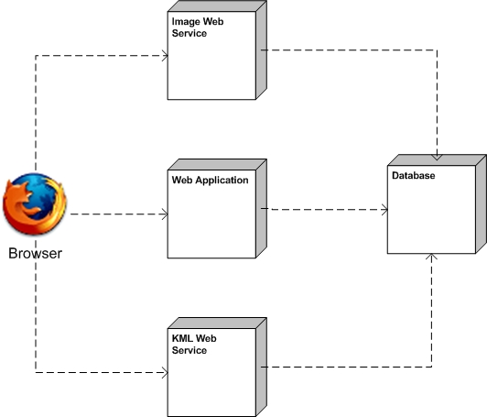

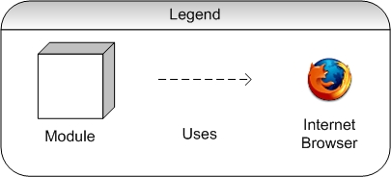

Subsystem Models
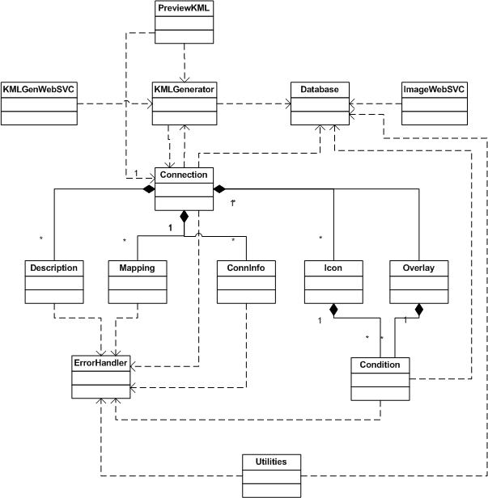

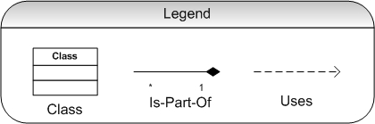

The Database class handles all transactions with our internal database and any external data sources. The ImageWebSVC class will process image requests sent to it from a web service and return an image file. The ImageWebSVC accomplishes this by connecting to our internal database, collecting information about the connection, and then connecting to the external database to retrieve the image. The KMLGenWebSVC class will receive requests from the user and generate a KML file via the KMLGenerator class. The KMLGenerator class will interface with the Database class to gather information about the connection and store that information in an instance of the Connection class. After gathering this information, the KMLGenerator class will, by using the Database class, gather the rows from the external data source and return a KML file. The PreviewKML class will take the connection parameters that are passed to it and populate a Connection class. It will then pass that connection object to the KMLGenerator class and return a KML file to the browser. The KML file generated by PreviewKML will be displayed by Google Maps in the user’s browser.

The Connection class is where most of the work in the system occurs. Its purpose is to store and verify all the information associated with a connection: connection settings, description, field mappings, icons, and icon overlays. The Description class stores a connection’s description and is responsible for verifying the contents of the description field. It also provides a user interface which allows the user to insert the following into the description box: column names, row values, and pictures. The Mapping class is used to store database mappings and verify that the specified fields map successfully to KML fields. The ConnInfo class is used to store and verify database connection information.

The Condition class is used to store and verify conditions for icons or overlays. The Overlay class is used to store color overlay information. The Icon class will store information about an icon. The ErrorHandler class will be used as the standard method for displaying error messages to the user. The Utilities class is used for storing any methods that are not suitable for any other class.

Hardware Configuration

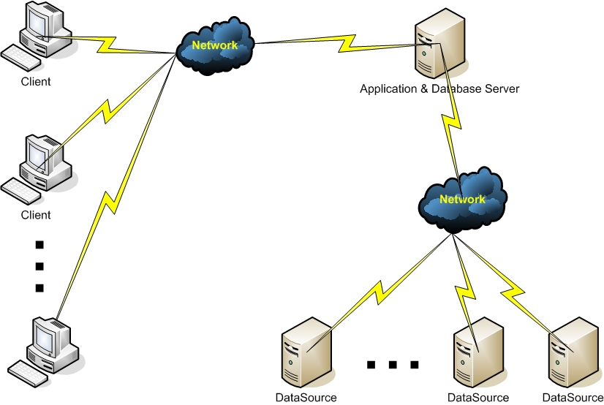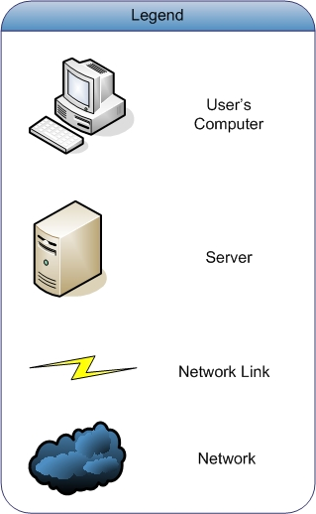

Dynamic Process Model

Overview
The following use cases are described in dynamic process models:
- Save Connection
- KML Generation by Web Service
- Create Connection
- Edit Connection
- Delete Connection
- View Connection
- Image Uploading via File
- Image Upload via Web URL
- Image Upload via Fetch and Store URL
- Image Generation Web Svc
- Generate KML via Web App
- Preview KML
- View Row Values from Datasource

Significant Dynamic Models

Save Connection
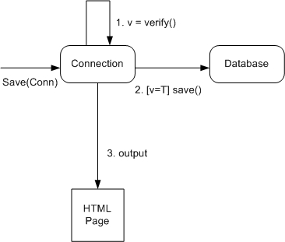

User requests ODBC2KML to save a connection.
If( isValid() == true )
saveConn();
else
ErrorHandler.displayError(errorText);
ODBC2KML displays the output

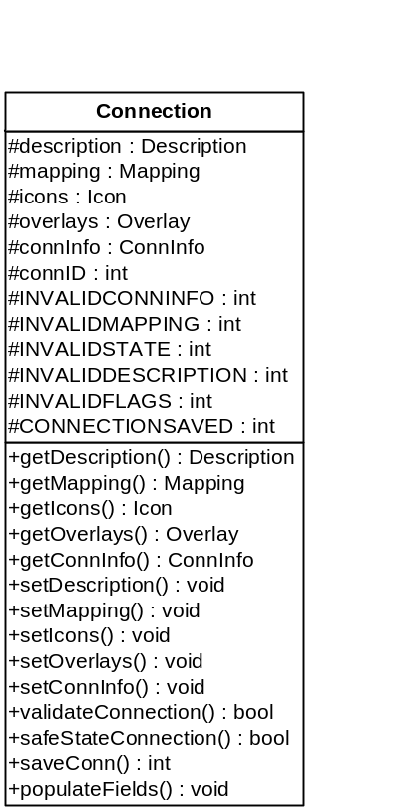
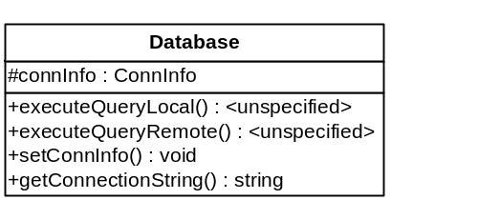

KML Generation by Web Service
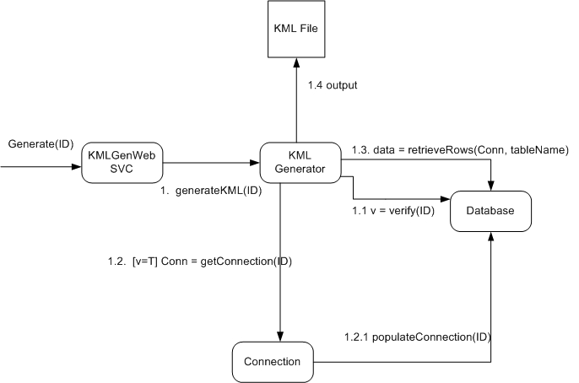Web Service container calls KMLGenWebSVC.getKML(connID).
KMLGenerator.generateKML(connID);
Create new Connection(connID)
Connection.populateFields(connID);
return KMLGenerator.generateKML(Connection);

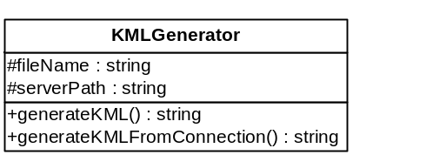
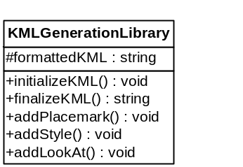

Create Connection
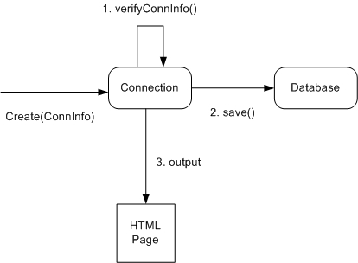

User clicks Create Connection button.
Form data is passed to Connection class as a ConnInfo object from web server.
If(ConnInfo.isValid())
saveConn();
return;
else
ErrorHandler.displayError(errorText);

Edit Connection
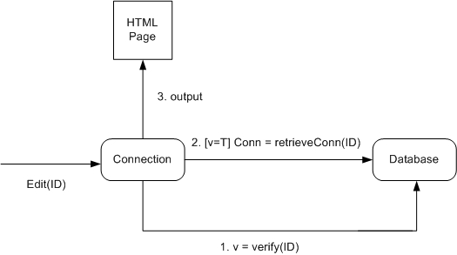
User clicks Edit Connection.
Connection class receives connID from web server.
If(Create new Connection(connID) != null)
populateFields(connID);
return Connection;
else
ErrorHandler.displayError(errorMessage);

Delete Connection
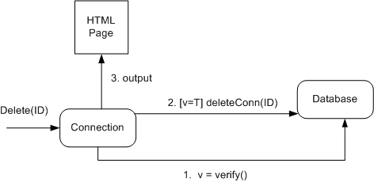
User clicks Delete Connection.
Connection class receives connID from web server.
If(Create new Connection(connID) != null)
Connection.deleteConn(connID);
Return;
else
ErrorHandler.displayError(errorMessage);

View Connection
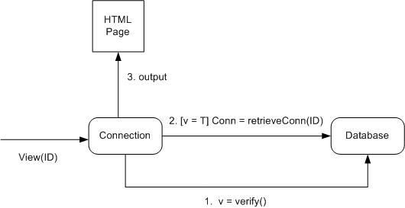
User clicks View Connection.
Connection class receives connID from web server.
If(Create new Connection(connID) != null)
populateFields(connID);
return Connection;
else
ErrorHandler.displayError(errorMessage);

Image Uploading via Local File
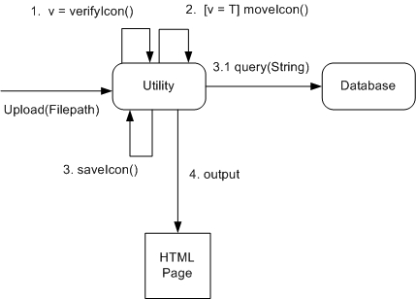
User uploads file to server via web application.
Web server calls Utilities.uploadIconFromFile(path)
If(Utilities.validateIcon(path))
Move icon to icon library folder.
Add icon to IconLibrary table.
else
ErrorHandler.displayError(errorMessage);

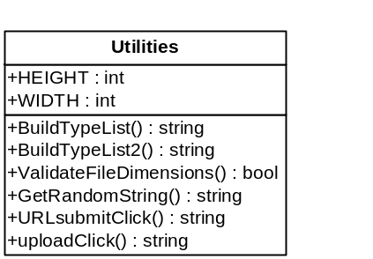

Image Upload via Web URL

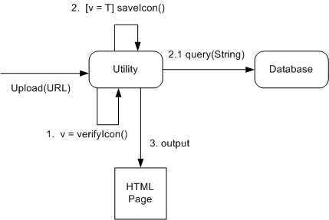
User uploads file to server via web application.
Web server calls Utilities.uploadIconFromURL(path, false)
If(Utilities.validateIcon(path))
Add icon to IconLibrary table.
else
ErrorHandler.displayError(errorMessage);

Image Upload via Fetch&Store URL

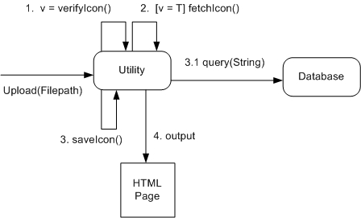
User uploads file to server via web application.
Web server calls Utilities.uploadIconFromURL(path, true)
If(Utilities.validateIcon(path))
Download icon and save icon to icon library folder.
Add icon to IconLibrary table.
else
ErrorHandler.displayError(errorMessage);

Image Generation Web Svc

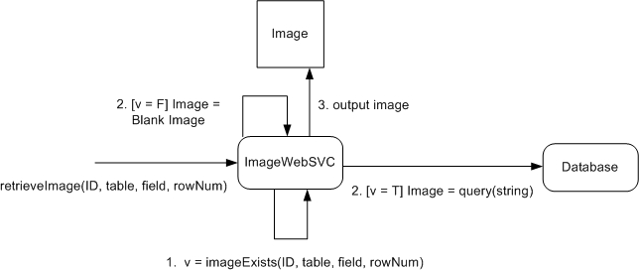
Web service container passes connID, table, field, rowNum to ImageWebSVC.
Return ImageWebSVC.getImage(connID, table, field, rowNum);

Generate KML via Web App

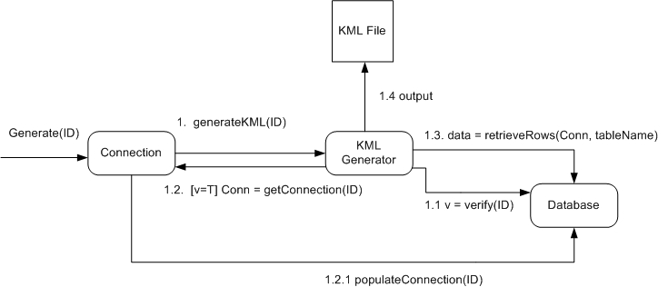
User clicks Generate KML.
KMLGenerator.generateKML(connID);
Create new Connection(connID)
Connection.populateFields(connID);
return KMLGenerator.generateKML(Connection);

Preview KML

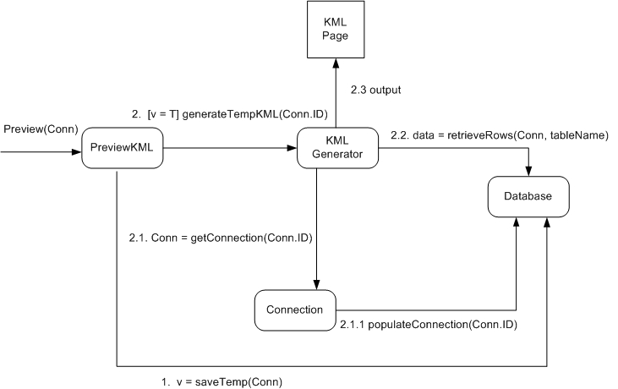

User clicks Preview KML.
Web application creates a new Connection based on user’s current form values.
If(Connection.isValid())
String KML = KMLGenerator.generateKML(Connection);
Return PreviewKML.createFile(KML);
Else
ErrorHandler.displayError(errorMessage);

View Row Values from Datasource
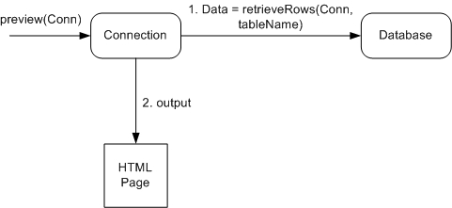

User clicks View Database Rows.
Return Connection.retrieveRows();

Relationship model
Not applicable.

Distribution Model
All of our components will be running on the same computer.

Implementation View
The following are the classes that will be implemented in this system:
- Condition
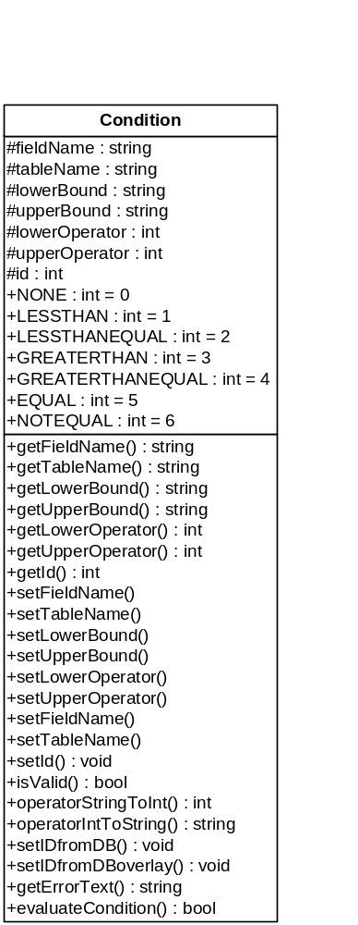
- Connection
- ConnInfo
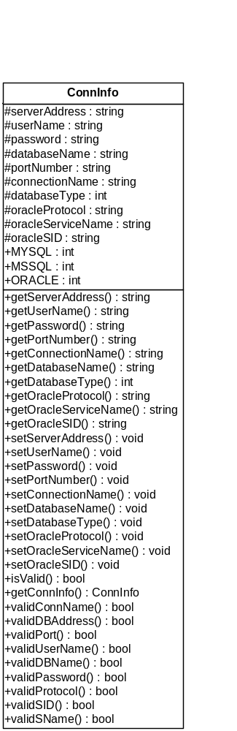
- Database
- Description
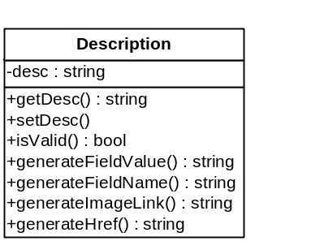
- ErrorHandler
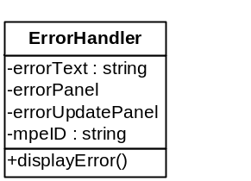
- Icon
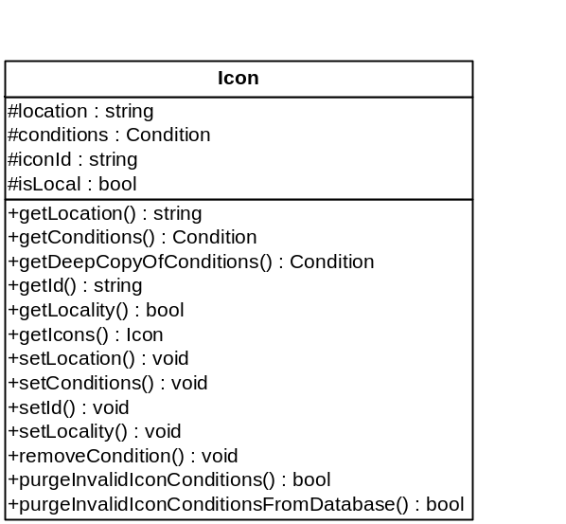

- KMLGenerator
- KMLGenerationLibrary
- Mapping
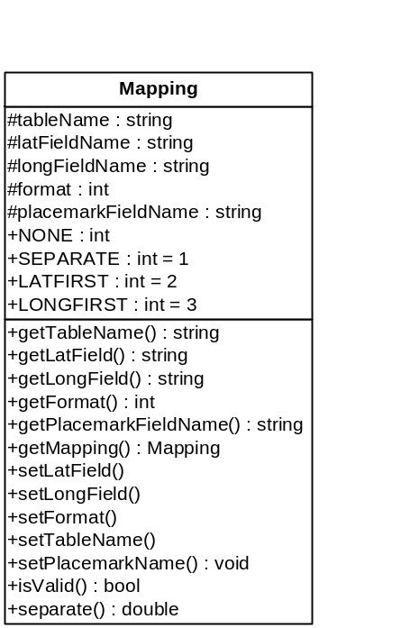
- ODBC2KMLException
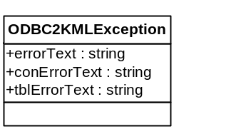

- Overlay
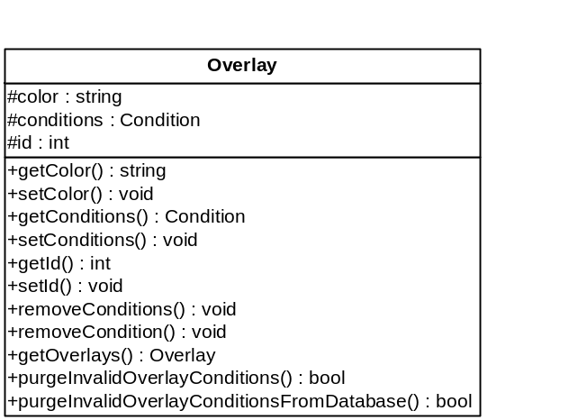
- Placemark
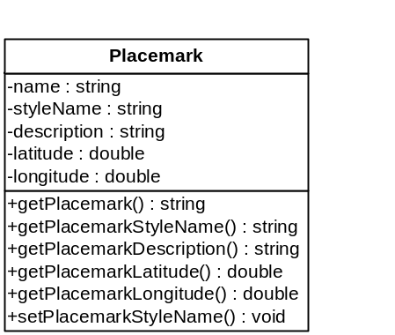
- Style
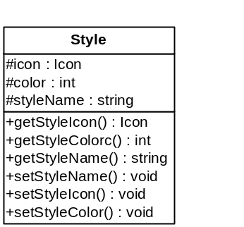
- Utilities

Database Design
