

ODBC2KML
Software Architecture Description

Version 1.0 – 12 Nov. 2009.

Revision History
Date | Version | Description | Author
<dd/mmm/yy> | <x.x> | <details> | <name>

Table of Contents

1. Introduction 4
1.1 Purpose 4
1.2 Scope 4
1.3 Definitions, Acronyms, and Abbreviations 4
1.4 References 4
1.5 Overview 4
2. Architectural Representation 4
2.1 Static Structural Model 4
2.1.1 Architectural Model 4
2.1.2 Subsystem Models 4
2.1.3 Hardware Configuration 4
2.2 Dynamic Process Model 5
2.2.1 Overview 5
2.2.2 Significant Dynamic Models 5
2.3 Interface model 5
2.4 Relationship model 5
2.5 Distribution Model 5
2.6 Implementation View 5
3. Quality 5

Software Architecture Documention

Introduction
[The introduction provides an overview of the entire Software Design Description. It includes the purpose, scope, definitions, acronyms, abbreviations, references, and overview of the Software Design Description.]

Purpose
[This section defines the role or purpose of the Software Design Description, in the overall project documentation. The specific audiences for the document is identified, with an indication of how they are expected to use the document.]

Scope
[A brief description of what the Software Design Description applies to; what is affected or influenced by this document.]

Definitions, Acronyms, and Abbreviations
[This subsection provides the definitions of all terms, acronyms, and abbreviations required to properly interpret the Software Design Description. This information may be provided by reference to the project’s Glossary.]

References
[This subsection provides a complete list of all documents referenced elsewhere in the Software Design Description. Identify each document by title, report number (if applicable), date, and publishing organization. Specify the sources from which the references can be obtained. This information may be provided by reference to an appendix or to another document.]

Overview
[This subsection describes what the rest of the Software Design Description contains and explains how the document is organized.]

Architectural Representation
[This section describes what software architecture is for the current system, and how it is represented. Of the Static Structural, Dynamic Process, Interface, Relationships, and Distribution Models, it enumerates the models that are necessary, and for each model, explains what types of model elements it contains.]

Static Structural Model

Architectural Model
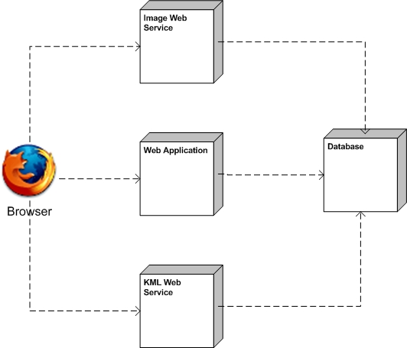

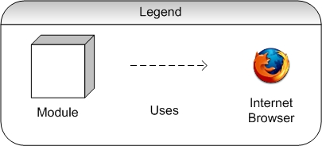

Subsystem Models
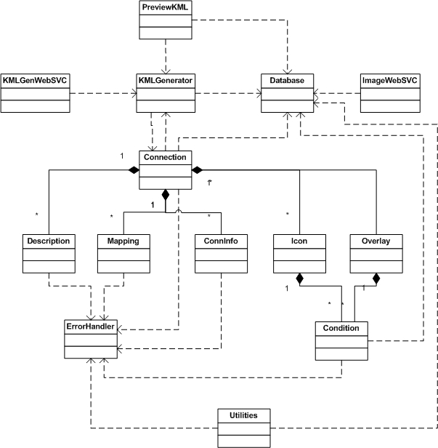

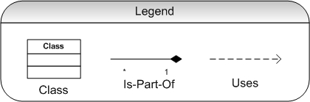

Hardware Configuration

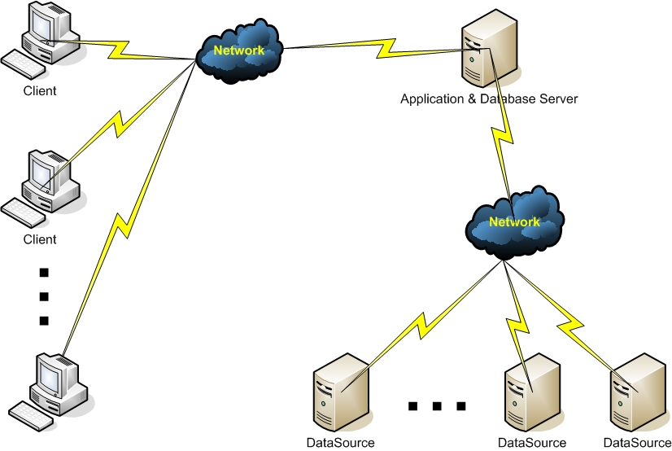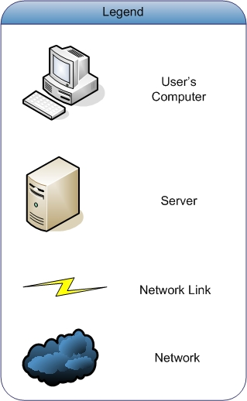

Dynamic Process Model
[This section describes the architecturally significant parts of the design model, such as collaboration diagrams. You should introduce architecturally significant classes and describe their responsibilities, as well as a few very important relationships, operations, and attributes.]

Overview
[This subsection lists the significant use cases that lead to system functions/services.]

Significant Dynamic Models

Save Connection
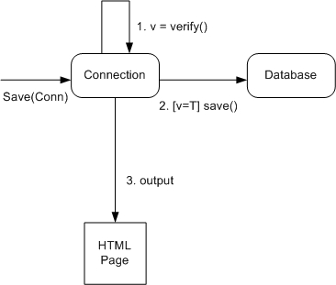

KML Generation by Web Service
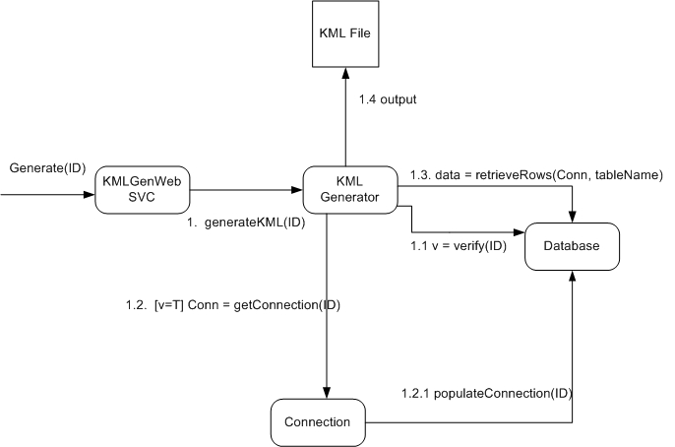

Create Connection
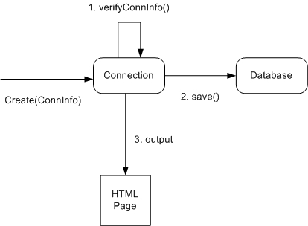

Edit Connection
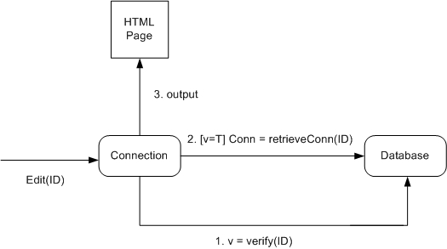

Delete Connection
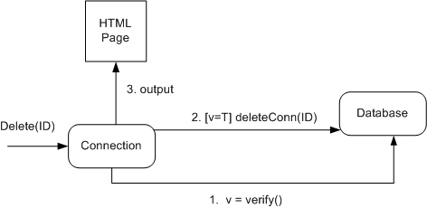

View Connection
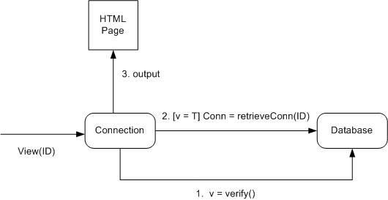

Image Uploading via Local File
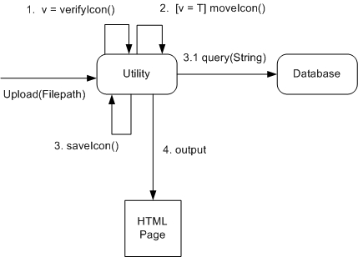

Image Upload via Web URL

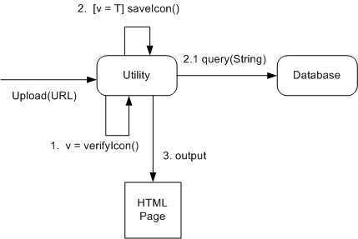

Image Upload via Fetch&Store URL

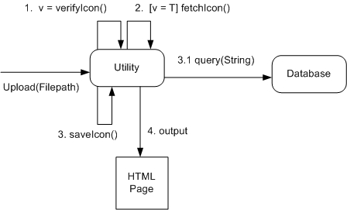

Image Generation Web Svc

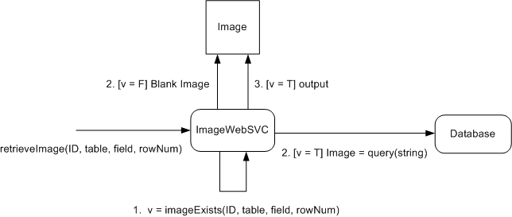

Generate KML via Web App

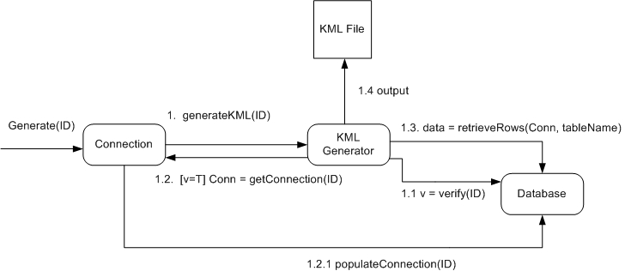

Preview KML

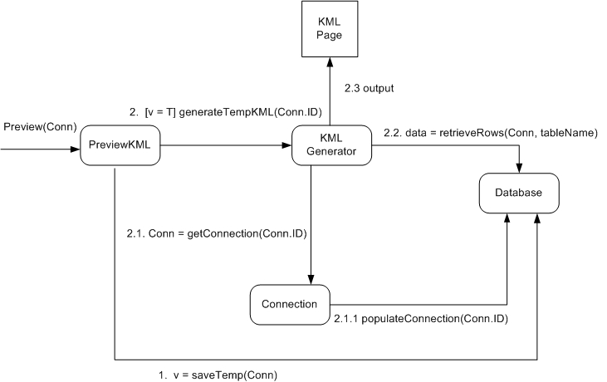

View Row Values from Datasource
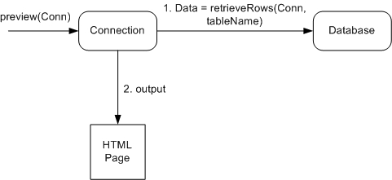

Interface model
[This section describes the interfaces among the subsystems.]

Relationship model
[This section provides and describes models such as data-flow diagrams for the system.]

Distribution Model
[This section describes how subsystems and components are distributed across computers.]

Implementation View
[This section provides significant classes that will be implemented and describes their responsibilities, as well as a few very important relationships, operations, and attributes.]

Quality
[A description of how the software architecture contributes to all capabilities (other than functionality) of the system: extensibility, reliability, portability, and so on. If these characteristics have special significance, such as safety, security or privacy implications, they must be clearly delineated.]

