**142128G Ong Swee Seng**

1. **Show the positional notation of the decimal number 4567**

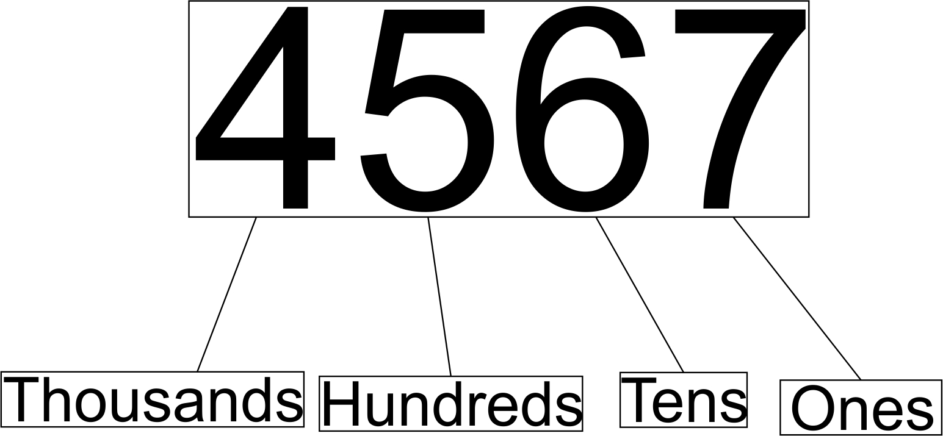

1. **How many numbers can a 16-bit system represent? Show your working.**

A 16-bit system can represent 65536 numbers,from 0 to +65535.

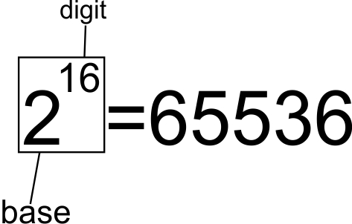

**3. Convert the decimals below to following formats: binary, octal and hexadecimal.**

|  |  |  |  |
| --- | --- | --- | --- |
| *Decimal* | *Binary* | *Octal* | *Hexadecimal* |
| a)8 | 0000 1000 | 10 | 8 |
| b)127 | 0111 1111 | 177 | 7F |
| c)257 | 0000 0001 0000 0001 | 401 | 101 |

**4. Convert the hexadecimals below to the following formats: decimal and binary.**

**a. AA55**

**b. CC33**

**c. 1234**

**d. 4321**

|  |  |  |
| --- | --- | --- |
| *Hexadecimal* | *Decimal* | *Binary* |
| a)AA55 | 43605 | 1010 1010 0101 0101 |
| b)CC33 | 52275 | 1100 1100 0011 0011 |
| c)1234 | 4660 | 0001 0010 0011 0100 |
| d)4321 | 17185 | 0100 0011 0010 0001 |

**5. Fill in the ASCII values (in decimal) for the letters that form the word “HELLO”. Note**

**that the ASCII values for UPPER and lower case are different.**

|  |  |  |  |  |  |
| --- | --- | --- | --- | --- | --- |
| **Character** | **H** | **E** | **L** | **L** | **O** |
| **ASCII (Dec)** | **72** | **69** | **76** | **76** | **79** |

