Détection de la LSF

<>

Questions
Dans l’algo des kmeans pour la couleur de la main, je récupère tous les pixels puis j’enlève les pixels blancs. C’est une boucle for sur des millions de pixels donc c’est très long. Quelle solution ?

Pour trouver les clusters sur des 1000ers de photos, il nous faut une grosse puissance de calcul. Y a-t-il des ordi que l’on peut utiliser ?

Imports
pip install opencv-python openCV2 et numpy
pip install matplotlib matplotlib.pyplot (affichage)
pip install sklearn sklearn.cluster (KMeans) & sklearn.preprocessing (scaler)

Banque de données
Images de mains : 11K Hands https://sites.google.com/view/11khands
Images langue des signes https://www.massey.ac.nz/~albarcza/gesture_dataset2012.html

Liste de banque de données https://homepages.inf.ed.ac.uk/rbf/CVonline/Imagedbase.htm#gesture

skin color
Utilise HSV avec un range sur H
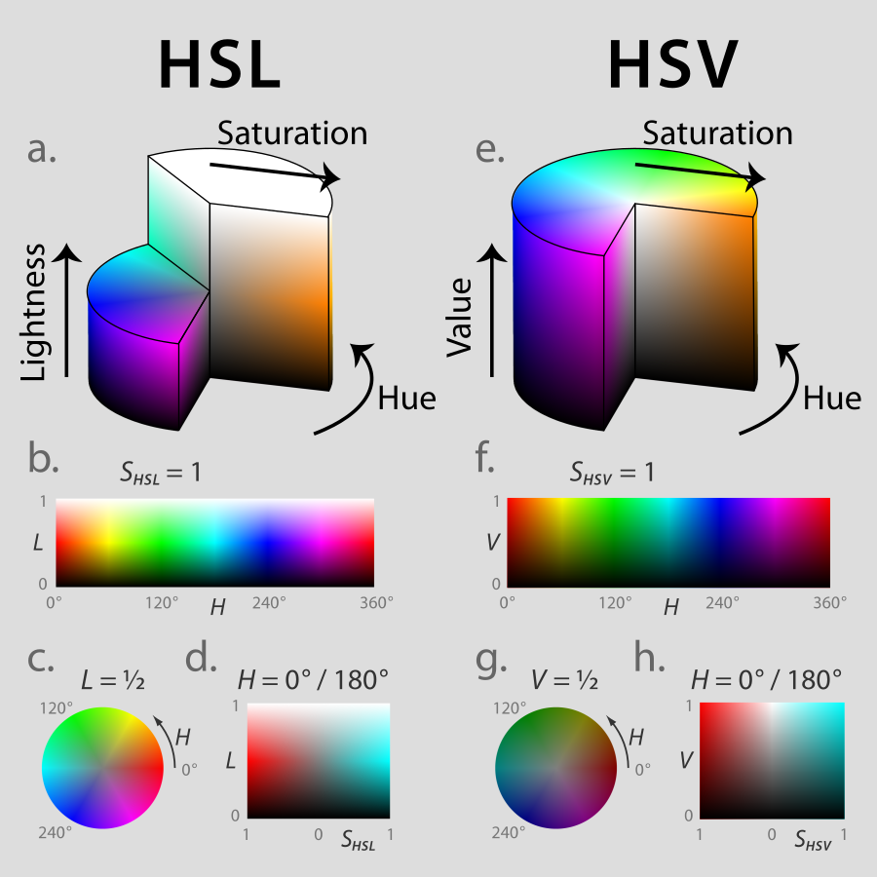

HLS
H in [0,180]
S,L in [0,255]
white is 0, 255, 255

HSV
For HSV in openCV, Hue range is [0,179], Saturation range is [0,255] and Value range is [0,255].
Different softwares use different scales. So if you are comparing OpenCV values with them, you need to normalize these ranges.

Remarque : You'll have to take extra care with very dark parts of the image and probably discard them altogether, as the HSV conversion gets really noisy for small values of V.

Solution alternative et + précise :
detect face (it's easy with oepncv). Then they extract the skin color of the face (which is very specific to the persons on the image). Then they detect skin using this color. Since the color is very specific, they should have much less false detection, than what you have with your fixed color range.
https://www.robots.ox.ac.uk/~vgg/research/hands/

k-means
Detailed tutorial (preprocessing, normalization of data etc.) https://realpython.com/k-means-clustering-python/#writing-your-first-k-means-clustering-code-in-python

init="k-means++" : ensure centroids are initialized with some distance between them (usually an improvement over "random").
n_init : increased to ensure we find a stable solution (10 by default).
max_iter : increased to ensure that k-means will converge.

Exemples
Hand detection using multiple proposals
https://www.robots.ox.ac.uk/~vgg/research/hands/

Archives
Ranger pour les couleurs de peau
ranges = [(np.array([200, 130, 95]), np.array([255, 255, 255])),
(np.array([100, 95, 45]), np.array([225, 165, 160])),
(np.array([140, 40, 0]), np.array([185, 75, 15])),
(np.array([30, 0, 0]), np.array([165, 105, 110]))]

