DOCKER ASSIGNMENT

1. Create a docker bridge docker network with name hu-devops-sdet1.0.
2. **Declare the base image nginx and version latest in the Dockerfile using from command.**

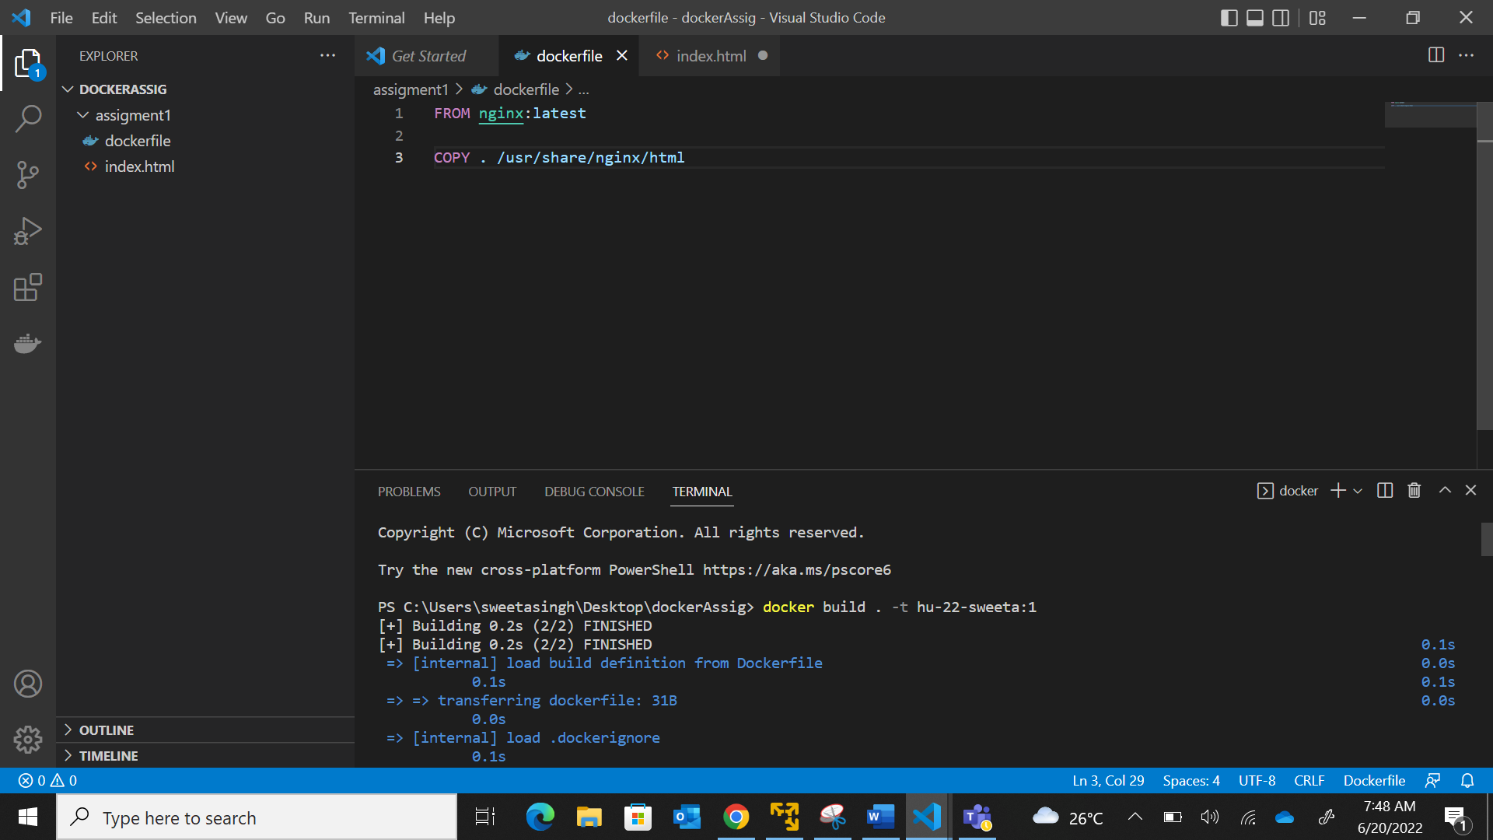

1. **Creating a index.html file to show on server**

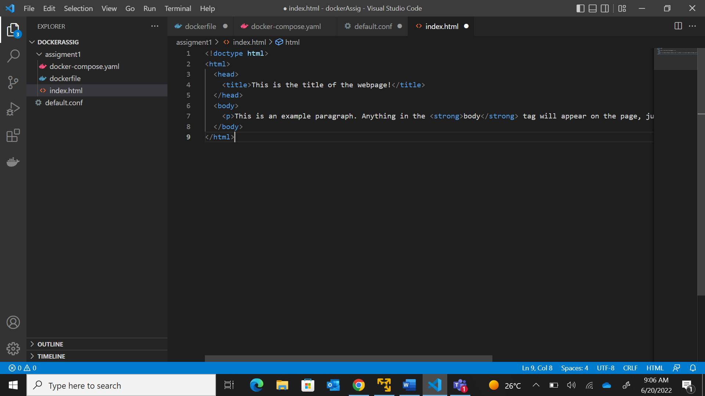

1. **Copying the html file to nginx using COPY command (COPY Instruction copy files and directories inside a Docker Container). Build the image using the tag name hu-22-mar-username, use command docker build . -t hu-22-sweeta:1 and run it in 8080 local host. Use command docker run -p 8080:80 hu-22-sweeta:1**



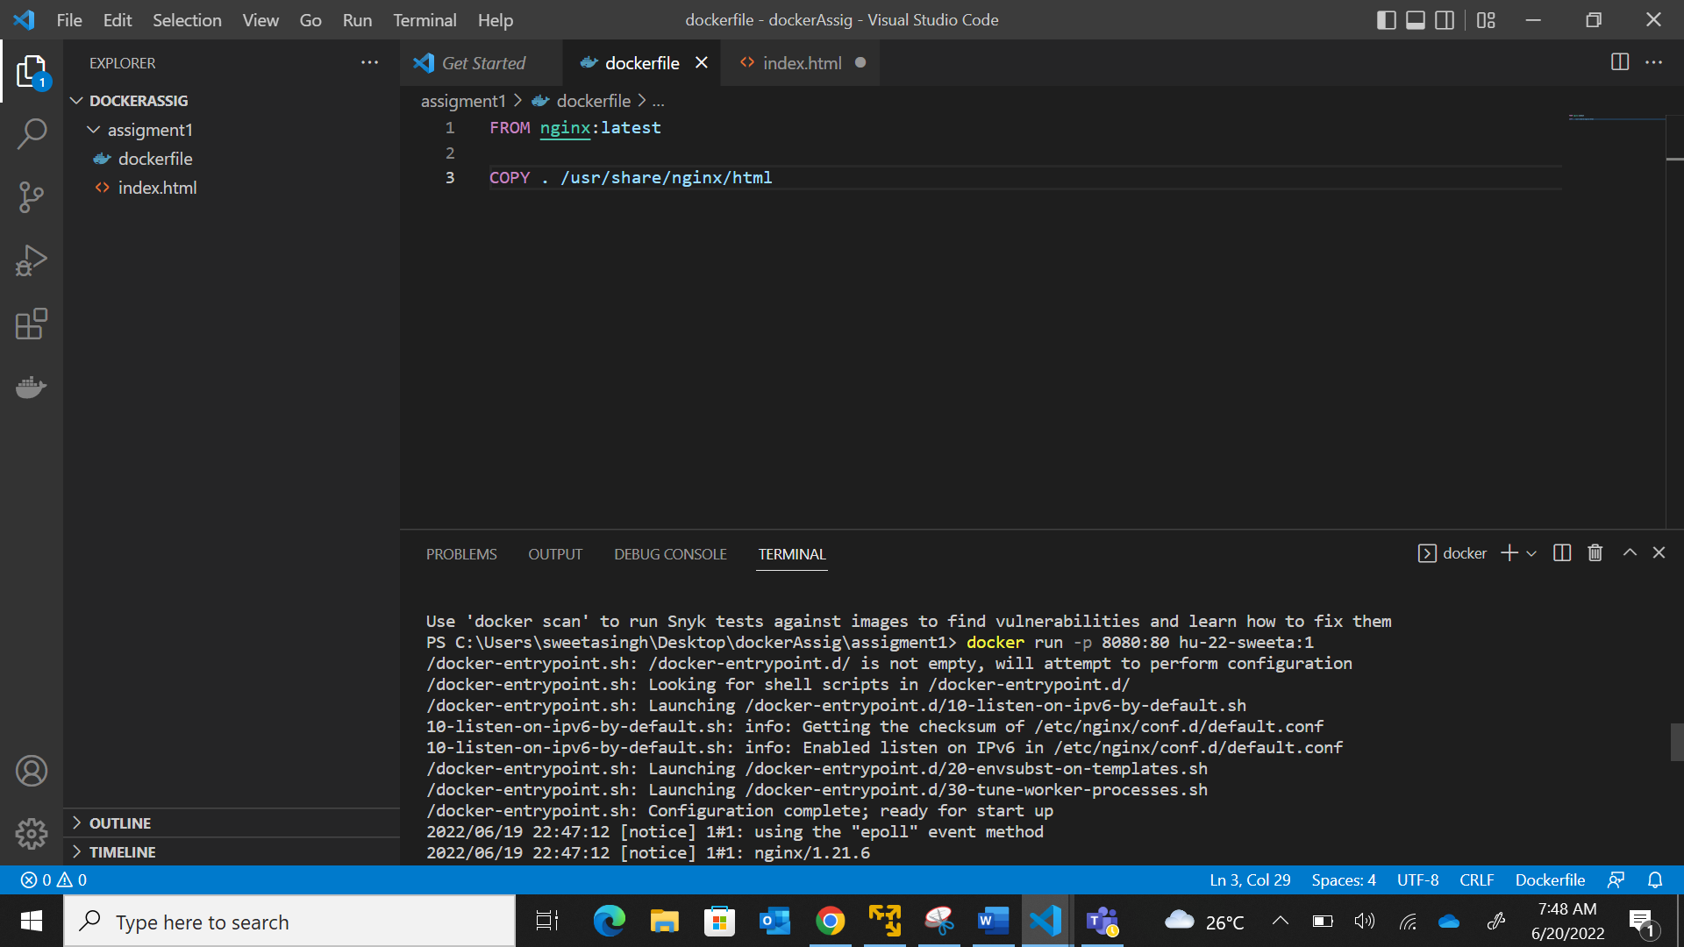

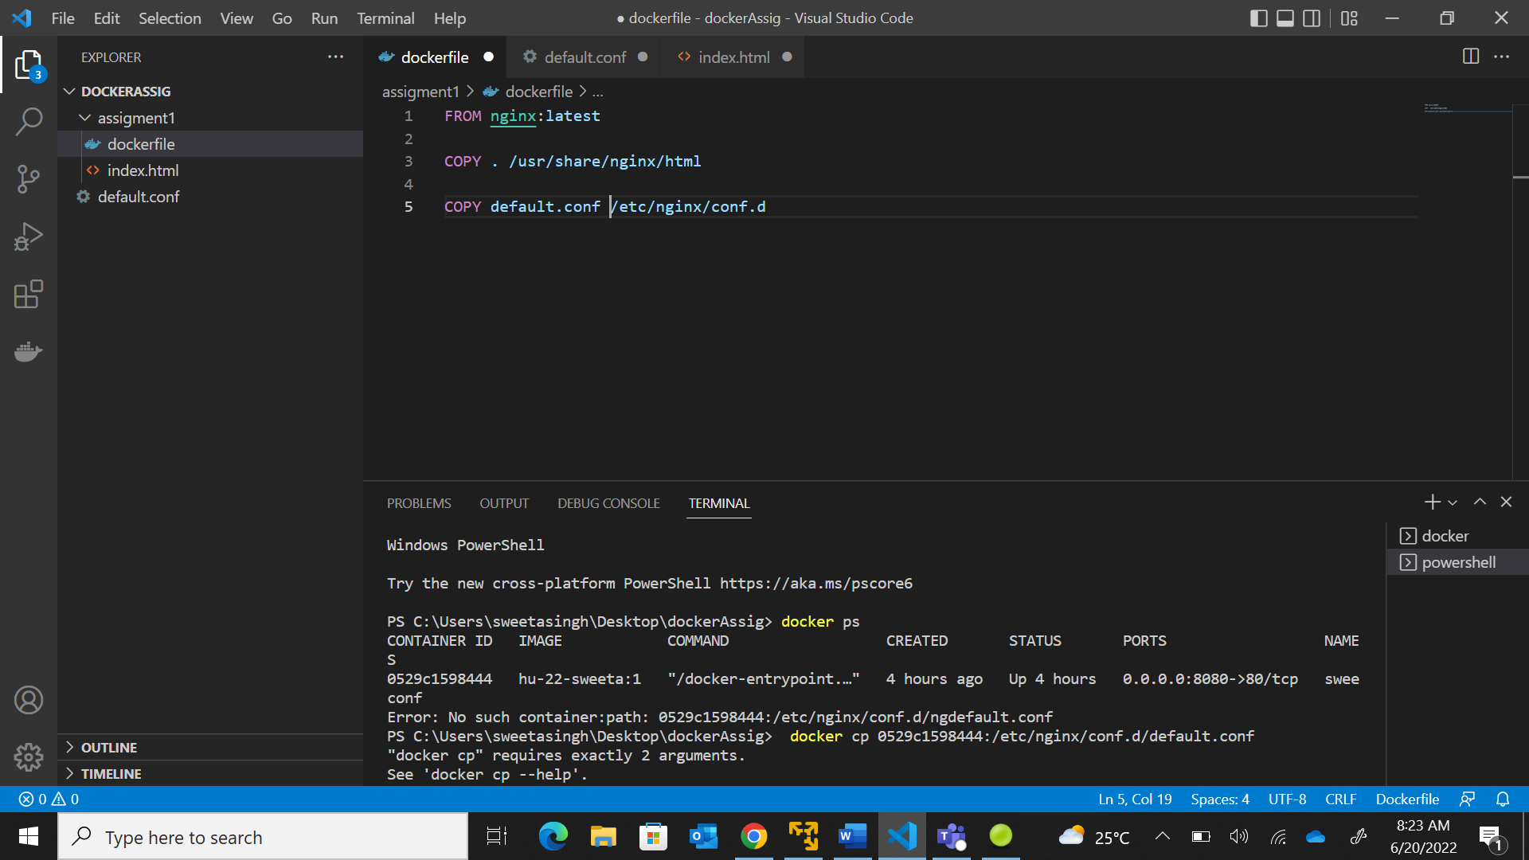

**c)Create a network using docker network create. Command used docker network create hu-devops-sdet1.0**

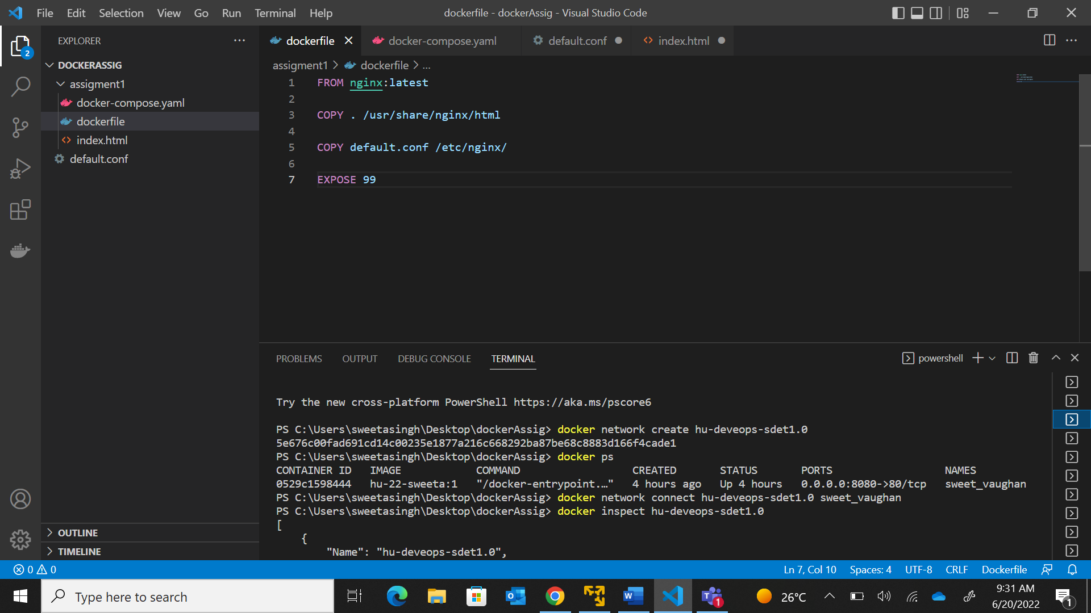

1. **Connect the network and the container with docker network connect and verify if the container is connected or not using inspect command**

