Linux Assignment

1. I have installed VMware Workstation Pro with Ubuntu 18.06
2. A) OS Version

b) kernel version

c) uptime

d)memory

e) cores and swap details

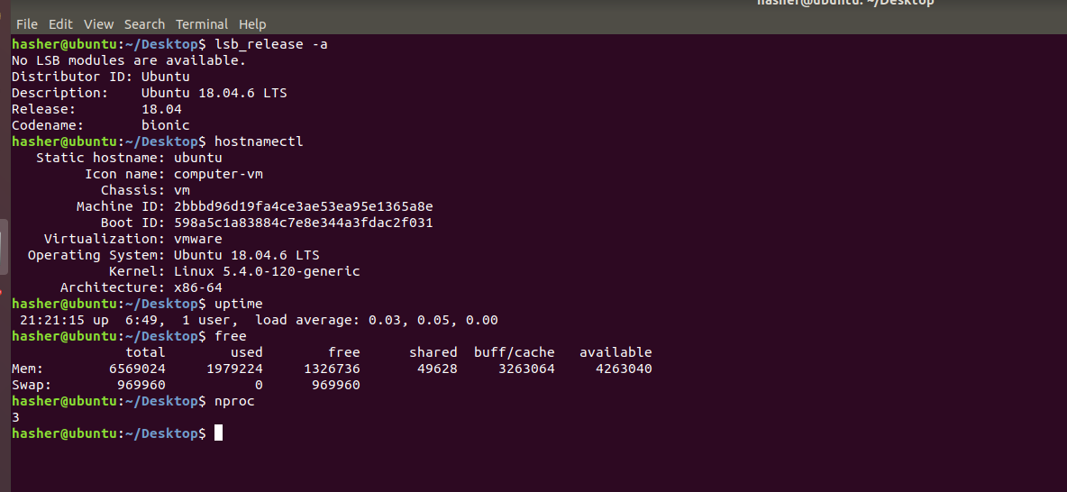

2.c) Increase the ulimit for the current user to 1028.



2.d) Change the time zone to IST

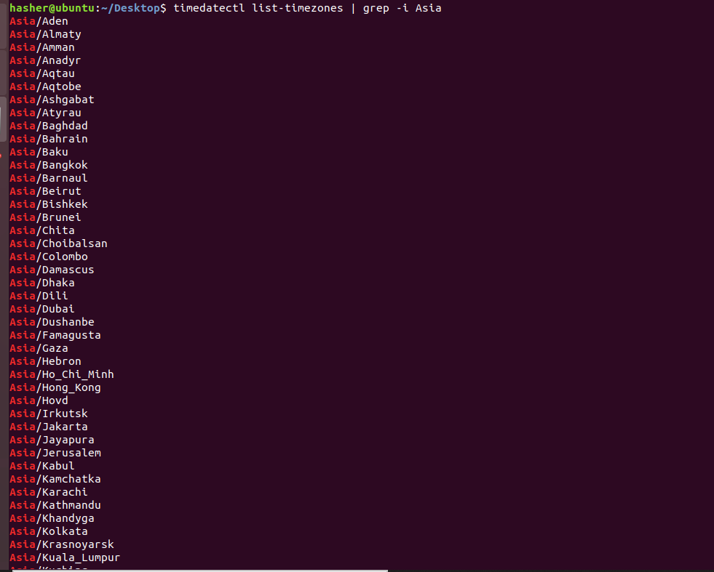

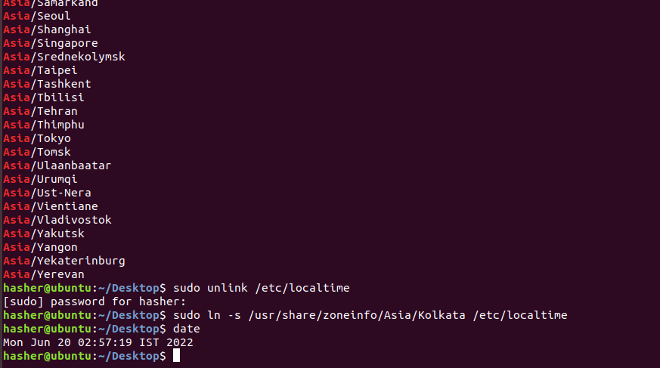

1. Install nginx   
   a. Configure the web server. Change the default location    
   b.Route all the requests to port 8080.   
   c. Configure the web server which shows files/directories and make them downloadable from the web page.

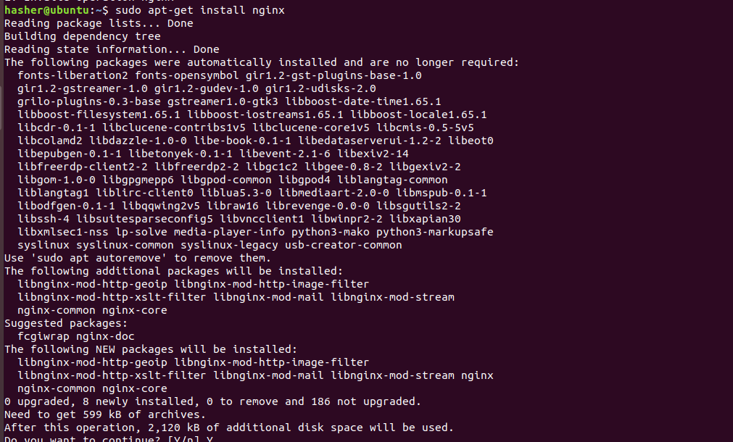

1. Date and Calendar should print whenever I open the terminal

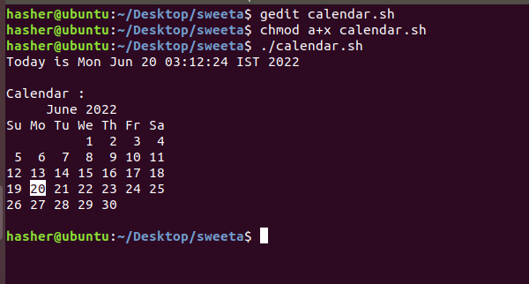

1. Create a User, and give it sudo privileges. But remove the power of rm.

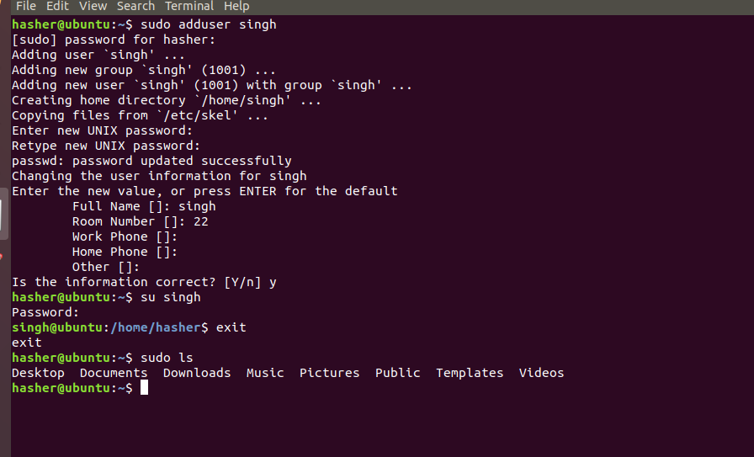

1. Change the default port number for RDP to 8339 and document on the same.
2. Create a script to take regular backup of the database(MySql & Postgres), say every day at 11PM.
3. Detecting which process has the highest priority in the system. Now find out what its purpose is.

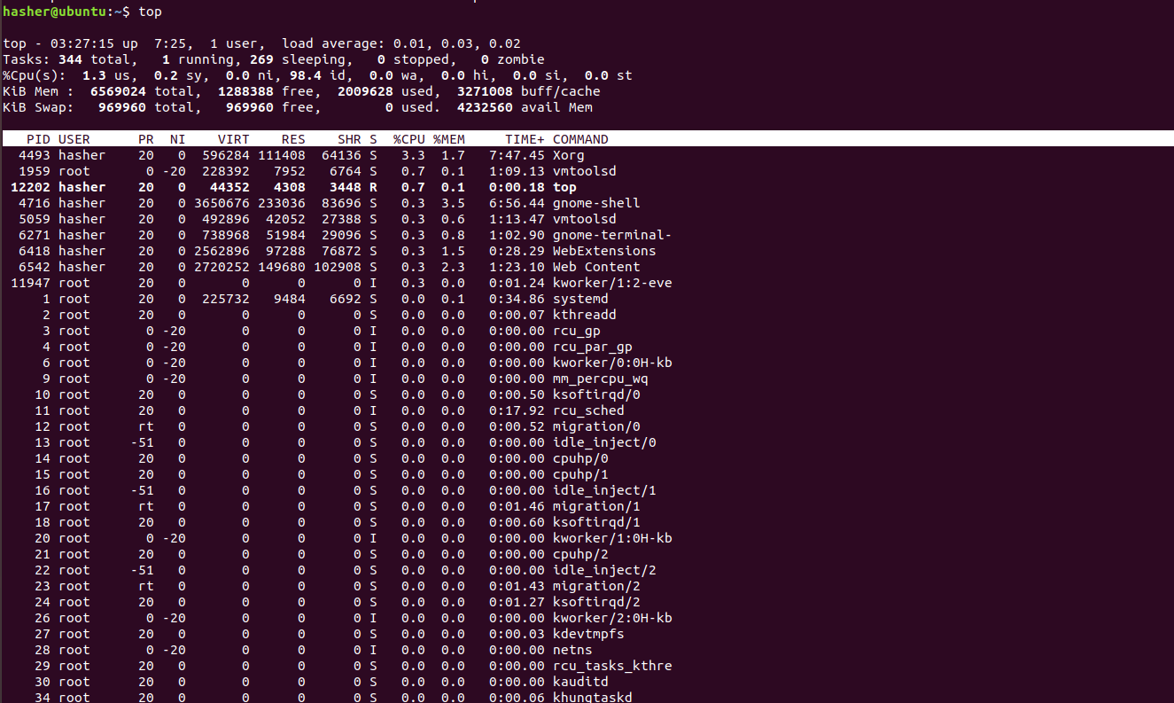

1. Find a file with all command line history and Delete the Complete Command line History.

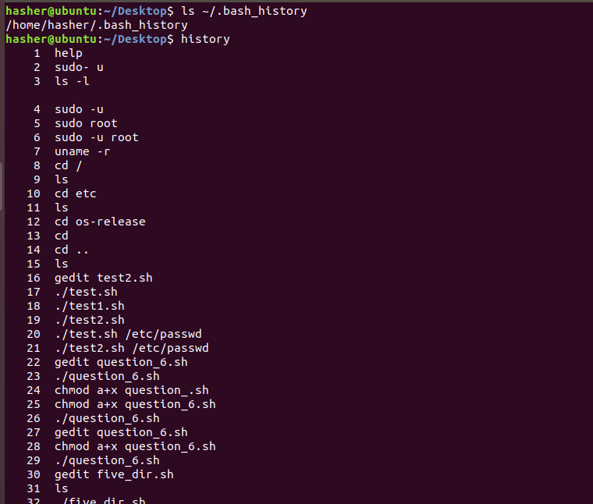

1. Get Tasks, Threads, Running Processes, Load Average and Uptime using htop command.

