Assignment Shell Script:

1. Write a script five_dirs.sh that does these tasks:  
   a. make a directory five.  
   b. make five subdirectories five/dir1 through five/dir5.  
   c. in each subdirectory, make four files, file1 through file4, such that file1 has one line containing the digit 1, file2 has two lines, each containing the digit 2, ..., and file4 has four lines, each containing the digit 4.

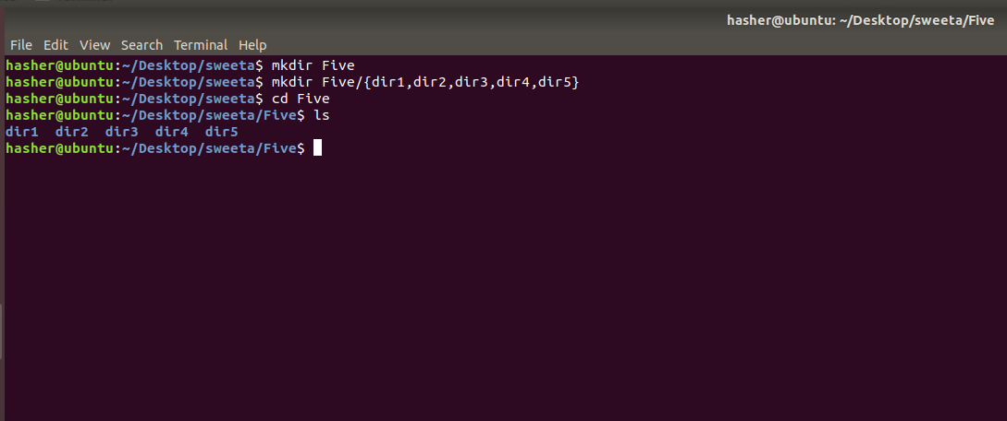

1. Get user input of file path and evaluate the status of a file ( Whether it is writable, executable/searchable, readable, directory etc)

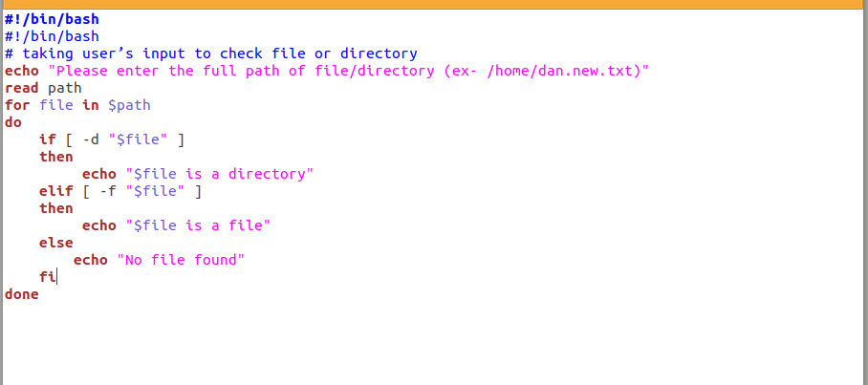

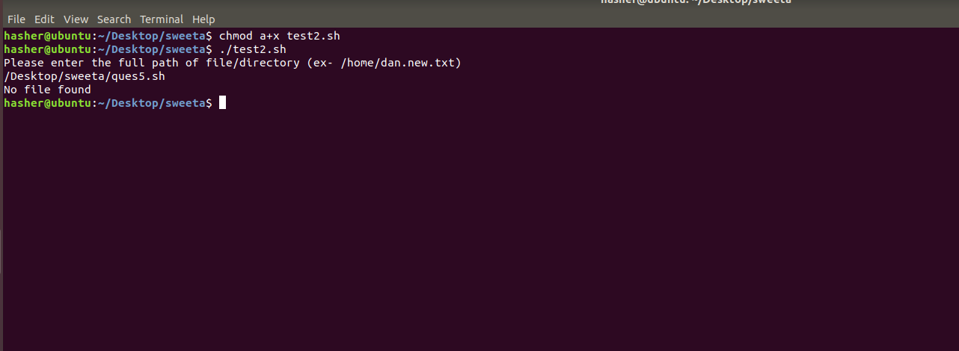

1. Write a program to calculate overtime pay of employees. Overtime is paid at the rate of Rs. 12.00 per hour for every hour worked above 40 hours. Assume that employees do not work for fractional part of an hour.

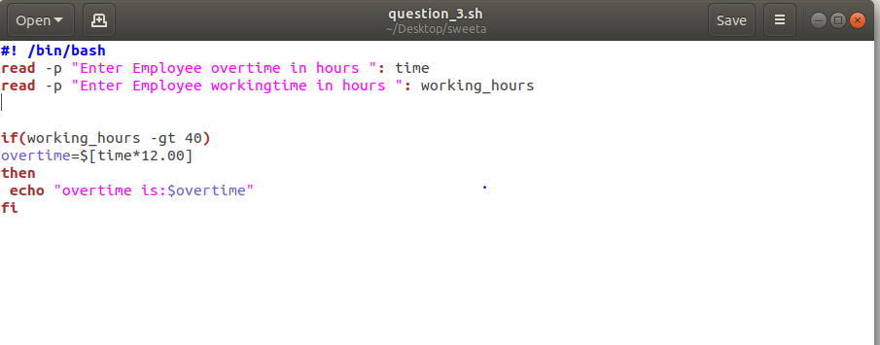

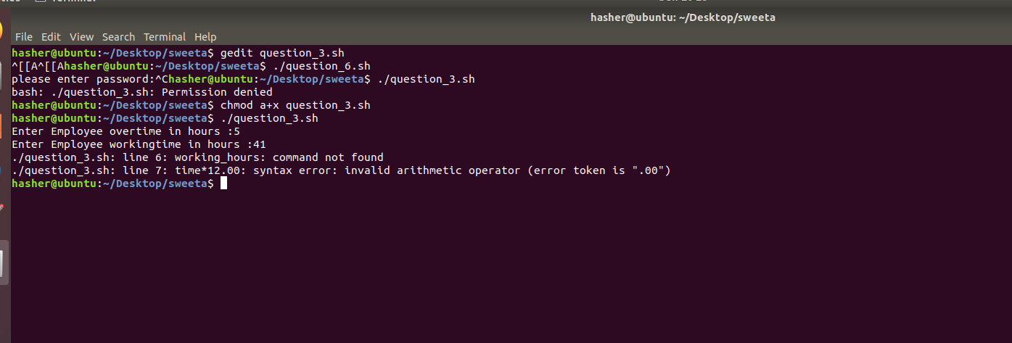

1. Write a shell script that will take an input file and remove identical lines (or duplicate lines from the file).

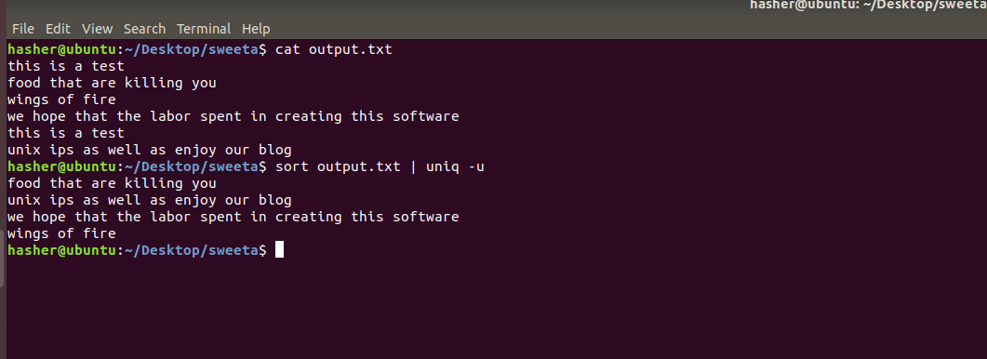

1. Create a bash file to assess password strength.

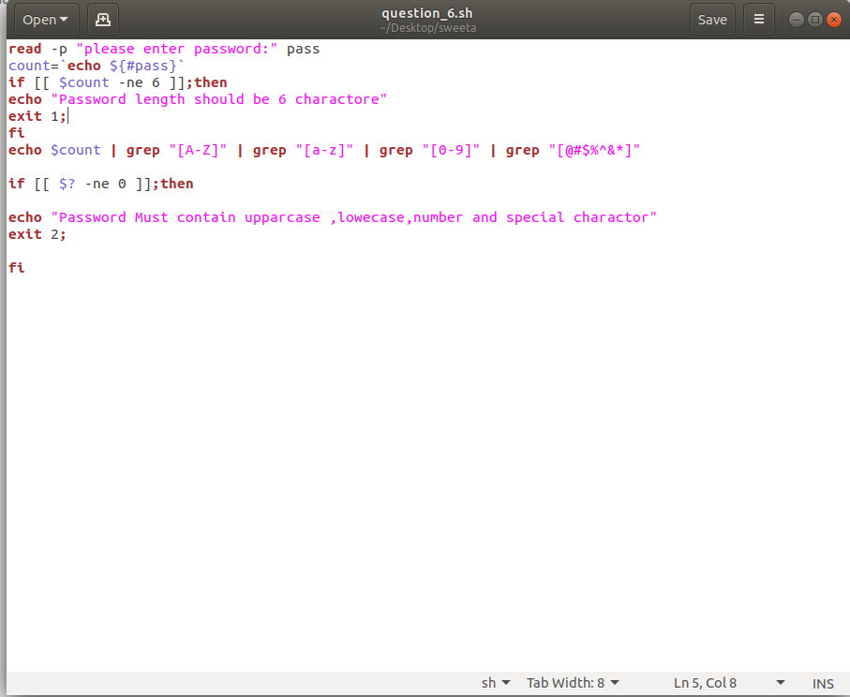

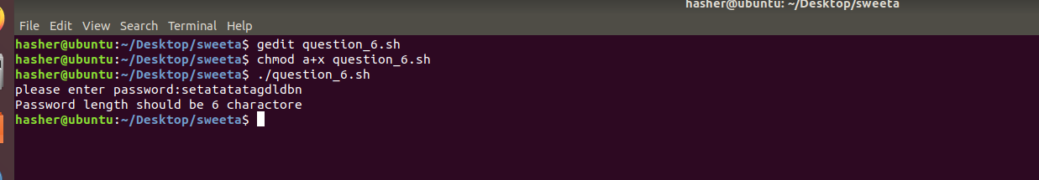

6) Write a shell script to accept two integer values for two variables Perform following actions -  
Create the following functions for the same -

