# Terraform Assigment

# Q1)

**Step 1) create a virtual machine manually in AWS.**

**2) Login in the instance using ssh through your command prompt**

**3)install the terraform packages using these commands**

1. wget <https://releases.hashicorp.com/terraform/1.2.3/terraform_1.2.3_linux_amd64.zip>
2. unzip terraform_1.2.3_linux_amd64.zip
3. sudo mv terraform /usr/local/bin
4. make provider.tf and nginx.sh file where you will write configuration file to define our resources and in nginx.sh file the data source for nginx.
5. Create ssh key and store it in a location.
6. Write the script for the resource we have to create by using nano provider.tf command.
7. terraform init- prepared the configuration in the working directory
8. terraform plan- command shows the desired state of all the resources.
9. Terraform apply- make the changes defined by the configuration file to create the resources.

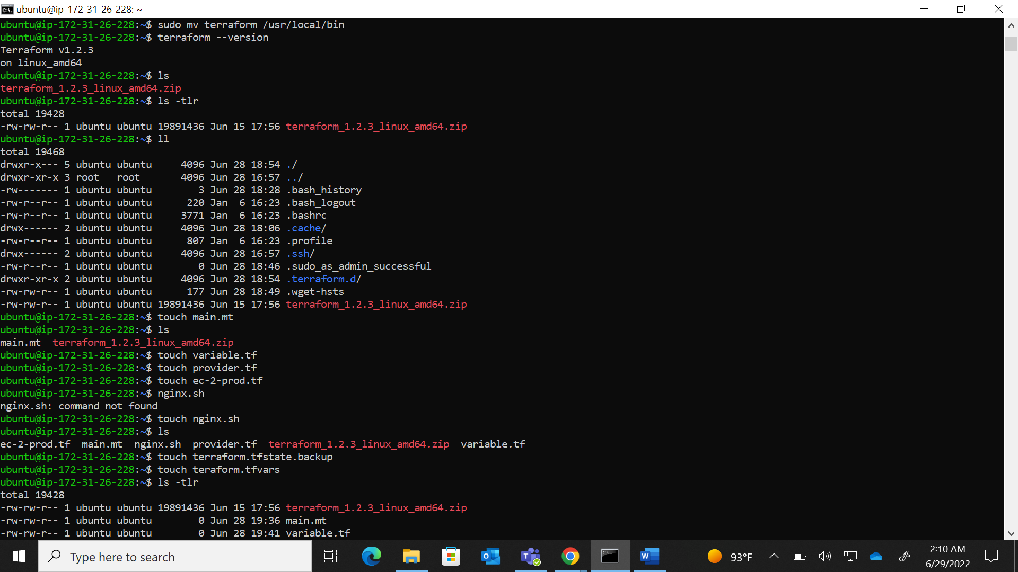

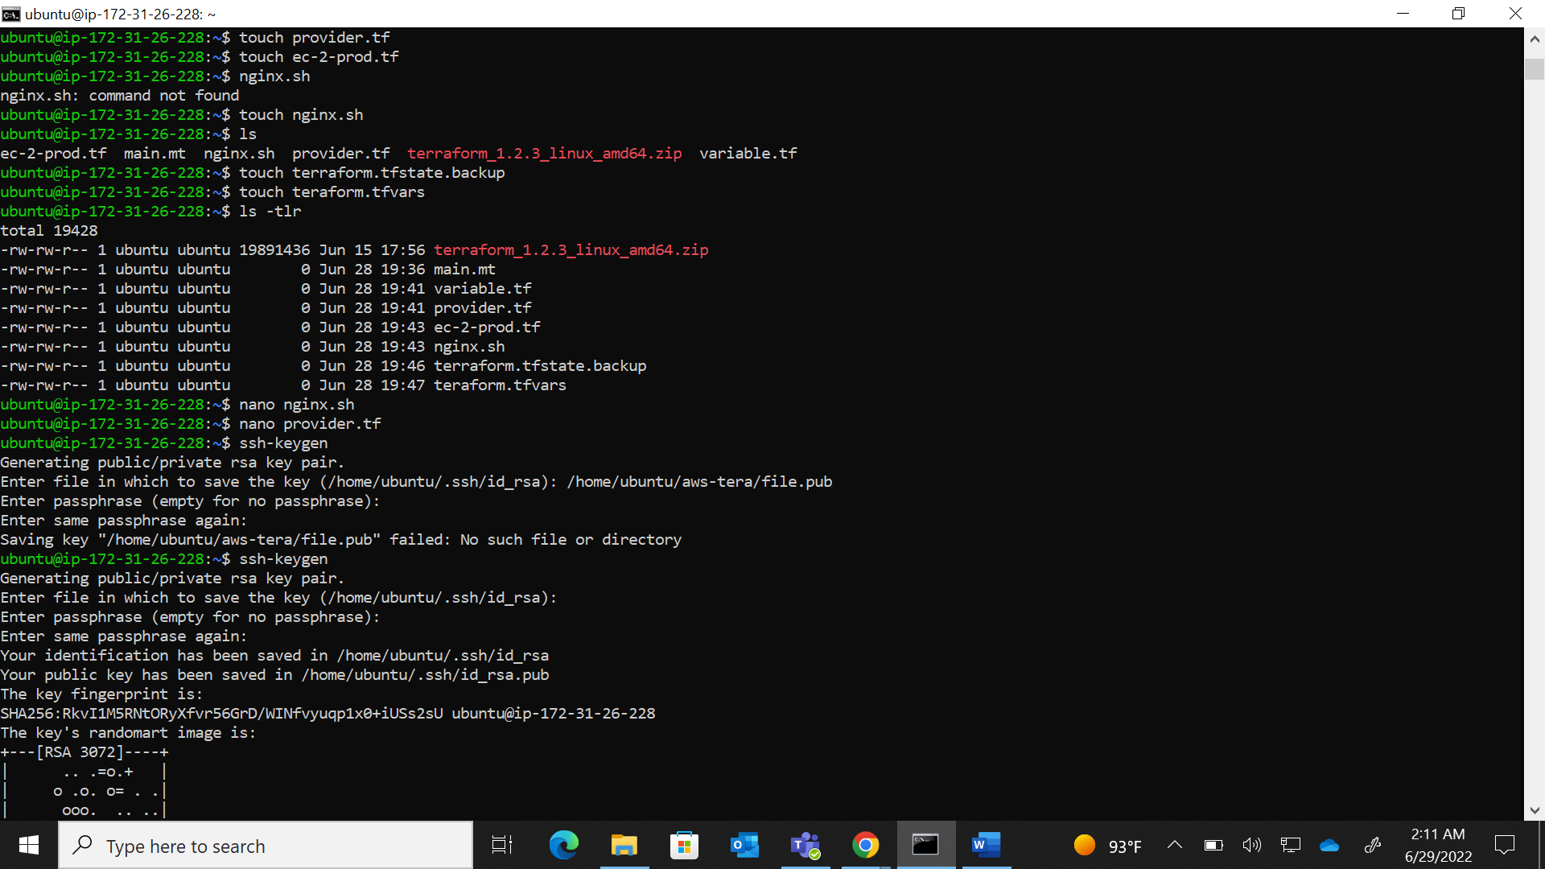

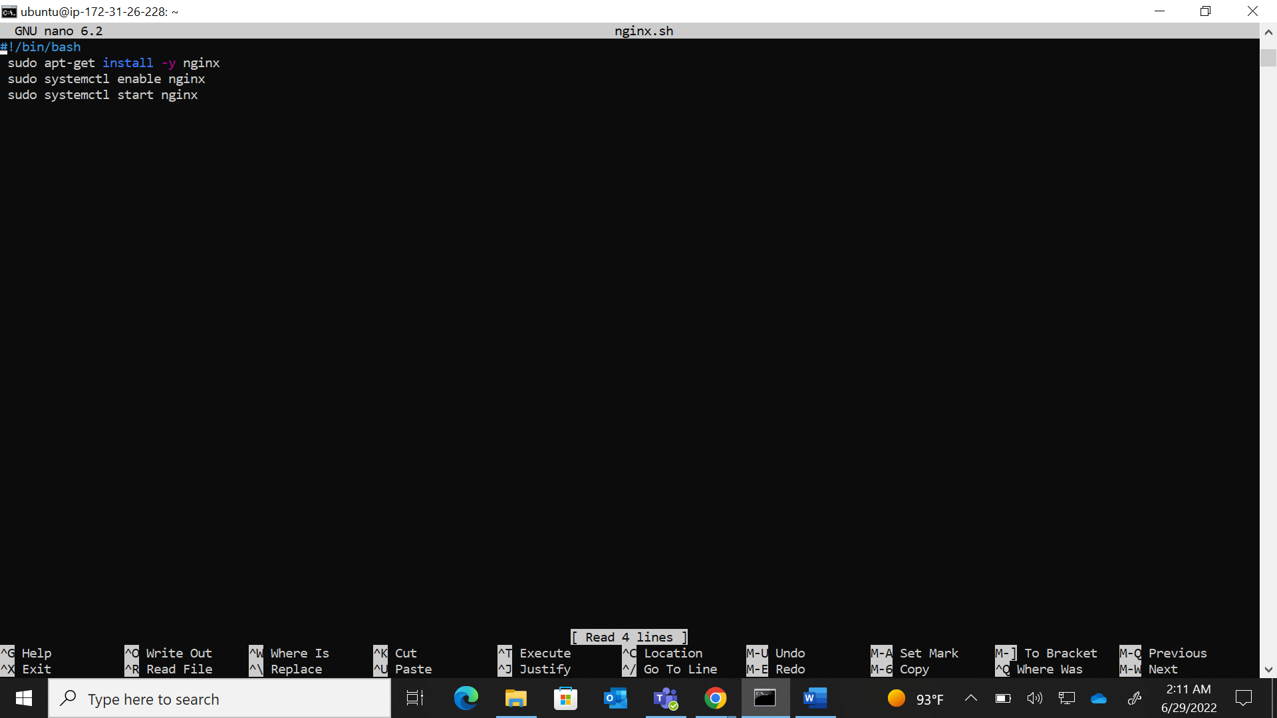

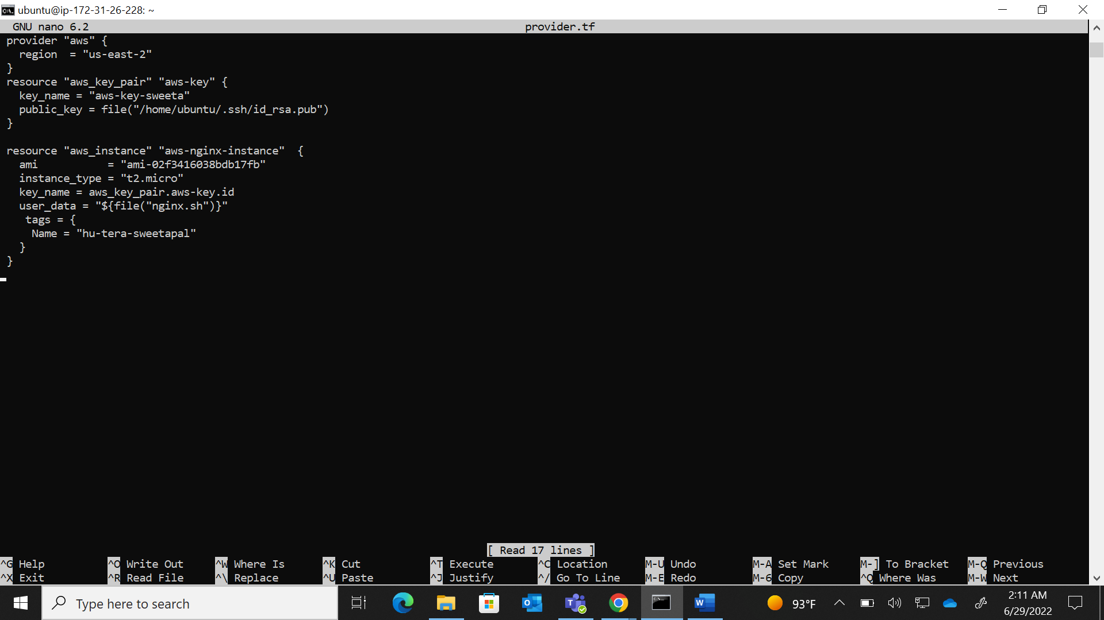

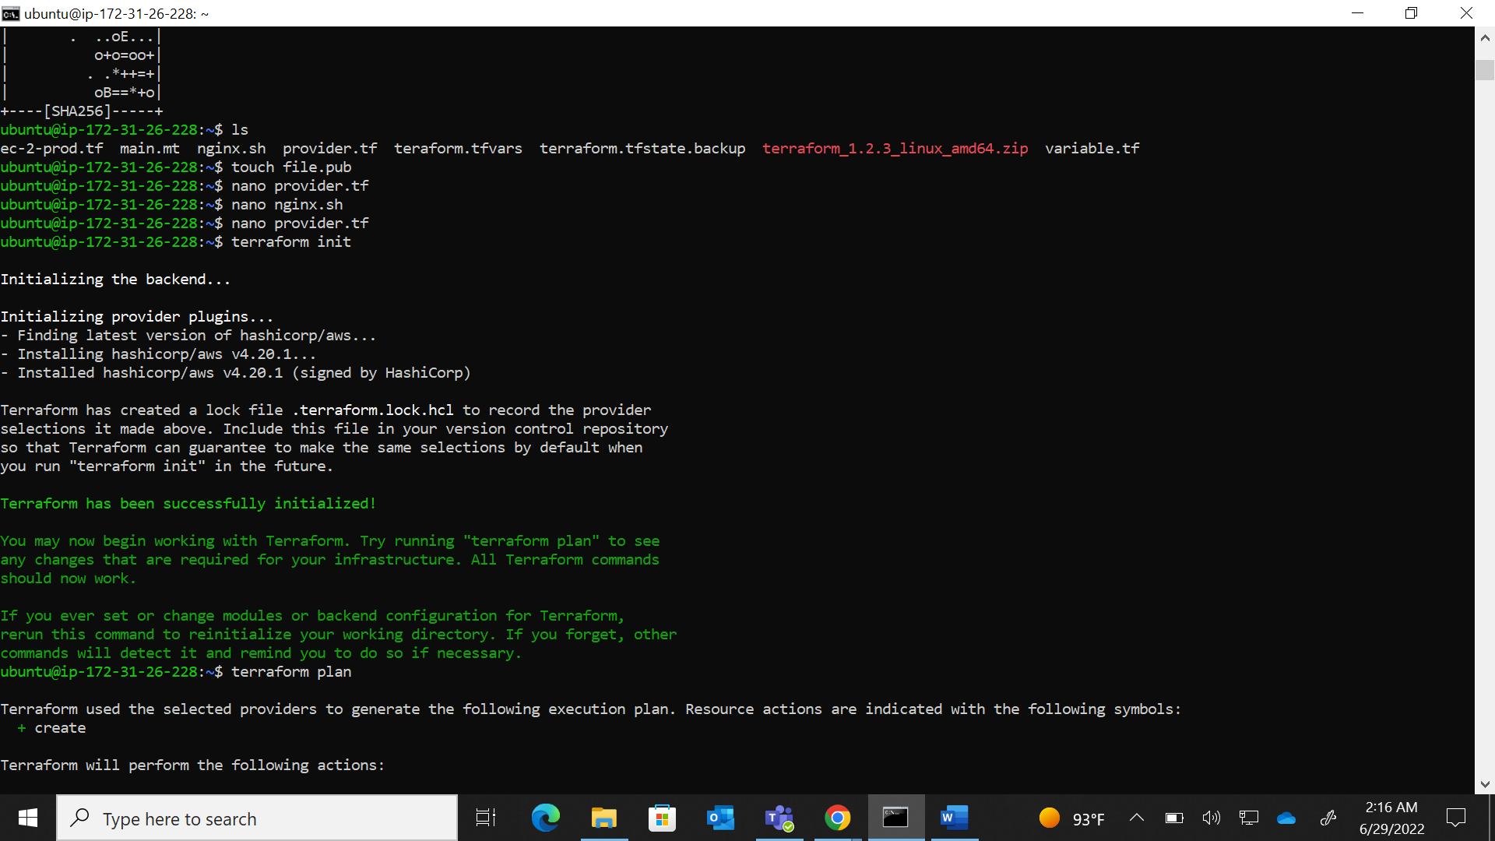

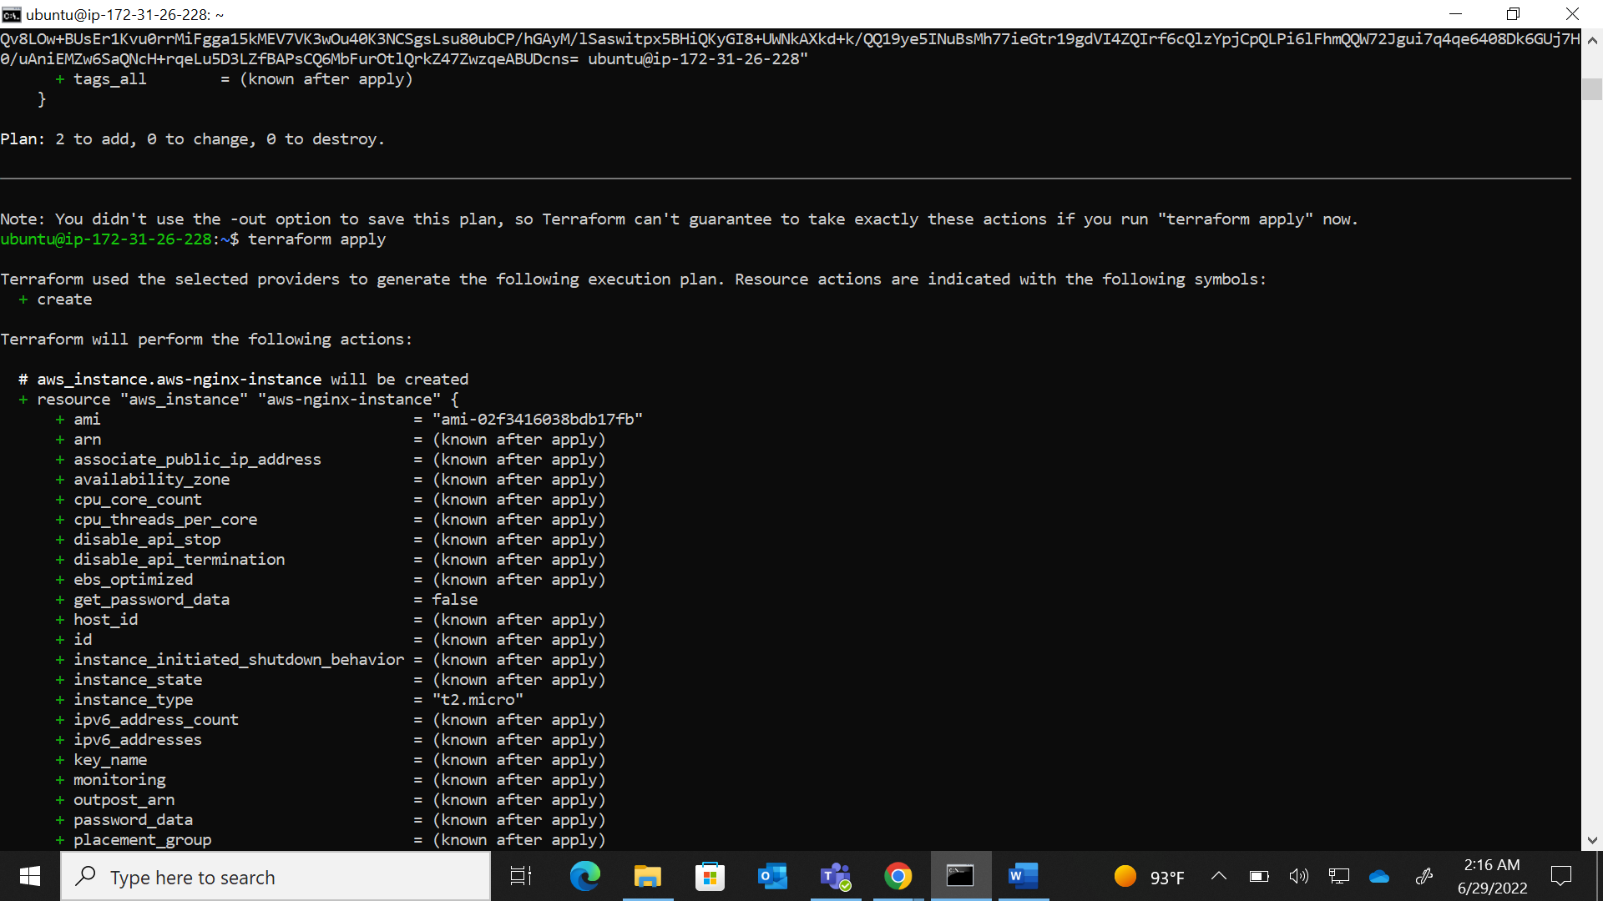

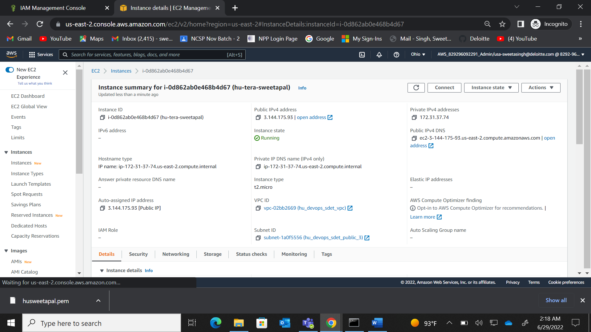

Q3)

**Step 1) create a virtual machine manually in AZURE.**

**2) Login in the instance using ssh through your command prompt**

**3)install the terraform packages using these commands**

1. sudo apt-get update && sudo apt-get install -y gnupg software-properties-common curlunzip terraform_1.2.3_linux_amd64.zip
2. curl -fsSL https://apt.releases.hashicorp.com/gpg | sudo apt-key add –
3. sudo apt-add-repository "deb [arch=amd64] https://apt.releases.hashicorp.com $(lsb_release -cs) main"
4. sudo apt-get update && sudo apt-get install terraform

**4) install azure CLI**

1. sudo apt install azure-cli
2. az login
3. az account show
4. make main.tf and sweetafile.txt file where you will write configuration file to define our resources and txt file to upload in the container.
5. Write the script for the resource we have to create by using nano main.tf command.
6. terraform init- prepared the configuration in the working directory
7. terraform plan- command shows the desired state of all the resources.
8. Terraform apply- make the changes defined by the configuration file to create the resources.

