QAP 1 – Java (ElliottButt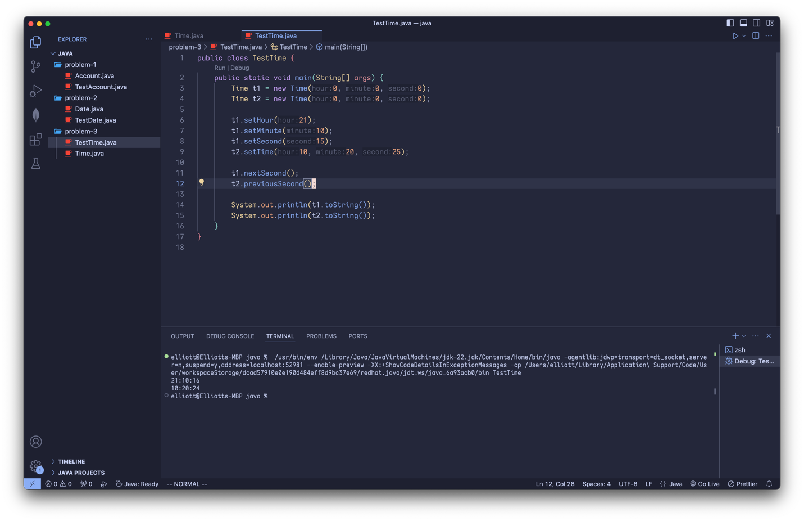

Extra Questions:

1. A bit less than an hour to complete.
2. A little bit of random googling, stack overflow and java documentation
3. No help from friends needed.
4. No extra help from instructors needed.
5. Easy overall. I would be confident working on more complex questions in the future.