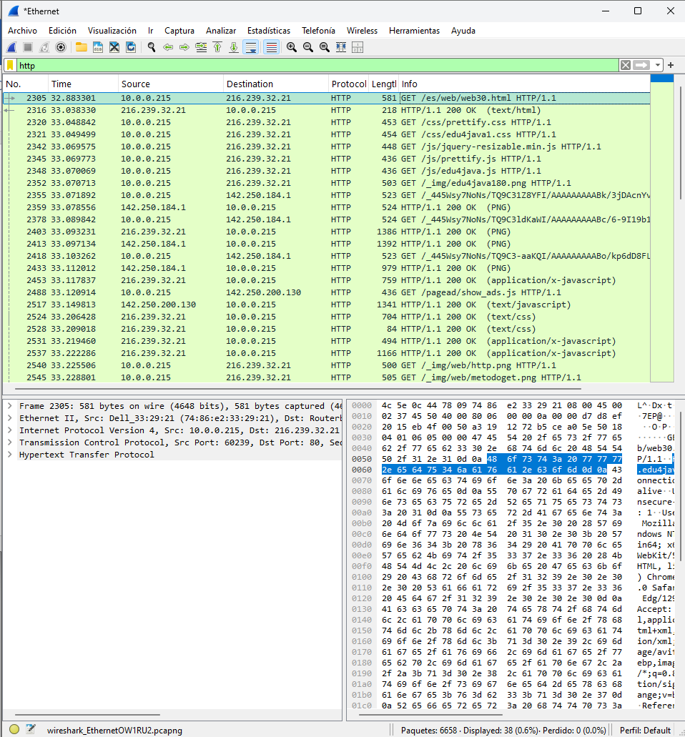

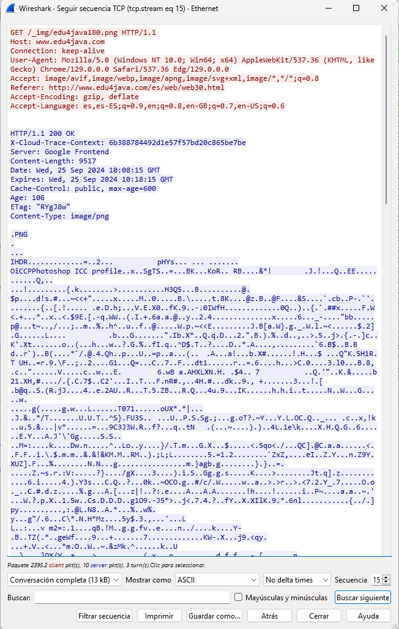

HEADERS

ACCEPT_ENCODING response header

ACCEPT_LANGUAGE