

***Дисциплина: Учебная практика***

**Отчет по выполнению задания на тему: «Lesson 2».**

Выполнил:

Группа: **1ИСП-11-18**

Студент: Белякова Анастасия

Проверил преподаватель:

Мартиросян Ваган Артемович

Москва 2022 г.

Задание 1.

create database ProductShop;

create table Products

(

ID int primary key identity,

productname nvarchar(50) unique not null,

price int not null,

quantity int not null,

stroragenumber int check (stroragenumber > 0 and stroragenumber <= 5)

);

insert into Products(productname, price, quantity, stroragenumber) values

('Капуста', 18, 154, 3),

('Лук', 10, 105, 4),

('Бедра куриные', 100, 654, 5),

('Сок яблочный', 80, 174, 1),

('Картофель', 25, 174, 1);

create table Staff

(

ID int primary key identity,

FirstName nvarchar(50) not null,

LastName nvarchar(50) not null,

Salary int,

Post nvarchar(50),

age int constraint DF_Staff_age default 20,

number nvarchar(16) unique,

constraint CK_Staff_age CHECK (age > 0 and age < 75)

);

insert into Staff(FirstName, LastName, age, Post, number, Salary) values

('Мария', 'Лодкина', 25, 'Диспетчер 1', '89776523698', 90000),

('Иван', 'Петров', 36, 'Диспетчер 2', '98775871122', 80000),

('Денис', 'Самойлов', 24, 'Диспетчер 3', '89785236698', 40000),

('Ирина', 'Кузнецова', 20, 'Диспетчер 4', '89586321456', 60000),

('Дмитрий', 'Юров', 27, 'Диспетчер 5', '89154558936', 60000);

create table Orders

(

ID int primary key identity,

productID int,

staffID int,

createdat datetime default current_timestamp,

foreign key (staffID) references staff (ID) on delete set null

);

insert into Orders(productID, staffID) values

(2, 5),

(1, 4),

(4, 2),

(3, 3),

(5, 1);

SELECT * FROM Staff;

SELECT * FROM Orders;

SELECT * FROM Products;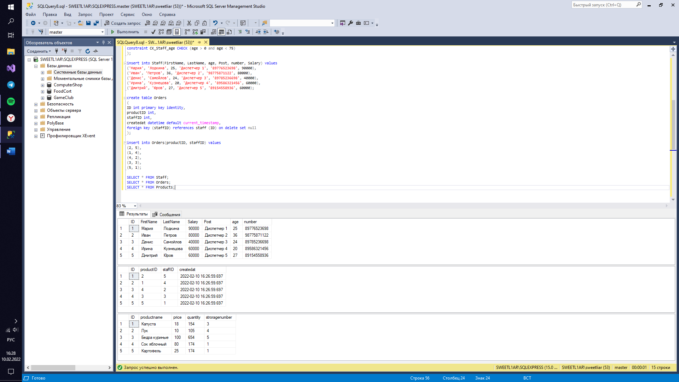

Задание 1.5

create database VegetFood;

create table customer

(

id int primary key identity,

firtsname nvarchar(50) not null,

lastname nvarchar(50) not null,

number nvarchar(18) unique,

email nvarchar(50) unique,

gender nvarchar(1) check (gender in ('М', 'Ж')),

adress nvarchar(90) not null

);

insert into customer(firtsname, lastname, number, email, gender, adress) values

('Мария', 'Иванова', '89162589632', 'mariaa31@mail.ru', 'Ж', 'ул. Куйбышева, 31'),

('Иван', 'Петров', '89151258745', 'ivan@gamail.com', 'М', 'ул. Ромашки, 56');

create table cart

(

order_code int primary key identity(0001, 1),

customerID int references customer (id),

delivery_or_pickup nvarchar(70) check (delivery_or_pickup in ('Самовывоз', 'Доставка'))not null,

registration_date date not null,

cost_of_order int check (cost_of_order > 0) not null,

sale int

);

insert into cart(customerID, delivery_or_pickup, registration_date, cost_of_order, sale) values

(1, 'Самовывоз', '2018-06-03', 1220, 100),

(2, 'Доставка', '2019-05-14', 1300, 0);

create table product

(

id int primary key identity(001, 1),

productname nvarchar(100) not null,

cost int check (cost > 0) not null,

specifications nvarchar(300) not null,

kkal nvarchar(10),

country_of_origin nvarchar(50)

);

insert into product(productname, cost, specifications, kkal, country_of_origin) values

('Свекольно-томатный суп-пюре', 1220, 'Свекла, томаты, лук, соль, перец, вода', '200', 'Россия'),

('Хумус с овощными палочками', 1300, 'Нут, чеснок, лимон, оливковое масло, зира, паприка, морковь, сельдерей', '450', 'Россия');

create table payment_method

(

id int primary key identity,

customerID int references customer (id),

cards nvarchar(3) check (cards in ('Да', 'Нет')),

cash nvarchar(3) check (cash in ('Да', 'Нет')),

online_card nvarchar(3) check (online_card in ('Да', 'Нет'))

);

insert into payment_method (customerID, cards, cash, online_card) values

(1, 'Да','Нет','Нет'),

(2, 'Нет','Нет','Да');

create table orders

(

id int primary key identity,

orderID int references cart (order_code),

productname nvarchar(100),

delivery_or_pickup nvarchar(70) check (delivery_or_pickup in ('Самовывоз', 'Доставка'))not null,

cost_of_order int check (cost_of_order > 0) not null

);

insert into orders(orderID, productname, delivery_or_pickup, cost_of_order) values

(0001, 'Свекольно-томатный суп-пюре', 'Самовывоз', 1220),

(0002, 'Хумус с овощными палочками', 'Доставка', 1300);

create table point_of_issue

(

id int primary key identity,

address_pickup_point nvarchar(100) not null,

driving_directions nvarchar(100),

working_hours nvarchar(20) not null,

number nvarchar(18) unique,

);

insert into point_of_issue(address_pickup_point, driving_directions, working_hours, number) values

('м. Домодедовская, Ореховый бульвар, 14 к.3', 'выход из 14 выхода, последний вагон из центра', 'с 10.00 до 23.00', '84995236985'),

('м. Каширская, Каширское шоссе 26', 'выход из 3-4 выхода, последний вагон из центра', 'с 9.00 до 22.00', '84956852147');

create table staff

(

id int primary key identity,

firtsname nvarchar(50) not null,

lastname nvarchar(50) not null,

number nvarchar(18) unique,

email nvarchar(50) unique,

gender nvarchar(1) check (gender in ('М', 'Ж')),

post nvarchar(50) not null,

salary int not null

);

insert into staff(firtsname, lastname, number, email, gender, post, salary) values

('Дмитрий', 'Серегин', '89775241258', 'seregindm@ya.ru', 'М', 'Продавец', 45000),

('Ирина', 'Сметанина', '89754256389', 'smetana@bk.ru', 'Ж', 'Диспетчер', 30000);

create table delivery

(

id int primary key identity,

ordersID int references orders (id),

number nvarchar(18) unique,

working_hours nvarchar(20) not null,

type_of_delivery nvarchar(50),

status_of_delivery nvarchar(50),

);

insert into delivery(ordersID, number, working_hours, type_of_delivery, status_of_delivery) values

(1, '84956325874', 'c 08.00 до 23.00', 'В пункт выдачи', 'В пути'),

(2, '84996587415', 'с 09.00 до 24.00', 'Курьером', 'Доставлено');

create table providers

(

id int primary key identity,

providername nvarchar(70),

email nvarchar(50) unique,

number nvarchar(18) unique,

adress nvarchar(200)

);

insert into providers(providername, email, number, adress) values

('Geel Food', 'foodgeel@gmail.com', '74953694179', 'г. Москва, ул. Марашала Бирюзова, д. 27'),

('VegaFood', 'vegafood@mail.ru', '88007707999', 'г. Москва, ул. 1905 года, д. 44');

create table receipts

(

id int primary key identity,

prodID int references product(id),

quantity int not null,

delivery_date date,

delivery_amount nvarchar(50)

);

insert into receipts(prodID, quantity, delivery_date, delivery_amount) values

(001, 200, '2017-05-02', '244 000 р.'),

(002, 600, '2016-06-09', '780 000 р.');

select * from customer;

select * from staff;

select * from product;

select * from cart;

select * from orders;

select * from providers;

select * from delivery;

select * from point_of_issue;

select * from receipts;

select * from payment_method;

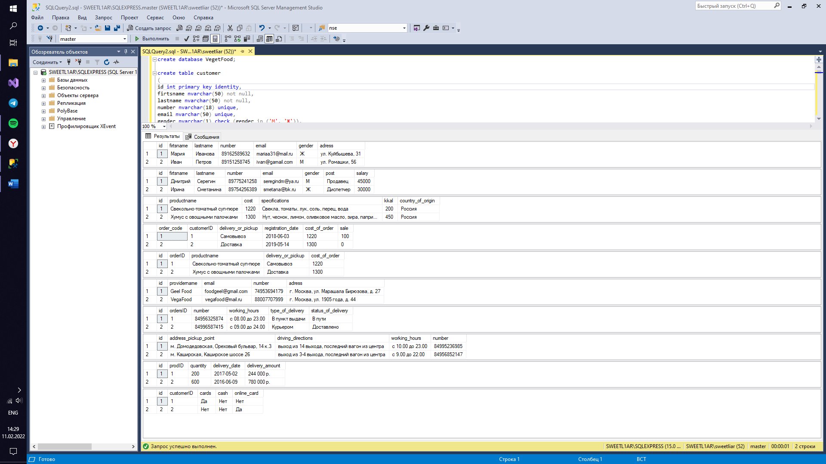

Задание 2.

create database KeyboardShop;

create table Products

(

ID int primary key identity,

productname nvarchar(200) unique not null,

price int not null,

quantity int check (quantity > 0) not null,

);

insert into Products(productname, price, quantity) values

('Клавиатура Logitech K270', 2390, 154),

('Клавиатура Oklick 760G GENESIS', 1100, 105),

('Клавиатура A4TECH Bloody B500N', 2199, 654),

('Клавиатура Microsoft Ergonomic', 3890, 174),

('Клавиатура Defender Metal Hunter GK-140L', 829, 174);

create table customer

(

ID int primary key identity,

FirstName nvarchar(50) not null,

LastName nvarchar(50) not null,

ordername nvarchar(30) not null,

cart nvarchar(200) not null

);

insert into customer(FirstName, LastName, ordername, cart) values

('Дмитрий', 'Иванов', 2205, 'Клавиатура Defender Metal Hunter GK-140L'),

('Ирина', 'Дмитрова', 1055, 'Клавиатура Oklick 760G GENESIS'),

('Иван', 'Людин', 2360, 'Клавиатура Microsoft Ergonomic'),

('Сергей', 'Петров', 4590, 'Клавиатура A4TECH Bloody B500N'),

('Мария', 'Семенова', 4582, 'Клавиатура Logitech K270');

create table Staff

(

ID int primary key identity,

FirstName nvarchar(50) not null,

LastName nvarchar(50) not null,

Salary int,

Post nvarchar(50),

age int constraint DF_Staff_age default 20,

number nvarchar(16) unique,

constraint CK_Staff_age CHECK (age > 0 and age < 75)

);

insert into Staff(FirstName, LastName, age, Post, number, Salary) values

('Мария', 'Лодкина', 25, 'Диспетчер 1', '89776523698', 90000),

('Иван', 'Петров', 36, 'Диспетчер 2', '98775871122', 80000),

('Денис', 'Самойлов', 24, 'Диспетчер 3', '89785236698', 40000),

('Ирина', 'Кузнецова', 20, 'Диспетчер 4', '89586321456', 60000),

('Дмитрий', 'Юров', 27, 'Диспетчер 5', '89154558936', 60000);

create table Orders

(

ID int primary key identity,

productID int,

staffID int,

createdat datetime default current_timestamp,

foreign key (staffID) references staff (ID) on delete set null

);

insert into Orders(productID, staffID) values

(1, 2),

(2, 1),

(3, 3),

(4, 5),

(5, 4);

select * from Staff;

select * from customer;

select * from Products;

select * from Orders;

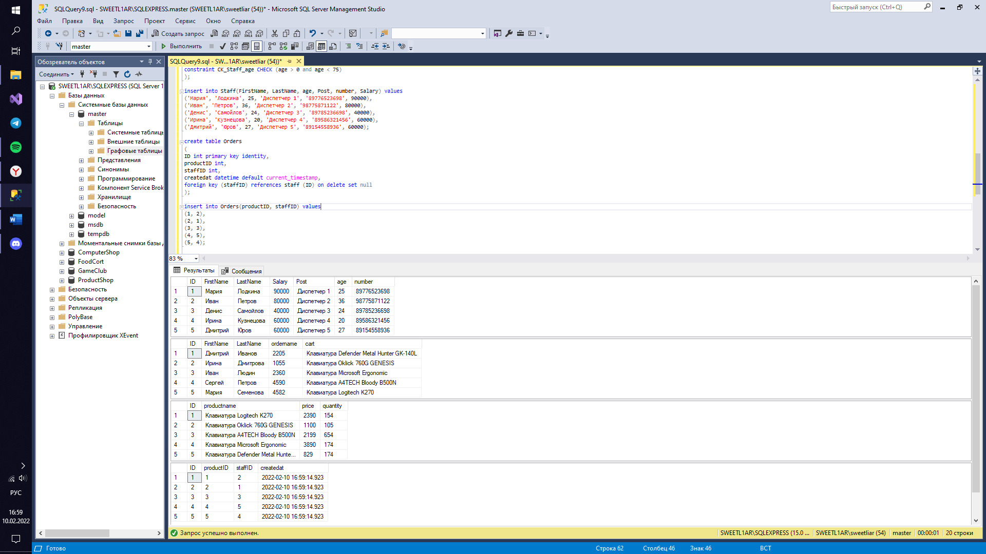

Задание 2.5

create database MouseShop;

create table customer /*заказчик*/

(

id int primary key identity,

firtsname nvarchar(50) not null,

lastname nvarchar(50) not null,

number nvarchar(18) unique,

email nvarchar(50) unique,

gender nvarchar(1) check (gender in ('М', 'Ж')),

adress nvarchar(90) not null

);

insert into customer(firtsname, lastname, number, email, gender, adress) values

('Мария', 'Иванова', '89162589632', 'mariaa31@mail.ru', 'Ж', 'ул. Куйбышева, 31'),

('Иван', 'Петров', '89151258745', 'ivan@gamail.com', 'М', 'ул. Ромашки, 56');

create table cart /*корзина*/

(

order_code int primary key identity(0001, 1),

customerID int references customer (id),

delivery_or_pickup nvarchar(70) check (delivery_or_pickup in ('Самовывоз', 'Доставка'))not null,

registration_date date not null,

cost_of_order int check (cost_of_order > 0) not null,

sale int

);

insert into cart(customerID, delivery_or_pickup, registration_date, cost_of_order, sale) values

(1, 'Самовывоз', '2018-06-03', 3790, 100),

(2, 'Доставка', '2019-05-14', 1490, 0);

create table product /*продукция*/

(

id int primary key identity(001, 1),

productname nvarchar(100) not null,

cost int check (cost > 0) not null,

specifications nvarchar(300) not null,

warranty nvarchar(10),

country_of_origin nvarchar(50)

);

insert into product(productname, cost, specifications, warranty, country_of_origin) values

('Мышь Logitech G305 Lightspeed', 3790, 'беспроводная, 12000 dpi, 5 кнопок', '24 мес.', 'Китай'),

('Мышь A4TECH Bloody V7', 1490, 'проводная, 3200 dpi, 8 кнопок', '12 мес.', 'Китай');

create table payment_method /*метод оплаты*/

(

id int primary key identity,

customerID int references customer (id),

cards nvarchar(3) check (cards in ('Да', 'Нет')),

cash nvarchar(3) check (cash in ('Да', 'Нет')),

online_card nvarchar(3) check (online_card in ('Да', 'Нет'))

);

insert into payment_method (customerID, cards, cash, online_card) values

(1, 'Да','Нет','Нет'),

(2, 'Нет','Нет','Да');

create table orders /*заказ*/

(

id int primary key identity,

orderID int references cart (order_code),

productname nvarchar(100),

delivery_or_pickup nvarchar(70) check (delivery_or_pickup in ('Самовывоз', 'Доставка'))not null,

cost_of_order int check (cost_of_order > 0) not null

);

insert into orders(orderID, productname, delivery_or_pickup, cost_of_order) values

(0001, 'Мышь Logitech G305 Lightspeed', 'Самовывоз', 3790),

(0002, 'Мышь A4TECH Bloody V7', 'Доставка', 1490);

create table point_of_issue /*пункт выдачи*/

(

id int primary key identity,

address_pickup_point nvarchar(100) not null,

driving_directions nvarchar(100), /*маршрут*/

working_hours nvarchar(20) not null,

number nvarchar(18) unique,

);

insert into point_of_issue(address_pickup_point, driving_directions, working_hours, number) values

('м. Домодедовская, Ореховый бульвар, 14 к.3', 'выход из 14 выхода, последний вагон из центра', 'с 10.00 до 23.00', '84995236985'),

('м. Каширская, Каширское шоссе 26', 'выход из 3-4 выхода, последний вагон из центра', 'с 9.00 до 22.00', '84956852147');

create table staff /*стаф*/

(

id int primary key identity,

firtsname nvarchar(50) not null,

lastname nvarchar(50) not null,

number nvarchar(18) unique,

email nvarchar(50) unique,

gender nvarchar(1) check (gender in ('М', 'Ж')),

post nvarchar(50) not null,

salary int not null

);

insert into staff(firtsname, lastname, number, email, gender, post, salary) values

('Дмитрий', 'Серегин', '89775241258', 'seregindm@ya.ru', 'М', 'Продавец', 45000),

('Ирина', 'Сметанина', '89754256389', 'smetana@bk.ru', 'Ж', 'Диспетчер', 30000);

create table delivery /*доставка*/

(

id int primary key identity,

ordersID int references orders (id),

number nvarchar(18) unique,

working_hours nvarchar(20) not null,

type_of_delivery nvarchar(50),

status_of_delivery nvarchar(50),

);

insert into delivery(ordersID, number, working_hours, type_of_delivery, status_of_delivery) values

(1, '84956325874', 'c 08.00 до 23.00', 'В пункт выдачи', 'В пути'),

(2, '84996587415', 'с 09.00 до 24.00', 'Курьером', 'Доставлено');

create table providers /*поставщик*/

(

id int primary key identity,

providername nvarchar(70),

email nvarchar(50) unique,

number nvarchar(18) unique,

adress nvarchar(200)

);

insert into providers(providername, email, number, adress) values

('Ситилинк', 'Zapros_mskb2b@citilink.ru', '74957802002', 'г.Москва, Багратионовский пр-д, д.5'),

('DNS', 'DNS-shop@gmail.com', '88007707999', 'г. Москва, ул. Генерала Кузнецова, дом 22');

create table receipts /*поступления*/

(

id int primary key identity,

prodID int references product(id),

quantity int not null,

delivery_date date,

delivery_amount nvarchar(50)

);

insert into receipts(prodID, quantity, delivery_date, delivery_amount) values

(001, 150, '2017-05-02', '568 500 р.'),

(002, 250, '2016-06-09', '3725 000 р.');

select * from customer;

select * from staff;

select * from product;

select * from cart;

select * from orders;

select * from providers;

select * from delivery;

select * from point_of_issue;

select * from receipts;

select * from payment_method;

