

***Дисциплина: Учебная практика***

**Отчет по выполнению задания на тему: «Lesson 1».**

Выполнил: Белякова А.А.

Проверил преподаватель:

Москва 2021 г.

Задание 1.

using System;

namespace ConsoleApp1

{

class Program

{

static void Main(string[] args)

{

string a, b;

Console.WriteLine("Enter your name: ");

a = Console.ReadLine();

Console.WriteLine("Enter your surname: ");

b = Console.ReadLine();

Console.WriteLine("Your name is {0}, surname {1}", a, b);

Console.ReadKey();

}

}

}

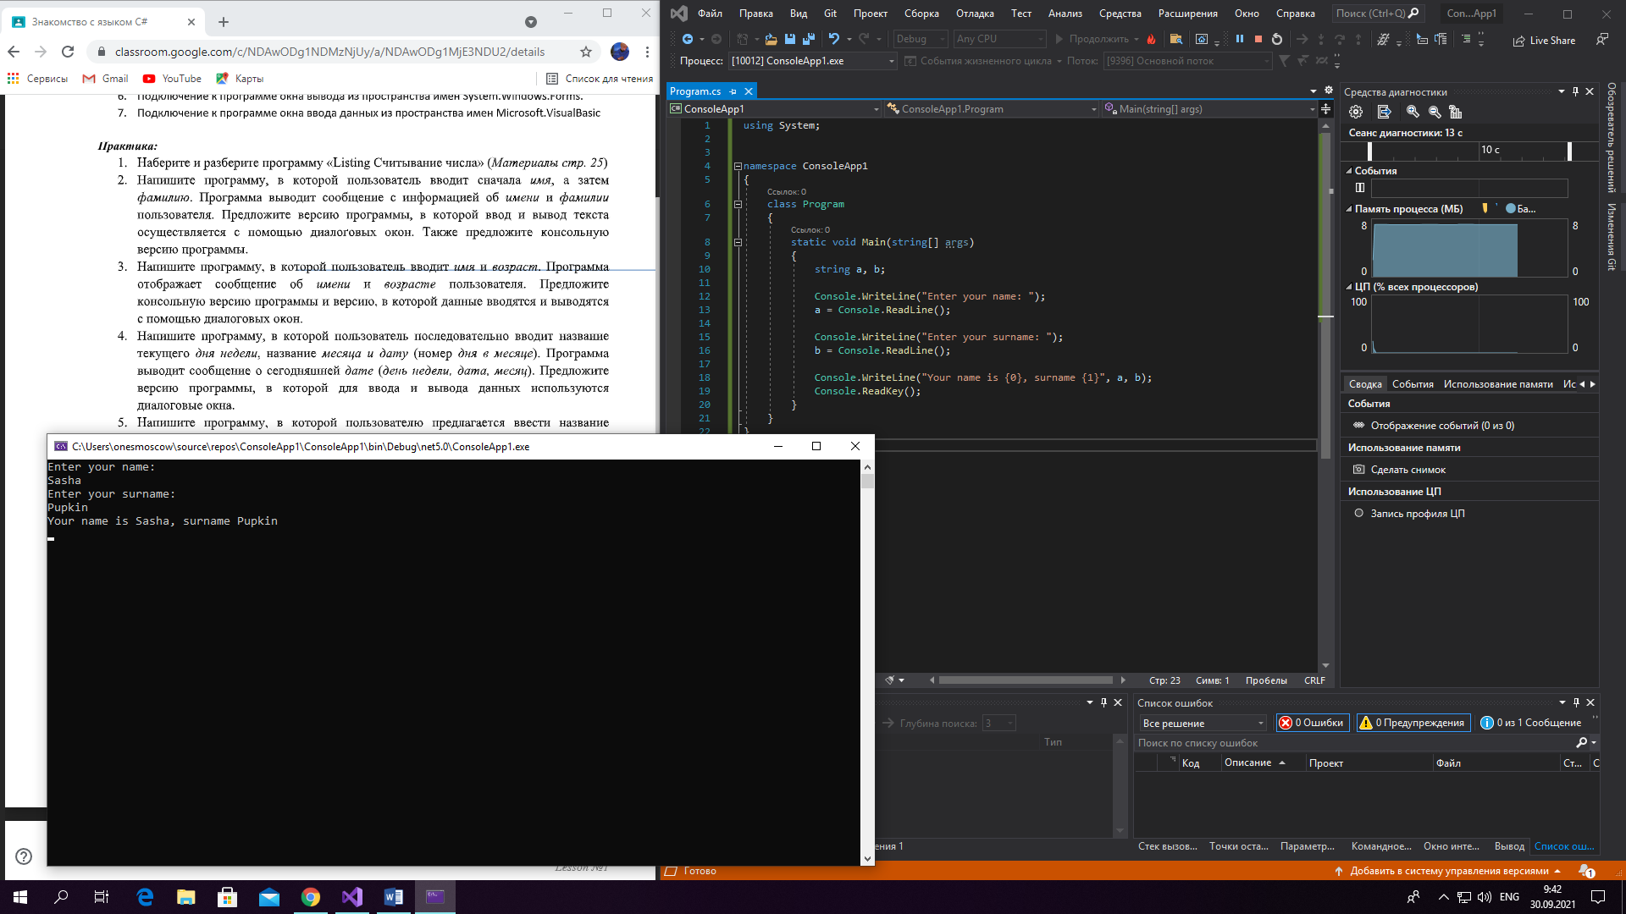

Задание 2.

using System;

namespace ConsoleApp1

{

class Program

{

static void Main(string[] args)

{

string a;

int b = 0;

Console.WriteLine("Enter your name: ");

a = Console.ReadLine();

Console.WriteLine("Enter your age: ");

b = int.Parse(Console.ReadLine());

Console.WriteLine("Your name is {0}, you are {1} y.o.", a, b);

Console.ReadKey();

}

}

}

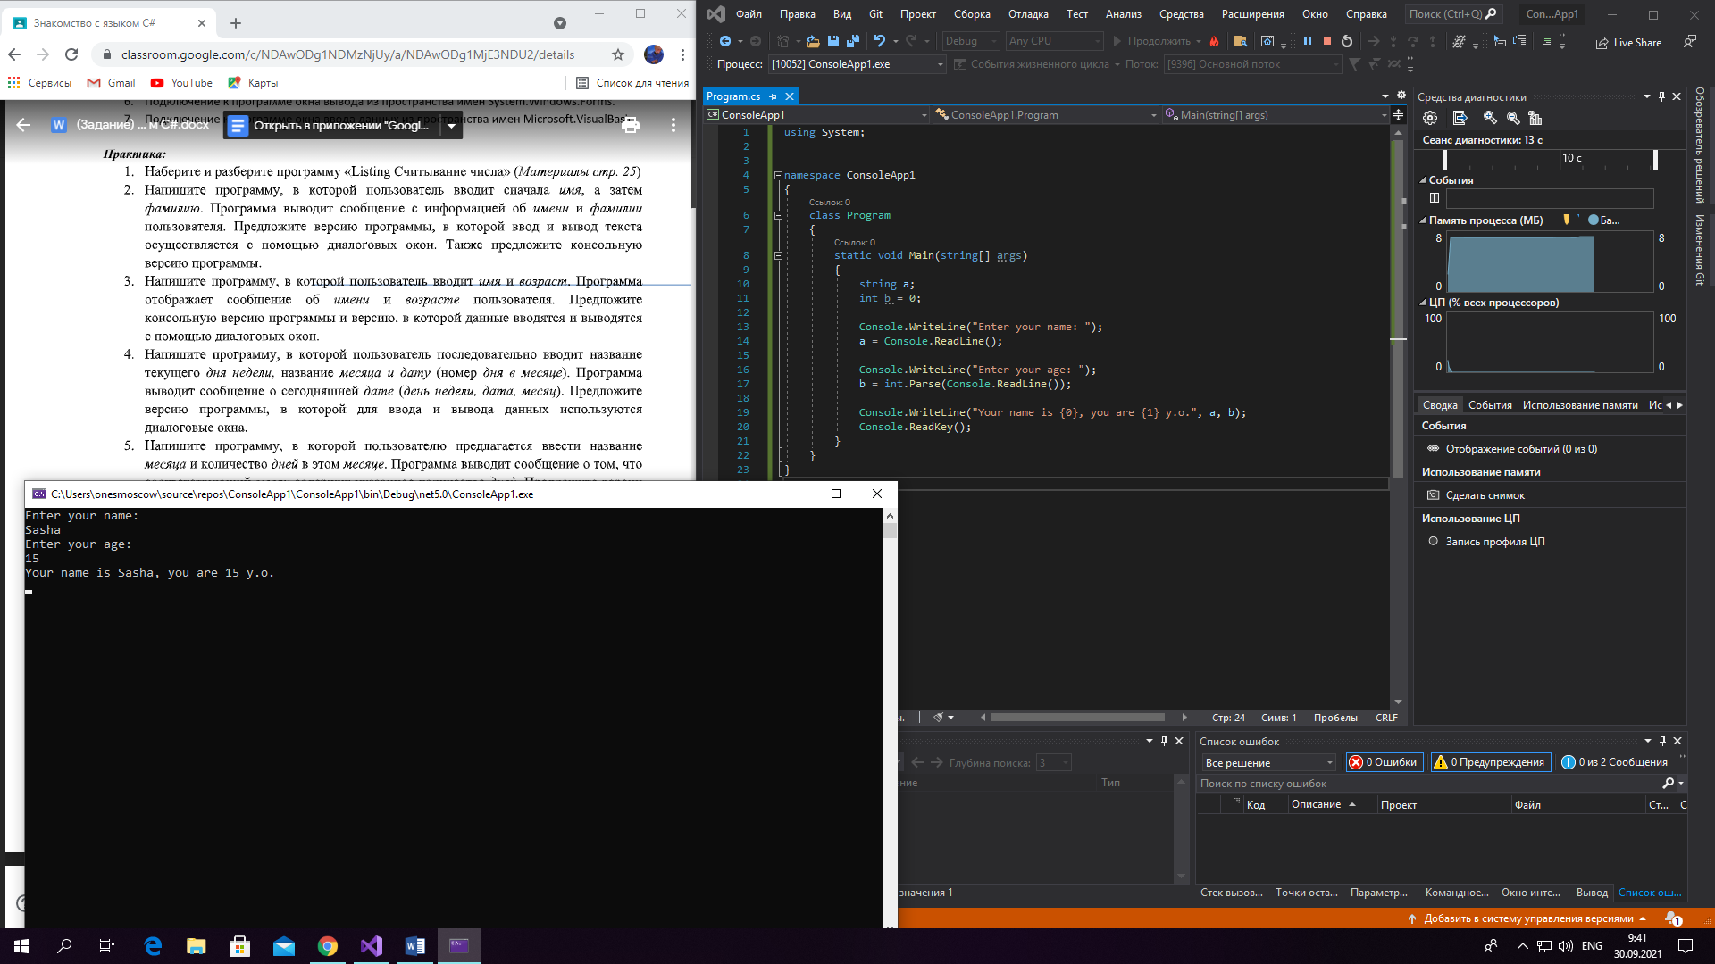

Задание 3.

using System;

namespace ConsoleApp1

{

class Program

{

static void Main(string[] args)

{

string a, c;

int b = 0;

Console.WriteLine("Enter the name of day: ");

a = Console.ReadLine();

Console.WriteLine("Enter the name of months: ");

c = Console.ReadLine();

Console.WriteLine("Enter the date: ");

b = int.Parse(Console.ReadLine());

Console.WriteLine("Today is {0}, {1}, {2}", a, b, c);

Console.ReadKey();

}

}

}

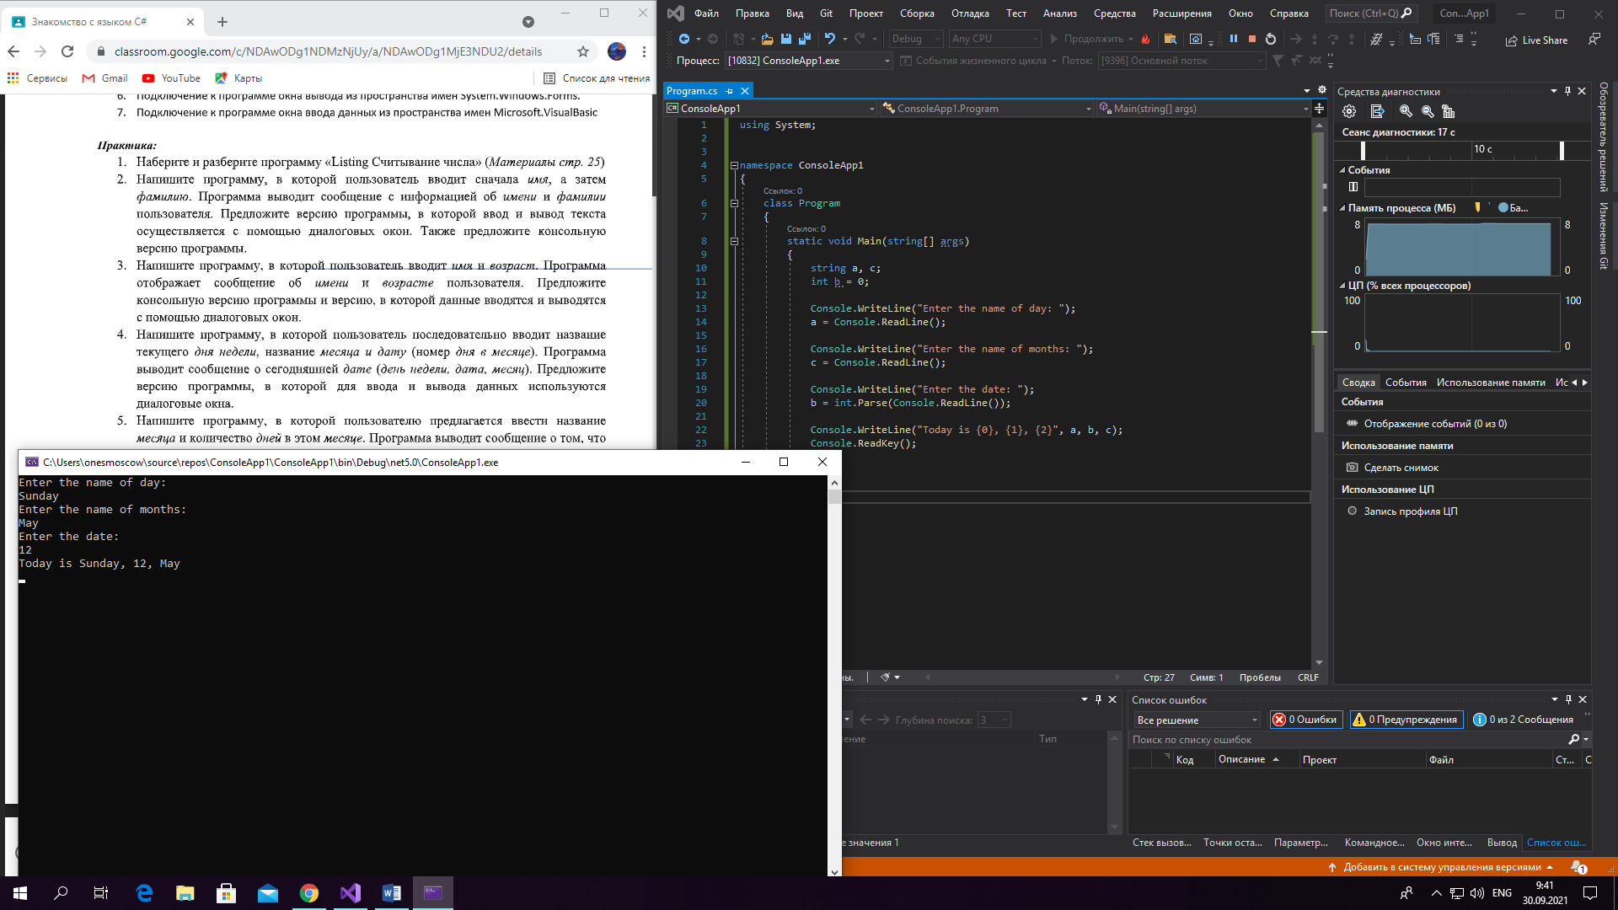

Задание 4.

using System;

namespace ConsoleApp1

{

class Program

{

static void Main(string[] args)

{

string b;

int a = 0;

Console.WriteLine("Enter the number of days: ");

a = int.Parse(Console.ReadLine());

Console.WriteLine("Enter the name of months: ");

b = Console.ReadLine();

Console.WriteLine("{1} contains {0} days", a, b);

Console.ReadKey();

}

}

}

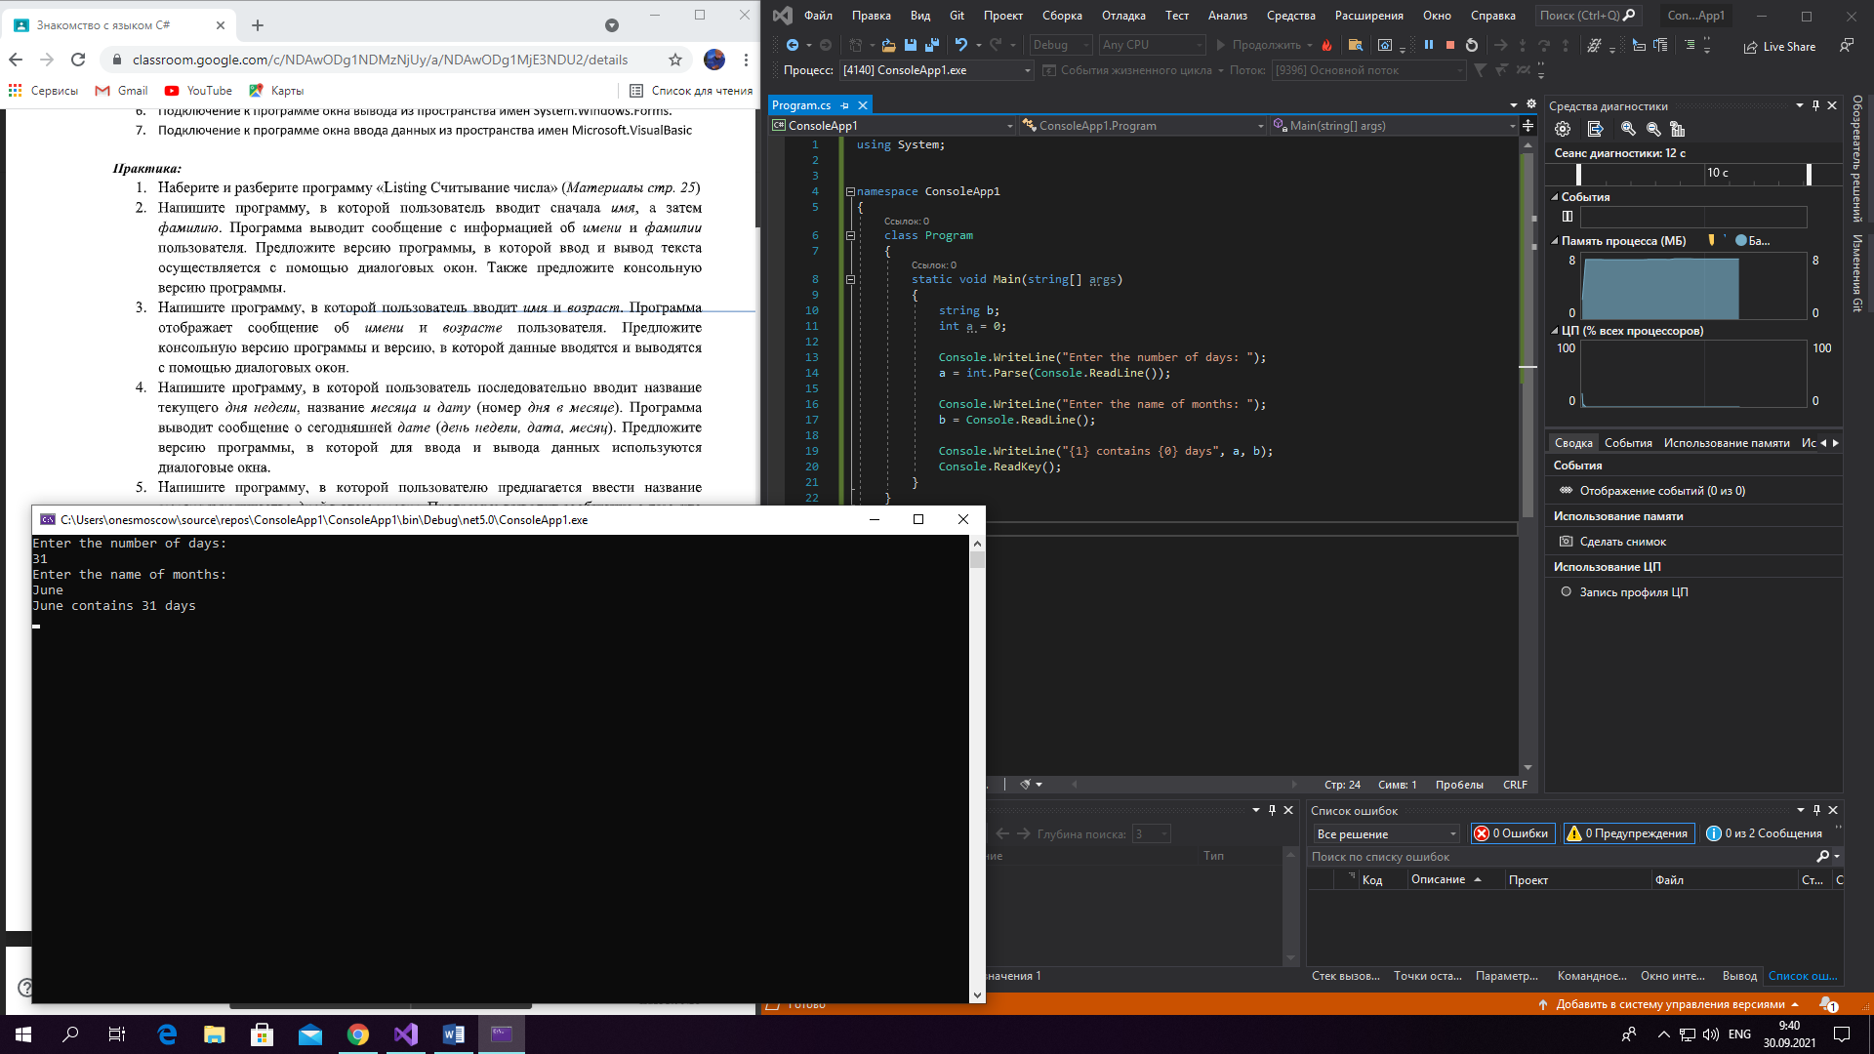

Задание 5.

using System;

namespace ConsoleApp1

{

class Program

{

static void Main(string[] args)

{

int a = 0, c = 2021;

Console.WriteLine("Enter the year of your birth: ");

a = int.Parse(Console.ReadLine());

Console.WriteLine("You are {0} y.o.", c - a);

Console.ReadKey();

}

}

}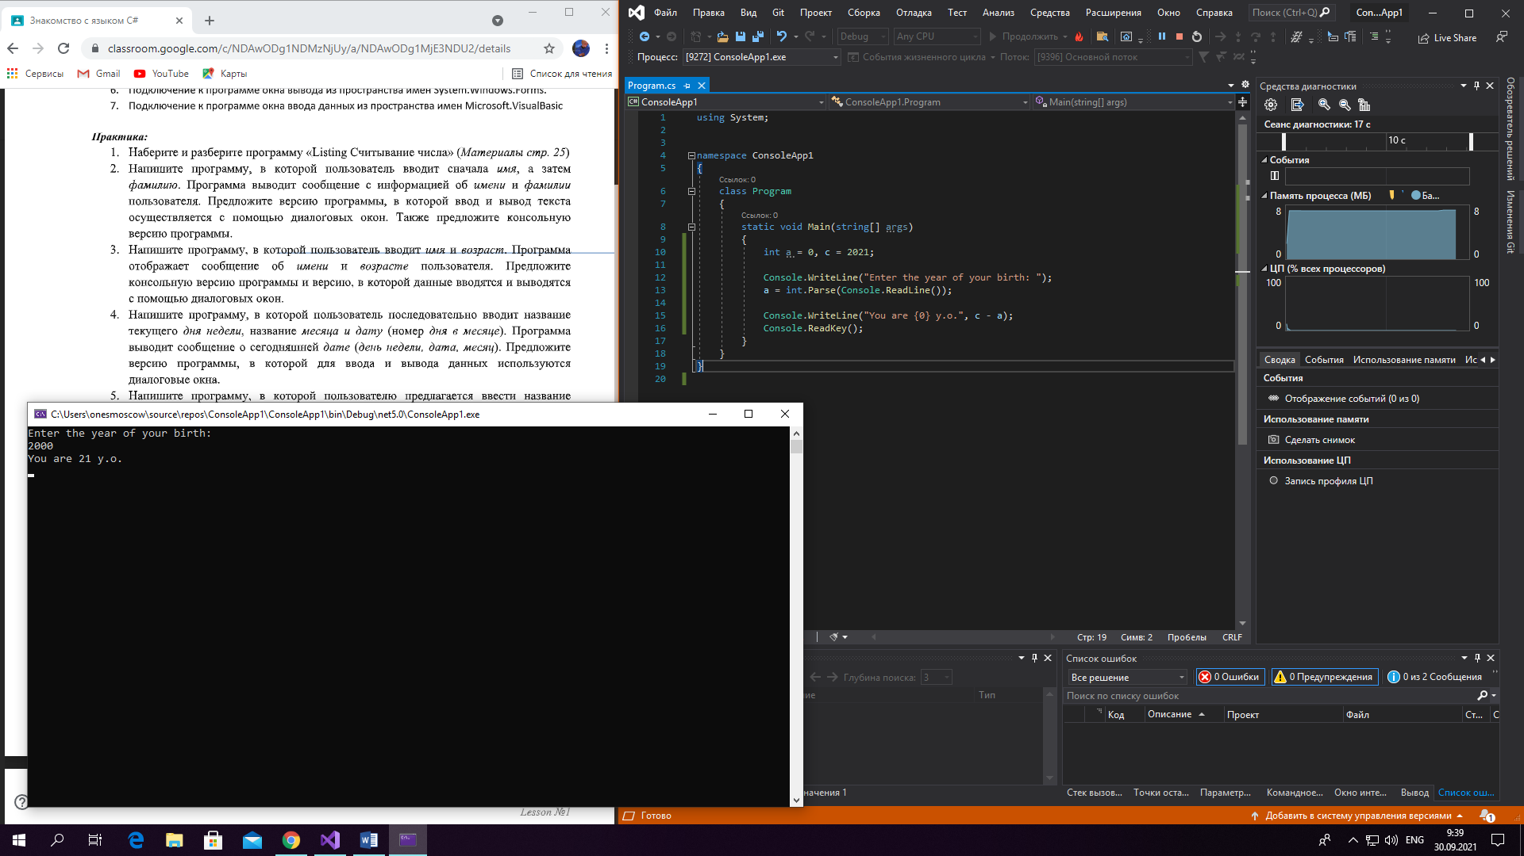

Задание 6.

using System;

namespace ConsoleApp1

{

class Program

{

static void Main(string[] args)

{

string a,b;

Console.WriteLine("Enter your name: ");

a = Console.ReadLine();

Console.WriteLine("Enter year of your birth");

b=Console.ReadLine();

Console.WriteLine("Your name is {0}, and year of your birth is {1}", a, b);

Console.ReadKey();

}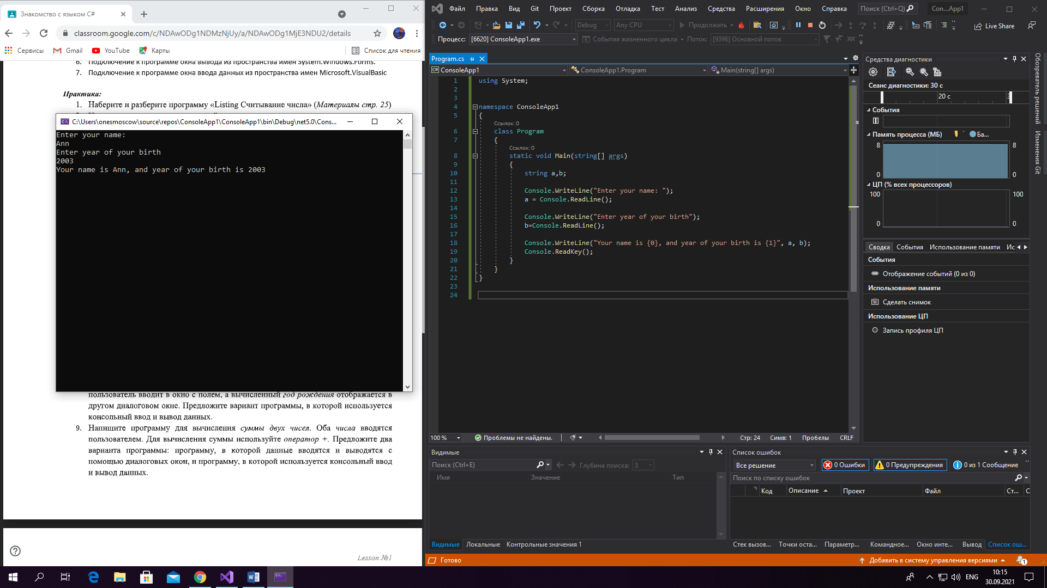

Задание 7.

using System;

namespace ConsoleApp1

{

class Program

{

static void Main(string[] args)

{

int a = 0, c = 2021;

Console.WriteLine("Enter your age: ");

a = int.Parse(Console.ReadLine());

Console.WriteLine("Year of your birth {0} ", c - a);

Console.ReadKey();

}

}

}

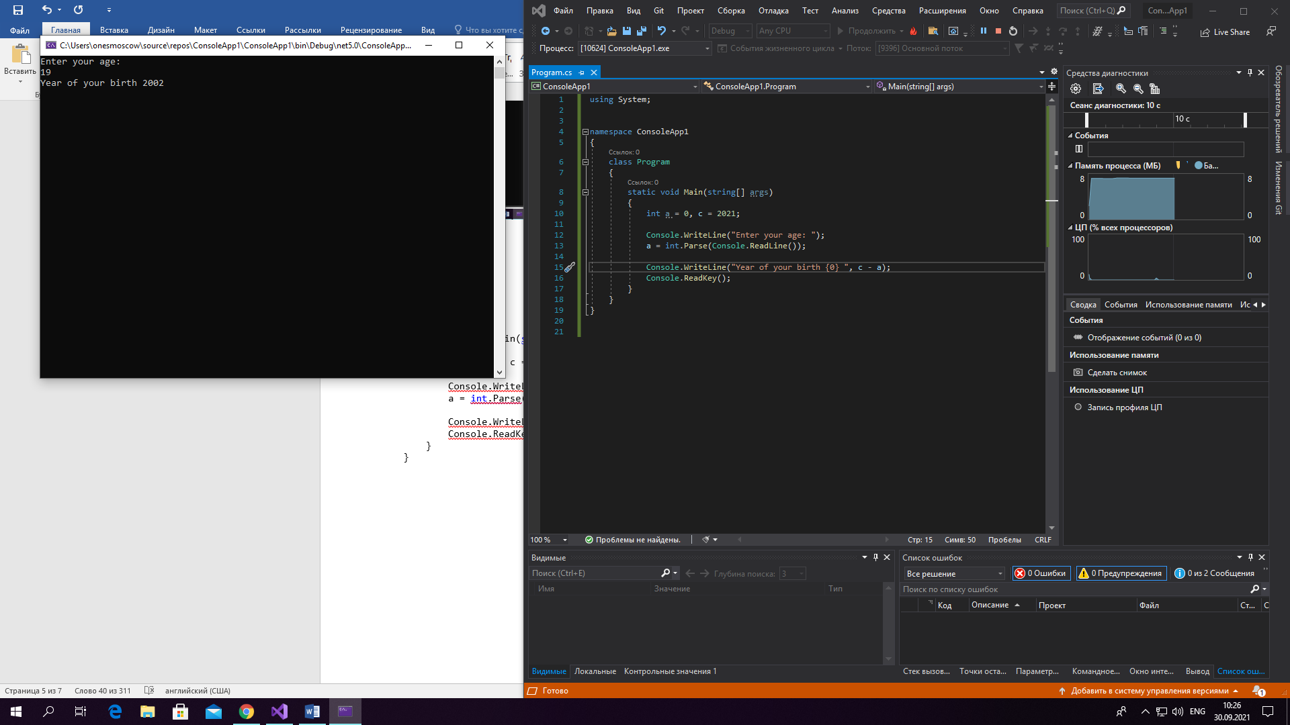

Задание 8.

using System;

namespace ConsoleApp1

{

class Program

{

static void Main(string[] args)

{

int a = 0, c = 1;

Console.WriteLine("Enter the number : ");

a = int.Parse(Console.ReadLine());

Console.WriteLine("Enter the second number");

c = int.Parse(Console.ReadLine());

Console.WriteLine($"Sum = {c+ a}");

Console.ReadKey();

}

}

}

