Creating Repository in GitHub

Step 1 Click new nearby repository

Step 2 Give the repository name

Step 3 select the "Add README"

Step 4 Click Create Repository

Adding Content to README file

Step 1 Open the repository create

Step 2 Open README.md in edit mode and add the content

Step 3 Click commit changes

Creating Repository in GitHub

Step 1 Click new nearby repository

Step 2 Give the repository name

Step 3 select the "Add README"

Step 4 Click Create Repository

Adding Content to README file

Step 1 Open the repository create

Step 2 Open README.md in edit mode and add the content

Step 3 Click commit changes

Creating Repository in GitHub

Step 1 Click new nearby repository

Step 2 Give the repository name

Step 3 select the "Add README"

Step 4 Click Create Repository

Adding Content to README file

Step 1 Open the repository create

Step 2 Open README.md in edit mode and add the content

Step 3 Click commit changes

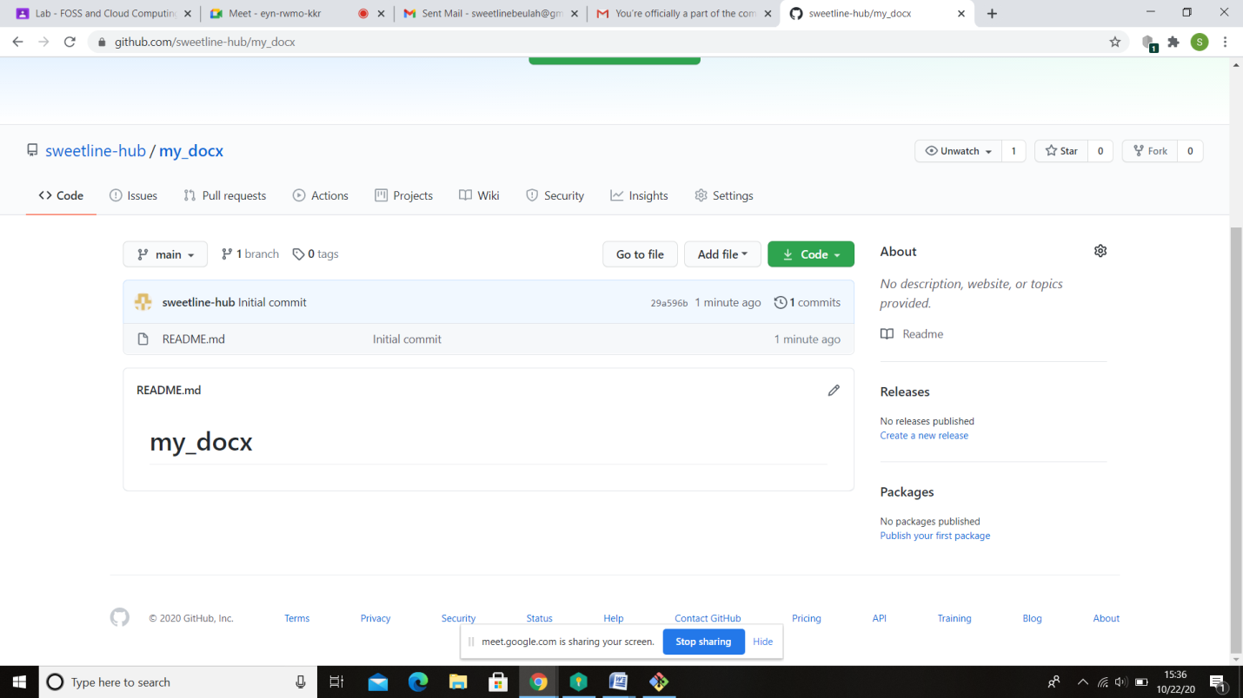

**CLONING REPOSITORY :**

$ ls

'3D Objects'/

AppData/

'Application Data'@

Contacts/

Cookies@

Desktop/

Documents/

Downloads/

Favorites/

IntelGraphicsProfiles/

Links/

'Local Settings'@

MicrosoftEdgeBackups/

Music/

'My Documents'@

my_doc/

NetHood@

NTUSER.DAT

ntuser.dat.LOG1

ntuser.dat.LOG2

NTUSER.DAT{1c3790b4-b8ad-11e8-aa21-e41d2d101530}.TM.blf

NTUSER.DAT{1c3790b4-b8ad-11e8-aa21-e41d2d101530}.TMContainer00000000000000000001.regtrans-ms

NTUSER.DAT{1c3790b4-b8ad-11e8-aa21-e41d2d101530}.TMContainer00000000000000000002.regtrans-ms

ntuser.ini

OneDrive/

Pictures/

PrintHood@

Recent@

'Saved Games'/

Searches/

SendTo@

'Start Menu'@

Templates@

Videos/

hp@DESKTOP-269QOF4 MINGW64 ~

$ git clone https://github.com/sweetline-hub/my_docx.git

Cloning into 'my_docx'...

remote: Enumerating objects: 3, done.

remote: Counting objects: 100% (3/3), done.

remote: Total 3 (delta 0), reused 0 (delta 0), pack-reused 0

Unpacking objects: 100% (3/3), 594 bytes | 3.00 KiB/s, done.

hp@DESKTOP-269QOF4 MINGW64 ~

$ ls

'3D Objects'/ Documents/ MicrosoftEdgeBackups/ NTUSER.DAT ntuser.ini Searches/

AppData/ Downloads/ Music/ ntuser.dat.LOG1 OneDrive/ SendTo@

'Application Data'@ Favorites/ 'My Documents'@ ntuser.dat.LOG2 Pictures/ 'Start Menu'@

Contacts/ IntelGraphicsProfiles/ my_doc/ NTUSER.DAT{1c3790b4-b8ad-11e8-aa21-e41d2d101530}.TM.blf PrintHood@ Templates@

Cookies@ Links/ my_docx/ NTUSER.DAT{1c3790b4-b8ad-11e8-aa21-e41d2d101530}.TMContainer00000000000000000001.regtrans-ms Recent@ Videos/

Desktop/ 'Local Settings'@ NetHood@ NTUSER.DAT{1c3790b4-b8ad-11e8-aa21-e41d2d101530}.TMContainer00000000000000000002.regtrans-ms 'Saved Games'/

**MOVING TO THE REPOSITORY :**

$ pwd

/c/Users/hp

hp@DESKTOP-269QOF4 MINGW64 ~

$ cd my_docx

**ADDING FILES TO REPOSITORY-ADD COMMAND :**