**Jennifer Main**

**CST-150 Programming in C# I**

**Activity 13 – TicTacToe**

**Due Date: 12/5/21**

Contents

Git Hub Link 3

Rubric - Create and utilize a two-dimensional array to manage a collection of data 3

Rubric - Use the .NET environment to develop a simple graphical user interface using built-in tools 3

# Git Hub Link

# Rubric - Create and utilize a two-dimensional array to manage a collection of data

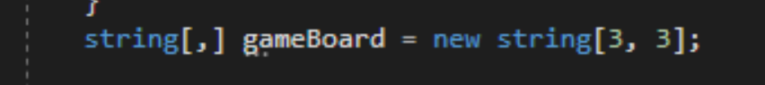

I create a blank 2D array

The array indexes are assigned based on text from the form.

# Rubric - Use the .NET environment to develop a simple graphical user interface using built-in tools

This time I tried changing colors

The user begins to play

When user wins the gameboard is disabled, the players receive a message box and are able to restart the game.