**Jennifer Main**

**CST-150 Programming in C# I**

**Activity 9 Method Stubs**

**Due Date: 11/28/21**

Contents

GitHub Links 3

Write a method that takes two integers and displays their sum. 3

Write a method that takes five doubles and returns their average. 3

Write a method that returns the sum of two randomly generated integers. 3

Write a method that takes three integers and returns true if their sum is divisible by 3, false otherwise. 3

Write a method that takes two strings and displays the string that has fewer characters. 4

Write a method that takes an array of doubles and returns the largest value in the array. 4

Write a method that generates and returns an array of fifty integer values. 4

Write a method that takes two bool variables and returns true if they have the same value, false otherwise. 5

Write a method that takes an int and a double and returns their product. 5

Write a method that takes a two-dimensional array of integers and returns the average of the entries. 5

# GitHub Links

# Write a method that takes two integers and displays their sum.

# Write a method that takes five doubles and returns their average.

# Write a method that returns the sum of two randomly generated integers.

# Write a method that takes three integers and returns true if their sum is divisible by 3, false otherwise.

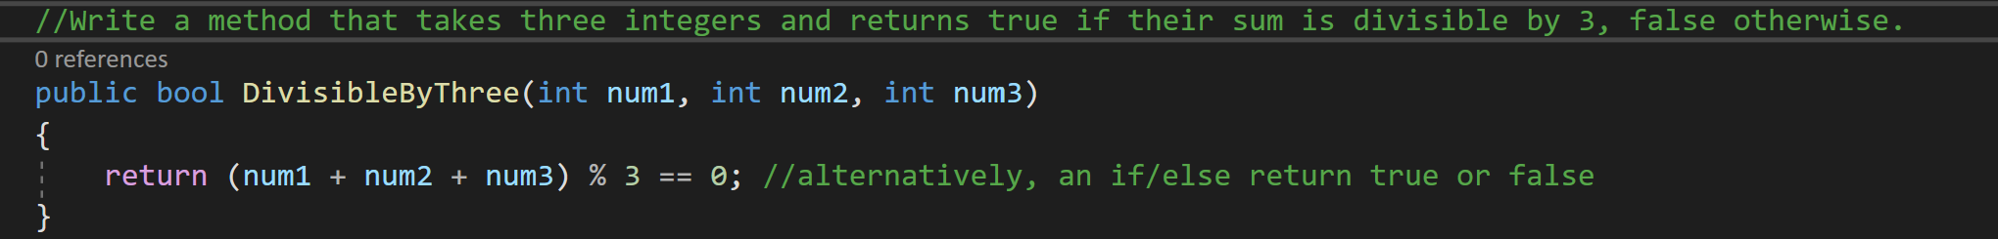

# Write a method that takes two strings and displays the string that has fewer characters.

# Write a method that takes an array of doubles and returns the largest value in the array.

# Write a method that generates and returns an array of fifty integer values.

# Write a method that takes two bool variables and returns true if they have the same value, false otherwise.

# Write a method that takes an int and a double and returns their product.

# Write a method that takes a two-dimensional array of integers and returns the average of the entries.

