ABSTRACT:

The Computer Vision takes place in modern world and deals with images. Recognition of hand signals of cyclist is a new type of CV project. Implementation of project has different steps and then
the steps are reunioned. The stages are detection of objects and training of body postures in order to predict the signal.Combination of the stages gives different result with respect to given input image.
The purposed aim is creating safety traffic and driving in a enviroment that contains autonomous systems and human beings.

1.INTRODUCTION :

In growthing world , scientific and innovative discoveries have focused on Artificial Intelligence and Automotive Systems. The researchs shows that growth in autonomous cars are increasing day-by-day

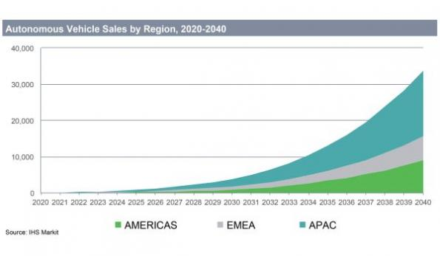

(1)

The developers of autonomous cars aim to increasing traffic safety and decreaing costs of products.
The first solution of finding roads and deciding of trace road is Computer Vision.

Computer vision is an interdisciplinary scientific field that deals with how computers can be made to gain high-level understanding from digital images or videos. From the perspective of engineering, it seeks to automate tasks that the human visual system can do.(2)

Computer vision deals with current problems:

- Safety
- Unclear Lane Markings
- Detect Small or Insıgnıfıcant Objects
- Stop at Police Signal
- Identify Traffic Lights
- Weather Independent

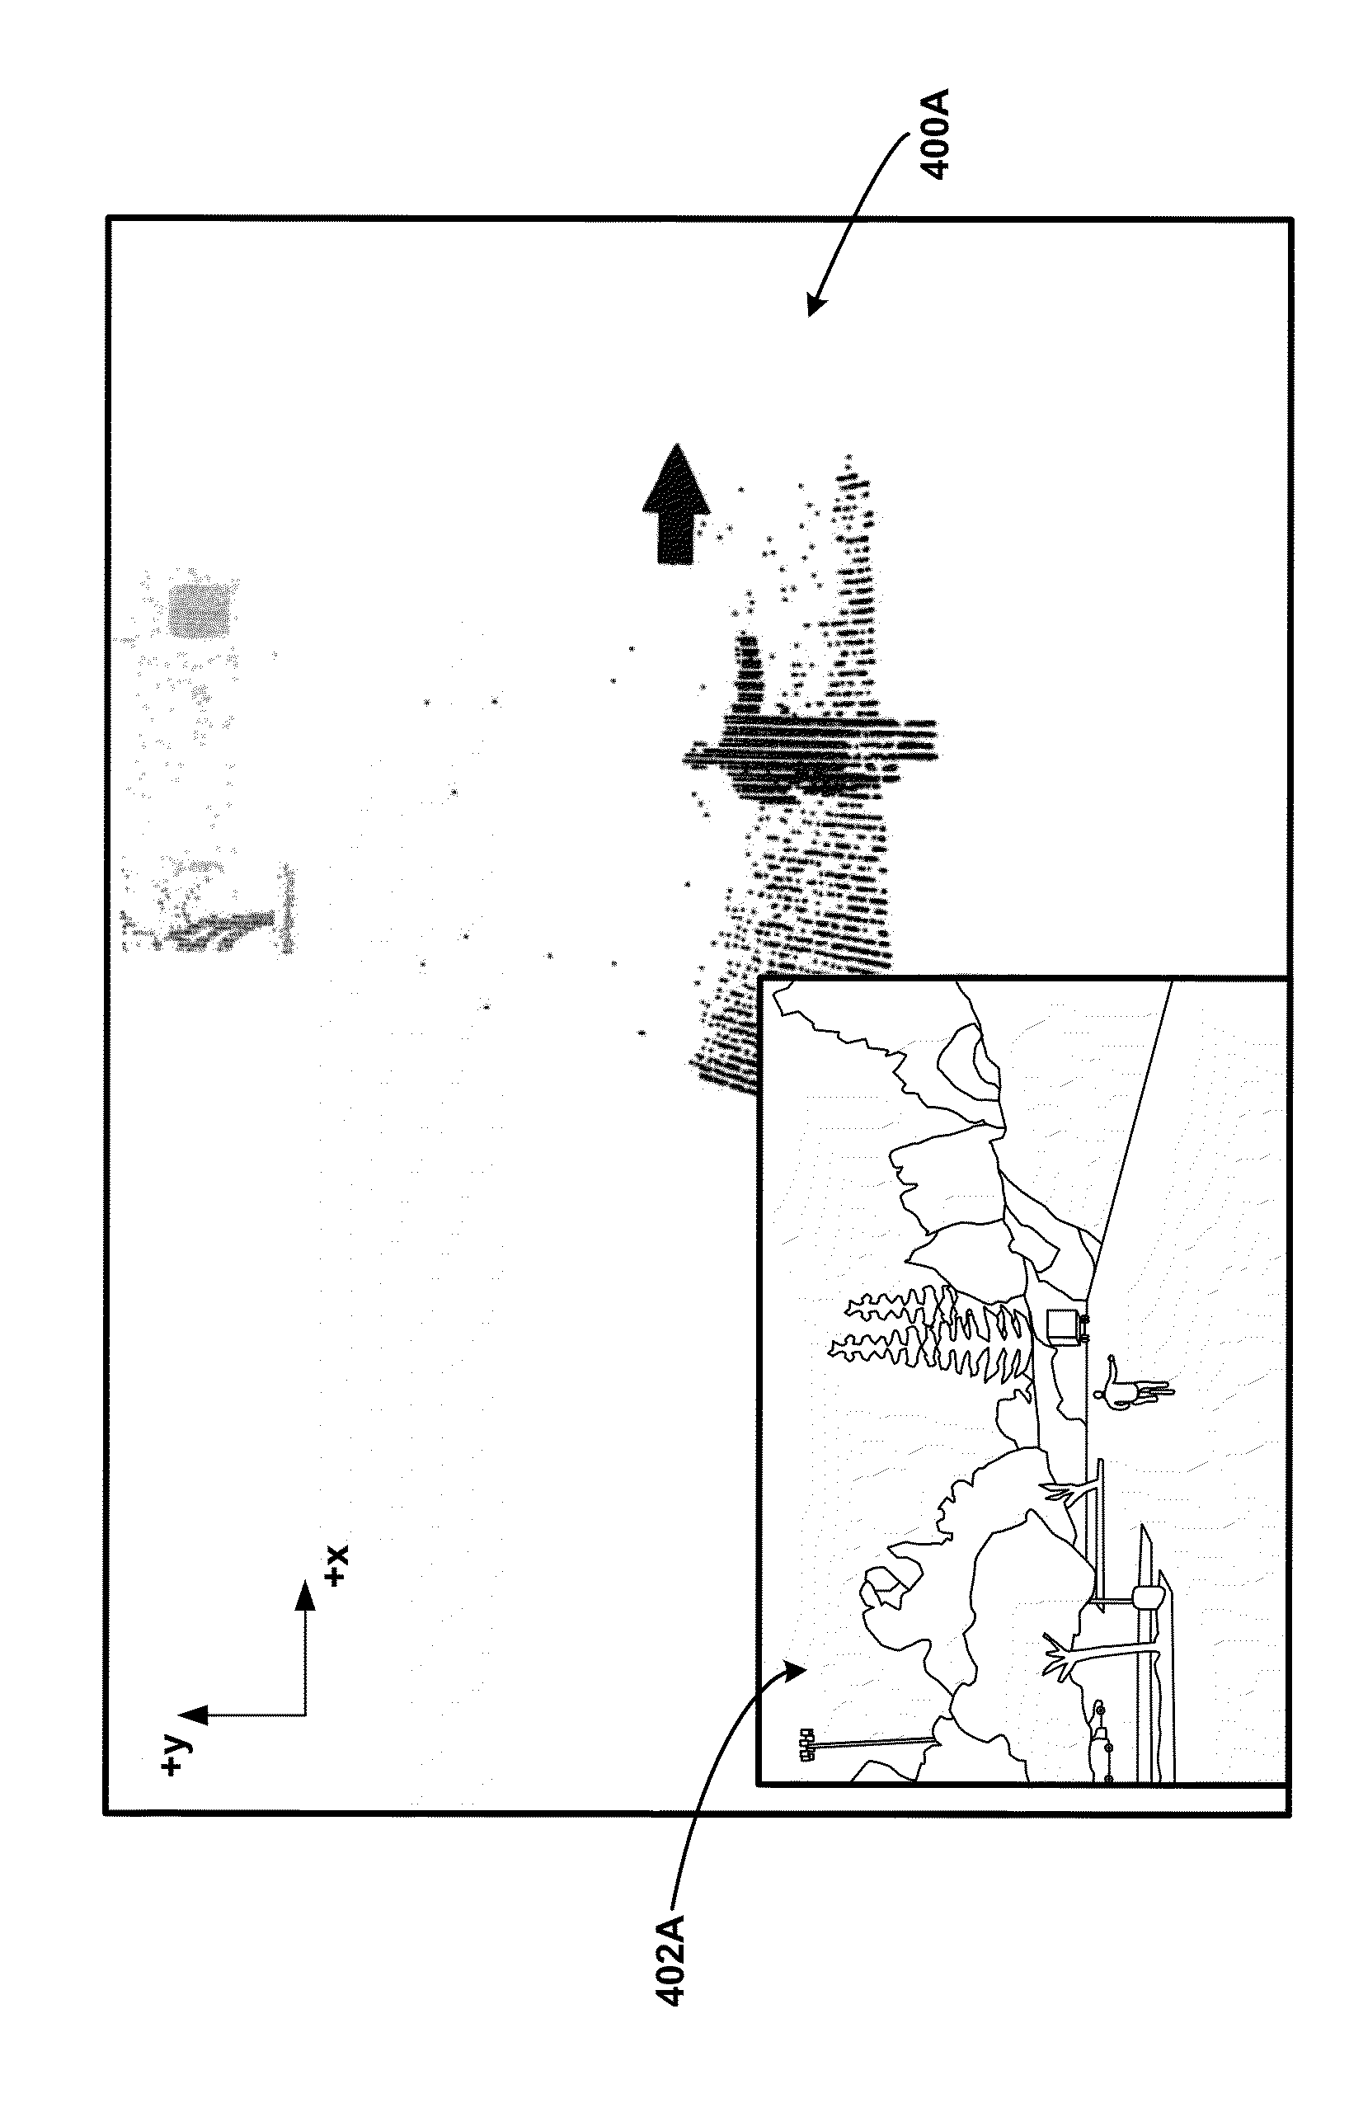
Recognition of Hand Sıgnals of Cyclist provides easiness to detect cyclist and predict her/his path.

(3)
The project is authentic and there is no researches on it. But the Google company had taken the all patents the project at 2015.
After setting this project onto Autonomous car , the car can understand hand signal of cyclist that in front of him and the car give decision how to acting in safety. The software is easly implementible on ADAS systems.

SIGNALS

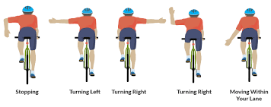

(4)

The systems has 12 different signals and half of them are from front view for coming cars perspective.
The software is written in Python 2.7 and used libraries that are listed below :

- Numpy
- Tensorflow
- Keras
- OpenCV
- Matplotlib
- Augmentor

The project used Convolutional Neural Networks that is deep learning technique.
Fırstly project used YOLOV2 in order to detect the object in front of camera and then used another CNN to predict the signal from posture of cyclist.
The Data is gotten at Izmır and the video is 12 MP and size of data is 10 minutes.

2) CONVOLUTIOANAL NEURAL NETWORKS

A Convolutional Neural Network (ConvNet/CNN) is a Deep Learning algorithm which can take in an input image, assign importance (learnable weights and biases) to various aspects/objects in the image and be able to differentiate one from the other. The pre-processing required in a ConvNet is much lower as compared to other classification algorithms. While in primitive methods filters are hand-engineered, with enough training, ConvNets have the ability to learn these filters/characteristics.(5)

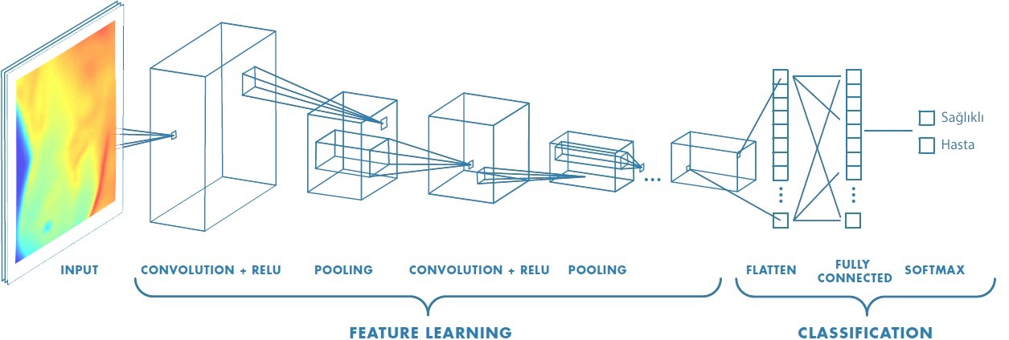
(6)

ARCHİTECTURE OF CNN :

- CONVOLUTIONAL LAYER : It is used to determine the characteristics.
- NON-LİNEARITY LAYER :It is used to introduce the non-linearity.
- POOLING LAYER :It decrease the complexity.
- FLATTENING LAYER :It modify the ınput data.
- FULLY-CONNECTED LAYER :It is custom neural network.

2.1) CONVOLUTIONAL LAYER

This layer is essential of CNN. It is responsible for detecting characteristics of image. This layer implements some filters in order to getting high features and low features of image. The filter may detect the edge of objects in image. The filters are always high-dimension and have pixel values.

Unlike traditional methods, features are not pre-defined according to a particular formalism, but learned by the network during the training phase. The nuclei of the filters denote the weights of the convolution layer. They are initialized and then updated by backpropagation of the gradient.
This is the strength of convolutional neural networks — they’re able to determine all the discriminating elements of an image, by adapting to the problem. For example, if the question is to distinguish cats from dogs, the automatically defined features can describe the shape of the ears or paws.

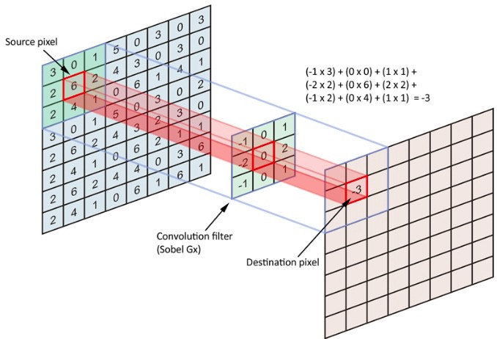
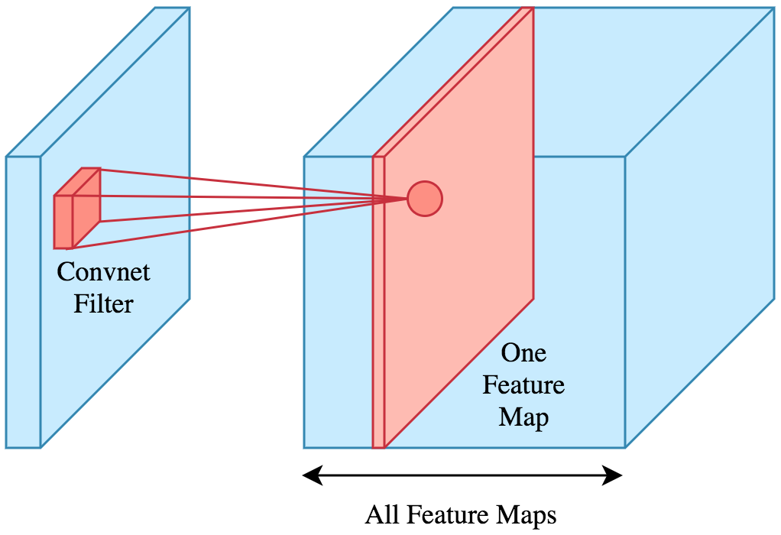

(7) (8)

The photo is below (9) illustrates the multiplication of source image and kernel. The kernel moves to 1 pixel right after product and then does same work. When kernel is multiply with all columns in a row , then moves 1 pixel down.

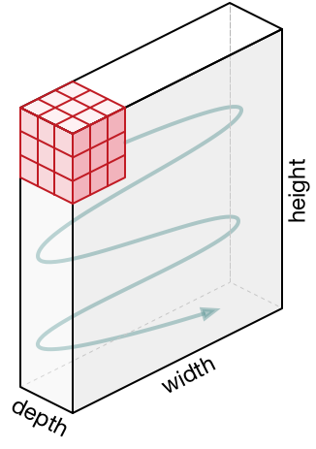

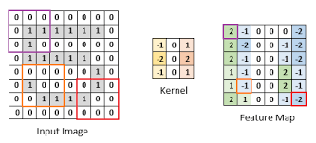

(9) (10)

2.2)NON-LİNEARITY LAYER

This layer is called Activation Layer because it uses one of activation functions. In past , researchers used like sigmoid and tanh functions but the Rectifier(Relu) provides the best as speed so non-linearity layer started to use the Relu function

RELU function f ( x ) = max ( 0 , x )

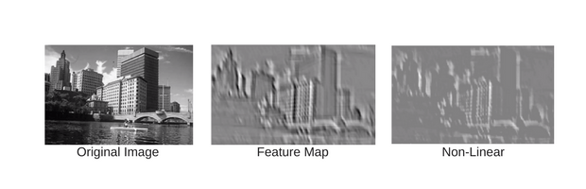
(11)

2.3) POOLİNG LAYER

Pooling layer is responsible for reducing the spatial size of the Convolved Feature. This is to decrease the computational power required to process the data through dimensionality reduction. Furthermore, it is useful for extracting dominant features which are rotational and positional invariant, thus maintaining the process of effectively training of the model.(12)

There are two types of Pooling: Max Pooling and Average Pooling. Max Pooling returns the maximum value from the portion of the image covered by the Kernel. On the other hand, Average Pooling returns the average of all the values from the portion of the image covered by the Kernel.

Max Pooling also performs as a Noise Suppressant. It discards the noisy activations altogether and also performs de-noising along with dimensionality reduction. On the other hand, Average Pooling simply performs dimensionality reduction as a noise suppressing mechanism. Hence, we can say that Max Pooling performs a lot better than Average Pooling.(13)

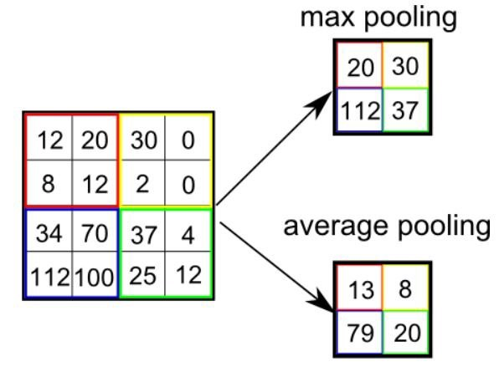

(14)

lots of studyind dont use pooling layer , instead use bigger Stride at CNN. Also variational autoencoders (VAEs) or generative adversarial networks (GANs) doesnt prefer to use pooling layer.

2.4) FLATTEN LAYER

This layer is prepare input before the most important layer that is Fully Connected Layer.This layer basically does flattening. The input is given as a matrix and the layer flatten it to (1 x X) matrix. The fully connected layer always need row data.

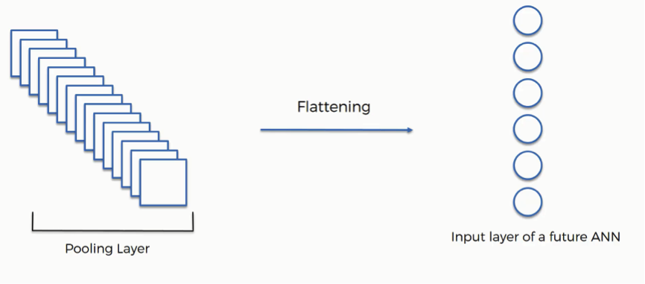

(15)

2.6) FULLY CONNECTED LAYER

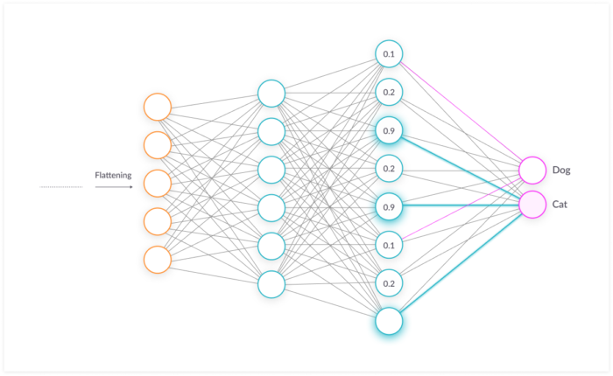

(16)
The objective of a fully connected layer is to take the results of the
convolution/pooling process and use them to classify the image into a label .The output of convolution/pooling is flattened into a single vector of values, each representing a probability that a certain feature belongs to a label. For example, if the image is of a cat, features representing things like whiskers or fur should have high probabilities for the label “cat”.(16)

The image below illustrates how the input values flow into the first layer of neurons. They are multiplied by weights and pass through an activation function (typically ReLu), just like in a classic artificial neural network. They then pass forward to the output layer, in which every neuron represents a classification label.The fully connected part of the CNN network goes through its own backpropagation process to determine the most accurate weights. Each neuron receives weights that prioritize the most appropriate label. Finally, the neurons “vote” on each of the labels, and the winner of that vote is the classification decision.(16)

2.6.1) FORWARD PROPAGATİON

The forward propagation is used to predict the output with respect to input. The flatted input is given to network’s to perceptrons and the perceptrons take and put the inputs to a activation function. The output of activation function is input of forward perceptron.Between 2 perceptron has weights that are multiplied by previous perceptrons output and convey to forward perceptron.

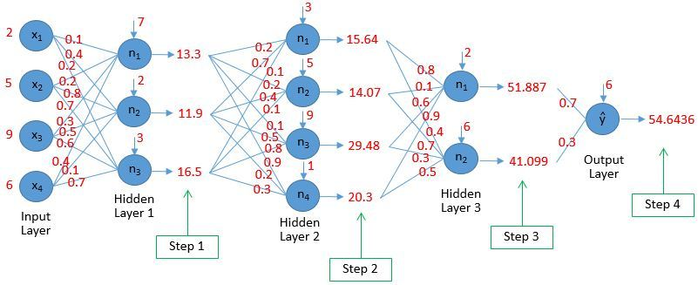
(17)

2.6.2) BACK PROPAGATION (18)

The algorithm is used to effectively train a neural network through a method called chain rule. In simple terms, after each forward pass through a network, backpropagation performs a backward pass while adjusting the model’s parameters (weights and biases).

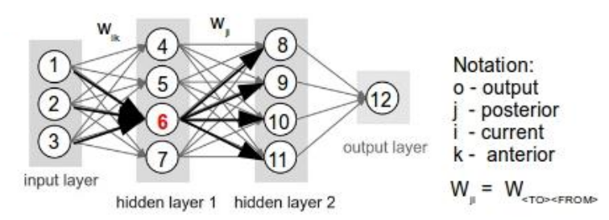

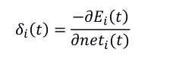

(1) The error signal for a certain unit i at training time t is given by:

where the net input to neuron i is

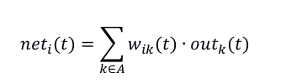

(2) The weight change for weight w ik is given by

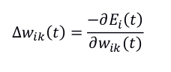

Starting from the weight change at the neuron level we can infer the representation of
the update in terms of the output of the previous layer and the error at the current
neuron:

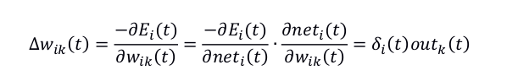

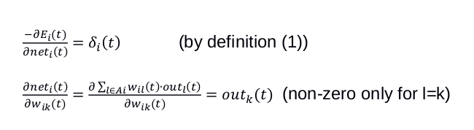

(3) Calculating the error of the output neuron

For the final output the dataset contains a desired value, target o , hence we can compute the error signal at the network output.
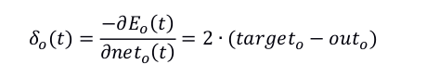

(4). Propagating the error back through the network

After computing the error at the network output we propagate the error signal back
through the network (hence the name of the learning mechanism).
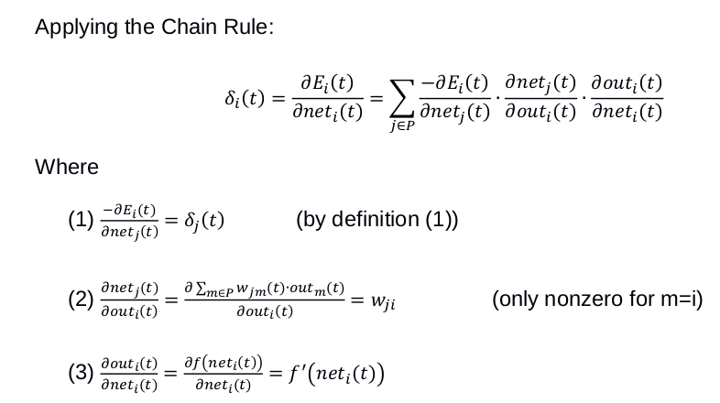

(5). Computing the weight update for weight anterior to posterior

Computing the weight update using the weight increment and the error signal

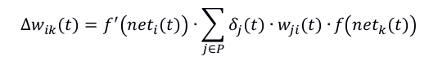
The final weight update is

3) YOLOV2

The yolov2 is pretrained CNN that is used to object detection in machine learning. The architecture

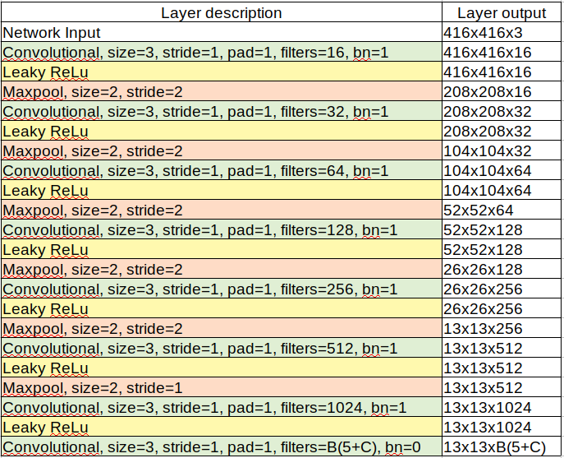

(19)

When the yolo is compared with other CNN architectures , there are 3 result ;

- Network runs faster at smaller-size images.
- For low resolution YOLOv2, at 90 FPS, mAP is as good as Fast R-CNN, which is ideal for smaller GPUs.
- For high resolution YOLOv2, 76.8% mAP is obtained at real-time speed.

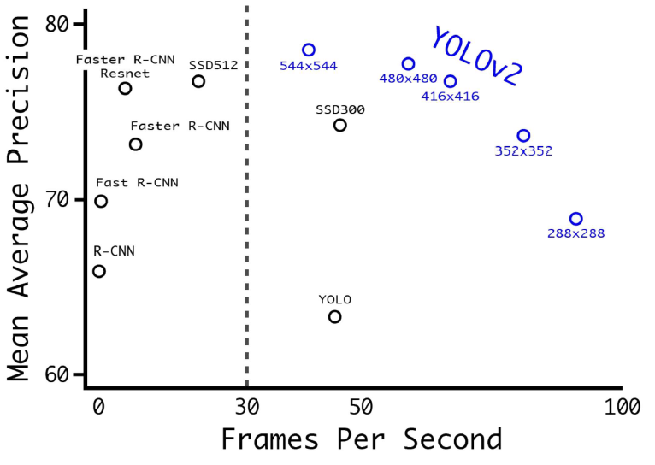

(20)

For MS COCO dataset, only YOLOv2 can get real-time performance among the approaches below.

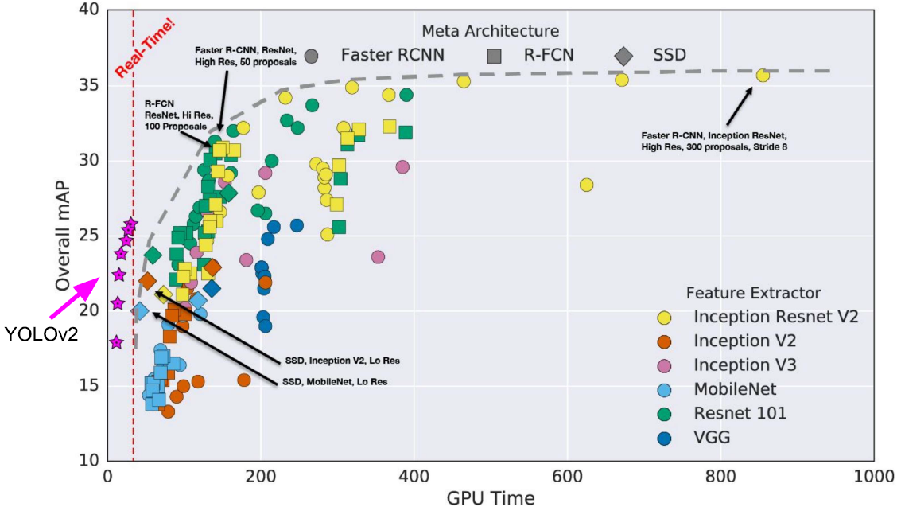

(21)
4) DATASET AND YOLOV2 IMPLEMENTATION

4.1) DATASET

The dataset is created at Izmır and it’s size is 10 minutes. The video is taken by backside and frontside in order to recognition of hand signal. Quality of video is 12mp.

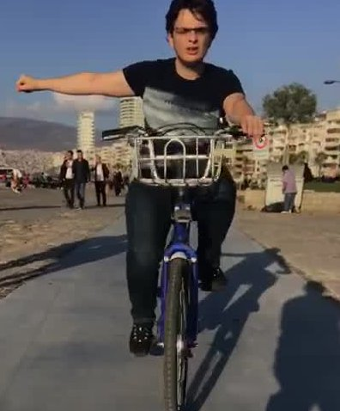
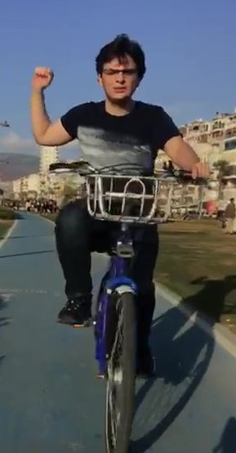
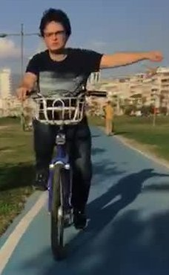
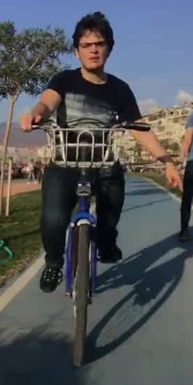

4.2) YOLO IMPLEMENTATION ON DATA
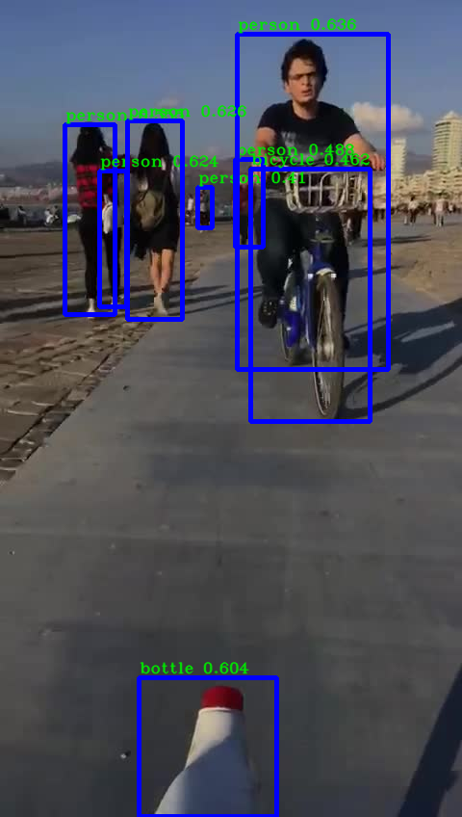
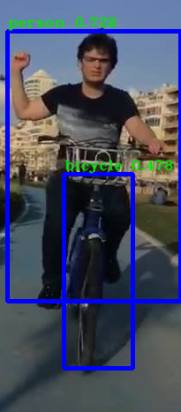
After implementing yolo the system gives outputs like this.

5) METHODS TO FINDING CYCLİST IN IMAGE

At this point we have to find the cyclist. The yolov2 gives us all the objects that are detected.
The firs approach is finding closest person to bcycle. This aproach assumes that always closest person to bcycle is cyclist , the steps are explained below ;

- Fındıng persons and their middle points
- Fındıng bcycle and it’s middle point
- Fındıng distances between persons and bcycle with respect to Euclidian distance (23)
- Selecting minimum distance and appointment it to as cyclist

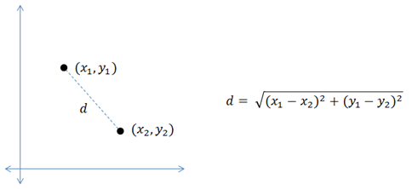
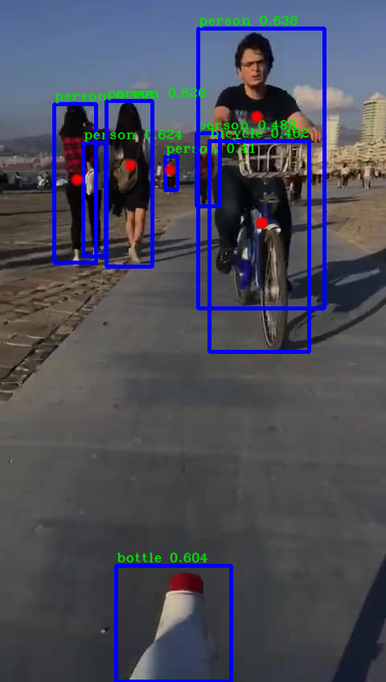

D2
D3

D4

D1
(23) Euclidian Distance

RESULT =MIN(D1,D2,D3,D4 )

Yolov2 Output

After finding minumun distance between persons and bcycle , the system crops the closest persons coordinates in order to send other CNN.
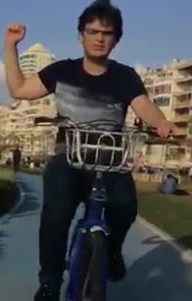

6) TRAINING AND VALIDATION

The system is trained over 1000 photos. The data is augmented in order to decreasing the loss.
The archictecture contains 3 Convolutional Layer-1 Flatten Layer-1 Fully Connected Layer.
The validation data rate is 0.2. The results are shown below

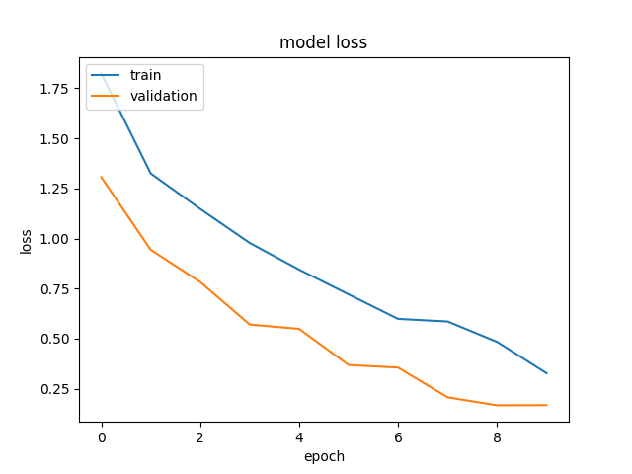

The loss is decreasing when epoch is increasing.The train error is higher than validation error.

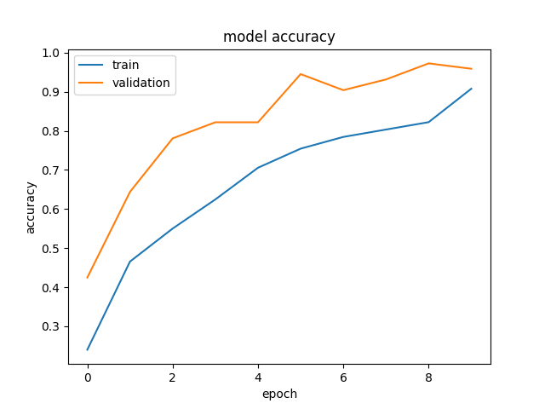

The model accuracy graph shows us that the model is overfitting and that means system memorize the inputs.
7 )RESULTS

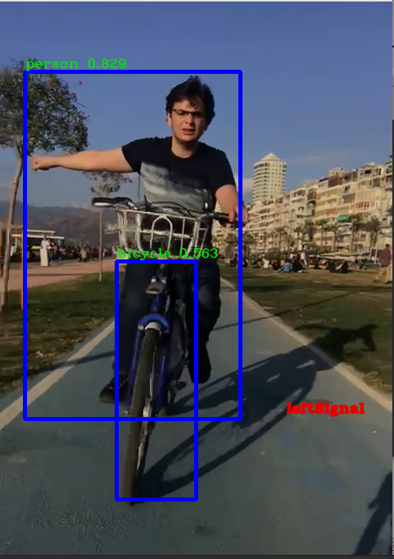

LEFT SIGNAL

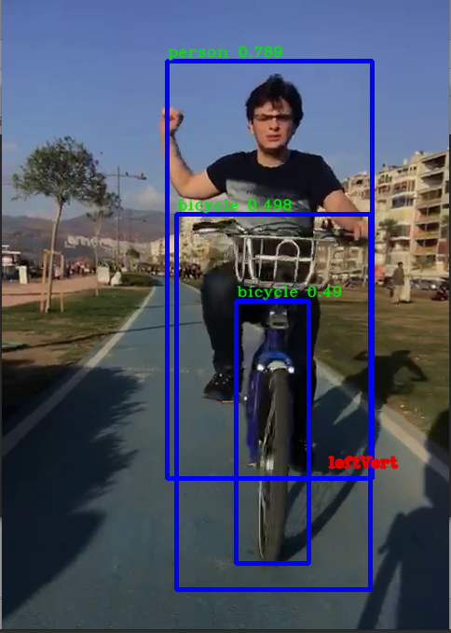

LEFT VERTİCAL SIGNAL

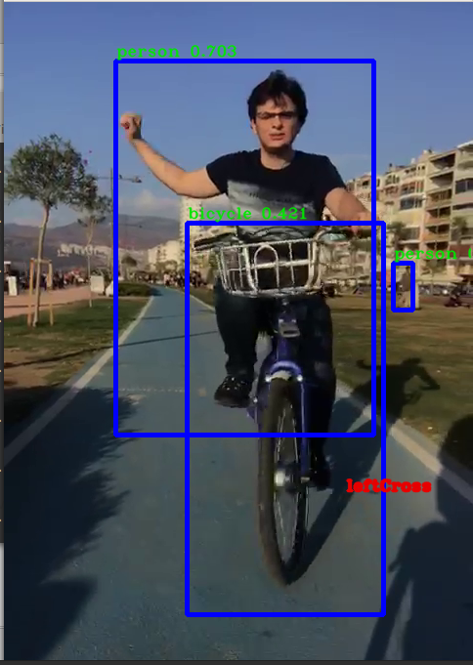

LEFT CROSS SIGNAL

8)CONCLUSION

This study shows us recognition of handsignal of cyclist is possible with normal cameras. The system need much more data in order to get rid of overfitting and increasing test accuracy.
The data should be gotten at different enviroments and by different persons.The study shows us CPU is insuefficient at ML projects, systems have to use GPU in order to catch real time solutions.
The are some paradox that are such as non-sense body posture ? What will system correspond to this posture or if there are more than 1 bcycle how system acts ? The questions need to be solved and that means the study have to be continued.

9)RECOMMENDATIONS

After the researches , LIDAR sensors might more efficient to detecting bcycle and recognize the signal. The LIDAR sensor need to get data from scratch so it might be more longer than using normal camera.

10 )REFERENCES

1--https://eenews.cdnartwhere.eu/sites/default/files/styles/inner_article/public/sites/default/files/images/2018-01-04-s20_autonomous_vehicle_mobility_robo-taxi_market.jpg?itok=f5ocWQ8t
2--https://en.wikipedia.org/wiki/Computer_vision
3--https://patents.google.com/patent/US9014905B1/en
4--https://www.mpi.mb.ca/Pages/cycling-sharing-the-road.aspx
5--https://towardsdatascience.com/a-comprehensive-guide-to-convolutional-neural-networks-the-eli5-way-3bd2b1164a53
6--https://medium.com/@tuncerergin/convolutional-neural-network-convnet-yada-cnn-nedir-nasil-calisir-97a0f5d34cad
7--https://heartbeat.fritz.ai/exploring-convolutional-neural-networks-cnns-from-an-ios-developers-perspective-162664130d5b
8--https://heartbeat.fritz.ai/exploring-convolutional-neural-networks-cnns-from-an-ios-developers-perspective-162664130d5b
9--https://www.codeproject.com/Articles/1264962/ANNT-Convolutional-neural-networks
10-https://towardsdatascience.com/a-comprehensive-guide-to-convolutional-neural-networks-the-eli5-way-3bd2b1164a53
11--https://towardsdatascience.com/a-comprehensive-guide-to-convolutional-neural-networks-the-eli5-way-3bd2b1164a53
12-13-14--https://towardsdatascience.com/a-comprehensive-guide-to-convolutional-neural-networks-the-eli5-way-3bd2b1164a53
15--https://www.superdatascience.com/blogs/convolutional-neural-networks-cnn-step-3-flattening
16--https://missinglink.ai/guides/convolutional-neural-networks/fully-connected-layers-convolutional-neural-networks-complete-guide
17--https://dwbi1.wordpress.com/2018/02/
18--ARTIFICIAL INTELLIGENCE AND MACHINE LEARNING - CRISTIAN AXENIE--2018-TECHNISCHE HOCHSCHULE INGOLSTADT
19--https://medium.com/@y1017c121y/how-does-yolov2-work-daaaa967c5f7
20--https://medium.com/@jonathan_hui/real-time-object-detection-with-yolo-yolov2-28b1b93e2088
21--https://www.researchgate.net/publication/311223153_Speedaccuracy_trade-offs_for_modern_convolutional_object_detectors

