CODE EXPLANATİON

CNN::::
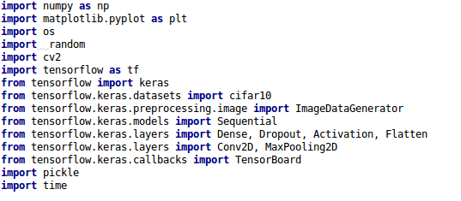

The modules are installed.

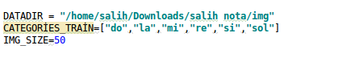

Data directory and its subfields are defined.

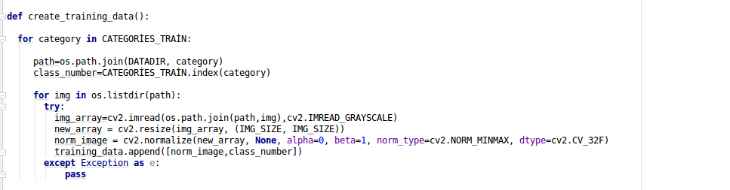

The data appointed to list as Features and Labels.

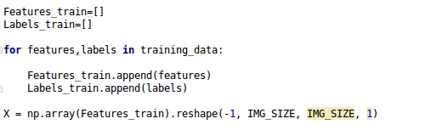

The data appointed to a new list for giving neural network and resized.

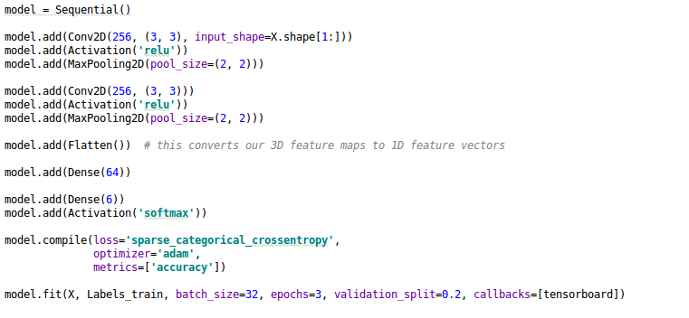

The model created and started to training.

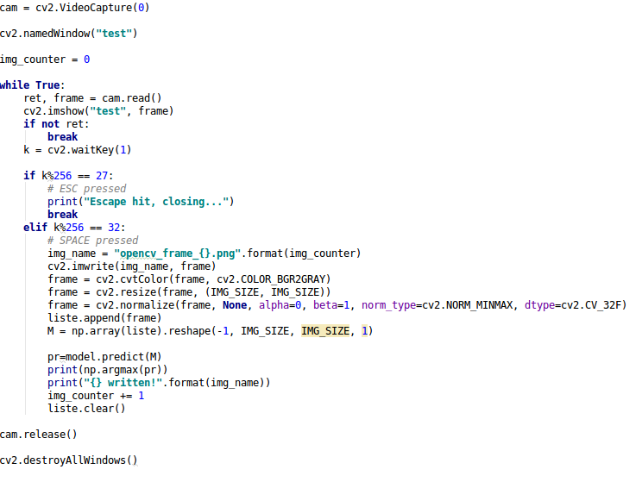
The camera opens and takes image when push to Space. The output gives us index of label.

DNN:::

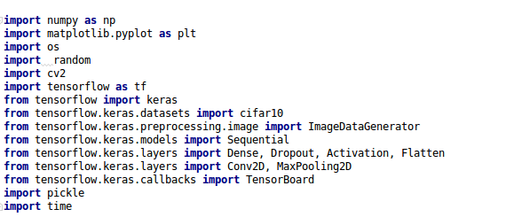
The modules are installed.
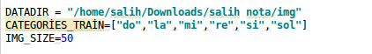

Data directory and its subfields are defined.

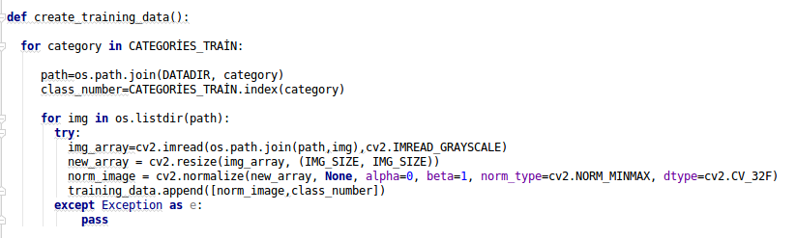

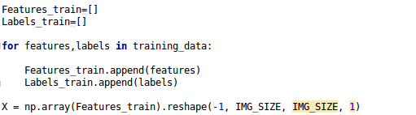

The data appointed to a new list for giving neural network and resized.

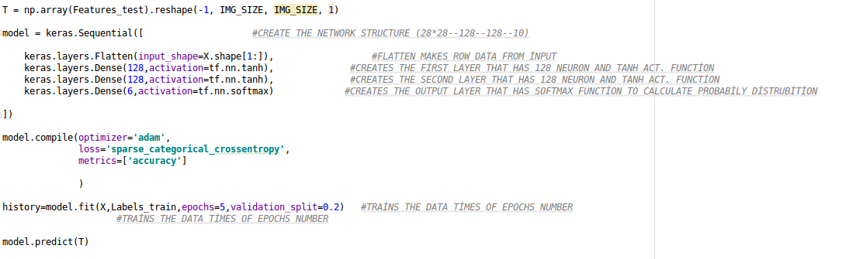
The model created and started to training.

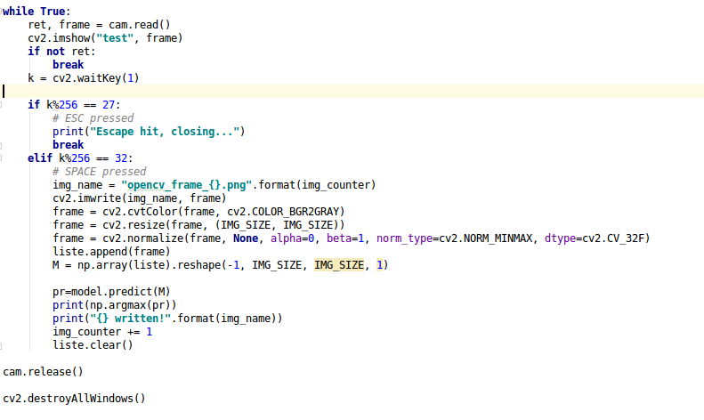
The camera opens and takes image when push to Space. The output gives us index of label.

Notes:

1---When you use the code, you should give true data directory path
2—The output(1-2-3-4-5-6) class corresponds to index number of photo directory.

