MUSIC NOTES RECOGNİTİON

SALİH BEŞKARDEŞ
Computer Science and Engineering Deparment, Manisa Celal Bayar University

Keywords: Music Notes Recognition, Convolutional Neural Networks, Deep Neural Networks

Abstract: The music notes has image format and they have different shapes in paper and they have different classes like do-re-mi-fa-sol-la-si. The notes has grayscale values and they are presented as matrix.The dataset has images that are notes.
The CNN and DNN figure out the releationship between value of pixels and their classes.The networks give us softmax function outputs.We aimed to get minimum loss and maximum accuracy.

1.İNTRODUCTİON

Music notes are created by gui d’Arezzo. In modern music world uses the known notes that are do-re-mi-fa-sol-la-si
The notes are certain and are not subjective.Notes creates the musics and their sequence that define musics charectaristic.
Our models aim to define the music notes’s class.The data set has 6 different notes. The Machine Learning algorithms train the itself by giving inputs and learns pattern shapes via their weights.Firstly Deep Neurol Network uses basic idea that figures out weights. The layers defines complexity of problem. When the problem is complex we must use more layer in order to get maximum accuracy.Convulutional Neural Networks has different structure that has feature extraction layers.
The layers extracts the inputs shape so that figure out their behaviour easily.Both structure has Back Propagation method that uses CrossEntropy error because of their output layer is softmax function.

2.DATASET

The dataset has created by Erdoğan Abacı. Each of class has 1000 photos that are 50*50 sized.The images have 4 black lines and 1 filled circle that defines note’s class.The dataset has some problems that are there is no different lights, different view of point, different shape of writing.This problems causes memorize the data.









3.DEEP NEURAL NETWORKS STRUCTURE:

The Dnn has 1 input layer-2 hidden layer- 1 outputlayer.Firstly the input layer takes the data as row data.The input data is normalized(1). Each hidden layers has 128 neuron and their activation function is tanh.(it might be softmax or relu.).
Size of output layer is 6 that are softmax functions. The network uses Backpropagation method. Backpropagation method depends on chain rule(2).The chain rule calculates each of weight’s derivation and update the weights.The loss function is Sparse Categorical Crossentropy.(3).
The number of epoch defines training number.Validation set is 20% because it is the most efficient way to find maximum accuracy.
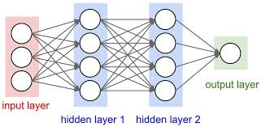

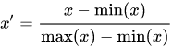
1)

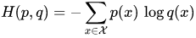
3)

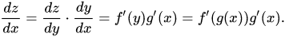
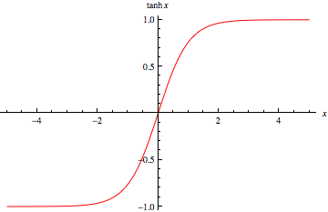
2)

3.CONVOLUTİONAL NEURAL NETWORK

The CNN has same dnn structure but the Cnn has also convolutioanal layers. The convolution layer extracts the images features
İt uses kernel that is 3X3 kernels and gives lots of outputs. The activiation fuction is relu but it depends on programmers choice. The Pooling layer does dimensionaltiy reduction that decrease the number of input layer of fully connected layer.
The Cnn has softmax output layer and Sparse Categorical Crossentropy Loss function. İt uses Backpropagation algorithm that uses Chain Rule.

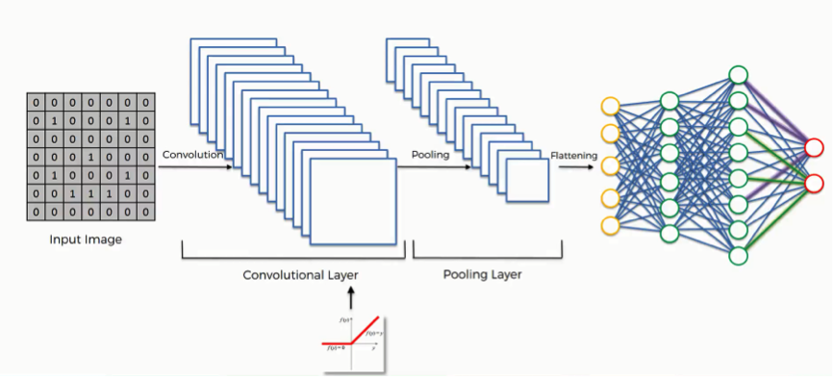

COMPARİSİON THE RESULTS

DNN:

The network memorize the data because of dataset. The dataset doesnt have variety that causes overfitting.

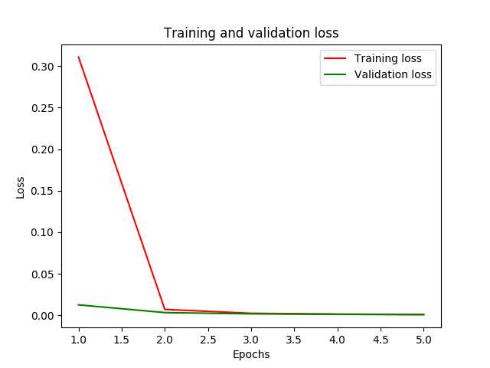

The loss of training decrease like validation loss but validation loss is always too small. Result say that network couldnt find optimal weights.

CNN:

Dnn gives result very slowly because it has convolutional layers. Result is same with DNN. İt memorize the data and gives output with high accuracy.

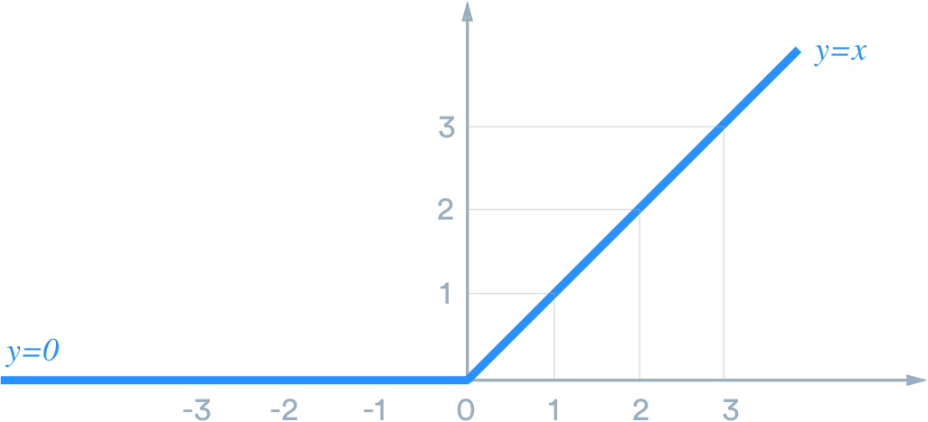
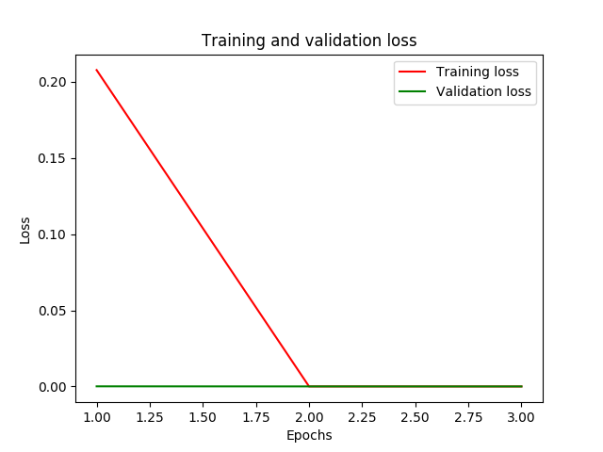
The Cnn gives us more precise result so validation error starts at 0.

CONCLUSİON:

The neural networks are higly usable but I think most important thing is you have to choose true network structre and have well data set. İf you have bad data set the network memorize the data and couldnt give high test validation.
The Cnn and Dnn have different properties. The Cnn gives higher accuray both train and validation.
When we have well dataset we can create more healtht systems.

