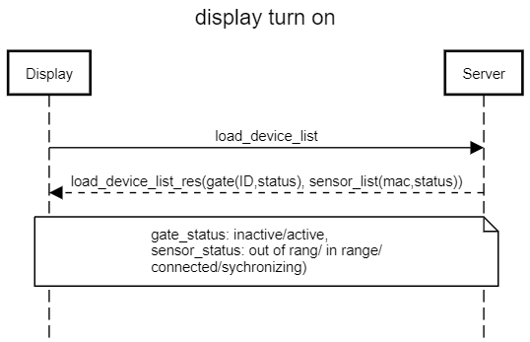

|  |  |  |
| --- | --- | --- |
| **DISPLAY TURN ON** | | |
|  | **Display -> Server** | **Server -> Display** |
| Pub | DISPLAY/REQ/GATE/SENSOR/<DISPLAY_ID> | SERVER/RES/GATE/SENSOR/<DISPLAY_ID> |
| Sub | SERVER/RES/GATE/SENSOR/<DISPLAY_ID> | DISPLAY/REQ/GATE/SENSOR/# |
| JSON | {  “display_id”:” 4eb2459ae05f004c”  } | {  "gateId": "ELCGW-001-00000000649af264",  "status": "active",  "sensorLst": [  {  "id": "bcbf91bd-c648-46fd-8bac-a0ee0b71d33b",  "gateId": "ELCGW-001-00000000649af264",  "patientId": "b9ae65c0-b730-458b-b4d8-bc797efec58a",  "name": "Sensor 01",  "model": "ASDF",  "sensorType": "BP",  "mac": "bcbf91bd-c648-46fd-8bac-a0ee0b71d33b",  "batteryValue": 90,  "status": 1,  "measureState": 0,  "isDeleted": 0,  "lastUpdatedAt": "2020-11-11 14:36:52"  },…….  ]  } |

|  |  |  |
| --- | --- | --- |
| **DISPLAY GET PATIENTS LIST** | | |
|  | **Display -> Server** | **Server -> Display** |
| Pub | GET/PATIENT/LIST/<display_id> | RES/PATIENT/LIST/<display_id> |
| Sub | RES/PATIENT/LIST/<display_id> | GET/PATIENT/LIST/# |
| JSON | {  “display_id”:”xxxx”  } | {  "gateId": "ELCGW-001-00000000649af264",  "status": "active",  "sensorLst": [  {  "id": "bcbf91bd-c648-46fd-8bac-a0ee0b71d33b",  "gateId": "ELCGW-001-00000000649af264",  "patientId": "b9ae65c0-b730-458b-b4d8-bc797efec58a",  "name": "Sensor 01",  "model": "ASDF",  "sensorType": "BP",  "mac": "bcbf91bd-c648-46fd-8bac-a0ee0b71d33b",  "batteryValue": 90,  "status": 1,  "measureState": 0,  "isDeleted": 0,  "lastUpdatedAt": "2020-11-11 14:36:52"  },  {  "id": "bcbf91bd-c648-46fd-8bac-a0ee0b71d33c",  "gateId": "ELCGW-001-00000000649af264",  "patientId": "2c150805-9216-4aa0-bf53-3d58ebb67c77",  "name": "Sensor 02",  "model": "ASFA",  "sensorType": "SPO2",  "mac": "bcbf91bd-c648-46fd-8bac-a0ee0b71d33c",  "batteryValue": 80,  "status": 1,  "measureState": 0,  "isDeleted": 0,  "lastUpdatedAt": "2020-11-11 14:36:52"  }  ]  } |

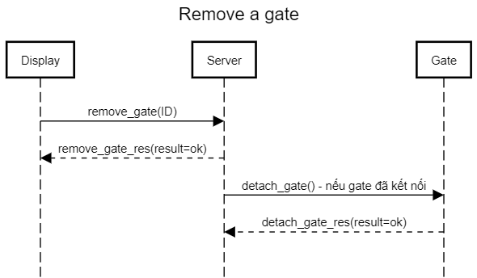

|  |  |  |
| --- | --- | --- |
| **REMOVE GATE** | | |
|  | **Display -> Server** | **Server -> Display** |
| Pub | DISPLAY/UNLINK/GATE/REQ/<display_id> | DISPLAY/UNLINK/GATE/RES/<display_id> |
| Sub | DISPLAY/UNLINK/GATE/RES/<display_id> | DISPLAY/UNLINK/GATE/REQ/# |
| JSON | {  "display_id":"111",  "gate_id":"123456"  } | Json :  {  "display_id":"111",  "gate_id":"123456",  "result":"OK"  } |

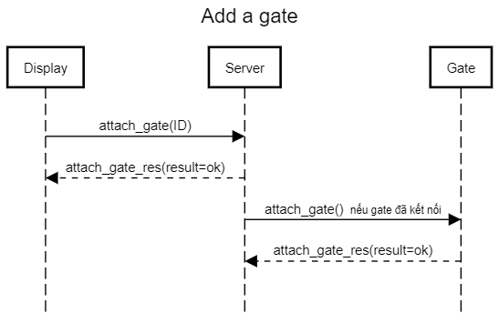

|  |  |  |
| --- | --- | --- |
| **ADD GATE** | | |
|  | **Display -> Server** | **Server -> Display** |
| Pub | DISPLAY/LINK/GATE/REQ/<display_id> | DISPLAY/LINK/GATE/RES/<display_id> |
| Sub | DISPLAY/LINK/GATE/RES/<display_id> | DISPLAY/LINK/GATE/REQ/# |
| JSON | {  "display_id":"111",  "gate_id":"123456"  } | {  "displayID":”111”,  “gateID”:”123456”,  "result","OK/FAILED/LINKED"} |

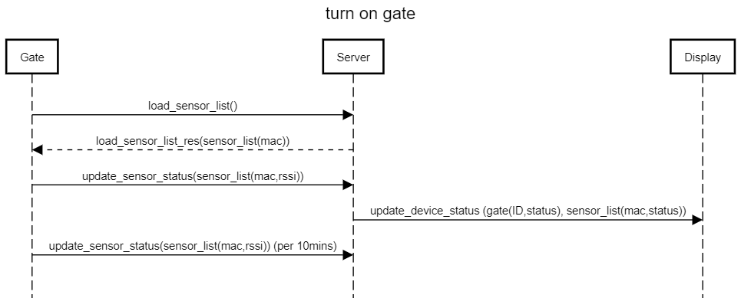

|  |  |  |
| --- | --- | --- |
| **TURN ON GATE** | | |
|  | **Gate -> Server** | **Server -> Gate** |
| Pub | GATE/REQ/DISPLAY/SENSOR/<gate_id> | SERVER/RES/SENSOR/LIST/<gate_id> |
| Sub | SERVER/RES/SENSOR/LIST/<gate_id> | GATE/REQ/DISPLAY/SENSOR/# |
| JSON | {  "display_id":"111",  "gate_id":"123456"  } | {  "displayID":”111”,  “gateID”:”123456”,  "result","OK/FAILED/LINKED"} |

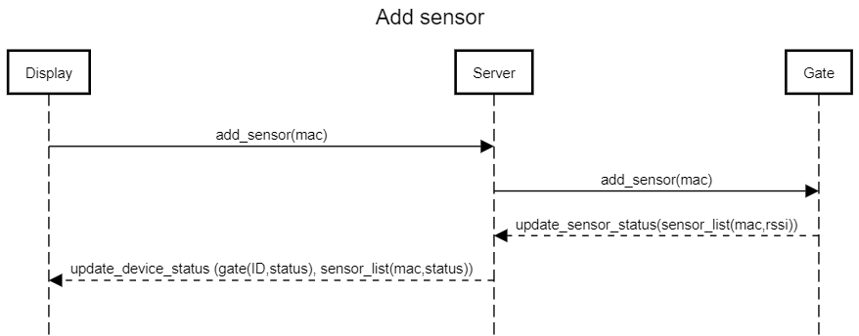

Mô tả : display send request gate add Sensor -> Gate response to server status -> Server response to Display

|  |  |  |
| --- | --- | --- |
| **ADD SENSOR** | | |
| **DISPLAY -> GATE** | | |
| DisPLay : Pub  Gate : Sub | DISPLAY/SERVER/ADD_SENSOR_GATE_REQ/<GATE_ID> | {  "display_id" : "12312312",  "gateId" : "1231231"  "mac" : "1b:23:12:2d:c3"  "name": "Máy đo huyết ap"  } |
| **GATE -> SERVER** | | |
| Gate : Pub  Server : Sub | GATE/SERVER/ADD_SENSOR_REQ/<GATE_ID> | GATE/SERVER/ADD_SENSOR_REQ/<GATE_ID>  {  "display_id" : "<DISPLAY_ID>",  "gateId" : "1231231",  "mac" : "1b:23:12:2d:c3",  "name": "Máy đo huyết ap",  "status" : 0,  "message" : "Thêm thành công"  }  - status = 1 thêm thành công  - status != 1 Thêm lỗi |
| **SERVER -> DISPLAY** | | |
| Server : Pub  Display : Sub | SERVER/DISPLAY/ADD_SENSOR_GATE_RES/<DISPLAY_ID**>** | {  "display_id" : "<DISPLAY_ID>",  "gateId" : "1231231",  "mac" : "1b:23:12:2d:c3",  "name": "Máy đo huyết ap",  "status" : 0,  "message" : "Thêm thành công"  } |

|  |  |  |
| --- | --- | --- |
| **DISPLAY SCAN GATE BY GATE_ID** | | |
| **DISPLAY -> GATE** | | |
| DisPLay : Pub  Gate : Sub | DISPLAY/SERVER/ADD_SENSOR_GATE_REQ/<GATE_ID> | {  "display_id" : "12312312",  "gateId" : "1231231"  "mac" : "1b:23:12:2d:c3"  "name": "Máy đo huyết ap"  } |
| **GATE -> SERVER** | | |
| Gate : Pub  Server : Sub | GATE/SERVER/ADD_SENSOR_REQ/<GATE_ID> | GATE/SERVER/ADD_SENSOR_REQ/<GATE_ID>  {  "display_id" : "<DISPLAY_ID>",  "gateId" : "1231231",  "mac" : "1b:23:12:2d:c3",  "name": "Máy đo huyết ap",  "status" : 0,  "message" : "Thêm thành công"  }  - status = 1 thêm thành công  - status != 1 Thêm lỗi |
| **SERVER -> DISPLAY** | | |
| Server : Pub  Display : Sub | SERVER/DISPLAY/ADD_SENSOR_GATE_RES/<DISPLAY_ID**>** | {  "display_id" : "<DISPLAY_ID>",  "gateId" : "1231231",  "mac" : "1b:23:12:2d:c3",  "name": "Máy đo huyết ap",  "status" : 0,  "message" : "Thêm thành công"  } |