STANDING PAYMENT INSTRUCTION

TO : TRENDSETTER EUROPE OU
RE : SALES CONTRACT NO EIC0026 DATED MAR.03.2020
(계약서 날짜)
Dear Sirs,

We refer to the captioned sales contract (the “Contract”) pursuant to which we are obligated to sell the goods specified therein against your payment of the price therefore

Please be advised that we have irrevocably designated KEB HANA BANK GONGDEOK-DONG BRANCH (the “bank”) as the payee and assignee for our account in respect of the payment of the price for all goods that we will sell to you on or after MAR.03.2020, pursuant to the Contract.
Therefore, we hereby instruct you to pay any portion or all of the price of such goods to the Bank through its account no 266-890023-29238 with KEB HANA BANK, GONGDEOKDONG BRANCH 137 MAPO-DAERO MAPO-GU SEOUL (SWIFT:KOEXKRSE)
when it becomes due and payable in accordance with the terms and conditions of the Contract.

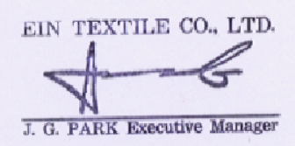
Please confirm your consent to the foregoing by countersigning the enclosed duplicate of this letter and sending it to us.

Very truly yours.

By
Name : J.G. PARK
Title : Executive Manager

ACKNOWLEDGEMENT AND CONSENT

We consent to the arrangement for payment of the price for the goods that we will purchase from
EIN TEXTILE Co., Ltd. (the “Seller”) under the Contract as proposed by the Seller in connection
with the sales contract(No. EIC0026) dated MAR.03.2020, entered into by and between the Seller and us.
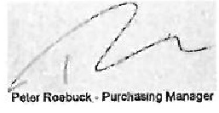
[Buyer]

By Name :
Title
STANDING PAYMENT INSTRUCTION

TO : E.CIMA
RE : SALES CONTRACT NO DBC0058 DATED JAN.22.2020

Dear Sirs,

We refer to the captioned sales contract (the “Contract”) pursuant to which we are obligated to sell the goods specified therein against your payment of the price therefore

Please be advised that we have irrevocably designated KEB HANA BANK GONGDEOK-DONG BRANCH (the “bank”) as the payee and assignee for our account in respect of the payment of the price for all goods that we will sell to you on or after JAN.22.2020, pursuant to the Contract.
Therefore, we hereby instruct you to pay any portion or all of the price of such goods to the Bank through its account no 266-890023-30238 with KEB HANA BANK, GONGDEOKDONG BRANCH 137 MAPO-DAERO MAPO-GU SEOUL (SWIFT:KOEXKRSE)
when it becomes due and payable in accordance with the terms and conditions of the Contract.

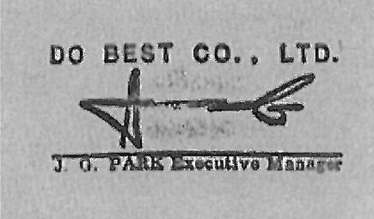
Please confirm your consent to the foregoing by countersigning the enclosed duplicate of this letter and sending it to us.

Very truly yours.

By
Name : J.G. PARK
Title : Executive Manager

ACKNOWLEDGEMENT AND CONSENT

We consent to the arrangement for payment of the price for the goods that we will purchase from DO BEST Co., Ltd. (the “Seller”) under the Contract as proposed by the Seller in connection
with the sales contract(No. DBC0058) dated JAN.22.2020, entered into by and between the Seller and us.

[Buyer]

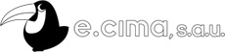
By Name :
Title

