

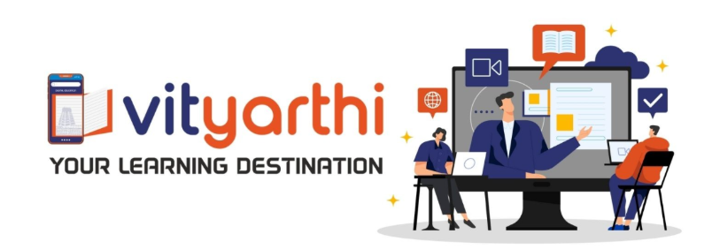

DIGITAL LITERACY (CSE0001)
Evaluated Course Project Report

NAME: SWEETY KUMARI

REGISTRATION NO.: 25BAI10432
Task 1: Create a Digital Literacy Awareness Infographic
Tool Used: Canva
Topics Covered: Digital Literacy Definition, Student Digital Tools, Safe Internet Practices, Professional Online Presence and Email Etiquette.
Report Description: As a Student Digital Ambassador, I made a "Roadmap" infographic to help my fellow students learn about literacy. The infographic has an idea that Digital Literacy is about being able to understand and create content not just using technology. I broke it down into four parts: "Choosing Gear" where I talked about tools like GitHub and Notion "Dressing for Success" where I discussed having a good LinkedIn profile "Securing the Journey" where I gave safety tips and "Mastering Communication" where I taught professional email habits.
One thing that was really interesting to me was figuring out how to organize the information. At first the design was not very detailed. I had to redo it to include clear labels like "Write like a pro!". Specific software names. This taught me that for a digital resource to be helpful to students it needs to look good and have information. The "Roadmap" idea makes sure that the information is not just read. Actually, used as a step-by-step guide to being good at digital things.

Task 2: Build your Student Digital Portfolio Reflection
For this task I set up my online presence by making accounts on GitHub, LinkedIn and Stack Overflow. I chose these three because they are important for an engineer. GitHub is where I show off my code and projects LinkedIn is like my resume and where I connect with people in the industry and Stack Overflow is where I can ask for help and share my knowledge.
Over the four years of my B.Tech. Journey I plan to use these platforms in a smart way. I will use GitHub to show how my projects are progressing, from exercises to complex applications. On LinkedIn I will connect with recruiters. Look for internship opportunities by building a strong professional brand. I will also use Stack Overflow to help others as I get better at coding. By keeping these profiles updated I hope to go from being a student to a professional with a proven track record of my skills.

Task 3: Explore Coding and Collaboration Platforms Reflection
For this module I learned about two digital skills: competitive programming and working with others online. For the coding part I used Hacker Rank to complete a challenge. This helped me learn how to read problems write code and fix mistakes. Skills that will be important for my interviews and coursework.
In the collaboration part I made a Google Form called "Digital Literacy Awareness Quiz". Connected it to a Google Sheet to collect data. This showed me how powerful the Google Workspace tools are for collecting and organizing data. These tools will be very helpful for group projects getting feedback from peers and sharing study resources. Learning to use these platforms will help me work efficiently in a team and share data in real-time.

Task 4 Reflection: Draft a professional email and etiquette guides
A problem with digital communication is when someone sends a bad email. For example, a student might send an email to a professor with the subject "Help". The body "i don't get the project." This email is not clear. Might get ignored.
To fix this the student should use a subject line and provide more details about what they need help with. This taught me that professional communication is not about using words but about being respectful of the other persons time and giving them enough information to help. Good etiquette makes professional relationships easier.

Task 5 Reflection: Cybercrime Awareness Case Study and prevention guide
I was looking into the "Urgent Internship" scam. I was really surprised by how people who do bad things on the internet use the things that college students need. For a B.Tech student getting an internship is a big deal and these bad people use that to make students think they have to act really fast. I found out that even a website that looks safe because it has "https" can be a website that is just trying to get your login information.
This class has really changed the way I use the internet. I realized that using the password for all my school accounts was not a good idea. One thing I am going to change away is to be more careful with emails I did not ask for. If I get an email about something like paying fees or an internship offer, I will call the school to make sure it is real before I click on any links. I am also going to use a device or app to make sure it is really me when I log in instead of just using a code that is sent to my phone because someone could get that code if they switch my phone number to a different phone. I will use Two-Factor Authentication to keep my accounts safe. The "Urgent Internship" scam and other scams, like it will not be able to trick me because I will be using Two-Factor Authentication.

