EC2-Daily task
- Launch one EC2 using Amazon Linux 2 image and add a script in user data to install Apache.
Launched ec2 instance
added script in user data to install Apache
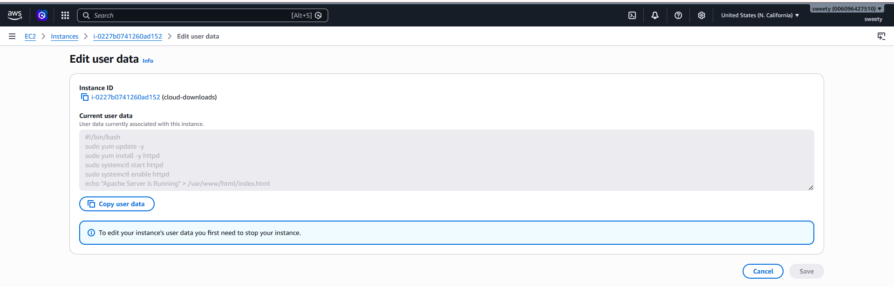
Successfully Apache activated
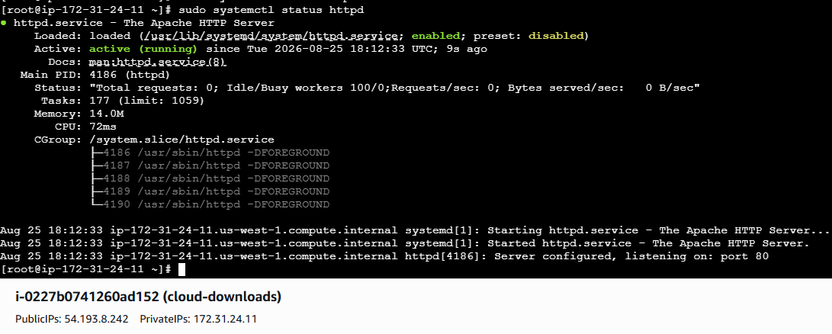

- Launch one EC2 using Ubuntu image and add a script in user data to install Nginx.
Step 1: Open EC2
1. Log in to the AWS Management Console.
2. Go to EC2.
3. Click Launch instance.
Step 2: Choose Ubuntu
Under Application and OS Images (AMI):
- Select Ubuntu
- Choose Ubuntu Server 24.04 LTS (64-bit)
- Architecture: 64-bit (x86)
Step 3: Choose instance type
For practice:
- Instance type: t3.micro or an eligible free-tier instance type available to your account.
- Select/create your key pair if SSH access is required.
Step 4: Configure Security Group
Create or select a security group and allow:
Type Port Source
SSH 22 My IP
HTTP 80 Anywhere 0.0.0.0/0

HTTP port 80 is important because Nginx will serve the web page through port 80.
Step 5: Add User Data
Scroll down to Advanced details → User data.
Paste:
#!/bin/bash
apt update -y
apt install nginx -y
systemctl enable nginx
systemctl start nginx
This script will automatically:
1. Update Ubuntu package information.
2. Install Nginx.
3. Enable Nginx so it starts after reboot.
4. Start Nginx immediately.
Step 6: Launch
Click Launch instance.
Wait until:
- Instance state → Running
- Status checks → 2/2 checks passed
Step 7: Verify Nginx
Copy the EC2 instance's Public IPv4 address.
Open your browser and enter:
http://<EC2-PUBLIC-IP>
You should see the Welcome to nginx! page.
Step 8: Verify through SSH
Connect to the Ubuntu instance:
ssh -i your-key.pem ubuntu@<EC2-PUBLIC-IP>
Then check:
systemctl status nginx
we should see:
Active: active (running)
we can also verify:
nginx -v
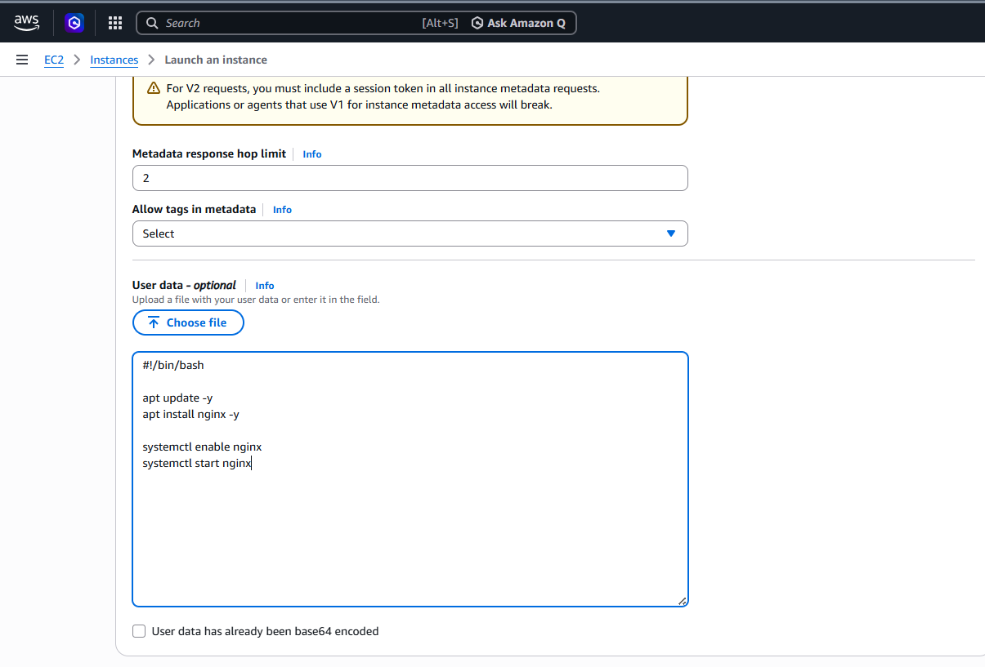
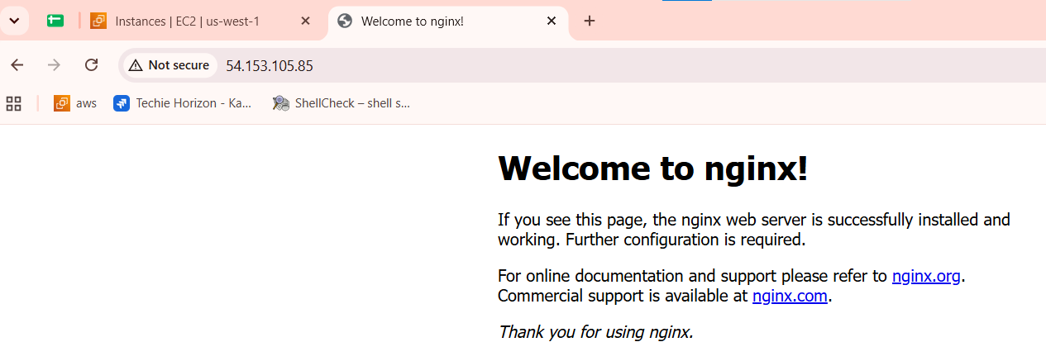
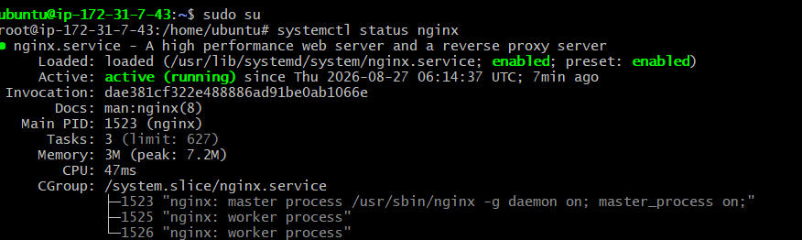

- Launch one Windows server and install Tomcat on Windows.
Go to AWS Console → EC2 → Launch instance.
Choose these settings
Name:
Windows-Tomcat-Server
AMI:
- Windows Server 2022 Base
- 64-bit (x86)
Instance type:
- t3.micro or another eligible small instance type available to you.
Key pair:
- Select your existing key pair or create a new one.
Security Group
Add:
Type |  | Port |  | Source
RDP |  | 3389 |  | My IP
Custom TCP |  | 8080 |  | Anywhere 0.0.0.0/0
Port 8080 is the default Tomcat port.
Click Launch instance.

2. Connect to Windows Server
Wait until the instance is Running.
Select the instance → Connect → RDP client.
Click Get password.
Upload the .pem key pair that you used when launching the instance.
Click Decrypt password.
You'll get:
Username: Administrator
Password: ********
Download the RDP file and open it.
Enter:
Username: Administrator
Password: <decrypted-password>
You should now be connected to the Windows Server desktop.

3. Install Java
Tomcat requires Java.
Open PowerShell as Administrator.
Check whether Java is already installed:
java -version
If Java isn't installed, install a JDK such as OpenJDK 17.
After installation, verify:
java -version
You should get something similar to:
openjdk version "17.x.x"

4. Download Tomcat
Open the official Apache Tomcat website and download a Tomcat 10.x Windows ZIP distribution.
https://tomcat.apache.org/?utm_source=chatgpt.com
or example, download:
apache-tomcat-10.x.x.zip
Extract it to:
C:\Tomcat
So you should have folders such as:
C:\Tomcat\bin
C:\Tomcat\conf
C:\Tomcat\webapps
C:\Tomcat\logs

5. Start Tomcat
Open PowerShell as Administrator:
cd C:\Tomcat\bin
Start Tomcat:
.\startup.bat
You should see a Tomcat command window.

6. Check Tomcat in the browser
From your local computer, open:
http://<EC2-PUBLIC-IP>:8080
For example:
http://54.xx.xx.xx:8080
You should see the Apache Tomcat welcome page.
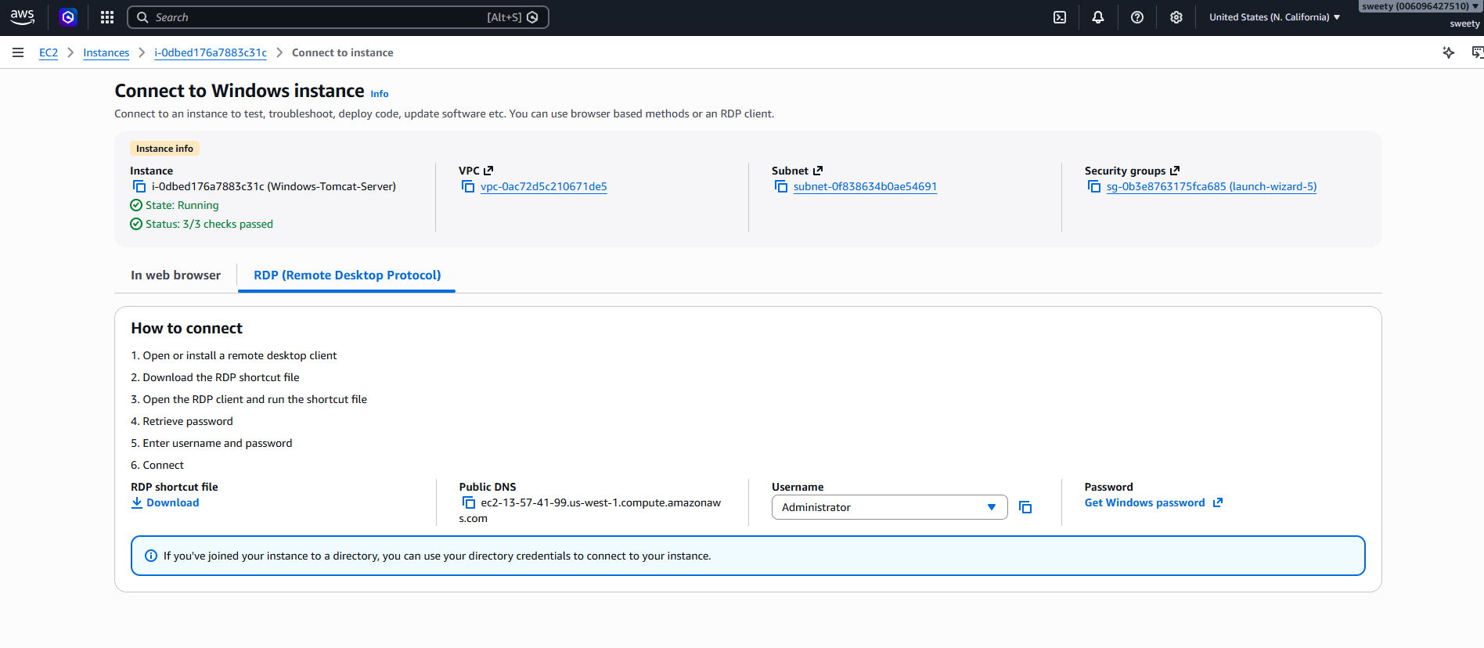
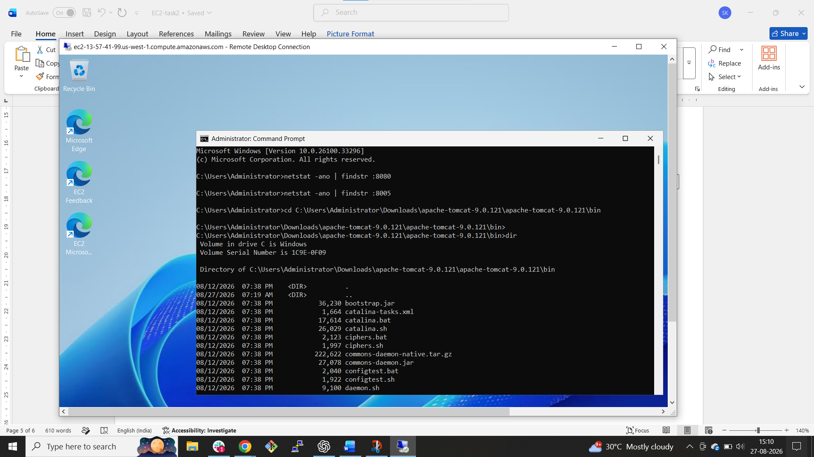

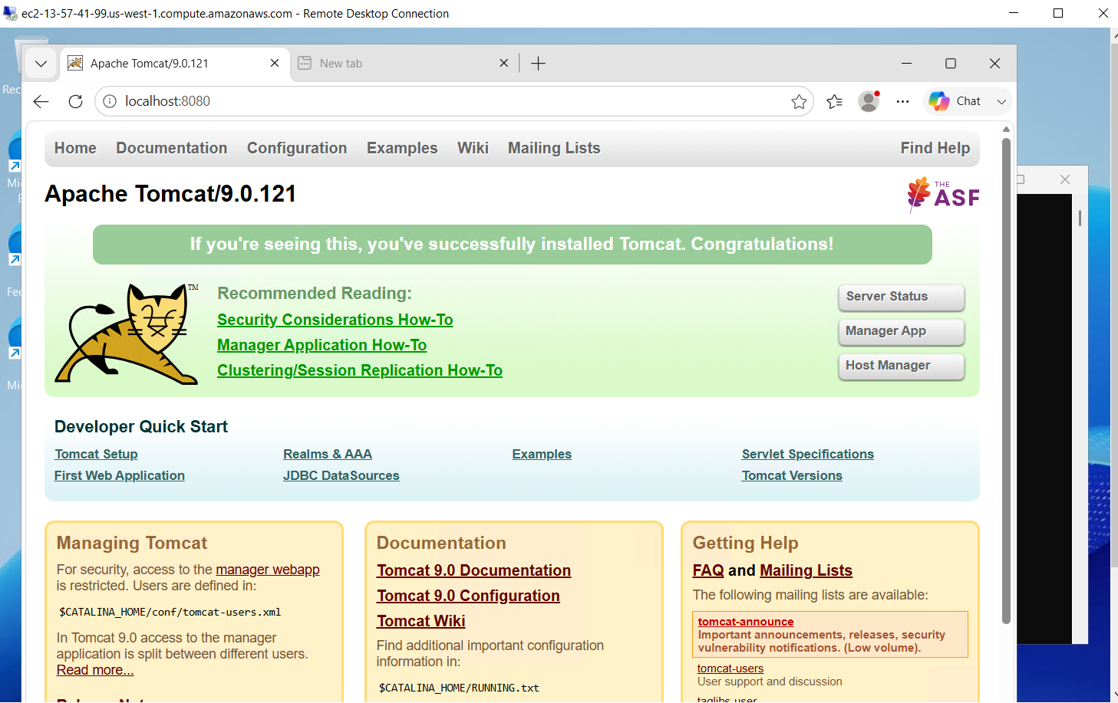

- Take a snapshot of the instance created in Task 1.
-select the inatance
-Go to Actions ->Image and Templates -> create Image ->give name of the backup file
-successfully created the backup instance
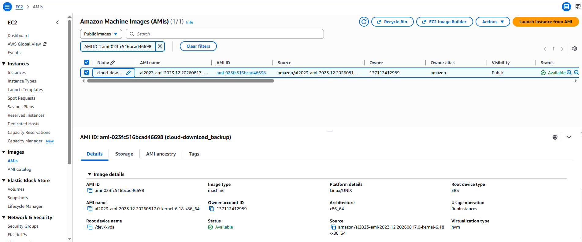

- Assign password less authentication for the EC2 created in Task 2.
ssh-keygen -t rsa -b 4096
↓
Created id_rsa + id_rsa.pub
↓
Connect to Ubuntu EC2
↓
Copy id_rsa.pub to ~/.ssh/authorized_keys
↓
chmod 700 ~/.ssh
chmod 600 ~/.ssh/authorized_keys
↓
Exit
↓
ssh -i ~/.ssh/id_rsa ubuntu@54.176.17.147
↓
Passwordless SSH login
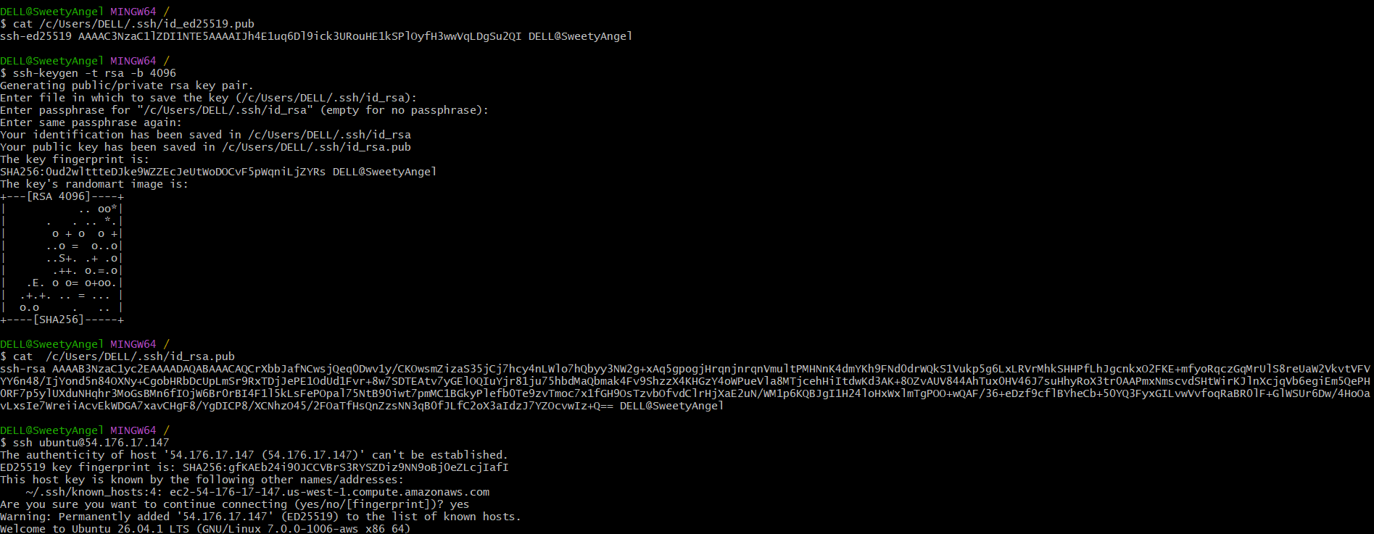

- Launch any EC2 using the spot purchasing option.
Step 1: Open EC2
Step 2: Give the instance a name
Step 3: Choose an AMI
Step 4: Choose instance type
Step 5: Select key pair
Step 6: Configure the Spot option
Step 7: Security Group
Step 8: Launch
Review your settings and click:
Launch instance
Wait for the instance to become:
Instance state: Running
Step 9: Verify that it is a Spot instance
Go to:
EC2 → Instances
Select your instance and check the instance details.
You should see information indicating that it is using Spot purchasing/capacity.
You can also check:
EC2 → Spot Requests
if your launch method created a Spot request.

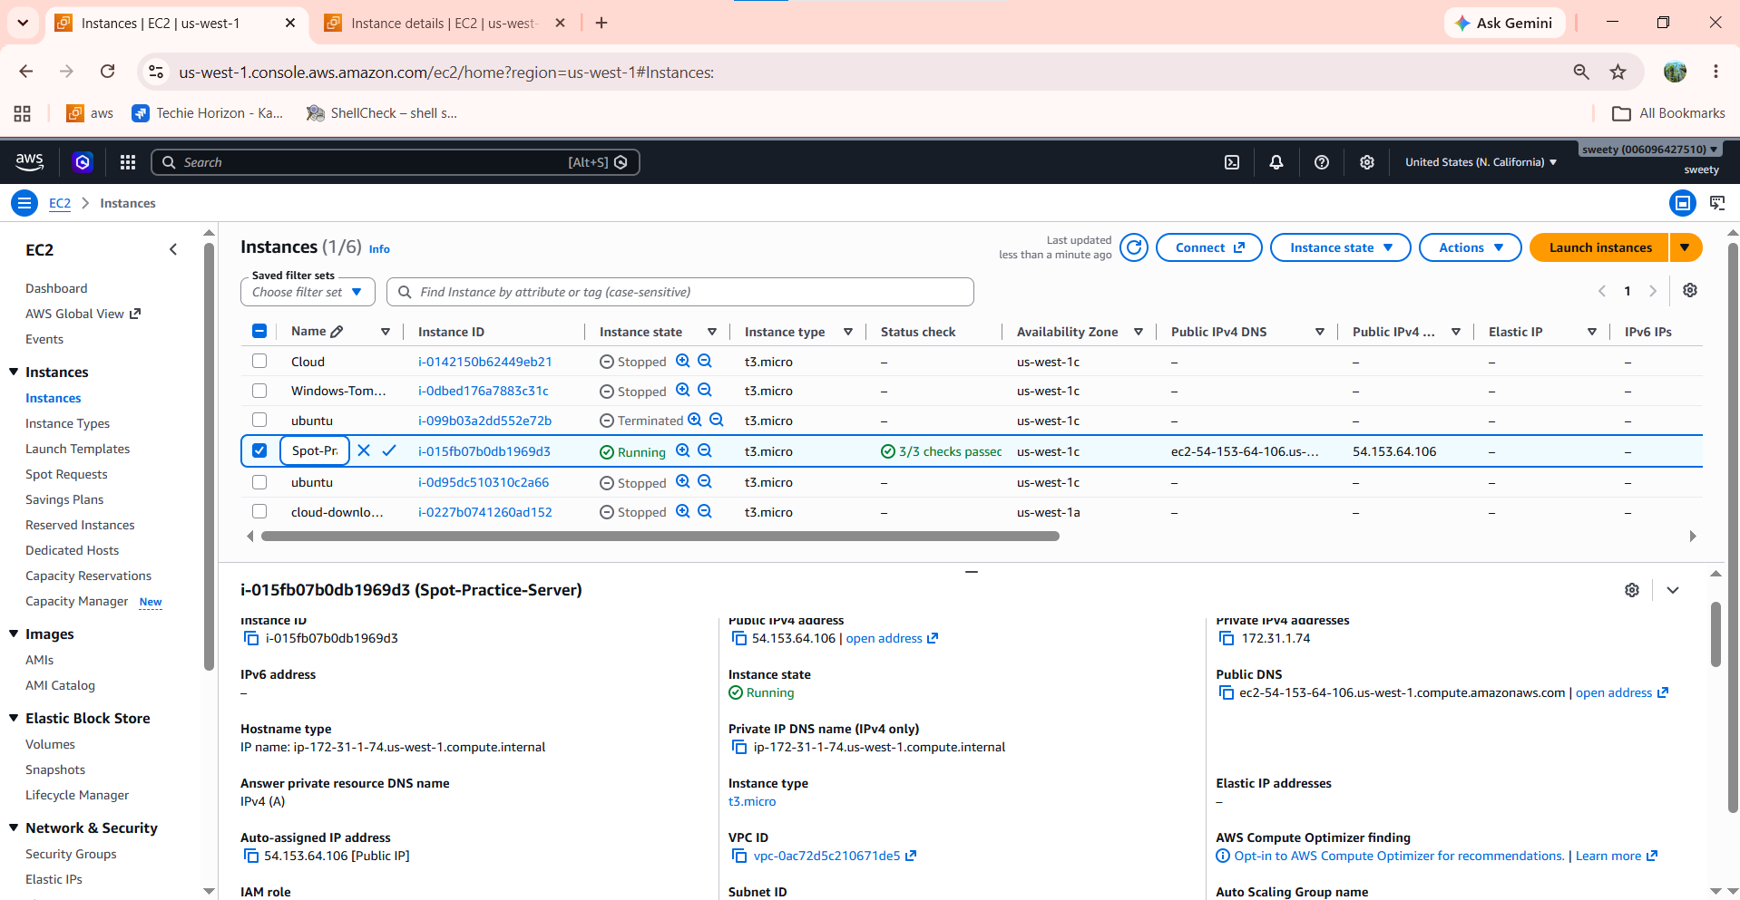
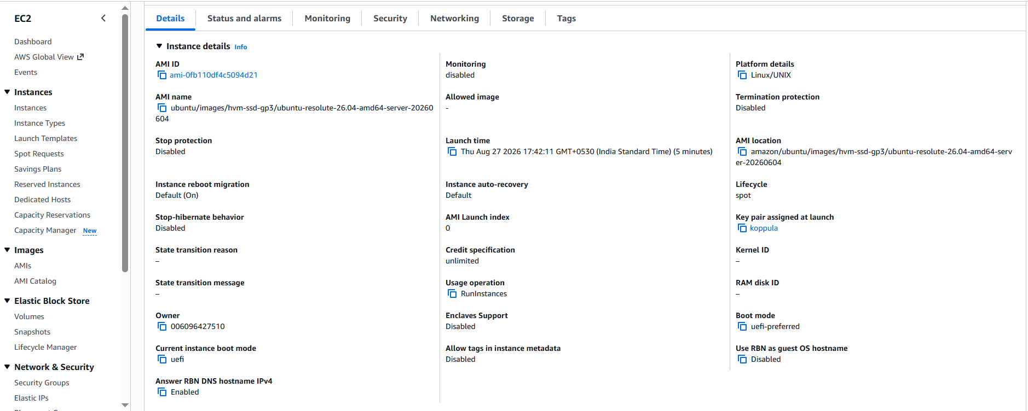

- Enable termination policy on the EC2 created in Task 2.
Without termination protection
↓
Actions → Terminate instance
↓
Instance can be terminated

With termination protection
↓
Actions → Terminate instance
↓
AWS prevents accidental termination
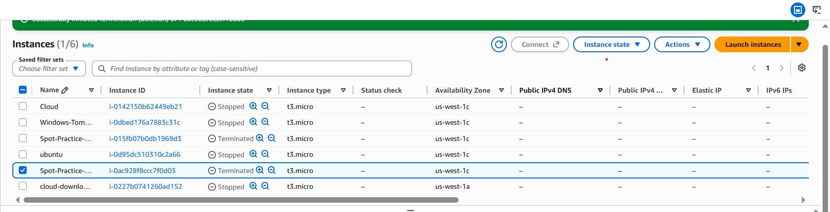

- Launch one EC2 using AWS CLI.
Check AWS CLI

aws --version

Configure AWS credentials

aws configure

Verify AWS account

aws sts get-caller-identity

Check available key pair

aws ec2 describe-key-pairs --query "KeyPairs[].KeyName" --output table

Launch EC2 instance

aws ec2 run-instances \
--image-id ami-08581f0d2f37de997 \
--instance-type t3.micro \
--count 1 \
--key-name koppula

Verify instance

aws ec2 describe-instances \
--query "Reservations[].Instances[].[InstanceId,State.Name,PublicIpAddress,PrivateIpAddress]" \
--output table

Get Public IP

aws ec2 describe-instances \
--query "Reservations[].Instances[].PublicIpAddress" \
--output text

Result: EC2 instance launched successfully and its public IP was obtained.

