Notes: Create a Jira ticket for this assignment, work on the tasks listed below, and submit the challenge completion document by EOD with clear steps and required evidence (outputs/screenshots).
First Challenge
- Launch oneEC2 instance using Amazon Linux 2.
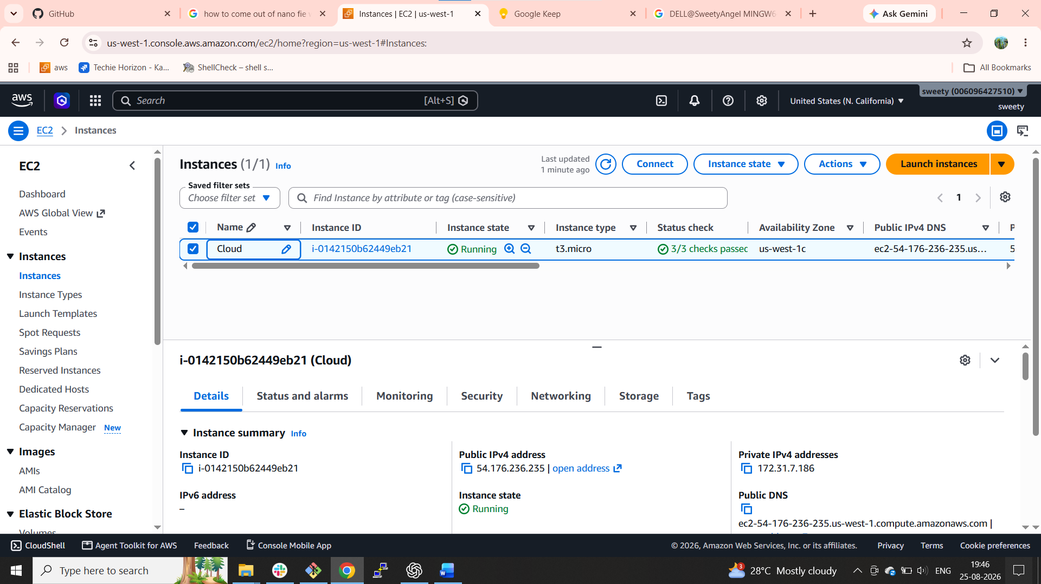
- Install Docker.
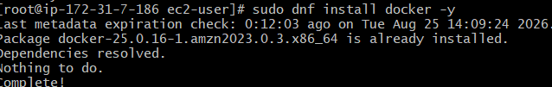
- Install Jenkins.
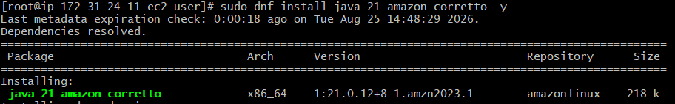
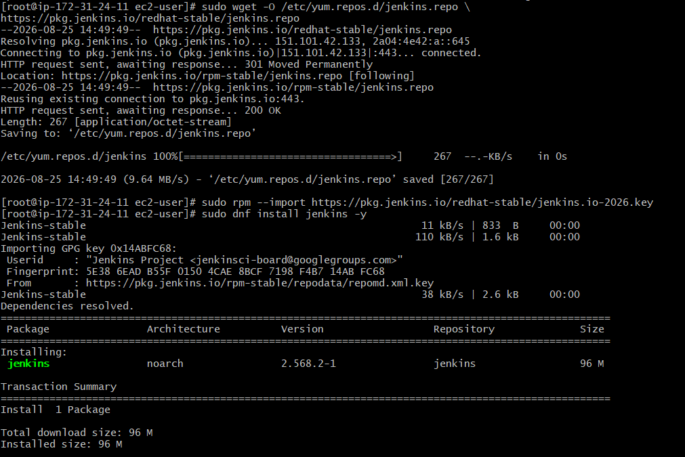
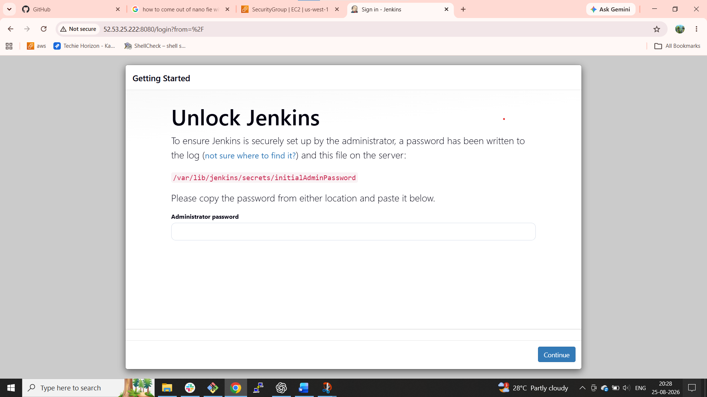
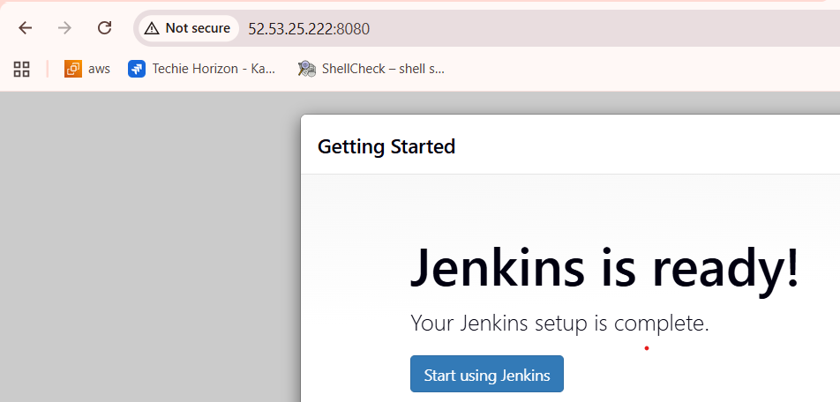

- Install Apache.
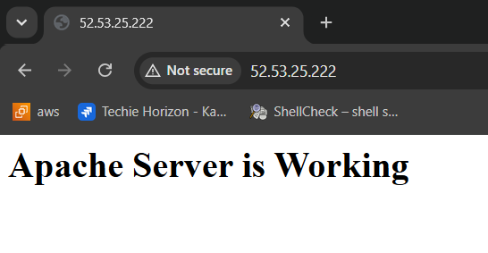
- Install Nginx.
Install nginx successfully
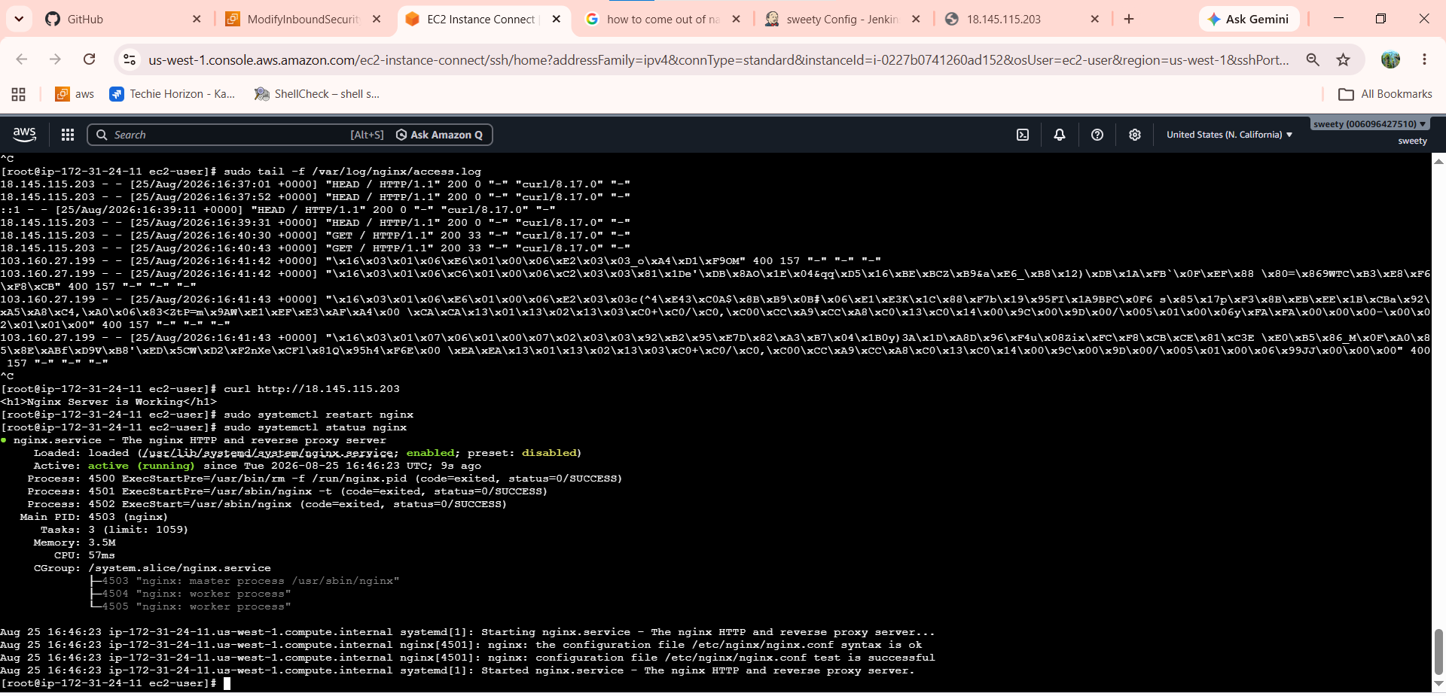
successfully running on port 80
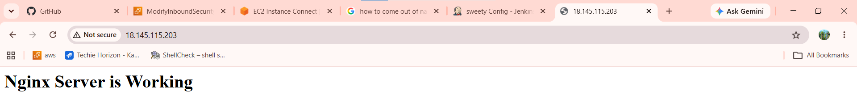
- Install Apache Tomcat.
before installing the tomcat
install java because java is dependence of tomcat
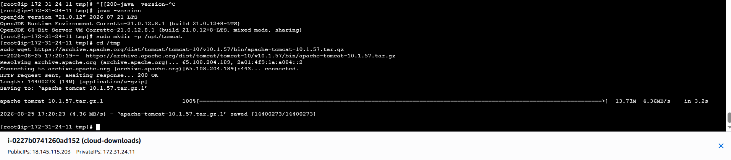

Created tar file
created the symbolic link
and given the ownership
and given permissions
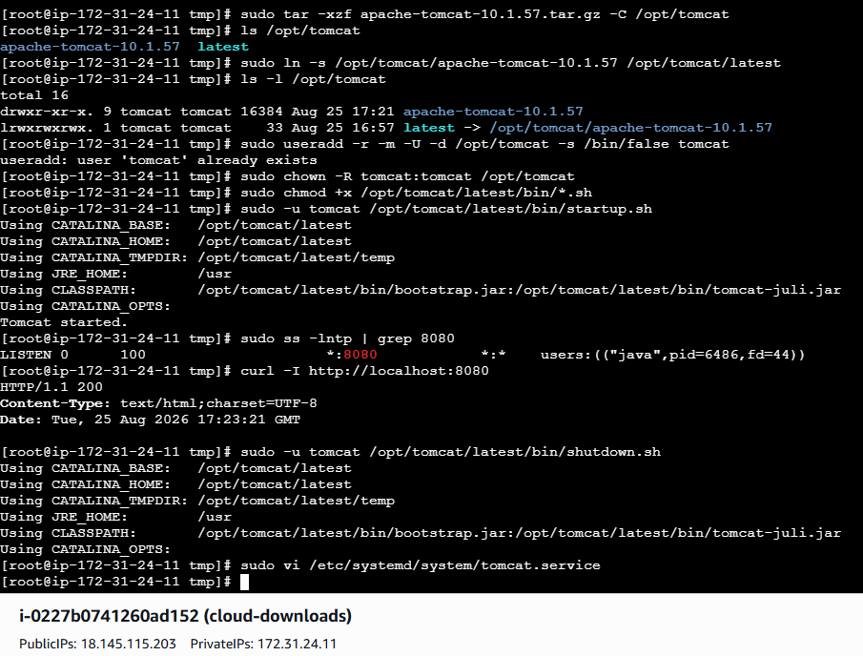
Created systemd service on tomcat
[Unit]
Description=Apache Tomcat Web Application Container
After=network.target
[Service]
Type=simple
User=tomcat
Group=tomcat
Environment="JAVA_HOME=/usr/lib/jvm/java-21-amazon-corretto.x86_64"
Environment="CATALINA_HOME=/opt/tomcat/latest"
Environment="CATALINA_BASE=/opt/tomcat/latest"
ExecStart=/opt/tomcat/latest/bin/catalina.sh run
ExecStop=/opt/tomcat/latest/bin/shutdown.sh
Restart=on-failure
RestartSec=10
[Install]
WantedBy=multi-user.target
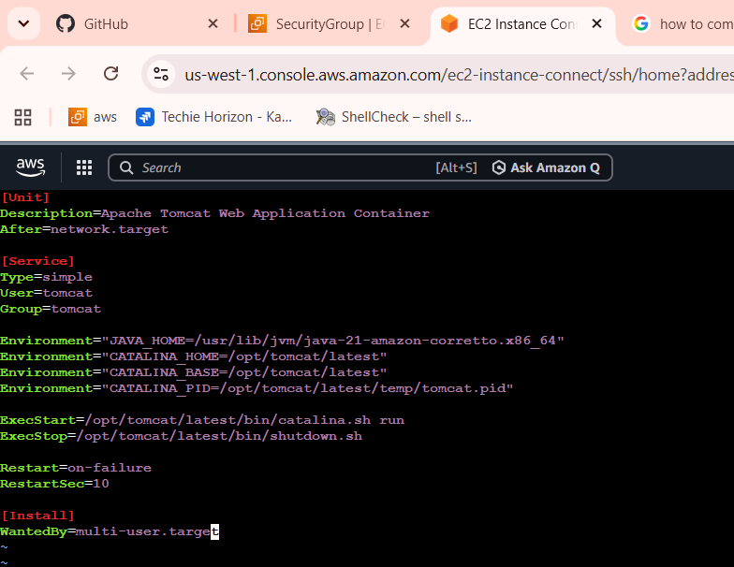
Apache tomcat is running successfully
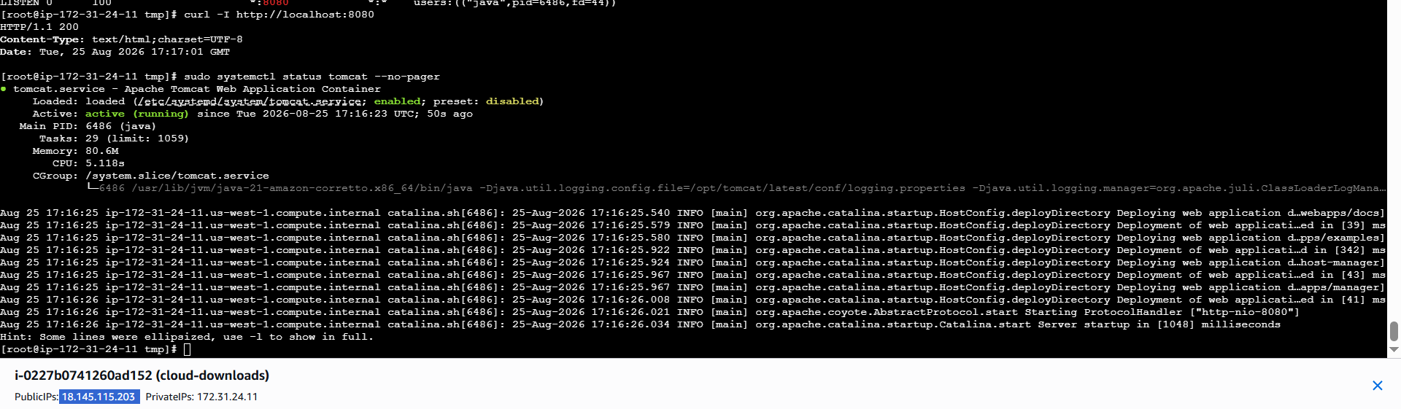
Tomcat installed successful on port 8080
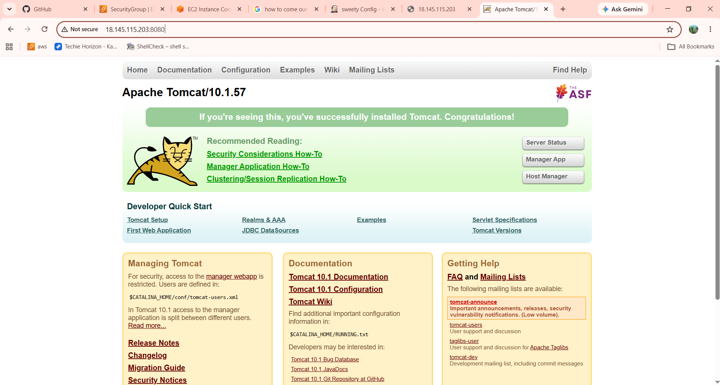
Everything needs to be setup and running on the same EC2.

