Webservers & App servers Task

Notes: Create a Jira ticket for this assignment, work on the tasks listed below, and submit the task completion document by EOD with clear steps and required evidence (outputs/screenshots)
- Install nginx and run nginx on port number 81.
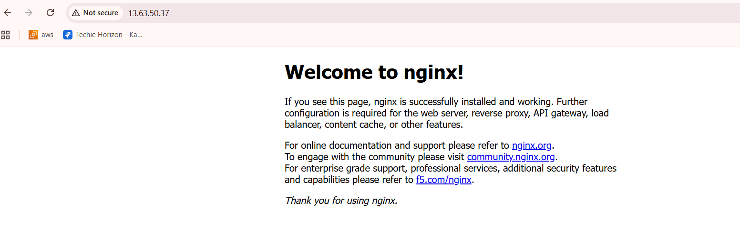

- Deploy a sample index.html file on nginx.

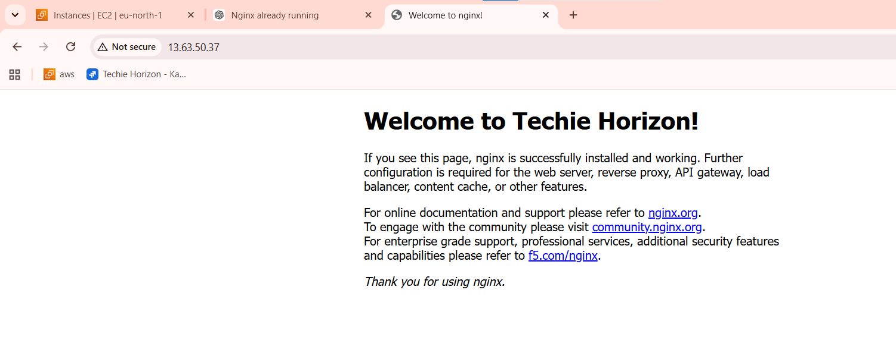
- Install Apache and run Apache on port number 82

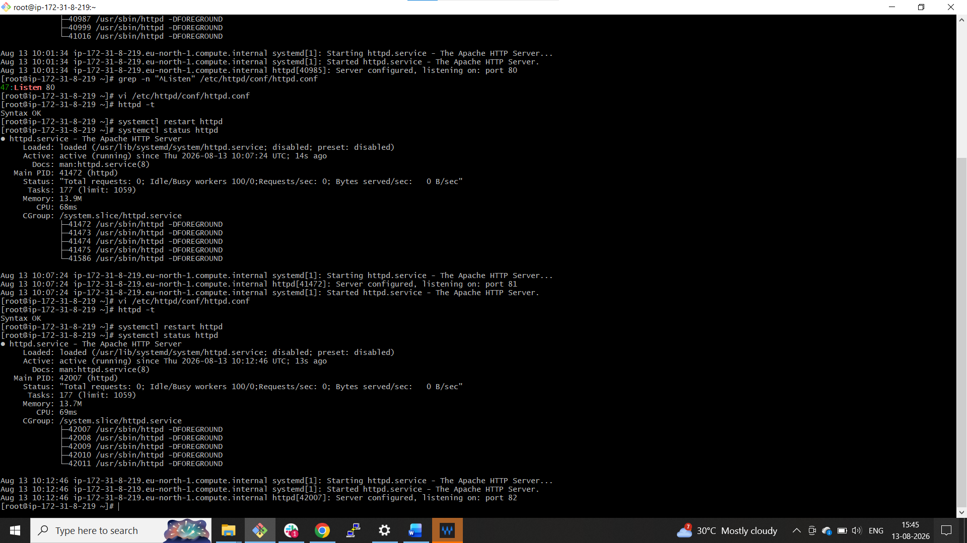


- Deploy a sample index.html file on Apache.
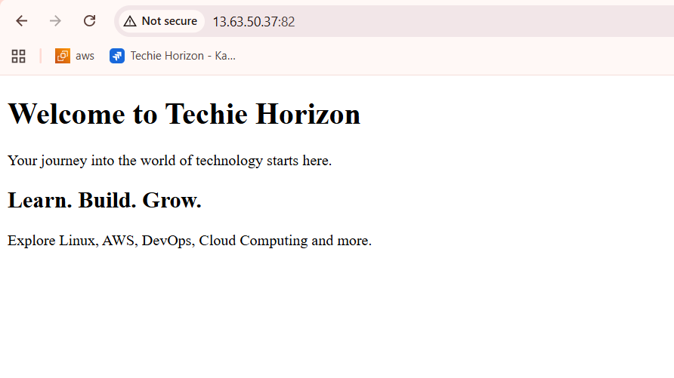
- Install Apache tomcat on port number 8082
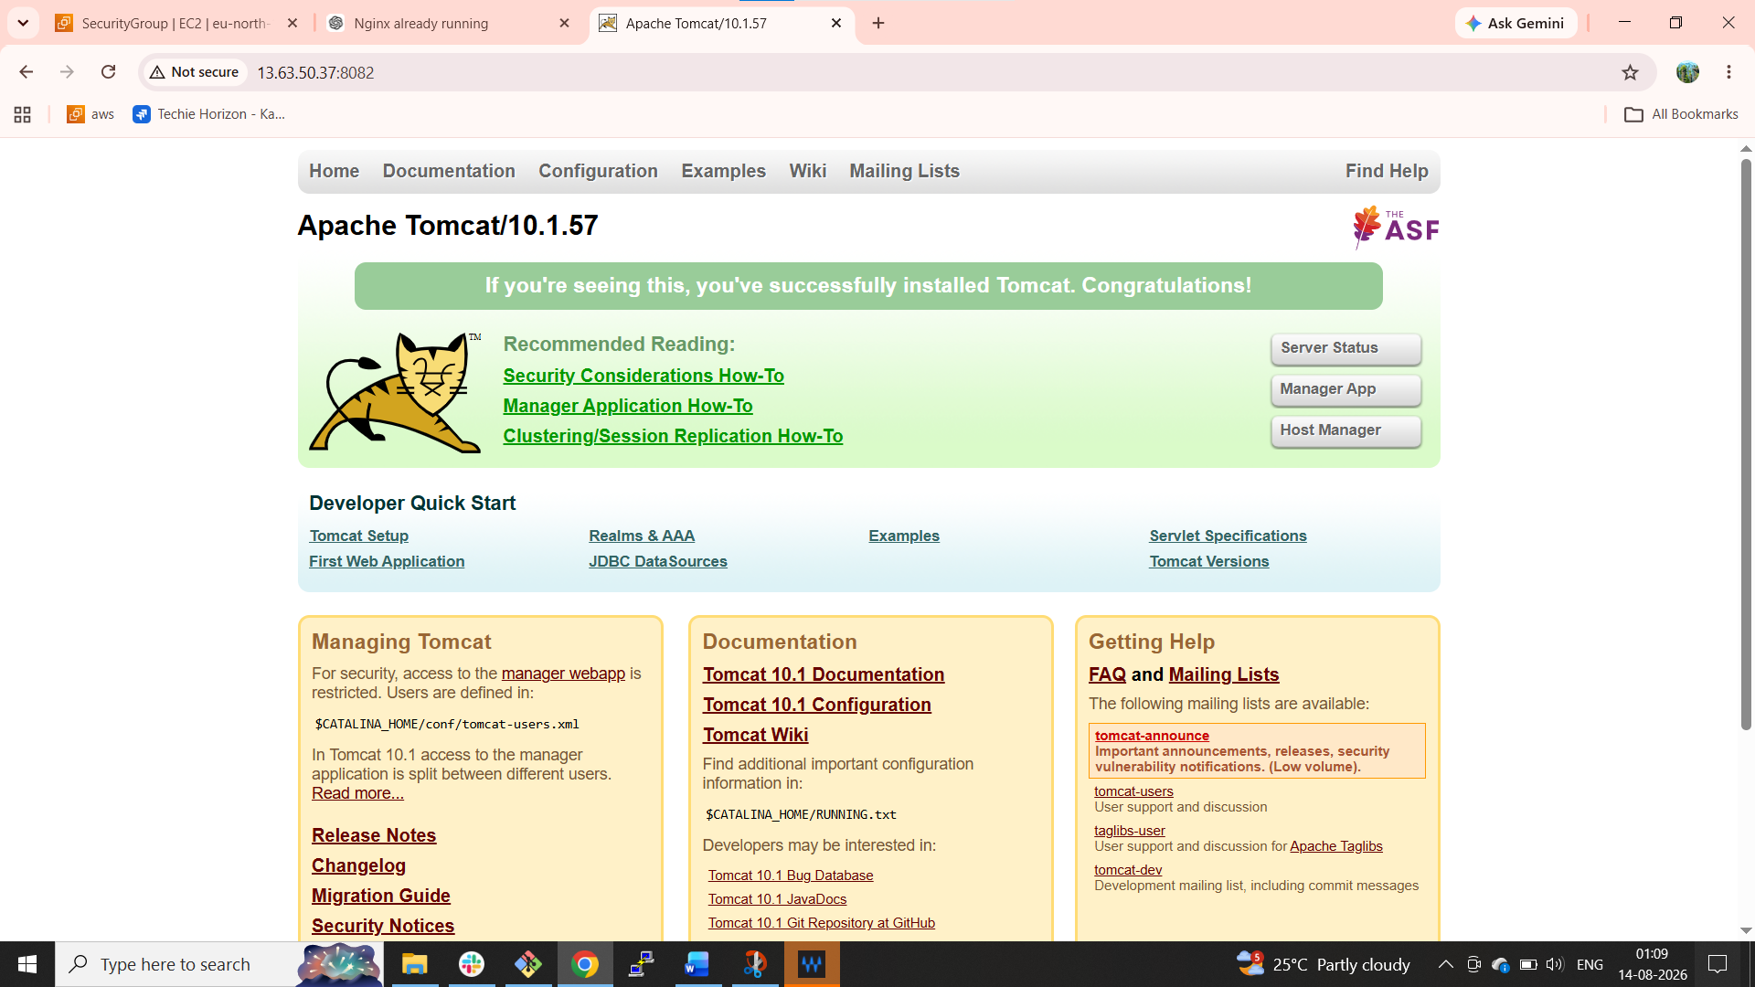

- Deploy a sample app on webapps
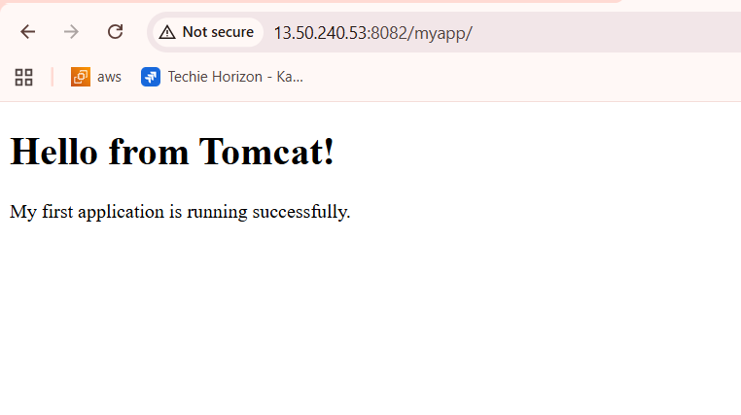

- Create a tomcat.service file for tomcat.
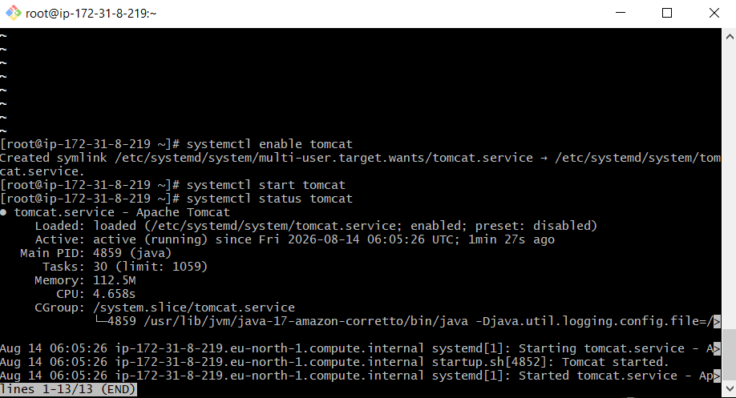
- Configure HA Proxy server
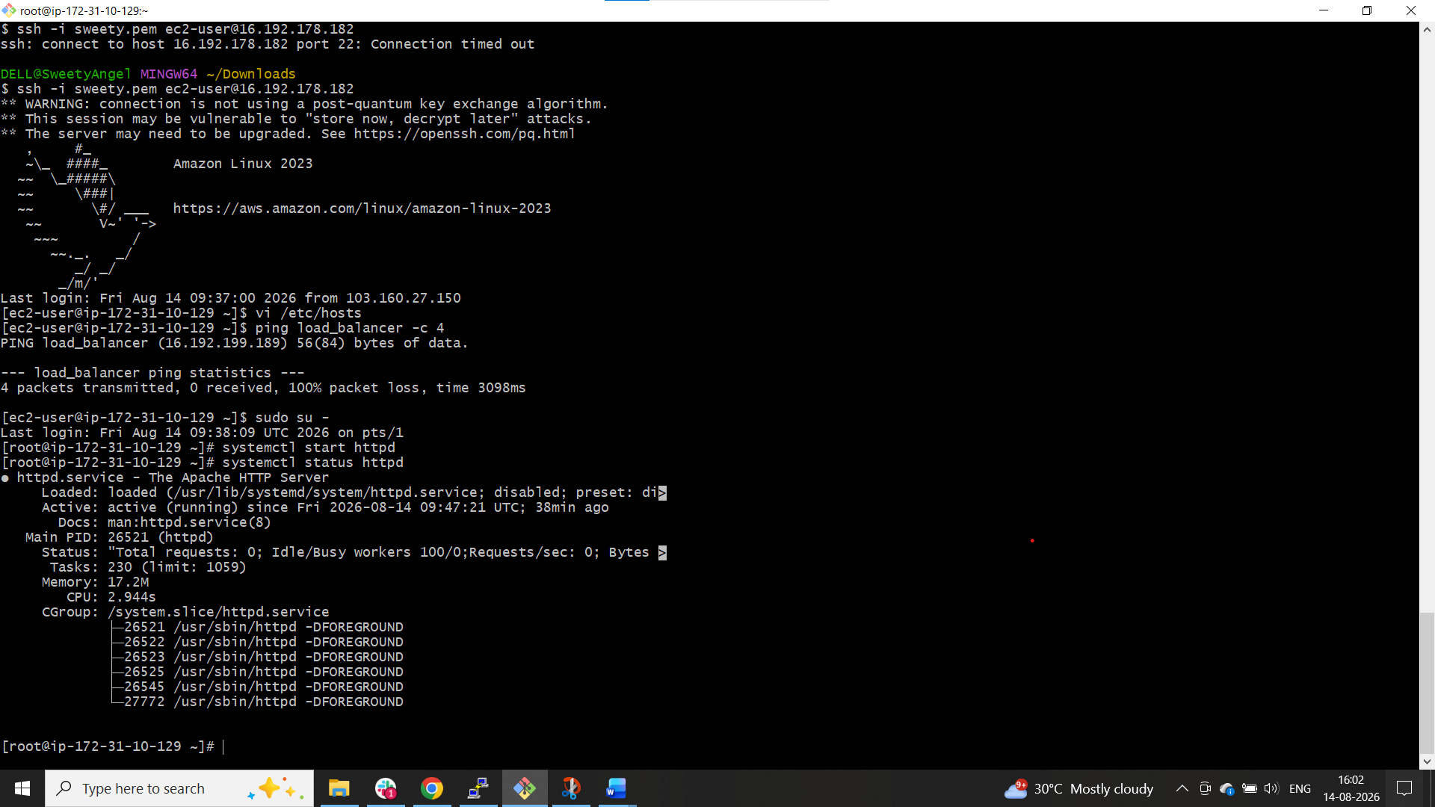


Server-2 Steps:
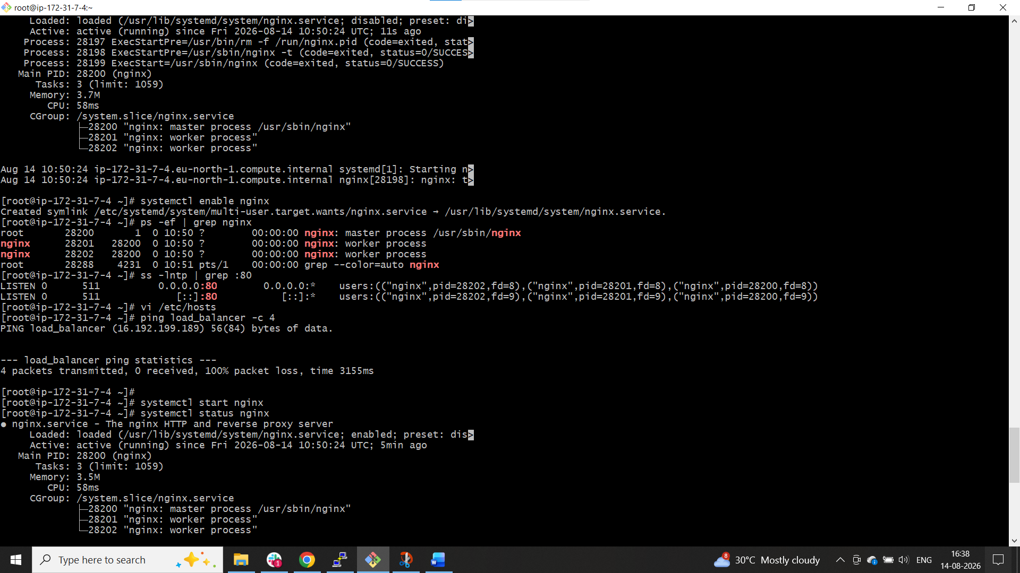
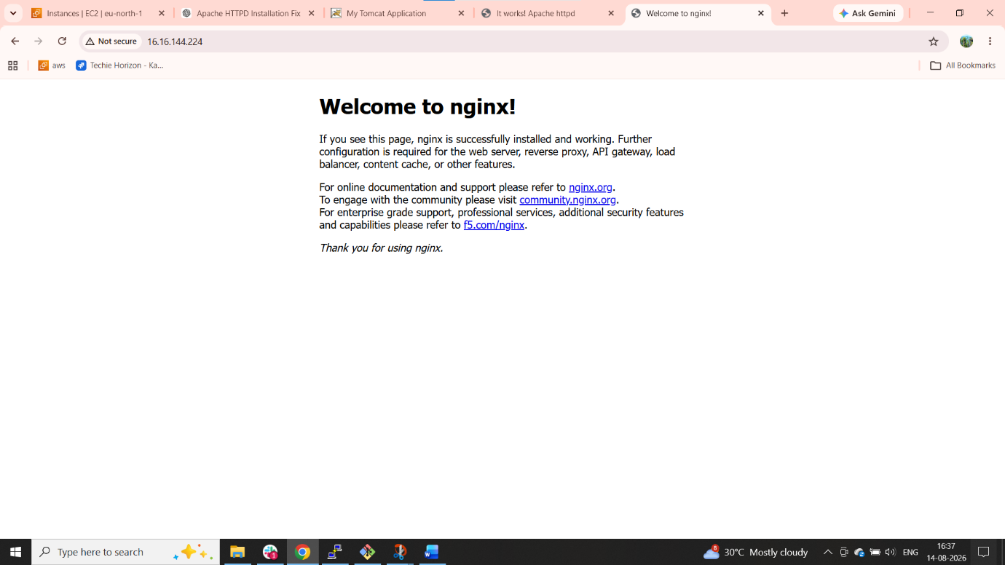

HA-Proxy-Server Steps:
