电子科技大学信息与软件工程学院

**实 验 报 告**

学 号 2017221303023

姓 名 陈奎

（实验） 课程名称 移动计算

理论教师 许毅

实验教师 许毅

**电子科技大学教务处制表**

**电 子 科 技 大 学**

**实 验 报 告**

**学生姓名：陈奎 学号：2017221303023 指导教师：许毅**

**实验地点：信软楼西304 实验时间：19.11.8**

**一、实验名称：**信息获取

**二、实验学时：**2学时

**三、实验目的：**

1. 学习和掌握内容提供器（Content Provider）
2. 学习和了解ContentResolver的基本用法
3. 学习和掌握如何获取电话本里的信息
4. 学习和掌握LocationManager的基本用法
5. 学习和掌握调用摄像头
6. 学习和掌握播放视频

**四、实验原理：**

基于AndroidStdio进行一系列的产品开发实践。

**五、实验内容：**

1. 使用Context中的getContentResolver()获取ContentResolver的实例
2. 使用Cursor查询联系人数据

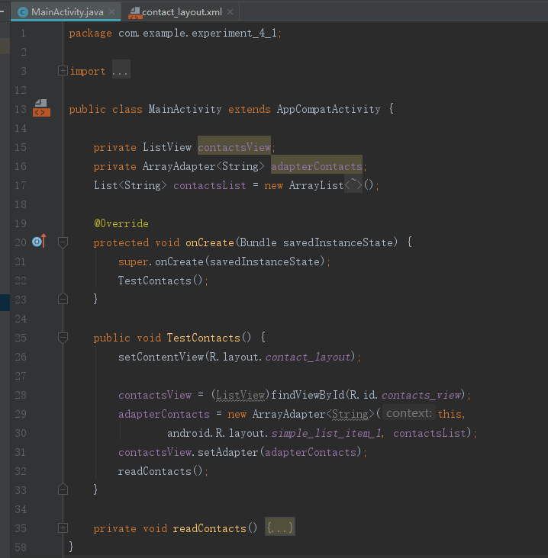

1. 编写程序获取GPS信息

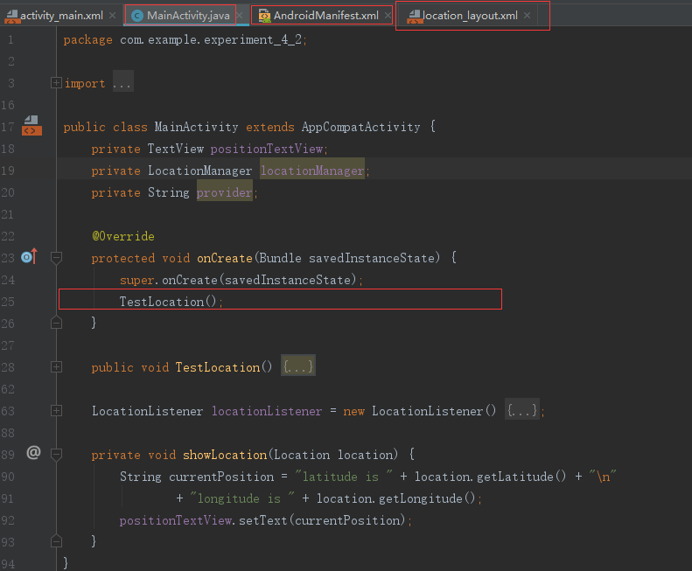

1. 编写程序调用摄像头

布局文件

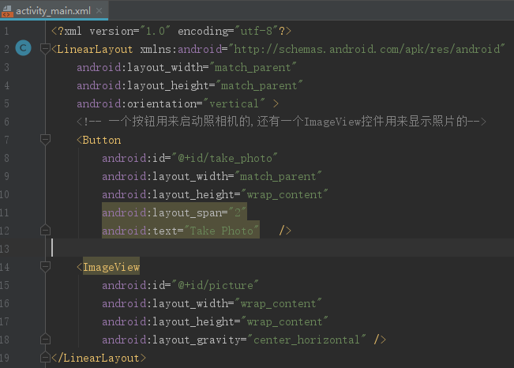

MainActivity.java文件

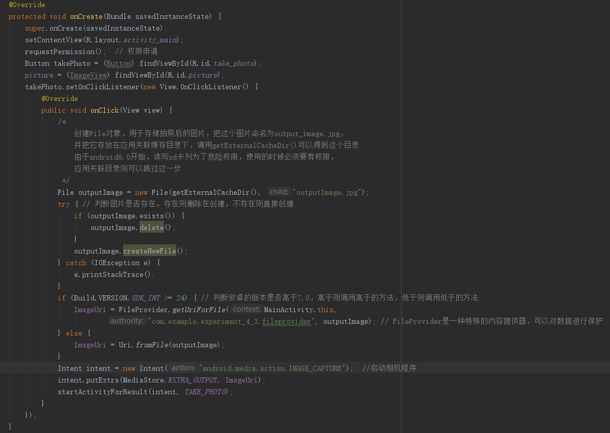

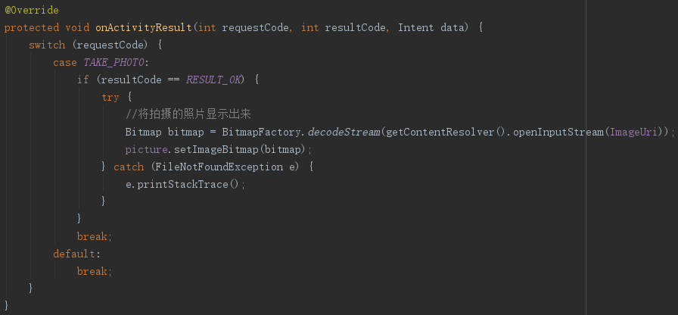

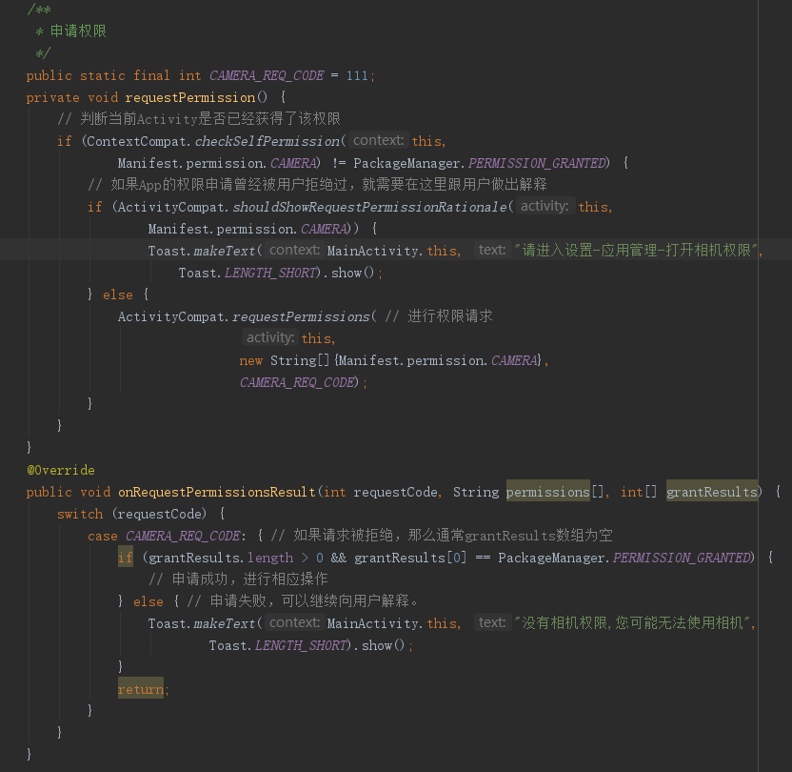

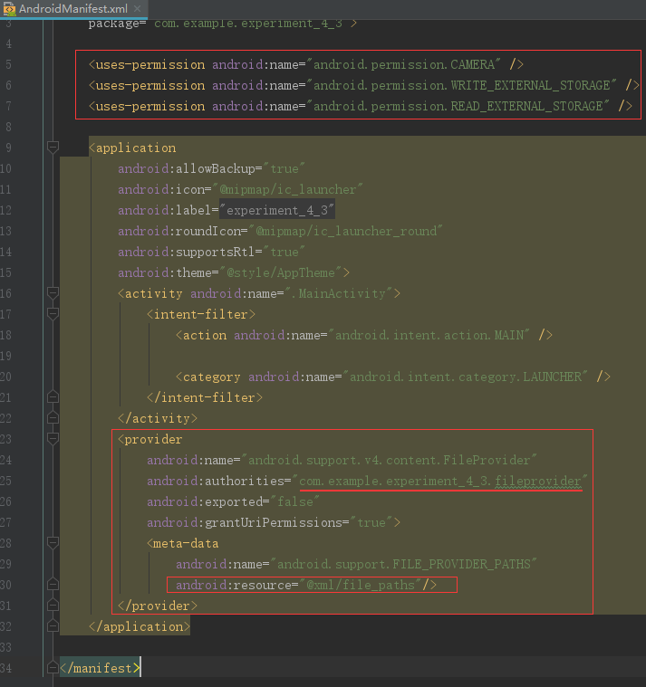

Res下新建Directory xml的文件

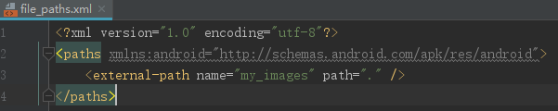

效果如下:

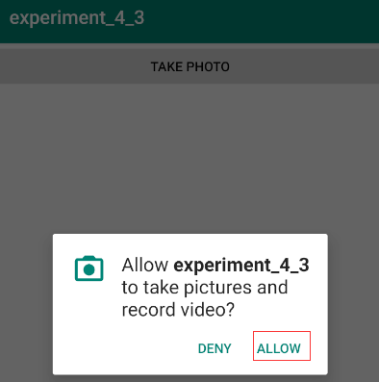

|  |  |
| --- | --- |
|  |  |

1. 编写程序播放视频

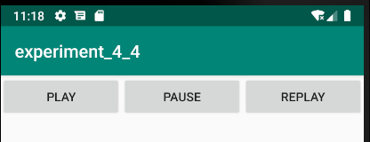

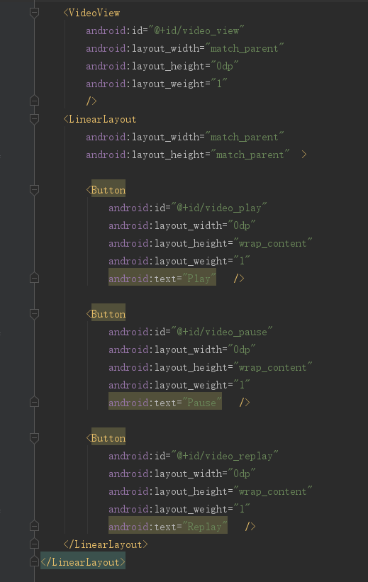

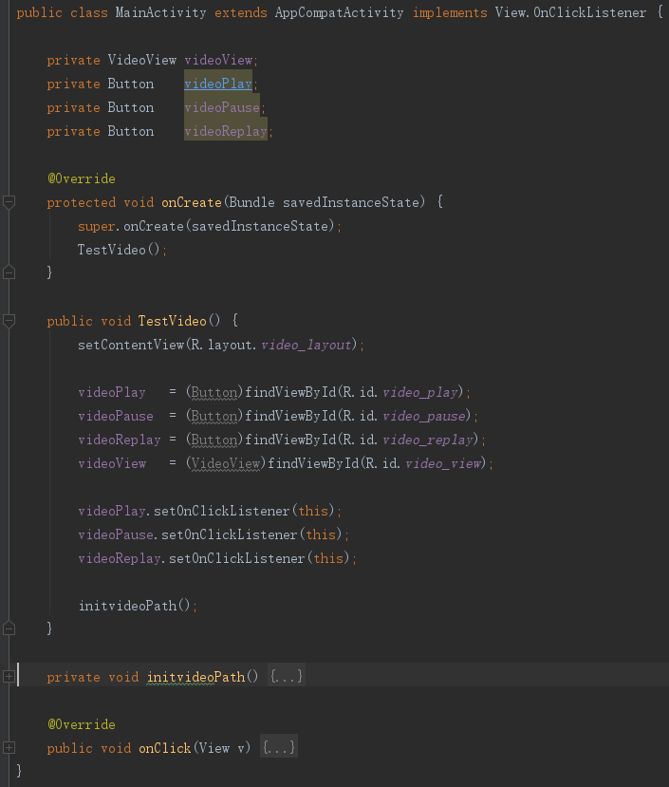

1. 编译、调试和查看程序运行结果

**六、实验器材（设备、元器件）：**

本实验开设方式为个人实验；实验授课时间0.5学时，上机3.5学时，每人一台PC单独完成实验，使用Eclipse（或Android Studio）、模拟器（或Android手机）编程调试。

**七、实验结果与分析（含重要数据结果分析或核心代码流程分析）**

1.在Android Studio开发环境中创建Android项目

2.使用Cursor查询联系人数据

Java代码

|  |
| --- |
| **package** com.example.application4;  **import** androidx.appcompat.app.AppCompatActivity; **import** android.database.Cursor; **import** android.os.Bundle; **import** android.provider.ContactsContract; **import** android.widget.ArrayAdapter; **import** android.widget.ListView; **import** java.util.ArrayList; **import** java.util.List;  **public class** MainActivity **extends** AppCompatActivity {  **private** ListView **contactsView**;  **private** ArrayAdapter<String> **adapterContacts**;  List<String> **contactsList**=**new** ArrayList<>();   @Override  **protected void** onCreate(Bundle savedInstanceState) {  **super**.onCreate(savedInstanceState);  TestContacts();  }   **public void** TestContacts(){  setContentView(R.layout.***activity_main***);  **contactsView**=(ListView)findViewById(R.id.***contacts_view***);  **adapterContacts**=**new** ArrayAdapter<String>(**this**,android.R.layout.***simple_list_item_1***,**contactsList**);  **contactsView**.setAdapter(**adapterContacts**);  readContacts();  }   **private void** readContacts(){  Cursor cursor=**null**;  **try**{  cursor=getContentResolver().query(ContactsContract.CommonDataKinds.Phone.***CONTENT_URI***,**null**,**null**,**null**,**null**);  **if**(cursor!=**null**){  **while**(cursor.moveToNext()){  String displayName=cursor.getString(cursor.getColumnIndex(ContactsContract.CommonDataKinds.Phone.***DISPLAY_NAME***));  String number=cursor.getString(cursor.getColumnIndex(ContactsContract.CommonDataKinds.Phone.***NUMBER***));  }  **adapterContacts**.notifyDataSetChanged();  }  }**catch** (Exception e){  e.printStackTrace();  }**finally** {  **if**(cursor!=**null**)  cursor.close();  }  }  } |

3.编写程序获取GPS信息

在AndroidManifest.xml中添加

|  |
| --- |
| <**uses-permission android:name="android.permission.ACCESS_FINE_LOCATION"**/> |

Activity_main.xml文件

|  |
| --- |
| *<?***xml version="1.0" encoding="utf-8"***?>* <**LinearLayout xmlns:android="http://schemas.android.com/apk/res/android"  android:layout_width="match_parent"  android:layout_height="match_parent"  android:orientation="vertical"**>   <**TextView  android:id="@+id/ms_msg"  android:layout_width="match_parent"  android:layout_height="match_parent"  android:padding="5dp"  android:textSize="20sp"  android:textStyle="bold"** />  </**LinearLayout**> |

Java代码

|  |
| --- |
| **package** com.example.application4_2;  **import** android.content.Context; **import** android.content.Intent; **import** android.content.pm.PackageManager; **import** android.location.Location; **import** android.location.LocationListener; **import** android.location.LocationManager; **import** android.provider.Settings;  **import** android.os.Bundle; **import** android.os.Message; **import** android.os.Handler; **import** android.widget.TextView; **import** android.widget.Toast;  **import** androidx.appcompat.app.AppCompatActivity;  **import static** android.Manifest.permission.***ACCESS_FINE_LOCATION***;  **public class** MainActivity **extends** AppCompatActivity {   **private** LocationManager **lm**;  **private** TextView **ms_msg**;  **private** String **loc_msg**;   **private** Handler **handler** = **new** Handler(**new** Handler.Callback(){   @Override  **public boolean** handleMessage(Message msg) {  **if** ( msg.**what** == 0x001 ) {  **ms_msg**.setText(**loc_msg**);  }   **return false**;  }  });   **private** LocationListener **mLocationListener** = **new** LocationListener() {  @Override  **public void** onLocationChanged(Location location) {  *// 当GPS定位信息发生改变时，更新定位* updateShow(location);  }   @Override  **public void** onStatusChanged(String provider, **int** status, Bundle extras) {   }   @Override  **public void** onProviderEnabled(String provider) {   *// 如果没权限，打开设置页面让用户自己设置* **if** ( checkCallingOrSelfPermission(***ACCESS_FINE_LOCATION***) != PackageManager.***PERMISSION_GRANTED***) {   Toast.*makeText*(MainActivity.**this**, **"请打开GPS~"**, Toast.***LENGTH_SHORT***).show();   Intent intent = **new** Intent(Settings.***ACTION_LOCATION_SOURCE_SETTINGS***);  startActivityForResult(intent, 0);  **return**;  }   *// 当GPS LocationProvider可用时，更新定位* updateShow(**lm**.getLastKnownLocation(provider));  }   @Override  **public void** onProviderDisabled(String provider) {  updateShow(**null**);  }  };   @Override  **public void** onCreate(Bundle savedInstanceState) {   **super**.onCreate(savedInstanceState);  setContentView(R.layout.***activity_main***);  **ms_msg** = (TextView) findViewById(R.id.***ms_msg***);   **lm** = (LocationManager) getSystemService(Context.***LOCATION_SERVICE***);   locationUpdate();  }   **public void** onResume() {  **super**.onResume();  locationUpdate();  }   **public void** onPause() {  **super**.onPause();  **lm**.removeUpdates(**mLocationListener**);  }   *//定义一个更新显示的方法* **private void** updateShow(Location location) {  **if** (location != **null**) {  StringBuilder sb = **new** StringBuilder();  sb.append(**"当前的位置信息：\n"**);  sb.append(**"经度："** + location.getLongitude() + **"\n"**);  sb.append(**"纬度："** + location.getLatitude() + **"\n"**);   **loc_msg** = sb.toString();  } **else loc_msg** = **""**;   **handler**.sendEmptyMessage(0x001);  }   **public void** locationUpdate() {   *// 如果没权限，打开设置页面让用户自己设置* **if** ( checkCallingOrSelfPermission(***ACCESS_FINE_LOCATION***) != PackageManager.***PERMISSION_GRANTED***) {   Toast.*makeText*(MainActivity.**this**, **"请打开GPS~"**, Toast.***LENGTH_SHORT***).show();   Intent intent = **new** Intent(Settings.***ACTION_LOCATION_SOURCE_SETTINGS***);  startActivityForResult(intent, 0);  **return**;  }   Location location = **lm**.getLastKnownLocation(LocationManager.***NETWORK_PROVIDER***);   updateShow(location);   *// 设置间隔两秒获得一次 GPS 定位信息* **lm**.requestLocationUpdates(LocationManager.***GPS_PROVIDER***, 2000, 8,**mLocationListener**);  }  } |

在手机上运行，获得运行结果：

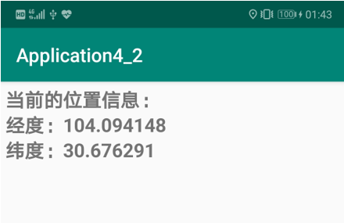

4.编写程序调用摄像头

Activity.xml文件

|  |
| --- |
| *<?***xml version="1.0" encoding="utf-8"***?>* <**LinearLayout xmlns:android="http://schemas.android.com/apk/res/android"  android:layout_width="match_parent"  android:layout_height="match_parent"  android:orientation="vertical"**>  <**Button  android:id="@+id/take_photo"  android:layout_width="match_parent"  android:layout_height="wrap_content"  android:layout_span="2"  android:text="Take Photo"**/>  <**ImageView  android:id="@+id/picture"  android:layout_width="wrap_content"  android:layout_height="wrap_content"  android:layout_gravity="center_horizontal"**/>  </**LinearLayout**> |

MainActivity文件

|  |
| --- |
| **package** com.example.application4_3;  **import** androidx.appcompat.app.AppCompatActivity; **import** androidx.core.app.ActivityCompat; **import** androidx.core.content.ContextCompat; **import** androidx.core.content.FileProvider;  **import** android.Manifest; **import** android.content.Intent; **import** android.content.pm.PackageManager; **import** android.graphics.Bitmap; **import** android.graphics.BitmapFactory; **import** android.net.Uri; **import** android.os.Build; **import** android.os.Bundle; **import** android.provider.MediaStore; **import** android.view.View; **import** android.widget.Button; **import** android.widget.ImageView; **import** android.widget.Toast;  **import** java.io.File; **import** java.io.FileNotFoundException; **import** java.io.IOException;  **public class** MainActivity **extends** AppCompatActivity {   **public static final int *TAKE_PHOTO*** = 1;  **private** Uri **ImageUri**;  **private** ImageView **picture**;   @Override  **protected void** onCreate(Bundle savedInstanceState) {  **super**.onCreate(savedInstanceState);  setContentView(R.layout.***activity_main***);  requestPermission();  Button takePhoto = (Button) findViewById(R.id.***take_photo***);  **picture** = (ImageView) findViewById(R.id.***picture***);  takePhoto.setOnClickListener(**new** View.OnClickListener() {  @Override  **public void** onClick(View v) {  File outputImage = **new** File(getExternalCacheDir(), **"outputImage.jpg"**);  **try** {  **if** (outputImage.exists()) {  outputImage.delete();  }  outputImage.createNewFile();  } **catch** (IOException e) {  e.printStackTrace();  }  **if** (Build.VERSION.***SDK_INT*** >= 24) {  **ImageUri** = FileProvider.*getUriForFile*(MainActivity.**this**, **"package com.example.application4_3.fileprovider"**, outputImage);  } **else** {  **ImageUri** = Uri.*fromFile*(outputImage);  }  Intent intent = **new** Intent(**"android.media.action.IMAGE_CAPTURE"**);  intent.putExtra(MediaStore.***EXTRA_OUTPUT***, **ImageUri**);  startActivityForResult(intent, ***TAKE_PHOTO***);  }  });  }    **protected void** onActicityResult(**int** requestCode, **int** resultCode, Intent data) {  **switch** (requestCode) {  **case *TAKE_PHOTO***:  **if** (requestCode == ***RESULT_OK***) {  **try** {  Bitmap bitmap = BitmapFactory.*decodeStream*(getContentResolver().openInputStream(**ImageUri**));  **picture**.setImageBitmap(bitmap);  } **catch** (FileNotFoundException e) {  e.printStackTrace();  }  }  **break**;  **default**:  **break**;  }  }   **public static final int *CAMER_REQ_CODE*** = 111;   **private void** requestPermission() {  **if** (ContextCompat.*checkSelfPermission*(**this**, Manifest.permission.***CAMERA***) != PackageManager.***PERMISSION_GRANTED***) {  **if** (ActivityCompat.*shouldShowRequestPermissionRationale*(**this**, Manifest.permission.***CAMERA***)) {  Toast.*makeText*(MainActivity.**this**, **"请进入设置-应用管理-打开相机权限"**, Toast.***LENGTH_SHORT***).show();  } **else** {  ActivityCompat.*requestPermissions*(**this**, **new** String[]{Manifest.permission.***CAMERA***}, ***CAMER_REQ_CODE***);  }  }  }   @Override  **public void** onRequestPermissionsResult(**int** requestCode, String permission[], **int**[] grantResults) {  **switch** (requestCode) {  **case *CAMER_REQ_CODE***: {  **if** (grantResults.**length** > 0 && grantResults[0] == PackageManager.***PERMISSION_GRANTED***) {  } **else** {  Toast.*makeText*(MainActivity.**this**, **"没有相机权限，可能无法使用。"**, Toast.***LENGTH_SHORT***).show();  }  **return**;  }  }  } } |

AndroidManifest.xml文件

|  |
| --- |
| *<?***xml version="1.0" encoding="utf-8"***?>* <**manifest xmlns:android="http://schemas.android.com/apk/res/android"  package="com.example.application4_3"**>  <**uses-permission android:name="android.permission.CAMERA"**/>  <**uses-permission android:name="android.permission.WRITE_EXTERNAL_STORAGE"**/>  <**uses-permission android:name="android.permission.READ_EXTERNAL_STORAGE"**/>   <**application  android:allowBackup="true"  android:icon="@mipmap/ic_launcher"  android:label="@string/app_name"  android:roundIcon="@mipmap/ic_launcher_round"  android:supportsRtl="true"  android:theme="@style/AppTheme"**>  <**activity android:name=".MainActivity"**>  <**intent-filter**>  <**action android:name="android.intent.action.MAIN"** />   <**category android:name="android.intent.category.LAUNCHER"** />  </**intent-filter**>  </**activity**>  <**provider  android:authorities="com.example.application4_3.fileprovider"  android:name="androidx.core.content.FileProvider"  android:exported="false"  android:grantUriPermissions="true"**>  <**meta-data  android:name="android.support.FILE_PROVIDER_PATHS"  android:resource="@xml/file_paths"**/>  </**provider**>   </**application**>  </**manifest**> |

Res下新建Directory xml的文件



|  |
| --- |
| *<?***xml version="1.0" encoding="utf-8"***?>* <**paths xmlns:android="http://schemas.android.com/apk/res/android"**>  <**external-path  name="my_images"  path="."**/> </**paths**> |

运行结果示例

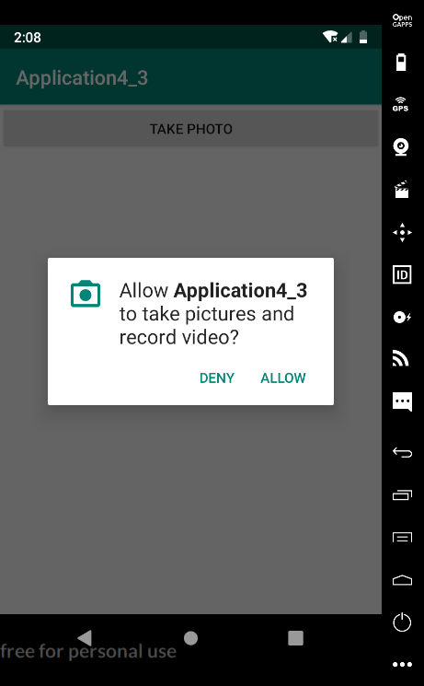 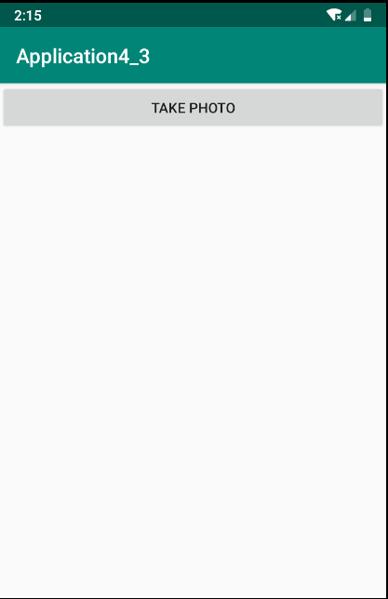

5.编写程序播放视频

将视频文件放入res下的raw目录下



AndroidManifest.xml中添加

|  |
| --- |
| <**uses-permission android:name="android.permission.READ_EXTERNAL_STORAGE"**/> <**uses-permission android:name="android.permission.WRITE_EXTERNAL_STORAGE"**/> <**uses-permission android:name="android.permission.INTERNET"**/> |

Activity_main.xml文件代码

|  |
| --- |
| *<?***xml version="1.0" encoding="utf-8"***?>* <**LinearLayout xmlns:android="http://schemas.android.com/apk/res/android"  android:layout_width="match_parent"  android:layout_height="match_parent"  android:orientation="vertical"**>  <**VideoView  android:layout_width="match_parent"  android:layout_height="0dp"  android:layout_weight="1"  android:id="@+id/video_view"**/>  <**LinearLayout  android:layout_width="match_parent"  android:layout_height="match_parent"**>  <**Button  android:id="@+id/video_play"  android:layout_width="0dp"  android:layout_height="wrap_content"  android:layout_weight="1"  android:text="Play"**/>  <**Button  android:id="@+id/video_pause"  android:layout_width="0dp"  android:layout_height="wrap_content"  android:layout_weight="1"  android:text="Pause"**/>  <**Button  android:id="@+id/video_replay"  android:layout_width="0dp"  android:layout_height="wrap_content"  android:layout_weight="1"  android:text="Replay"**/>  </**LinearLayout**>  </**LinearLayout**> |

MainAcitivity.java代码

|  |
| --- |
| **package** com.example.application4_4;  **import** androidx.annotation.NonNull; **import** androidx.appcompat.app.AppCompatActivity; **import** androidx.core.app.ActivityCompat; **import** androidx.core.content.ContextCompat;  **import** android.Manifest; **import** android.content.pm.PackageManager; **import** android.os.Bundle; **import** android.os.Environment; **import** android.view.View; **import** android.widget.Button; **import** android.widget.Toast; **import** android.widget.VideoView;  **import** java.io.File;  **public class** MainActivity **extends** AppCompatActivity **implements** View.OnClickListener{   **private** VideoView **videoView**;  **private** Button **videpPlay**;  **private** Button **videoPause**;  **private** Button **videoReplay**;  @Override  **protected void** onCreate(Bundle savedInstanceState) {  **super**.onCreate(savedInstanceState);  TestVideo();   }  **public void** TestVideo(){  setContentView(R.layout.***activity_main***);   **videpPlay**=(Button)findViewById(R.id.***video_play***);  **videoPause**=(Button)findViewById(R.id.***video_pause***);  **videoReplay**=(Button)findViewById(R.id.***video_replay***);  **videoView**=(VideoView)findViewById(R.id.***video_view***);  **videpPlay**.setOnClickListener(**this**);  **videoReplay**.setOnClickListener(**this**);  **videoPause**.setOnClickListener(**this**);  **if**(ContextCompat.*checkSelfPermission*(MainActivity.**this**,Manifest.permission.***WRITE_EXTERNAL_STORAGE***)!=  PackageManager.***PERMISSION_GRANTED***){  ActivityCompat.*requestPermissions*(MainActivity.**this**,**new** String[]{Manifest.permission.***WRITE_EXTERNAL_STORAGE***},1);  }**else** {  initviedoPath();  }  }   **private void** initviedoPath(){  File file=**new** File(Environment.*getExternalStorageDirectory*(),**"test1.mp4"**);  **videoView**.setVideoPath(file.getPath());  }  **public void** onRequestPermissionsResult(**int** requestCode, @NonNull String[] permissions,@NonNull **int**[] grantResults){  **switch** (requestCode){  **case** 1:  **if**(grantResults.**length**>0&&grantResults[0]==PackageManager.***PERMISSION_GRANTED***){  initviedoPath();  }**else** {  Toast.*makeText*(**this**,**"拒绝权限无法使用程序"**,Toast.***LENGTH_SHORT***).show();  finish();  }  **break**;  **default**:  **break**;  }  }  **public void** onClick(View v){  **switch** (v.getId()){  **case** R.id.***video_play***:  **if**(!**videoView**.isPlaying())  **videoView**.start();  **break**;  **case** R.id.***video_pause***:  **if**(**videoView**.isPlaying())  **videoView**.pause();  **break**;  **case** R.id.***video_replay***:  **videoView**.resume();  **break**;  }  } } |

运行结果

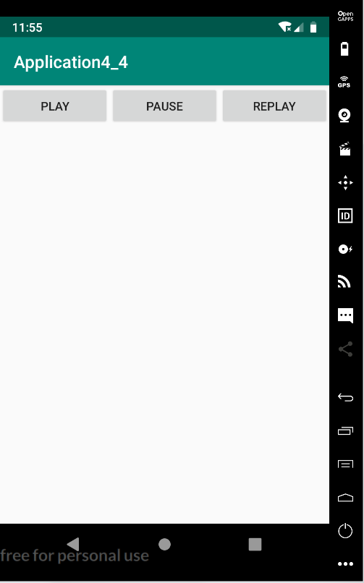

**八、总结及心得体会：**

通过本次实验了解了Android开发时一些敏感权限的请求操作，比如调用GPS定位，读取系统文件等。成功实现了编写程序调用相机、播放视频、获取定位信息等操作，加深了对Android开发的理解。

**报告评分：**

**指导教师签字：**