# Task Management Application

## Deployment

The web app is live and can be accessed [here](https://fluffy-tanuki-c0bc5b.netlify.app/).

## Table of Contents

* Overview
* Installation
* Features
* Technologies Used
* Components
* State Management
* Styling
* Screenshots
* Contributing

## Overview

This is a task management application built using React, Redux, and Tailwind CSS. It supports task creation, deletion, updating task status, and filtering tasks based on a search query. The application also provides a drag-and-drop interface for managing tasks across different statuses like “To Do”, “In Progress”, “Peer Review”, and “Closed”.

## Installation

Clone the repository:

git clone https://github.com/AbhishekIT22112002/KanbanBoard.git

To access directory:

cd KanbanBoard

Install dependencies:

npm install

Start the development server:

npm run dev

Build for production:

npm run build

## Features

1. **Add Task:**
   * Click on the “Create Task” button to open a modal where you can enter the task name and description.
   * Click “Add Task” to save the task.
2. **Managing Tasks:**
   * Tasks can be dragged and dropped between different sections (“To Do”, “In Progress”, “Peer Review”, and “Closed”).
   * You can also delete tasks by clicking the delete icon.
3. **Searching Tasks:**
   * Use the search input to filter tasks by their name.
   * The task list will update in real-time as you type.
4. **Responsive Design:**
   * The application is responsive and works well on mobile devices.

## Technologies Used

* **React**: A JavaScript library for building user interfaces.
* **Redux**: A state management tool for managing application state.
* **React DnD**: A drag-and-drop library for React applications.
* **React Hot Toast**: Notifications for task actions like creation and deletion.
* **Tailwind CSS**: Utility-first CSS framework for styling.
* **uuid**: For generating unique task IDs

## Components

1. **App.jsx**

* This is the root component that integrates all the main features of the application. It sets up the drag-and-drop context using ***DndProvider***, initializes the tasks from local storage, and manages the layout of the main components like ***Search***, ***CreateButton***, and ***ListTasks***.

1. **CreateButton.jsx**

* A button that opens a modal for creating a new task. It uses Tailwind CSS for styling and handles the opening and closing of the modal.

1. **CreateTask.jsx**

* A form inside the modal where users can enter the task name and description. It dispatches the addTask action to save the new task.

1. **Header.jsx**

* Displays the section header, including the title and the count of tasks in that section.

1. **ListTasks.jsx**

* Renders the sections of tasks categorized by their status (“To Do”, “In Progress”, “Peer Review”, “Closed”). Each section displays tasks that can be dragged and dropped.

1. **Modal.jsx**

* A modal component that wraps the ***CreateTask*** form. It handles closing the modal and includes a close button.

1. **Search.jsx**

* An input field that allows users to search tasks by name. It updates the ***searchQuery*** in the Redux store.

1. **Section.jsx**

* Renders a specific task section based on status. It integrates the drag-and-drop functionality and displays tasks that belong to that section.

1. **Task.jsx**

* Represents an individual task in the list. It supports dragging to move the task between sections and includes a delete button to remove the task.

## State Management

The application uses Redux for state management, particularly the ***taskSlice*** for handling tasks and search functionality.

1. **taskSlice.js**
   * **State Structure:**
     + ***tasks***: An array of task objects.
     + ***filteredTasks***: An array of tasks filtered by the search query.
     + ***searchQuery***: The current search query string.
   * **Reducers:**
     + ***setTasks***: Sets the list of tasks.
     + ***addTask***: Adds a new task to the list.
     + ***removeTask***: Removes a task from the list.
     + ***updateTaskStatus***: Updates the status of a task (e.g., from “To Do” to “In Progress”).
     + ***setSearchQuery***: Updates the search query for filtering tasks.
2. **store.js**

* Configures the Redux store and integrates the ***taskSlice*** reducer.

## Styling

* **Tailwind CSS:** Used for styling components. The utility-first CSS framework allows for quick and responsive design.
* **Custom CSS:** Some components use additional custom styles for specific UI elements, such as the modal.

## Screenshots

Add screenshots of your application here to demonstrate its functionality.

* **Main Screen:**
  + *Chrome View*
  + [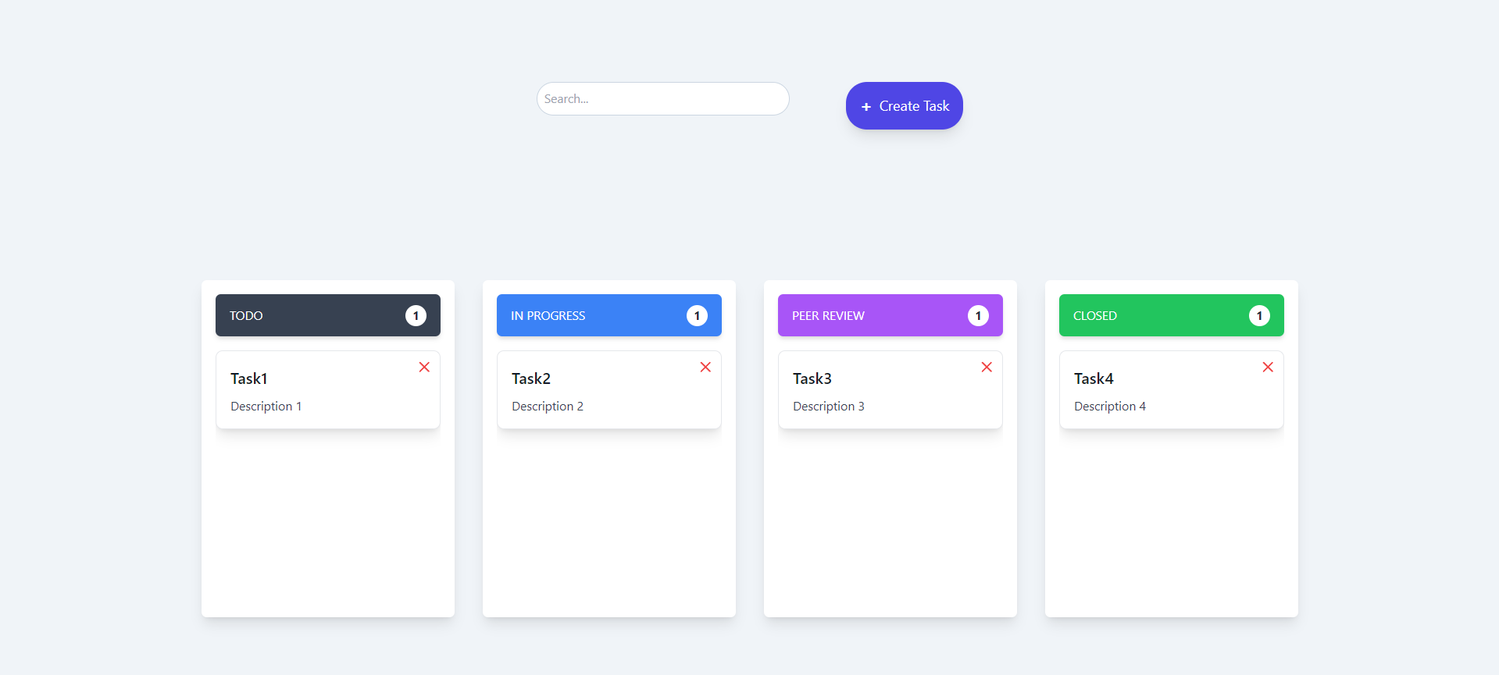](https://github.com/AbhishekIT22112002/KanbanBoard/blob/main/src/assets/ChromeView/Main-Screen.png)
  + *Mobile View*

[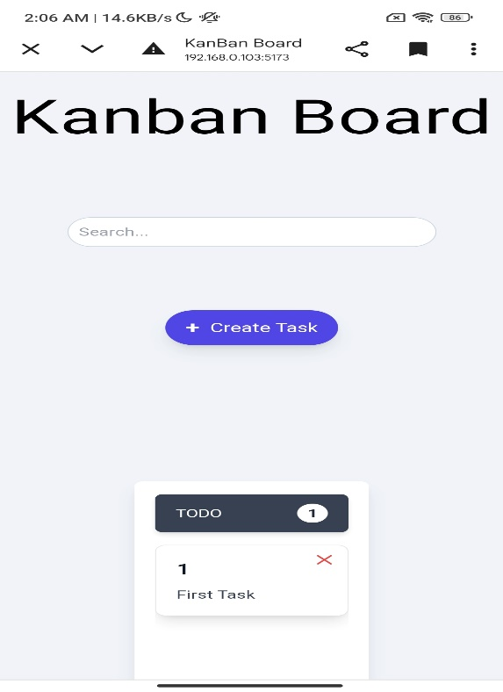](https://github.com/AbhishekIT22112002/KanbanBoard/blob/main/src/assets/Mobile-View/Main-Screen1.jpg)

[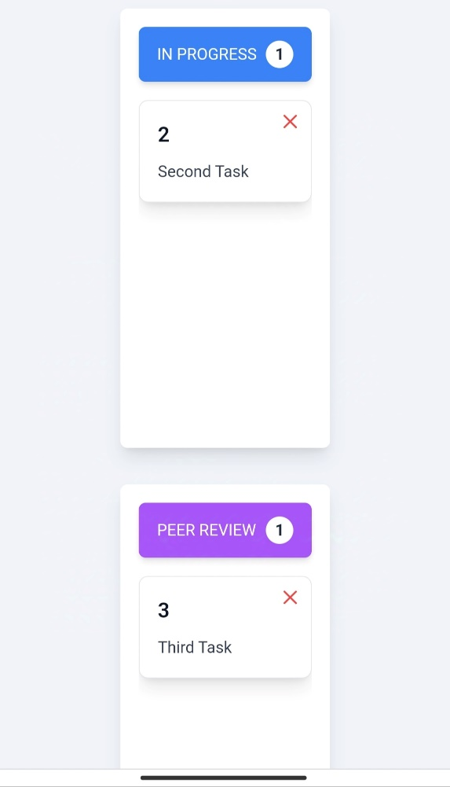](https://github.com/AbhishekIT22112002/KanbanBoard/blob/main/src/assets/Mobile-View/Main-Screen2.jpg)

[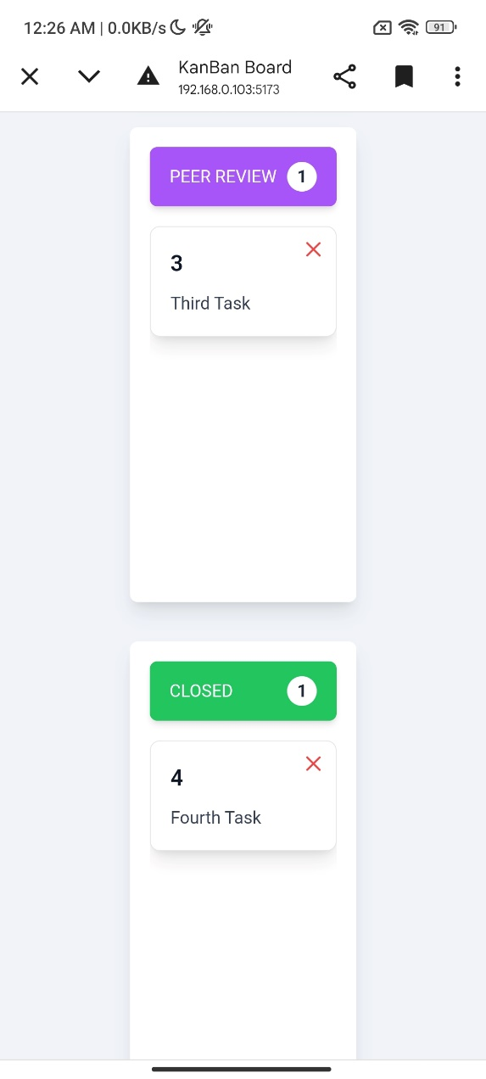](https://github.com/AbhishekIT22112002/KanbanBoard/blob/main/src/assets/Mobile-View/Main-Screen3.jpg)

* **Create Task Modal:**
  + *Chrome View*
  + [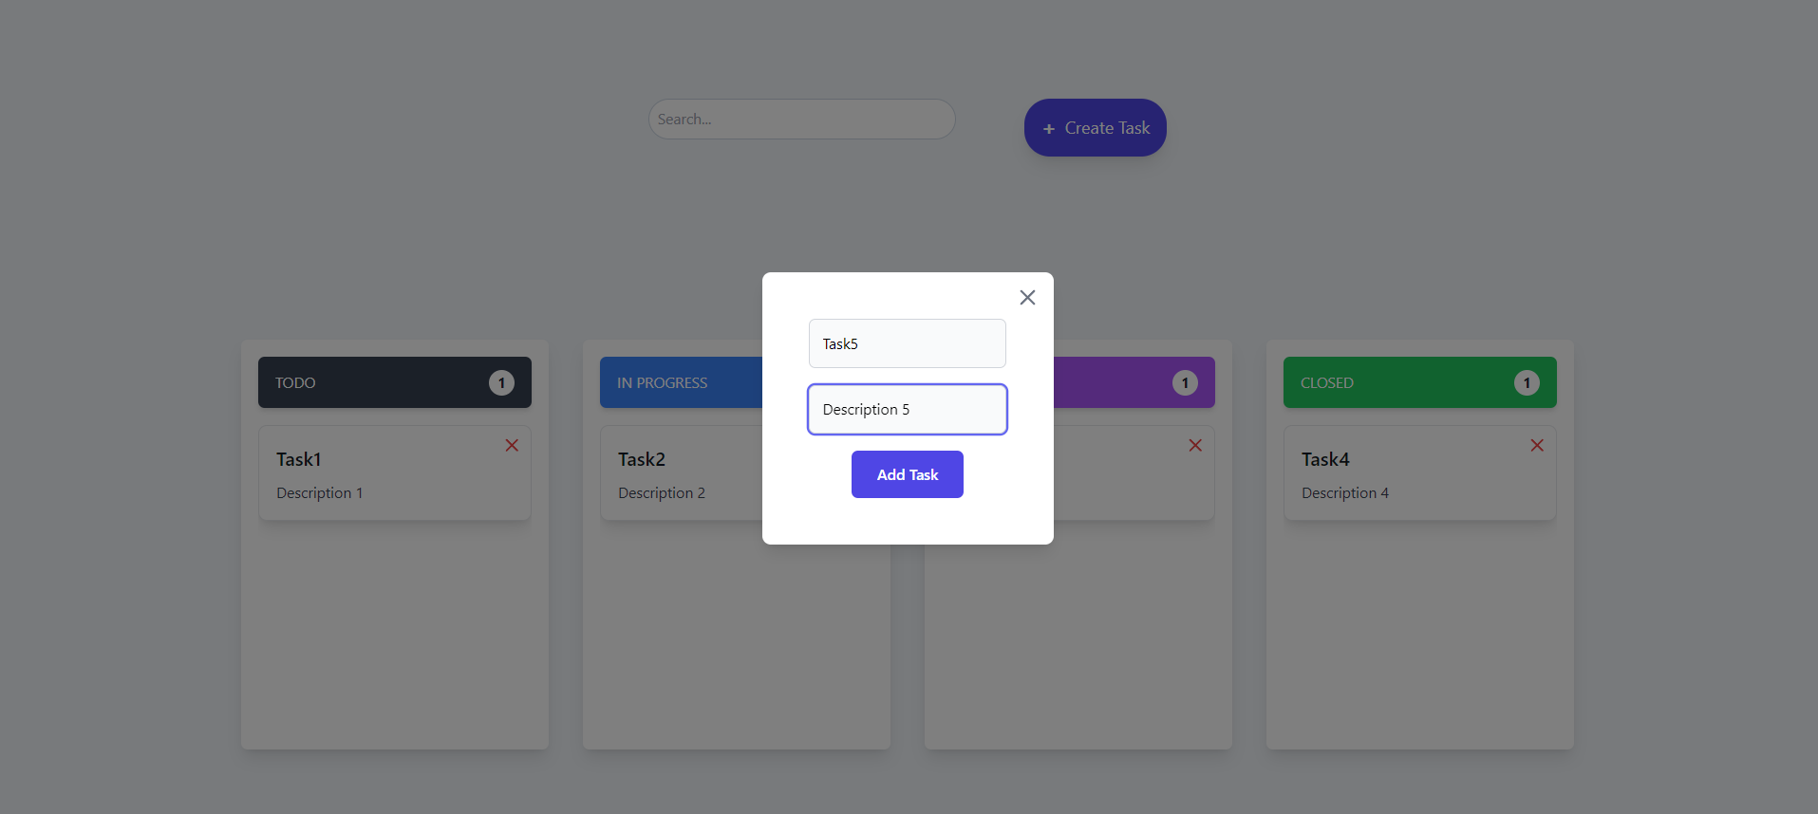](https://github.com/AbhishekIT22112002/KanbanBoard/blob/main/src/assets/ChromeView/Create-Task.png)
  + *Mobile View*

[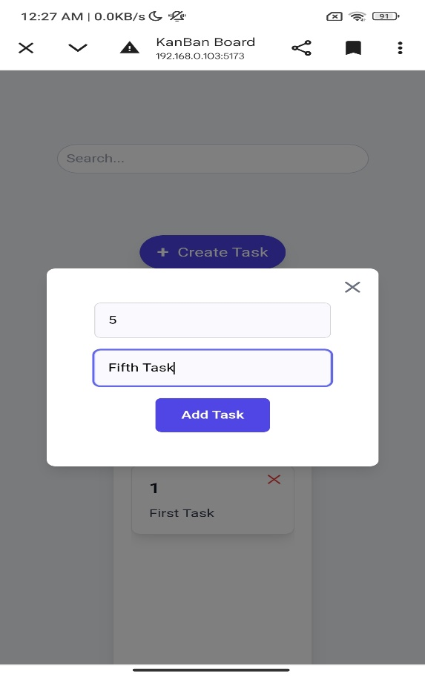](https://github.com/AbhishekIT22112002/KanbanBoard/blob/main/src/assets/Mobile-View/Add-Task.jpg)

* **Drag and Drop:**
  + *Chrome View*
  + **Drag**
  + [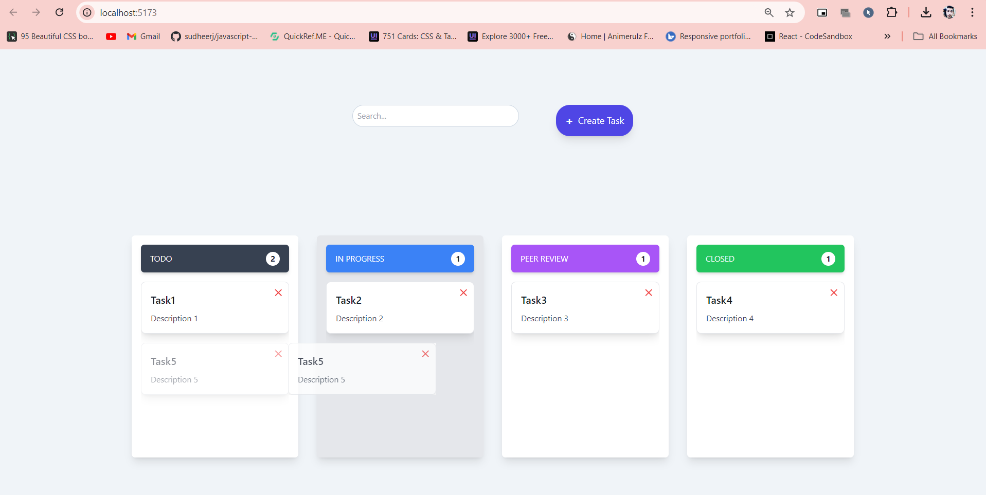](https://github.com/AbhishekIT22112002/KanbanBoard/blob/main/src/assets/ChromeView/Drag.png)
  + **Drop**
  + [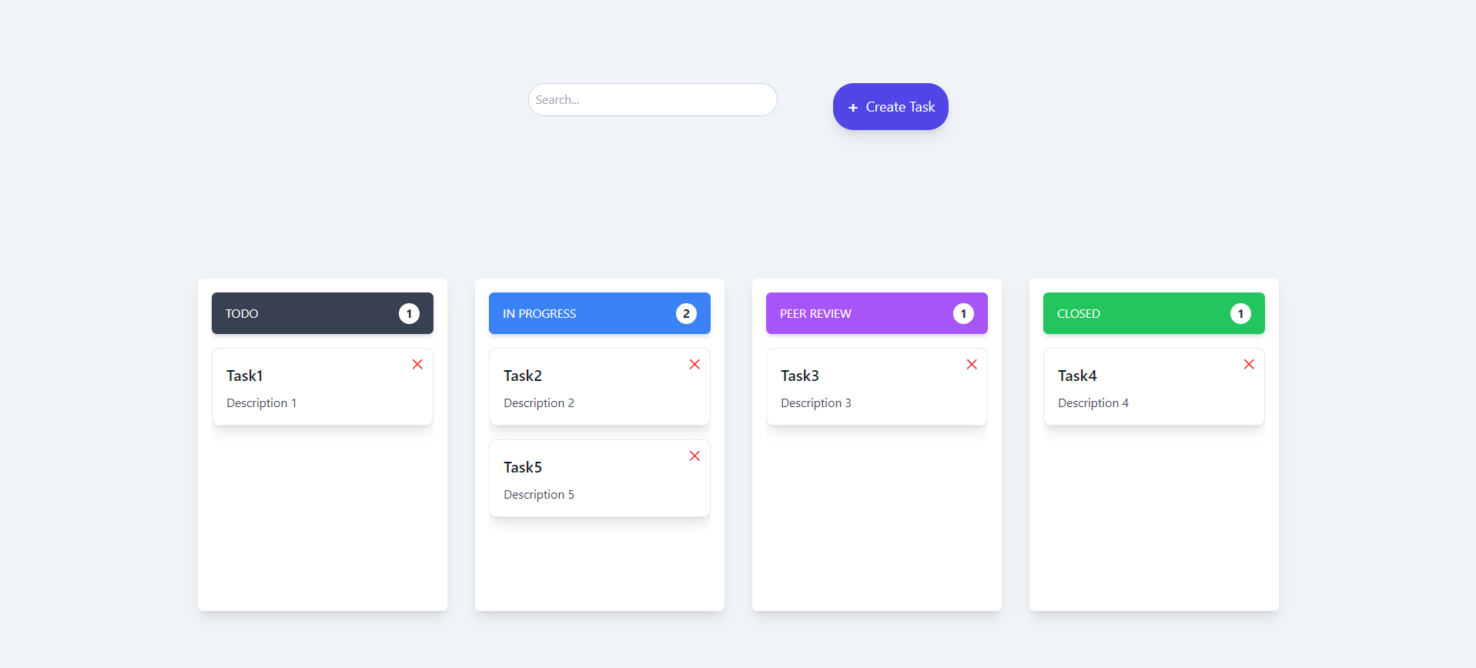](https://github.com/AbhishekIT22112002/KanbanBoard/blob/main/src/assets/ChromeView/Drop.png)
  + *Mobile View*
  + **Drag**
    - *Tap on the which you want to drag*

[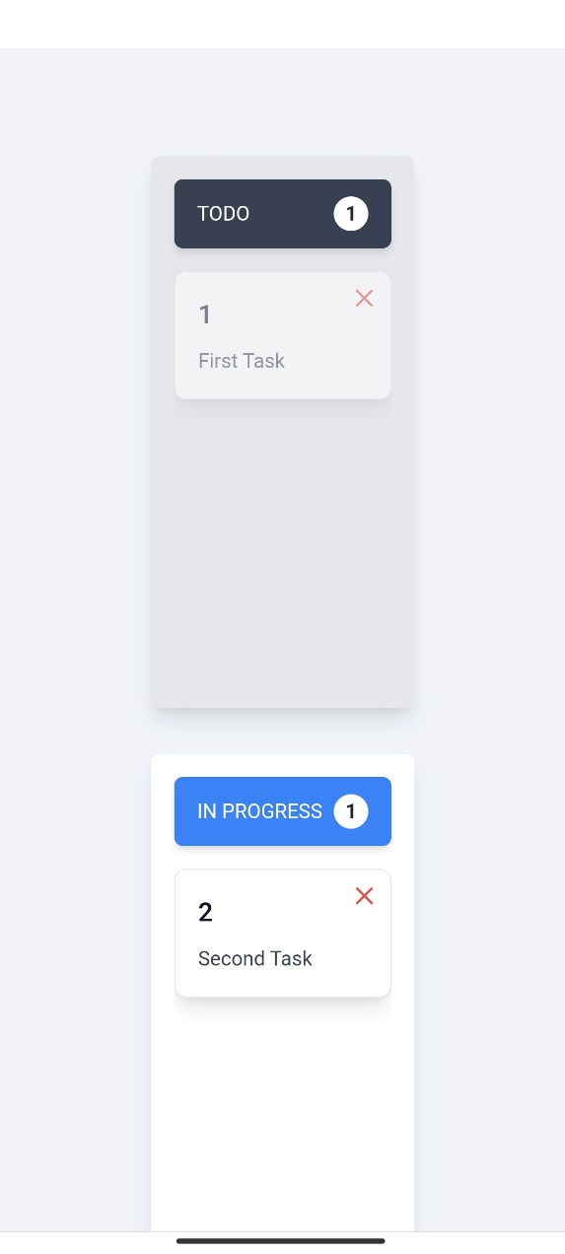](https://github.com/AbhishekIT22112002/KanbanBoard/blob/main/src/assets/Mobile-View/Drag.jpg)

* + **Drop**
    - *Then drag till the box where you want to drop that item*

[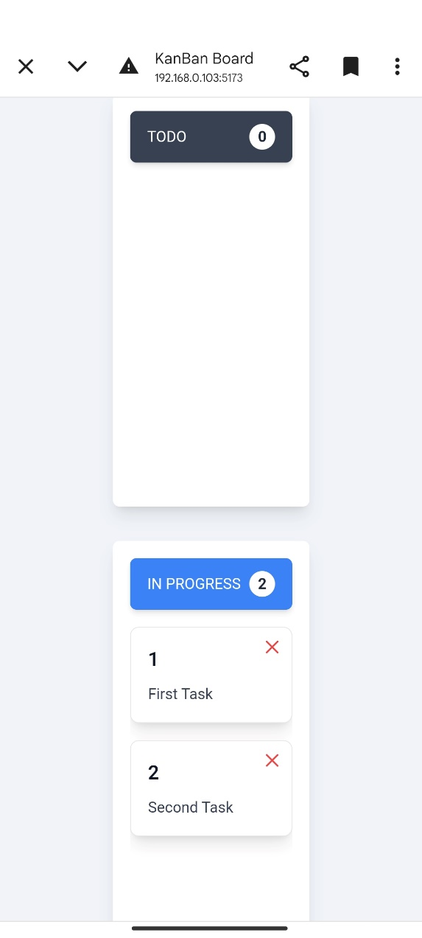](https://github.com/AbhishekIT22112002/KanbanBoard/blob/main/src/assets/Mobile-View/Drop.jpg)

* **Search Task**
  + *Chrome View*

[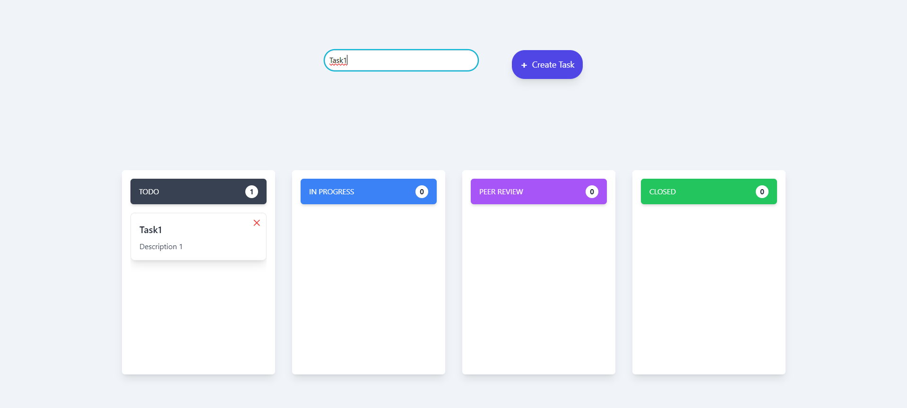](https://github.com/AbhishekIT22112002/KanbanBoard/blob/main/src/assets/ChromeView/Search-Task.png)

* + *Mobile View*
    - *Search the task you want to*

[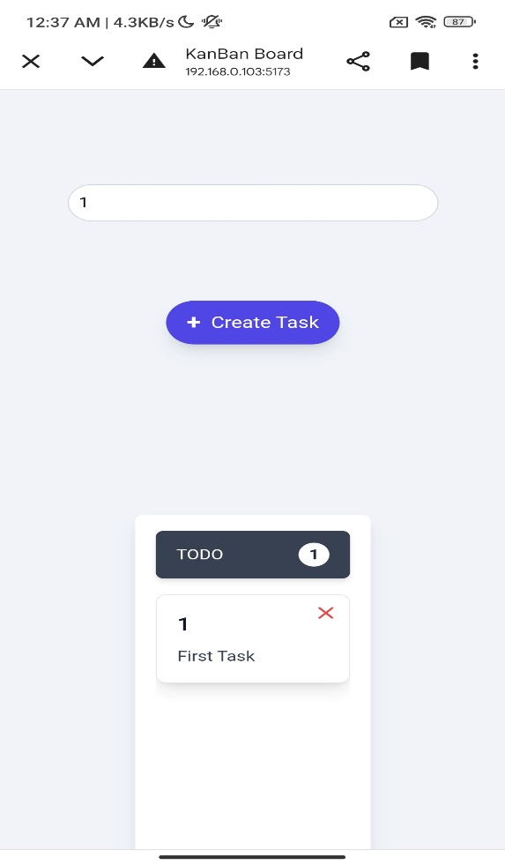](https://github.com/AbhishekIT22112002/KanbanBoard/blob/main/src/assets/Mobile-View/Search-1.jpg)

[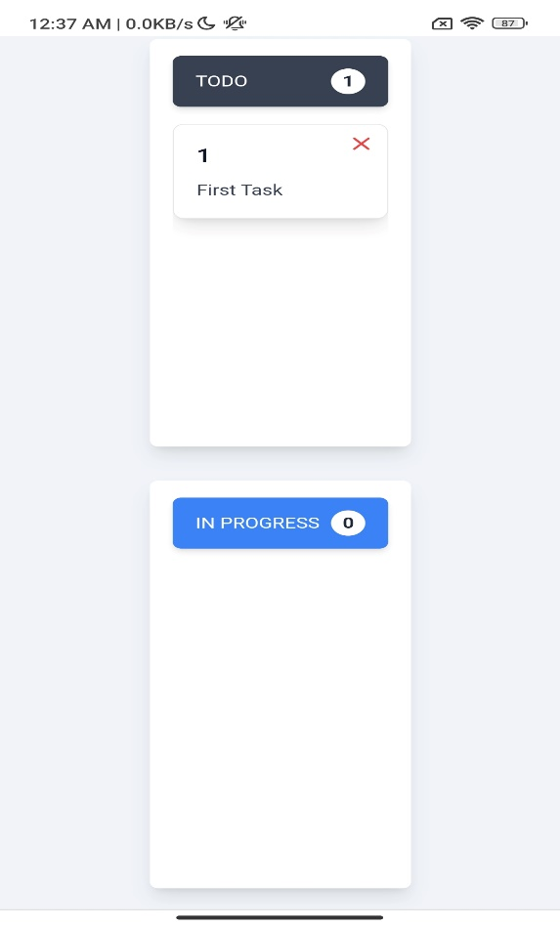](https://github.com/AbhishekIT22112002/KanbanBoard/blob/main/src/assets/Mobile-View/Search-2.jpg)

## Contributing

Contributions are welcome! Please open an issue or submit a pull request for any changes.