**Aim:** Write a program to implement the linear regression using stochastic gradient descent approach of training for a sample training data set stored as a .CSV file.

**Source code:**

import pandas as pd

import numpy as np

import matplotlib.pyplot as plt

def predict(row, coefficients):

# Predicted value using linear regression equation

yhat = coefficients[0]

for i in range(len(row) - 1):

yhat += coefficients[i + 1] * row[i]

return yhat

def sgd(train, learning_rate, epochs):

# Initialize coefficients to zero

coef = [0.0 for i in range(len(train.columns))]

m = len(train.index) # Number of data points

for epoch in range(epochs):

sum_error = 0

for _ in range(m):

random_index = np.random.randint(m) # Randomly select a data point

row = train.iloc[random_index, :]

yhat = predict(row, coef)

error = yhat - row[-1]

sum_error += error**2

# Update intercept coefficient

coef[0] = coef[0] - learning_rate * error

# Update other coefficients

for i in range(len(train.columns) - 1):

coef[i + 1] = coef[i + 1] - learning_rate * error * row[i]

# Print metrics for each epoch (optional)

# print("epoch=%d, learning_rate=%.3f, error=%.3f" % (epoch, learning_rate, sum_error / m))

return coef

# Read data from CSV

df = pd.read_csv("Z:\ML\salary_data.csv")

learning_rate = 0.001

epochs = 400

# Shuffle the rows for stochasticity

df = df.sample(frac=1).reset_index(drop=True)

# Perform stochastic gradient descent

coef = sgd(df, learning_rate, epochs)

print("coefficients:", coef)

# Scatter plot of data points

plt.scatter(df.iloc[:, 0], df.iloc[:, 1], color='blue', label='Data points')

plt.xlabel('X')

plt.ylabel('y')

# Plot the regression line

x_values = np.linspace(min(df.iloc[:, 0]), max(df.iloc[:, 0]), 100)

y_values = coef[0] + coef[1] * x_values # Assuming there are two coefficients (intercept and slope)

plt.plot(x_values, y_values, color='red', label='Regression line')

plt.legend()

plt.show()

**Output:**

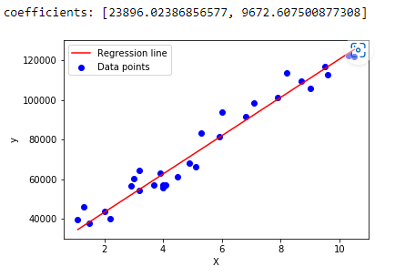

**Aim:** Write a program to implement the linear regression using Batch gradient descent approach of training for a sample training data set stored as a .CSV file.

**Source code:**

import pandas as pd

import matplotlib.pyplot as plt

def predict(row,coefficients):

yhat=coefficients[0]

for i in range(len(row)-1):

yhat+=coefficients[i+1]*row[i]

return yhat

def bgd(train,learning_rate,epochs):

coef=[0.0 for i in range(len(train.columns))]

for epoch in range(epochs):

sum_error=0

for row in range(len(train.index)):

yhat=predict(train.iloc[row,:],coef)

error=yhat-train.iloc[row,:][-1]

sum_error+=error**2

coef[0]=coef[0]-learning_rate*error

for i in range(len(train.columns)-1):

coef[i+1]=coef[i+1]-learning_rate*error*train.iloc[row,i]

#print("epoch=%d,learning_rate=%.3f,error=%.3f"%(epoch,learning_rate,sum_error))

return coef

df=pd.read_csv("Z:\ML\salary_data.csv")

learning_rate=0.001

epochs=40

coef=bgd(df,learning_rate,epochs)

print("coefficients:",coef)

x=df.iloc[:,0]

y=df.iloc[:,1]

z=coef[0]+coef[1]*x

plt.scatter(x,y)

plt.plot(x,z)

plt.show()

**Output:**

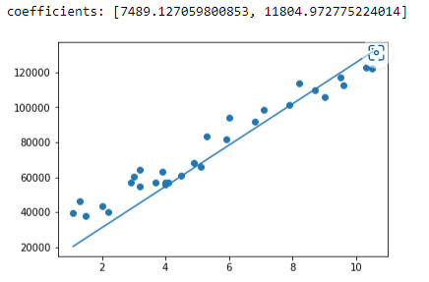

**Aim:** Write a program to implement the Logistic regression for a sample training data set stored as a .CSV file. Compute the performance of the classifier, considering few test data sets.

**Source code:**

import pandas as pd

import numpy as np

import matplotlib.pyplot as plt

import seaborn as sns

import warnings

warnings.simplefilter("ignore")

df=pd.read_csv('Z:\ML\Iris.csv')

print(df)

df.info()

df.isnull().sum()

df.columns

df=df.drop(columns="Id")

print(df)

df['Species'].value_counts()

sns.countplot(df['Species'])

X=df.iloc[:,:4]

y=df.iloc[:,4]

print(X)

print(y)

from sklearn.model_selection import train_test_split

X_train,X_test,y_train,y_test=train_test_split(X,y,test_size=1/3,random_state=9)

print(X_train.shape)

print(X_test.shape)

print(y_train.shape)

print(y_test.shape)

from sklearn.linear_model import LogisticRegression

model=LogisticRegression()

model.fit(X_train,y_train)

LogisticRegression()

y_pred=model.predict(X_test)

print(y_pred)

from sklearn.metrics import accuracy_score,confusion_matrix

confusion_matrix(y_test,y_pred)

accuracy=accuracy_score(y_test,y_pred)*100

print("Accuracy of the model is {:.2f}".format(accuracy))

**Output:**

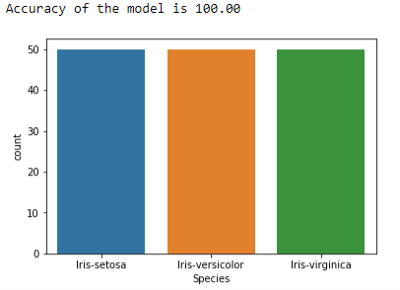

**Aim:** Linear regression

**Source code:**

import numpy as np

import pandas as pd

import warnings

from sklearn.linear_model import LinearRegression

from sklearn.model_selection import train_test_split

from sklearn.preprocessing import MinMaxScaler

from sklearn.metrics import mean_squared_error, mean_absolute_error

import statsmodels.api as sm

warnings.simplefilter("ignore")

housing = pd.read_csv("Z:\ML\Housing.csv")

#print(housing.head())

varlist = ['mainroad', 'guestroom', 'basement', 'hotwaterheating', 'airconditioning', 'prefarea']

def binary_map(x):

return x.map({'yes': 1, "no": 0})

housing[varlist] = housing[varlist].apply(binary_map)

status = pd.get_dummies(housing['furnishingstatus'])

status = pd.get_dummies(housing['furnishingstatus'], drop_first = True)

housing = pd.concat([housing, status], axis = 1)

housing.drop(['furnishingstatus'], axis = 1, inplace = True)

np.random.seed(0)

#print(housing.head())

df_train, df_test = train_test_split(housing, train_size = 0.9, test_size = 0.1, random_state = 0)

scaler = MinMaxScaler()

num_vars = ['area', 'bedrooms', 'bathrooms', 'stories', 'parking','price']

df_train[num_vars] = scaler.fit_transform(df_train[num_vars])

df_train

y_train = df_train.pop('price')

X_train = df_train

X_train_lm = sm.add_constant(X_train)

#X_train_lm

scaler = MinMaxScaler()

num_vars = ['area', 'bedrooms', 'bathrooms', 'stories', 'parking','price']

df_test[num_vars] = scaler.fit_transform(df_test[num_vars])

#df_test

y_test = df_test.pop('price')

X_test = df_test

X_test_lm = sm.add_constant(X_test)

#X_test_lm

model = LinearRegression()

model.fit(X_train_lm,y_train)

predictions = model.predict(X_test_lm)

print('mean_squared_error : ', mean_squared_error(y_test, predictions))

print('mean_absolute_error : ', mean_absolute_error(y_test, predictions))

from sklearn.metrics import r2_score

r2_score(y_test, predictions)

**Output:**

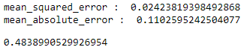

**Aim:** Logistic regression – Housing data

**Source code:**

import pandas as pd

from sklearn.model_selection import train_test_split

from sklearn.linear_model import LogisticRegression

from sklearn.metrics import accuracy_score, classification_report

import warnings

warnings.simplefilter("ignore")

housing = pd.read_csv("Z:\ML\Housing.csv")

def binary_map(x):\

return x.map({'yes':1,'no':0})

varlist = ['mainroad', 'guestroom', 'basement', 'hotwaterheating', 'airconditioning', 'prefarea']

housing[varlist]=housing[varlist].apply(binary_map)

print(housing.columns)

target_variable_name=housing.columns[-1]

features_to_keep=housing.columns[:-1]

x = housing[features_to_keep]

y = housing[target_variable_name]

x_train,x_test,y_train,y_test=train_test_split(x,y,test_size=0.2,random_state=42)

model=LogisticRegression()

model.fit(x_train,y_train)

y_pred=model.predict(x_test)

accuracy=accuracy_score(y_test,y_pred)

classification_report_result=classification_report(y_test,y_pred)

print("Accuracy: {:.2f}".format(accuracy))

print("Classification Report: ", classification_report_result)

**Output:**

