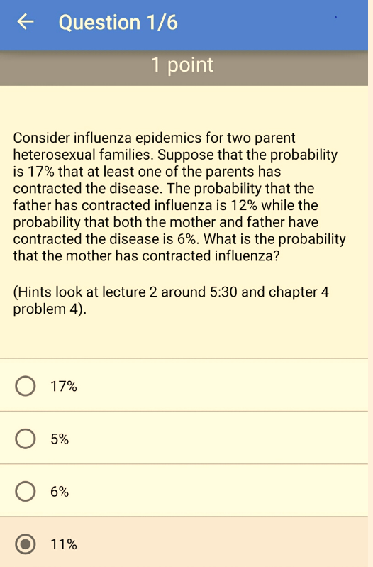

Q1:

Answer

$P(A \cup B) = .17$

$P(A) = .12$

$P(A \cap B) = .06$

$P(A \cup B) = P(A) + P(B) - P(A \cap B)$

filling in the values:

$.17 = .12 + P(B) - .06$

$P(B) = $

.17 - .12 + .06

## [1] 0.11

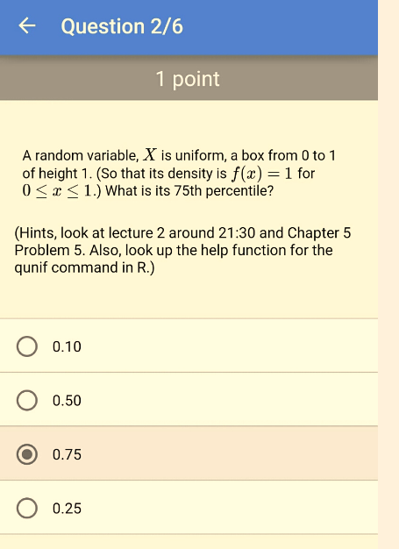Q2:

Answer

This density looks like a box. So, notice that $P(X \leq x) = width\times height = x$. We want 75th percentile: $.75 = P(X\leq x) = x$.

qunif(p=0.75, min=0, max=1)

## [1] 0.75

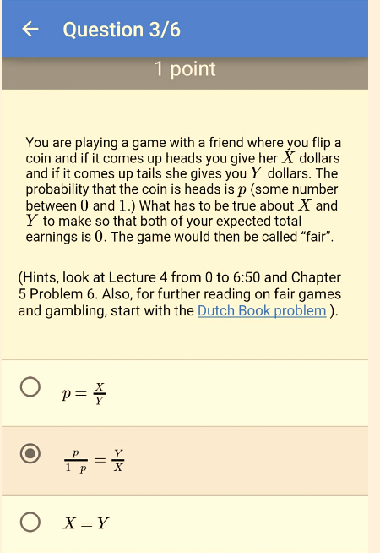Q3:

Answer

X * p - Y * (1 - p) = 0

X * p = Y * (1 - p)

p/(1 - p) = Y/X

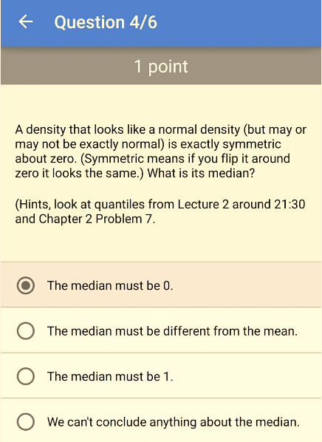Q4:

Answer

The median must be 0, because 50% of the probability is below 0 and 50% is above 0, when the density is symmetric at zero.

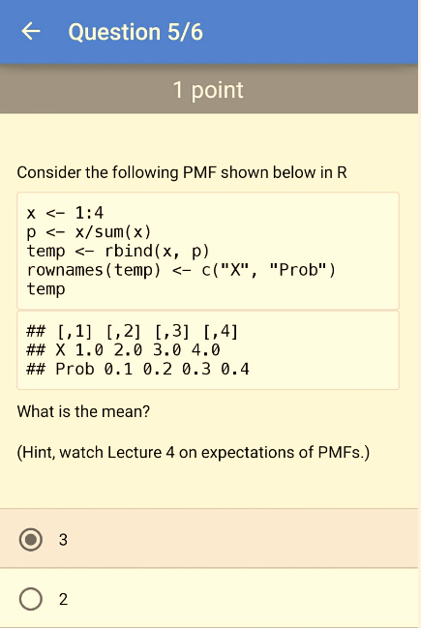 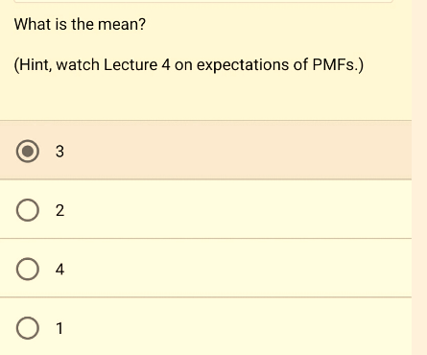Q5:

Answer

The center of mass of data is the empirical mean $\bar X = \sum\limits_{i=1}^n x_ip(x_i)$

The mean is the sum of the x and with it's related probability

Xmean <- sum(temp["X",] * temp["Prob",])

Xmean

## [1] 3

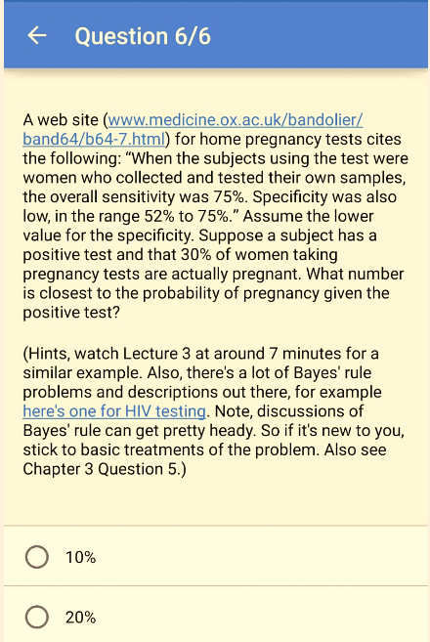 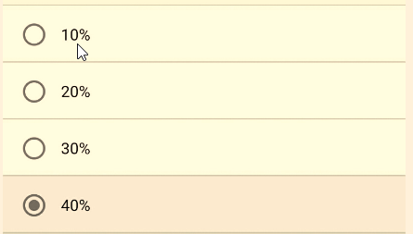Q6:

Answer

Ppregnant_pos = 0.75*0.30/(0.75*0.30+0.48*0.70)

round(Ppregnant_pos*100)

## [1] 40