**QUE.1**

Query all columns for all American cities in the **CITY** table with populations larger than 100000. The **CountryCode** for America is USA

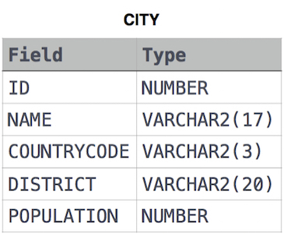

**Solution: -**

SELECT * FROM city

WHERE COUNTRYCODE = 'USA' AND

population > 100000

**QUE 2.**

Query the **NAME** field for all American cities in the **CITY** table with populations larger than 120000. The **CountryCode** for America is USA.



**Solution: -**

SELECT name FROM city WHERE countrycode = 'USA' AND population > 120000

**QUE.3**

Query all columns (attributes) for every row in the **CITY** table.



**Solution: -**

SELECT * FROM city

**QUE.4**

Query all columns for a city in **CITY** with the ID 1661.



**Solution: -**

SELECT * FROM city

WHERE ID = 1661