**QUE.1**

Query all attributes of every Japanese city in the **CITY** table. The **COUNTRYCODE** for Japan is JPN.  
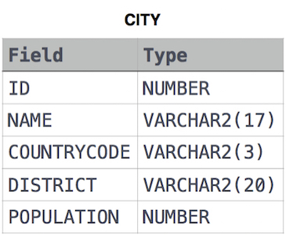

**Solution: -**

SELECT * FROM city WHERE countrycode = 'JPN'

**QUE.2**

Query the names of all the Japanese cities in the **CITY** table. The **COUNTRYCODE** for Japan is JPN.  
  


**Solution: -**

SELECT name FROM city

WHERE countrycode = 'JPN'

**QUE.3**

Query a list of **CITY** and **STATE** from the **STATION** table.  
The **STATION** table is described as follows:  
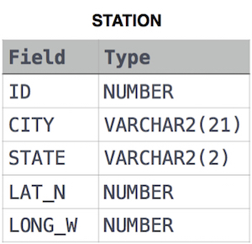

**Solution: -**

SELECT city, state FROM station;

**QUE.4**

Query a list of **CITY** names from **STATION** for cities that have an even **ID** number. Print the results in any order, but exclude duplicates from the answer.



**Solution: -**

SELECT DISTINCT city FROM station WHERE id % 2 = 0