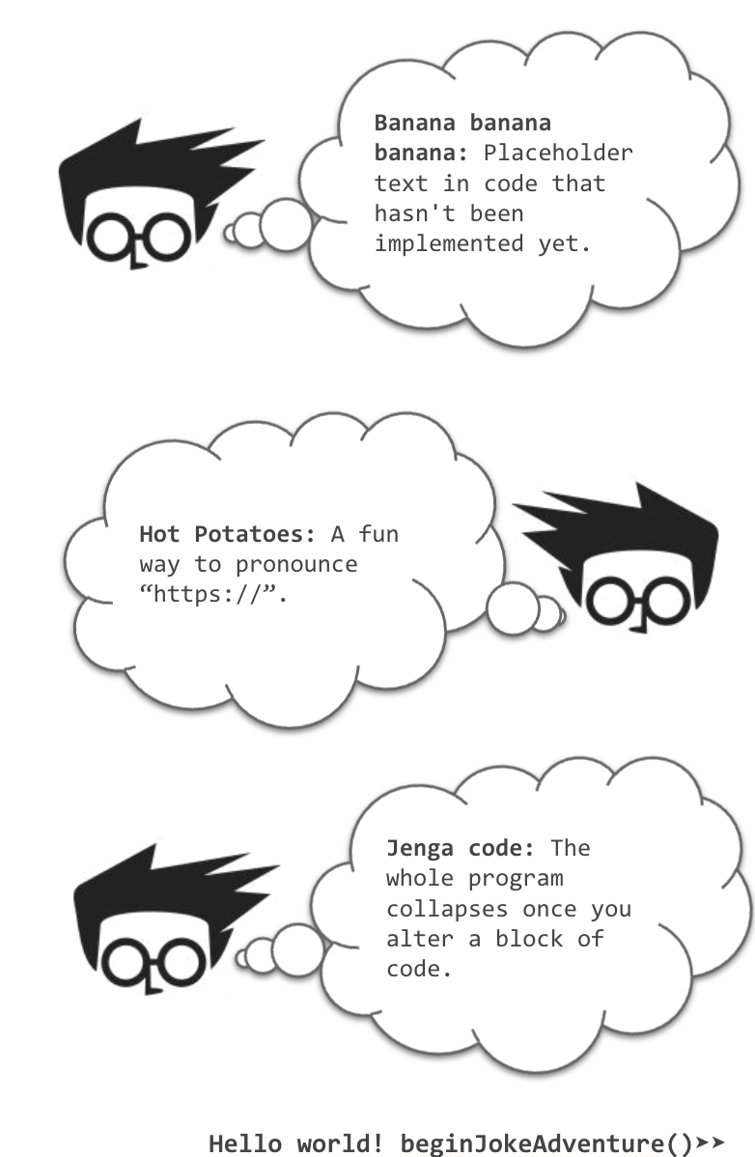

Q: What is a programmer’s favourite hangout place?

A: Foo bar.

Q: 0 is false and 1 is true, right?

A: 1

Q: Why do Java programmers have to wear glasses?

A: Because they don’t C# (see sharp).

*Programmer* (noun)  
A person who fixed a problem that you don’t know you have, in a way you don’t understand.

*Algorithm* (noun)

A word used by programmer when they do not want to explain what they did.

FORK YOU! (verb)

A verb said by the developer to the repository

“When I wrote this code, only God & I understood what I did.”

“Now.. Only god knows.”

Q: Can you please recommend book that made you cry?

A: Data Structures and Algorithms in Java.

“To replace programmers with Robots, clients will have to accurately describe what they want.”

“We’re safe.”

Do British web developers get annoyed every time they have to write “color” in their CSS?

Give a man a program, frustrate him for a day. Teach a man to program, frustrate him for a lifetime.

HR: “Thi job opening that requires 8+ years of Swift experience.”

Me: “Swift is a programming language that came out 3 years ago.”

“What is the biggest lie you have heard from a programmer?”

“It should work now.”

Q: Why did the database administrator leave his wife?

A: She had one-to-many relationships.

Q: Why did the child component have such great self-esteem?

A: Because its parent kept giving it props!

Debugging:   
Removing the needles from the haystack.

A programmer goes to the shop to buy some milk. His wife calls and says "While you're out, get some eggs."   
and he never returns …

My wife said: "Honey, please go to the market and buy 1 bottle of milk. If they have eggs, bring 6.”   
I came back with 6 bottles of milk.

She said, "Why the hell did you buy 6 bottles of milk?" I said,   
"Because they had eggs!!"

A UDP packet walks into a bar.   
A UDP packet walks into a bar.   
A UDP packet walks into a bar.   
A UDP packet walks into a bar.   
A UDP packet walks into a bar.   
The bartender says "hello."

A TCP packet walks into a bar and says "I’d like a beer." The barman replies "You’d like a beer?" "Yes," replies the TCP packet, "I’d like a beer."

A BitTorrent packet walks into a bar and asks for a beer. Everyone in the bar who already has a beer gives him a sip.

I wrote this function. Its name is meMaybe()

so that you can call meMaybe().

Man: "Make me a sandwich"  
Woman: "No"

Man: "sudo Make me a sandwich"  
Woman: "Okay"

To understand what recursion is, you must first understand recursion.

Q: Why do most programmers use dark mode?

A: Because the light attracts too many bugs.

Q: What did 0 say to 1?

A: You're a bit too much.

Q: Why did the functions stop calling each other?

A: Because they had too many arguments.

My programmer friend said I have a high IQ

He said it's 404.

I asked a programmer what his New Year's *resolution* will be.

He answered:640 x 480.

Whats at the end of every programmers suicide note?

“Goodbye World”

Programmer: "Honey, you're my number one..."

Wife: "Oh, really!? Well who's your number zero, you cheating bastard!?"

A programmer walks into a bar, holds up two fingers, and says “I’ll have three beers please.”

A programmer puts two glasses on his bedside table before going to sleep.

One full of water in case he gets thirsty and an empty one in case he doesn't.

Q: Why do exterminators make for good programmers?

A: They're experts in debugging!

Q: Why do programmers never go to sleep?

A: Because goto is evil.

Q: What do programmers want from their bosses?

A: Arrays (a raise).

Q: What do you call a programmer that doesn't use Stack Overflow?

A: A liar.

Q: Did you hear about the half-assed programmer?

A: Apparently he had a missing semi-colon.

Q: What do programmers do when they're hungry?

A: They grab a byte.

A programmer was arrested for writing unreadable code

He refused to comment.

Did you hear about the programmer who got sent to prison for using the wrong types in his C programs?

He's going to prison for along long time_t.

Wow why did my programmer wife grow big boobs?

Because She is a Full-stack Developer

Did you hear about the programmer who was apprehended before he could check in his code?

He was arrested for a crime; he didn’t commit.

Q: Why do Python programmers have low self esteem?

A: They're constantly comparing their self to other.

Q: How did html get drunk?

A: It had too many

I'm a programmer, wearing glasses

They are made to C#.

Q: What does a programmer wear?

A: Whatever is in the dress code.

Q: Why do programmers hang out together?

A: Because they are codependent

Q: What do you call the security outside of a samsung store?

A: Guardians of the Galaxy

I am a programmer. A journalist asked me what makes   
a software code bad. I said...

No comment

Q: How do you know if a programmer is really busy?

A: They’ve got a lot of issues.

Q: How did the programmer escape from prison?

A: from%20prison

Q: What do you call it when a programmer goes to the bathroom when they have a new idea?

A: A memory dump.

Q: What is it called when a programmer goes to hell?

A: Syntax.

Q: Why can't Communists be programmers?

A: Because there is a hierarchy of classes, inheritance, and private properties

I broke up with my girlfriend, Ruth..

Now her friends call me ruthless.

There was a catastrophic cyber attack recently...

The government is still looking for the hacker. They think he ran some ware.

Tesla released a new software update...

If you miss a car payment your car drives itself back to Tesla.

Q: Why can’t software developers distinguish between Halloween and Christmas?

A: Because OCT 31 == DEC 25

(hint: octal and decimal are numerical bases 8 and 10 respectively, happy holidays!)

Arguing with your wife…  
is like reading a software licensing agreement.

In the end you just ignore everything and click “I agree”.

When software doesn't work

It just bugs me.

Do you know the difference between a car salesperson and   
a software salesperson?

The car salesperson knows when they're lying.

My school found out that I was misusing the free Office software they gave us.

But you don’t have to take my Word for it.

Q: Why did the software engineer get into a car accident?

A: He wasn't able to C: Drive

Q: If bees start writing software, what are they called?

A: Beware

Q: What do we call a software engineer's unwanted child

A: A cum..pilation error

Q: What do you get when you cross a Software Engineer with an English teacher?

A: A programmar.

I installed anti virus software on my computer

Now my computer has autism

Q: Hey Girl! Are you a software program?

A: Because I want to execute you

Q: If pirates say "Arr", What do software pirates say?

A: .RAR

My computer was really laggy until someone helped me update my software

Turns out it was the bus driver

Got a B in my computer programming class

Call that a C++!

I used to date computer programs but that's over now

My girlfriend still worries that I may go back but I reply to her "they're just exes "

I almost bought a huge library out of old computer programming books...

...but the ascii price was way too high.

I would talk about computer science...

But it makes my mother board

Q: Why isn't there any beautiful girl in computer science?

A: Because they're all 0's and 1's

Q: Why did the software developer go broke?

A: He used up all his cache !

Q: Relationship status?

A: I'll leave the relations to the database.

Q: How do you get the code for the bank vault?

A: You checkout their branch.

Q: Why did the security conscious engineer refuse to pay their dinner bill?

A: Because they could not verify the checksum.

Q: What do you call a busy waiter?

A: A server.

Q: What do you call an idle server?

A: A waiter.

Q: Why did 10 get paid less than "10"?

A: There was workplace inequality.

Q: Why was the function sad after a successful first call?

A: It didn’t get a callback.

Q: What’s the object-oriented way to become wealthy?

A: Inheritance

Q: Why did the functions stop calling each other?

A: Because they had constant arguments.

Q: What did the spider do on the computer?

A: Made a website!

Q: Why was there a bug in the computer?

A: Because it was looking for a byte to eat?

Q: Where do all the cool mice live?

A: In their mousepads!

Java truly is an OOP language...

As in: OOPs I used Java!

-

Q: Why don't bachelors like Git?

A: Because they are afraid to commit.

Q: A SQL query goes into a bar, walks up to two tables and asks:

A: Can I JOIN you?

Q: What did JavaScript call his son?

A: JSON!

Q: What did the proud React component say to its child?

A: I've got to give you props

Q: What did the server say to his client who was having a bad day?

A: Everything's going to be 200

Q: How did the mafioso kill the Node server?

A: Tie await to it and let it async.

Q: Why do UPS drivers get nervous when their internet is unstable?

A: Because they might lose packets.

Q: A SQL developer walked into a NoSQL bar.

A: They left because they couldn't find a table.

Q: Why don't parents teach their kids about regular expressions?

A: Because they don't want them playing with matches.

Q: Why did the constant break up with the variable?

A: Because they changed.

Q: What did the Class say in court when put on trial?

A: I strongly object!

Q: How does a sysadmin keep a fire going?

A: They rotate the logs.

Q: What did the process say after working in an infinite loop all day?

A: I need a break.

Q: Why is Python like the Soviet Union?

A: Because it has no private fields

Q: Where did the API go to eat?

A: To the RESTaurant

Q: Why shouldn't you trust Matlab developers?

A: Because they're always plotting something.

Q: Why couldn't the React component understand the joke?

A: Because it didn't get the context.

Q: What do you call a beverage that is 75% Root Beer, and 75% Ice Cream?

A: A Float

Q: What accommodations did the JavaScript developer request at the hotel?

A: A room with a Vue.

Q: Why do assembly programmers need to know how to swim?

A: Because they work below C level.

Q: What kind of computer can hold a musical note?

A: A Dell.

Q: Why are machine learning models so fit?

A: Because they do weight training.

Q: What are clouds made of?

A: Mostly linux servers.

Q: Why are keyboards always working so hard?

A: Cause they have two shifts!

Q: How do JavaScript developers break up?

A: They always promise to callback

Q: Which programming language is the shortest?

A: HTML. Because it doesn't have a neck between its <head> and <body>.

I went to a street where the houses were numbered 8k, 16k, 32k, 64k, 128k, 256k and 512k.

It was a trip down Memory Lane.

Q: Why do Front-End Developers eat lunch alone?

A: Because, they don't know how to join tables.

Q: What advice do you give to a JS developer who has never played baseball?

A: Try catch.

Q: Why were A & B so frustrated?

A: Because they couldn’t cd…

Q: Why do Websockets make the best therapists?

A: They are always listening.

Q: Why do Elm developers type so loudly?

A: Because it's a strongly typed language.

Q: How do you know your baby is going to be a developer   
when they grow up?

A: Their first word is "Hello world!"

Q: How do you make a 4D Printer?

A: Take a 3D printer and give it some time

Q: What do hackers do on a boat?

A: Phishing.

Teacher: "How would you describe your level of programming?"

Students: "Low"

Teacher: "Ok, fine, you can write programs in assembler then"

My girlfriend told me I care more about my programming   
job than about her.

I told her she is the #1 thing I care about.

My code doesn’t work!

Let’s change nothing and run it again!

Q: What do the new MacBook and a black hole have in common?

A: There's no Escape!

Q: How did the Coder CEO build his company headquarters?

A: By calling the Constructor();

Ask a programmer to review 10 lines of code, he’ll find 10 issues.   
Ask him to do 500 lines and he’ll say it looks good.

Once I asked a recruiter “who’s Jason” when they were actually asking if I knew JSON.

Google Engineers right now!

Just google “how to fix servers”   
Oh wait-

Q: What is Hardware?

A: The part of the computer which you can kick.

Q: What is the problem with git jokes?

A: Everyone has their own version!

Married life of a developer

#wife {

right: 100%;

margin: 0;

}

99 year old man dying: “Oh! God, Save Me!!”

God: Ok, JPG or JPEG?

"Only my friends get to touch my private parts." -C++

Q: Why do programmers have bad digestion?

A: They only have semi-colons

Q: Why data scientists be charged with animal trafficking and animal abuse?

A: Because they import pandas and feed them to python.

Q: What do programmers inherit?

A: Technical Debt

I've been using VIM since about 5 years because I never find out how to quit.

Q: All programming languages went to a party. Who paid the bill?

A: Of course, PHP. PHP has many $.

Are you a RESTful API?   
because you GET my attention,   
PUT some love,   
POST the cutest smile, and   
DELETE my bad day

Q: How do you comfort a JavaScript bug?

A: You console it.

layman: Hey! What's your address

developer: 173.168.15.10

layman: No man. Your local address

developer: 127.0.0.1

layman: I mean your physical address

developer: 29.01.38.62.31.58

A: Anyone know any joke about sodium??   
A: NA

Q: Why does Python live on land?

A: Because it's above C-level

Q: How are computers and air conditioners similar?

A: They are both useless   
when you open windows

Q: Have you heard of the band with 1023 megabytes?

A: No, they just haven't had a gig yet.

Q: What screams "I'm insecure"?

A: Http

Q: Which type of shooting always hurt the shooter?

A: Trouble-shooting!

Q: Why did the react class component feel relieved?

A: Because it was now off the hook.